OPERATING SYSTEM

Assignment Number:1(a)

TITLE: Execution of basic & advanced unix commands

**Name : Tejas Desai**

**Roll No : 53**

**Div;CS-A**

**Batch:b2**

1. Guessing game using if, then and or

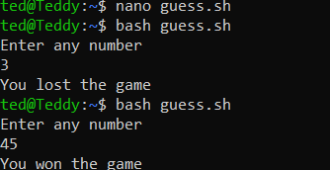

2.combine string content

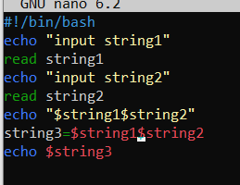

3.make a dir and check if it already exists

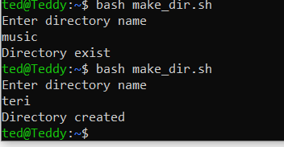

4. Check if the file exits

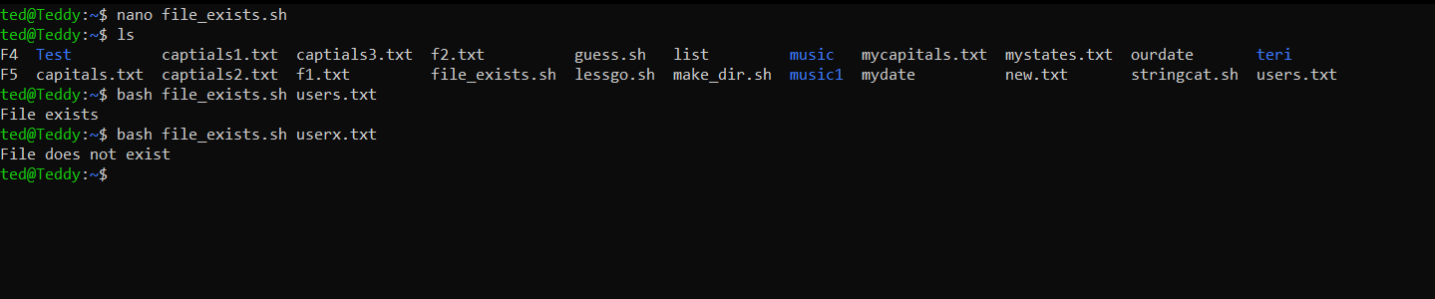

5. Find area

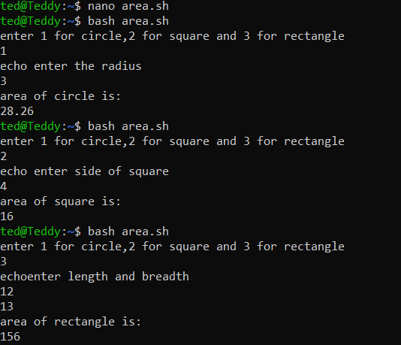

6. reverse a string

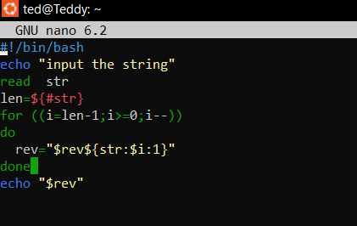

7) Function to find factorial

