Rui Gao

[gaorui@oregonstate.edu](mailto:gaorui@oregonstate.edu)

project#0

Simple OpenMP Experiment

1. Pick an array size to do the arithmetic on. Something like 16384 (16K) will do. Don't pick something too huge, as your machine may not allow you to use that much memory. Don't pick something too small, as the overhead of using threading might dominate the parallelism gains.

20,000

1. Using OpenMP, pairwise multiply two large floating-point arrays, putting the results in another array. Do this in a for-loop.  
   C[ i ] = A[ i ] * B[ i ];
2. Do this for one thread and do this for four threads:  
   #define NUMT 1  
   and  
   #define NUMT 4
3. Time the two runs. Convert the timing results into "Mega-Multiplies per Second".

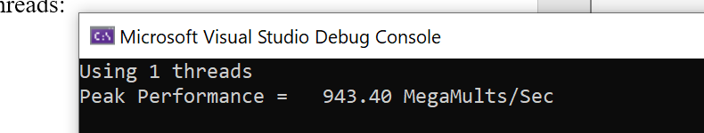

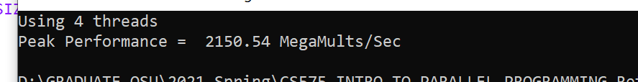

1. What speedup, S, are you seeing when you move from 1 thread to 4 threads?  
   **S** = (Execution time with one thread) / (Execution time with four threads) = (Performance with four threads) / (Performance with one thread)  
   This number should be greater than 1.0 . If not, be sure you are using the correct numerator and denominator.

S = 2150.54/943.4 = 2.2786

1. If your 1-thread-to-4-threads speedup is **S**, compute the parallel fraction:

float Fp = (4./3.)*( 1. - (1./S) );

Don't worry what this means just yet. This will become more meaningful soon.  
You must have used 1-thread-to-4-threads. The numbers in this equation depend on that.

Fp = 0.7481

1. Your written commentary (turned in as a PDF file) should include:
   1. Tell what machine you ran this on

Zephyrus 14, AMD Ryzen 4900hs

* 1. What performance results did you get?

943.4 MM/s for 1thread and 2150.54for 4 threads.

* 1. What was your 4-thread-to-one-thread speedup?

I believe it’s the reciprocal for S, so it’s 2150.54/943.4 = 2.2786.

* 1. If the 4-thread-to-one-thread speedup is less than 4.0, why do you think it is this way?

The separating of works take the time.

* 1. What was your Parallel Fraction, Fp?
     + 1/S is the percentage of threads 1: 4.
     + 1-(1/S) means the difference between them on the percentage aspect.
     + 4/3 is a constant, I guess the Fp is a formula for calculating the ideal speed/performance for an 1-thread-to-4-threads. If it’s equal to 1, the performance for 4 threads is ideal.