Vectorized Array Multiplication/Reduction using SSE

Rui Gao

gaorui@oregonstate.edu

Project 4

CS 575

1. What machine you ran this on

Zephyrus 14

1. Show the table of performances for each array size and the corresponding speedups

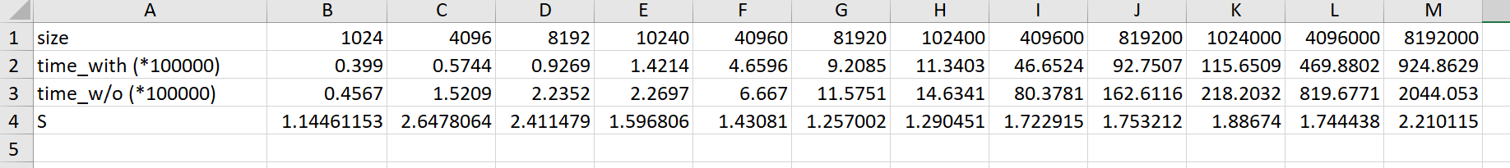

1. Show the graph of SIMD/non-SIMD speedup versus array size (one curve only)

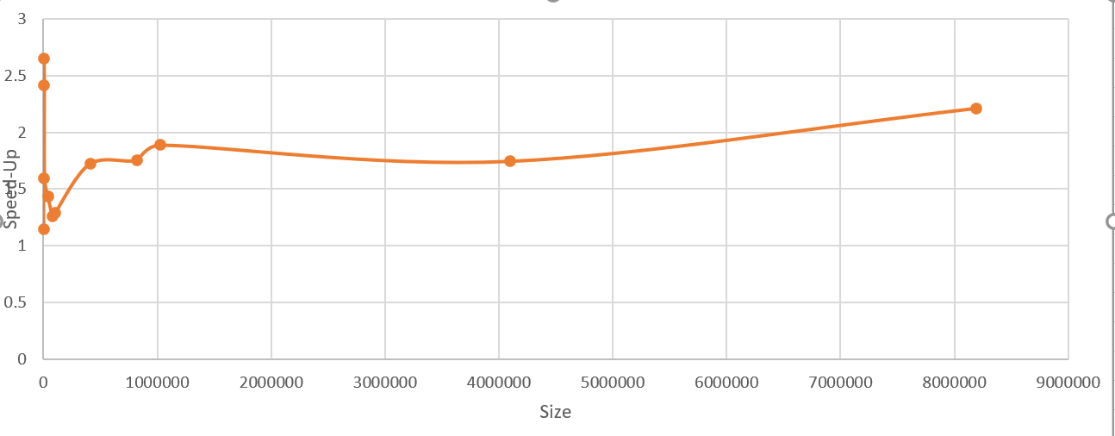

1. What patterns are you seeing in the speedups?

The curve increased first and then decreased. In the end, it increased again.

1. Are they consistent across a variety of array sizes?

No, they are not consistent. It has fluctuation.

1. Why or why not, do you think?

In the beginning, the size is small, so the real computation time occupies a small part of time and so, the S is small.

Then, as the size increase, so the real computation time occupies a bigger and bigger part of time and so, the advantage of SSE became obvious and the trending showed increasing.

Next, maybe the time costing of assigning increased, so the S decreased.

In the end, I don’t know, it backs to normal.