Rui Gao

CS 575

Project #7B

Autocorrelation using MPI

1.Show the Sums{1] ... Sums[255] vs. shift scatterplot.

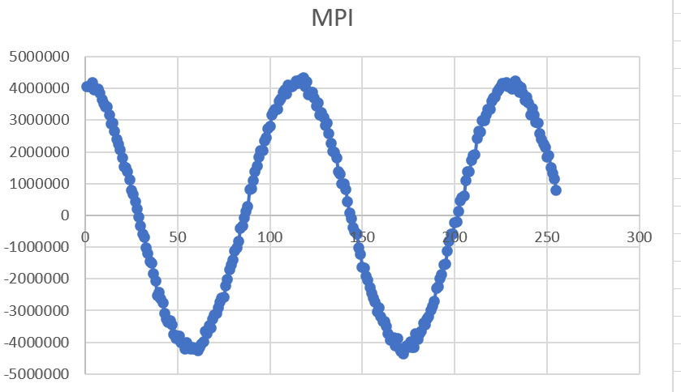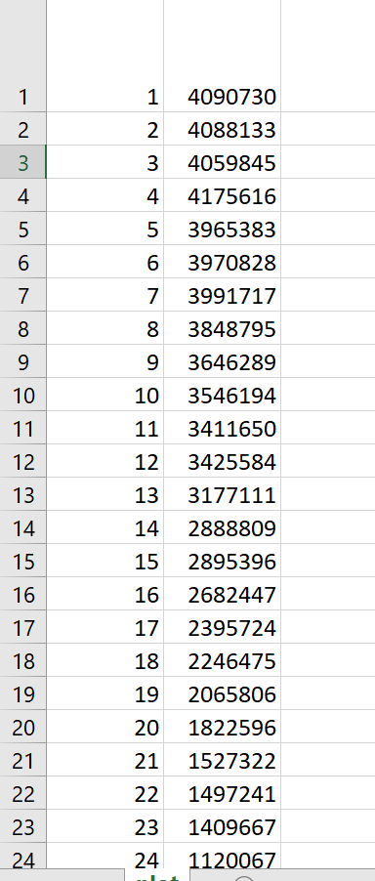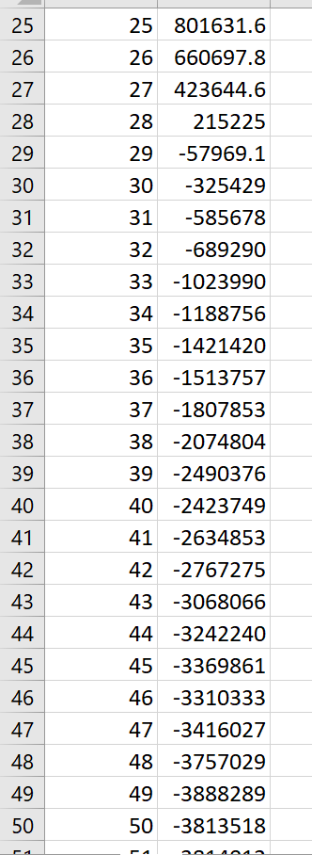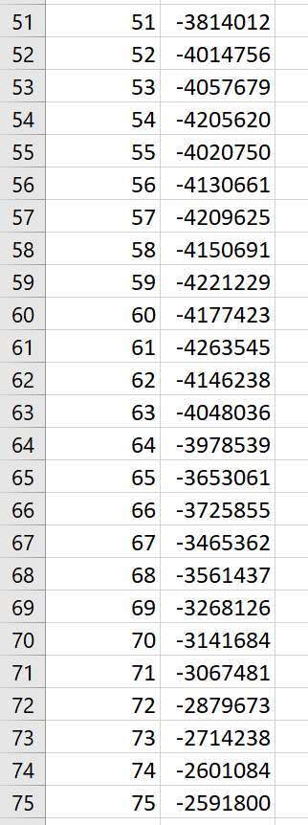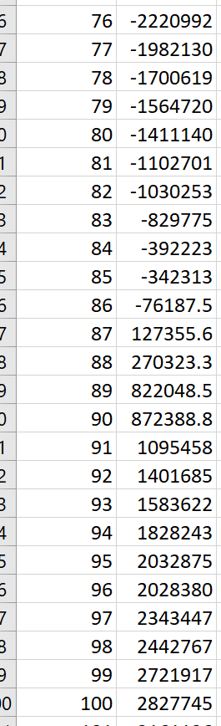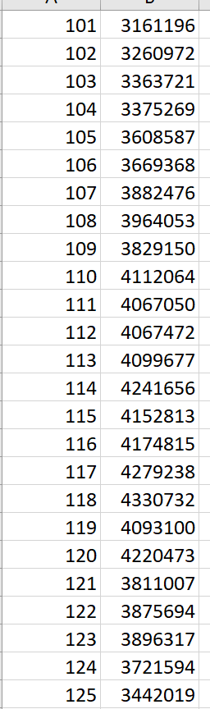

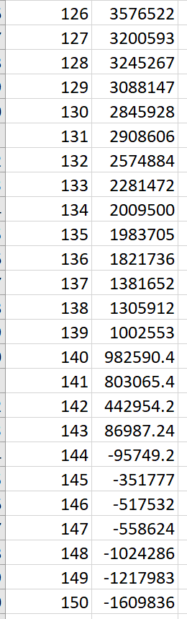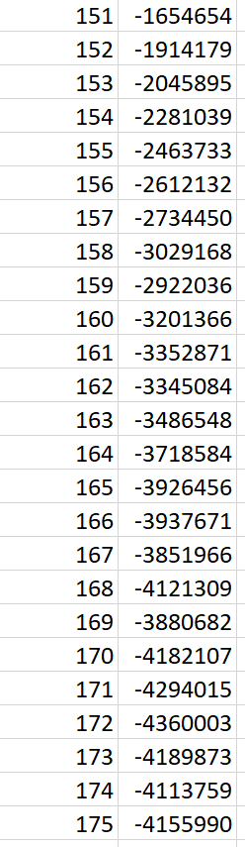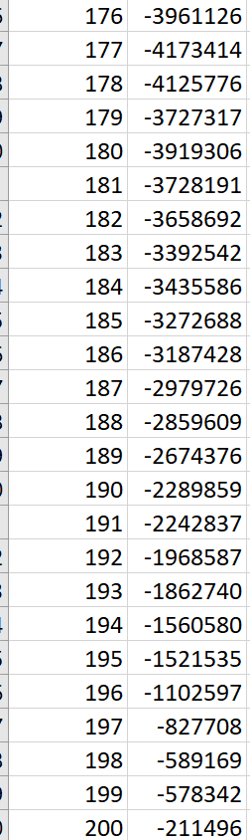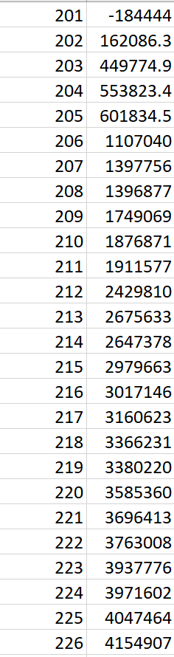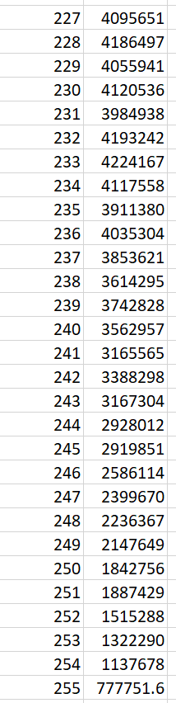

2.State what the secret sine-wave period is, i.e., what change in shift gets you one complete sine wave?

It’s a cosin wave and the period is around 120.

3.Show your graph of Performance vs. Number of Processors used.

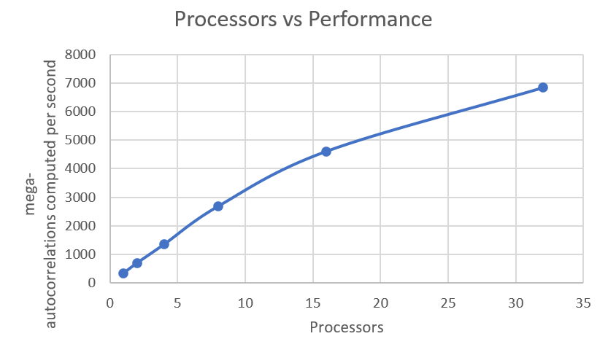

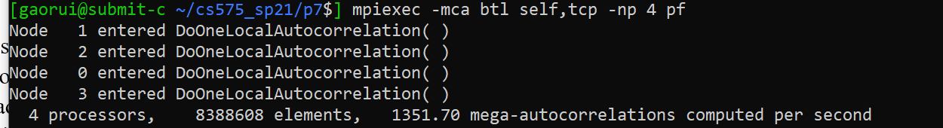

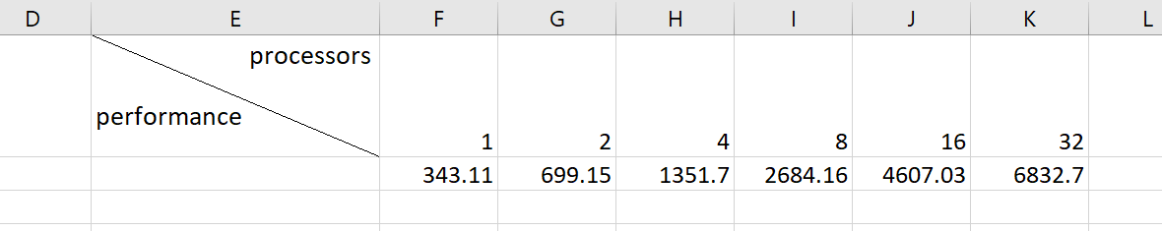

4.What patterns are you seeing in the performance graph?

The performance increases with the increasing of the number of processors.

It also become double when the processors grows to double in the beginning and it grows slower when the number of processors is a kind of big.

5.Why do you think the performances work this way?

I guess the reason is even though the MPI is able to fully using CPUs and do the communication job among CPUs, but as the amount of separating jobs increases, it takes more and more time on dividing and transforming.