User Manual

Group 2 EECS2311

April 15, 2020

Marco Carusoni

Arjun Kaura

Joseph Spagnuolo

Jeffrey Walker

Supervised by: Dr Vassilios Tzerpos

Updated Manual Submission

* **Installation**

To install the application, simply run the .jar file provided.

* **Getting Started**

Before launching the application, think about what you want your diagram to look like. When you run the application, you will see the following screen:

This is the welcome page. If you have an existing project, click “Open Existing Project” to open it. Select your project file from the screen that appears and click “Open”.

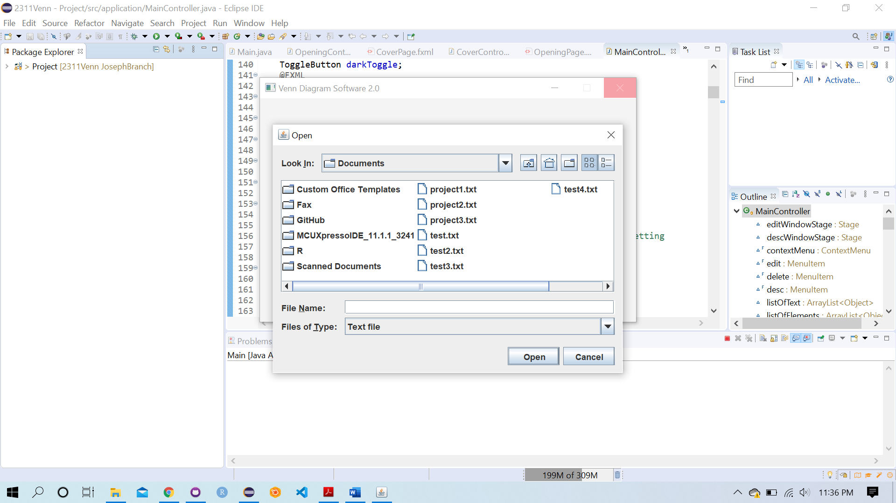

If you do not have an existing project, click “New Project” to make a new project as shown below.

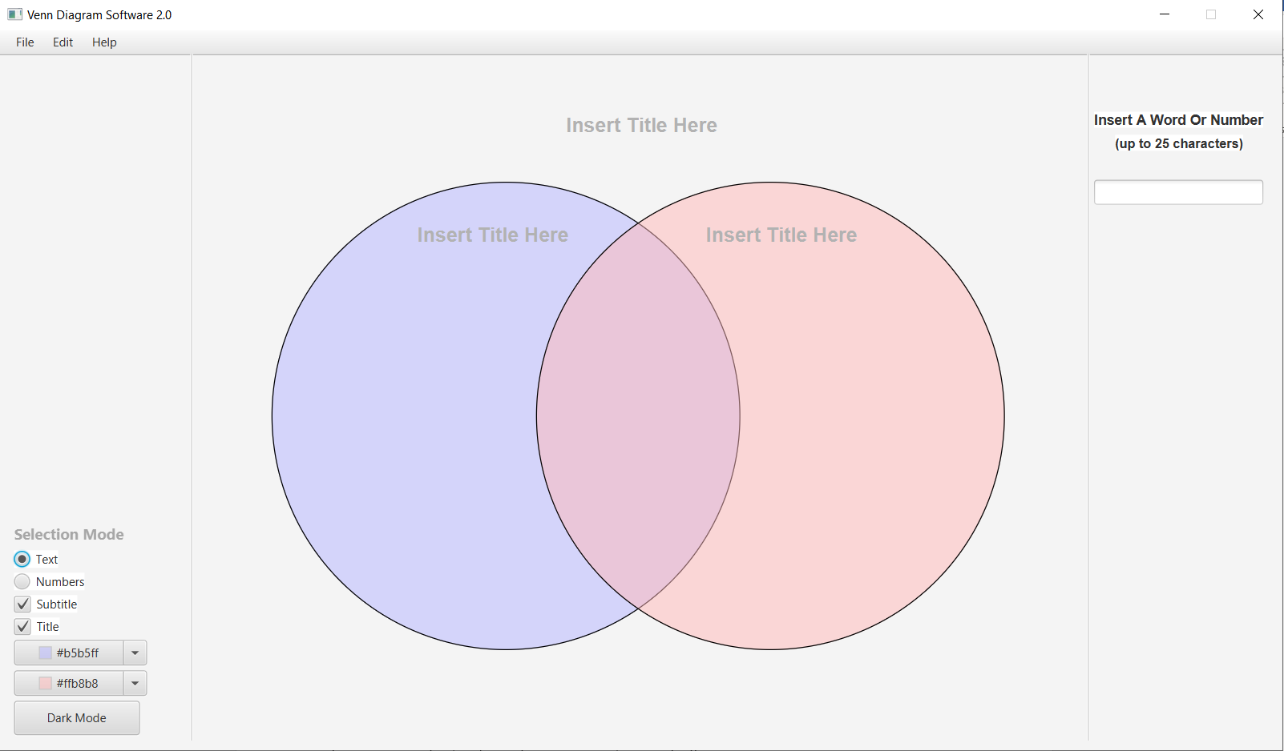

**2.1 Toolbar**

The toolbar (1) has three options: File, Edit, and Help.

When Help is pressed, and then Manual, you can see instructions on how to use the software.

When Help is pressed, and then About, you can see what the software does exactly.

A sub-option in the File tab is Save. By pressing Save the Venn diagram data, specifically the text elements that were in each circle, are saved as a .txt file which you choose the name of. When the user presses File > Open, they can open that text file, and the program will load the text elements from that save.

**2.2 Toggle Text Option**

Button (2) will be selected if you want text to be inside the Venn Diagram. For example, if you want to display qualitative data which requires text description, you would select button (2).

**2.3 Toggle Numbers Option**

Button (3) will be selected if you want only numbers to be inside the Venn Diagram. For example, if you want to display simply numerical data and nothing else, you would select button (3).

**2.4 Toggle Subtitles**

If you do not wish to display subtitles in your Venn Diagram, you would uncheck box (4). To add subtitles, check box (4), then click the "Insert Title Here" field at the top of each circle, and type your desired subtitle.

**2.5 Toggle Title**

Checkbox (5) will be automatically checked when first running the application. If you do not wish to display a title for the Venn Diagram, you would uncheck the box. To add a title, check the box, then click the "Insert Title Here" field above the Venn Diagram and type your desired title.

**2.6 Left & Right Circle Colour**

To change the colour of the left and right circle, click drop-down box (6) and select your desired colour from a pallet of different colours which will pop up.

**2.7 Dark Mode**

A button (7) at the bottom left can be pressed to toggle “Dark Mode” which makes the UI elements darker like the background, and then reversing the color of other elements so they can be seen easier.

Here is what Dark mode looks like:

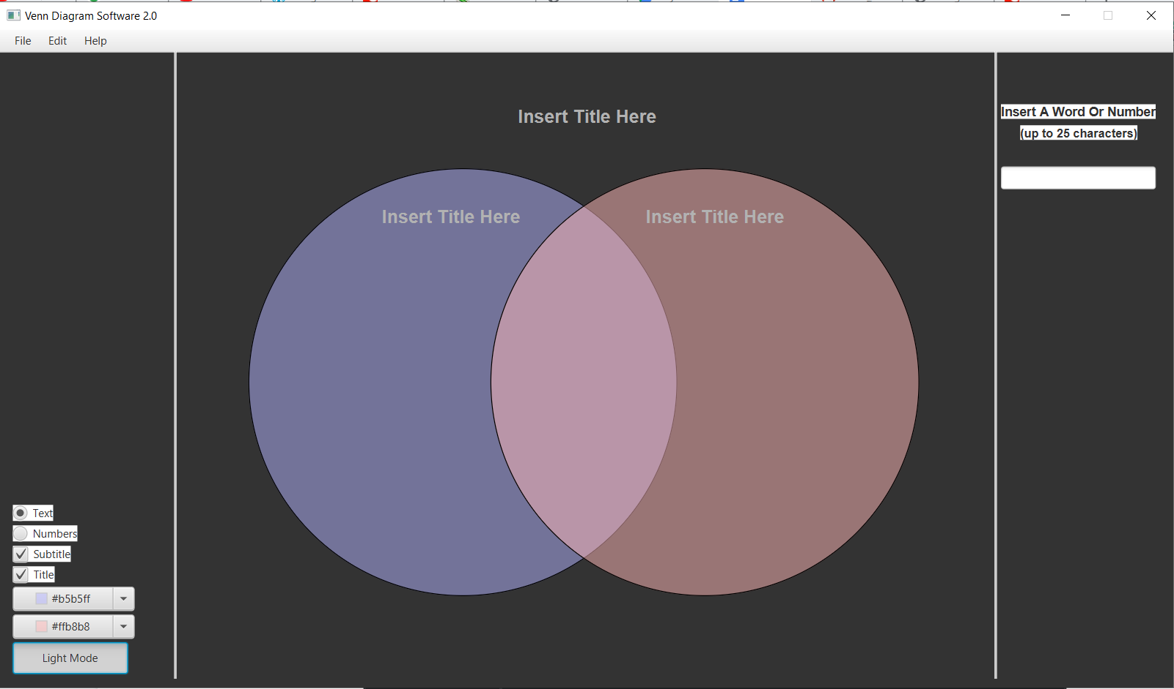

**2.8 Main Title Field**

Click on the field (8) to enter the title of the Venn.

**2.9 Subtitle Field**

Click on the fields (9) to enter the subtitles of the Venn’s circles.

**2.10 Enter Text Field**

Simply click on the text field (10) and enter the phrase you wish and press the Enter key. The text element will be added onto the right pane for the user to click and drag.

**2.11 Selection Mode Label**

When Ctrl is pressed, this label lights up and it means now when you left click on text elements placed on the Venn, you can select them to edit multiple at the same time. After all have been selected, you right click on any one of the selected and either click Edit or Delete.

**More Detail on Selection Mode**

Simply click on the text field (10) and enter the phrase you wish and press the Enter key. The text element will be added onto the right pane for the user to click and drag.

Below is an example of selecting two text elements. When selected they turn red around the border, and when clicked on again they are de-selected. Also when Ctrl is pressed again, Selection Mode is turned off and all selected are un-selected.

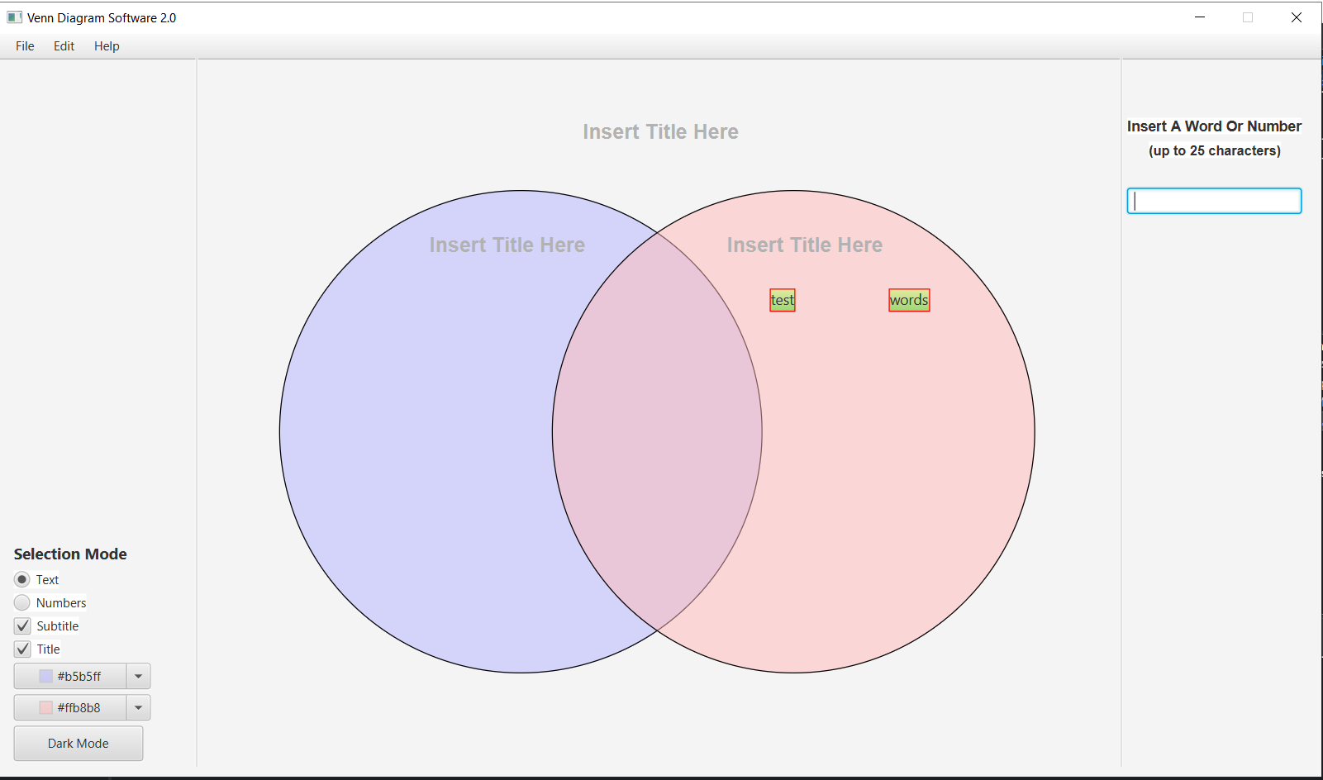

I right click on one of the two elements and choose Edit and the following options are available to me. When I change font size it changes it for all elements. Color change is still being worked on.

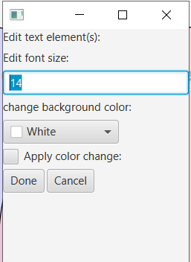

When only one text is selected and right clicked the following window pops us instead allowing user to edit text as well for the one individual text element. Individual elements can also be right clicked regardless of selection mode if you just want to edit the one element.

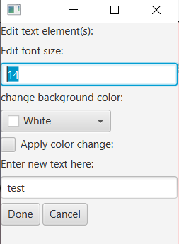

If Delete is selected instead of Edit, then all selected elements are deleted.

For more details on Selection Mode, press Help > Manual.

**Undo/Redo Function**

By pressing Edit and then Undo or Redo – changes such as text position, text content, text font, text delete/undelete can all be undone or redone.

**Description**

You can right-click on a text object and select Description to view/edit the description for that text element. Click “Save Description” to save your description once you are finished.

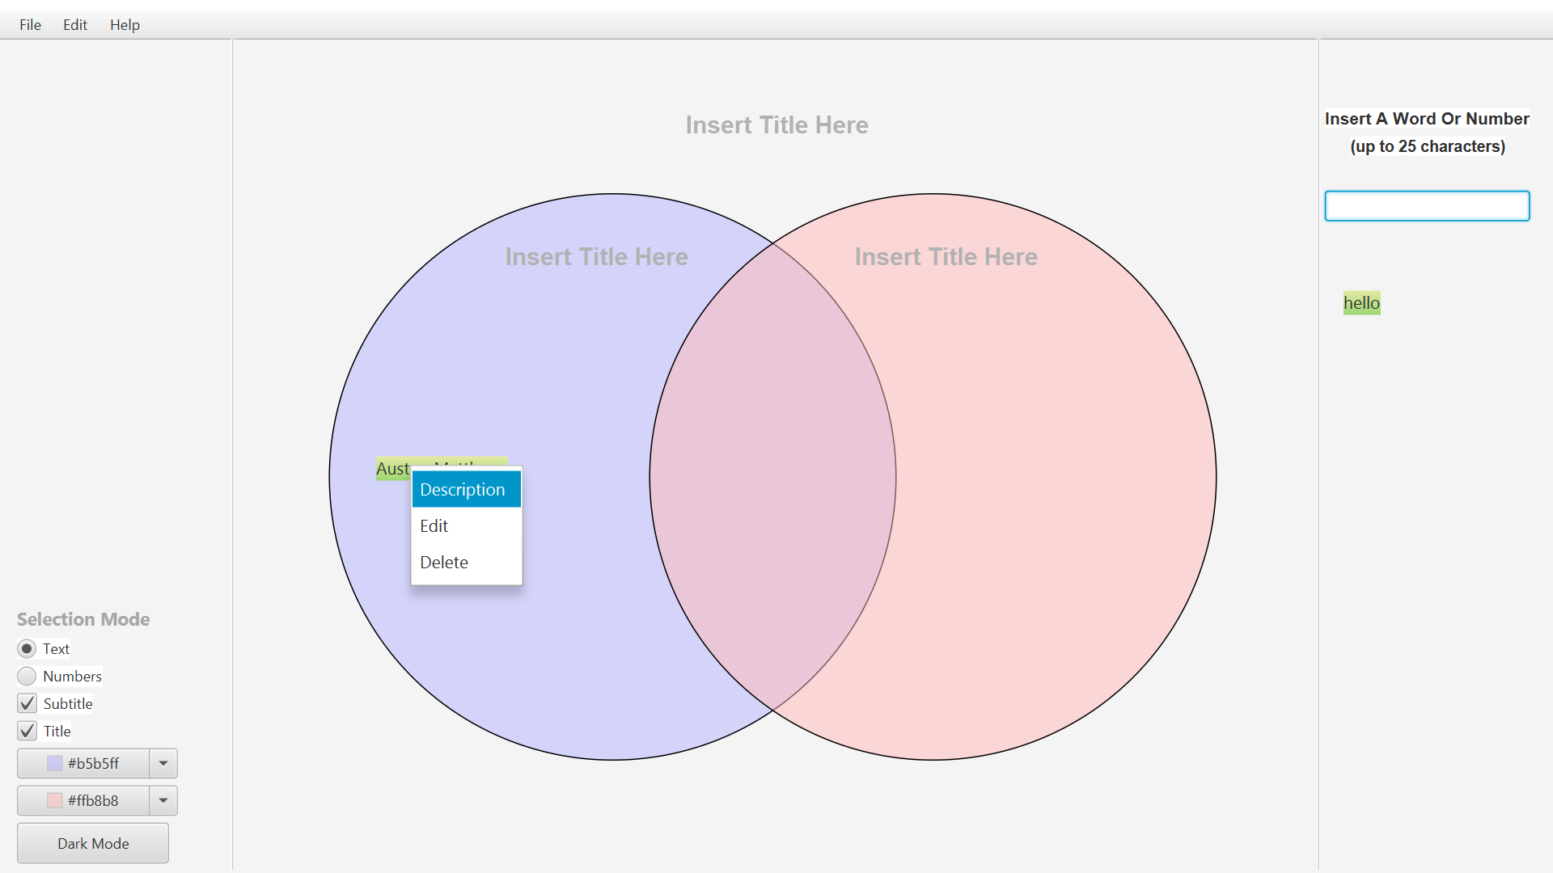 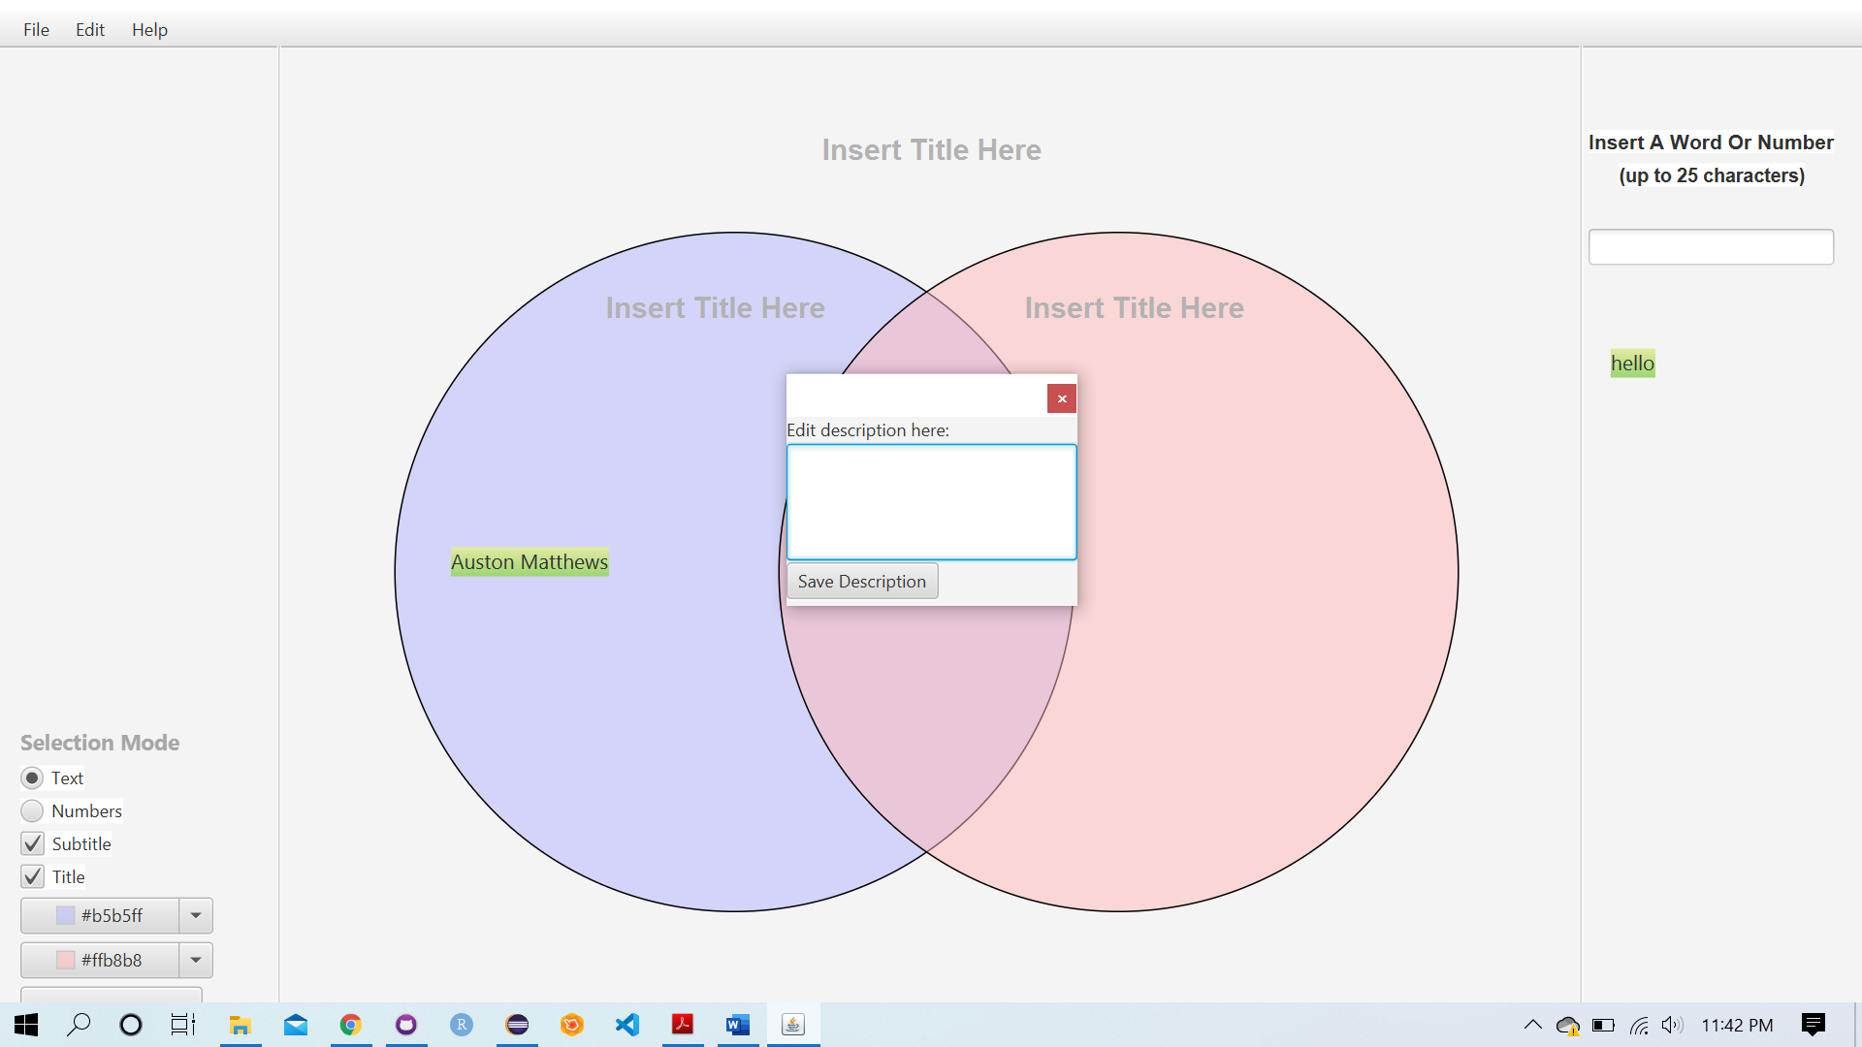

* **Usage Examples**

**3.1 Qualitative Venn Diagram**

The following is a simple, qualitative Venn diagram; a Venn diagram that takes text data. This option can be selected in the left pane. The data for this Venn diagram is entered in the right pane, where the user enters each phrase individually, and then drags and drops each one into whichever circle they choose.

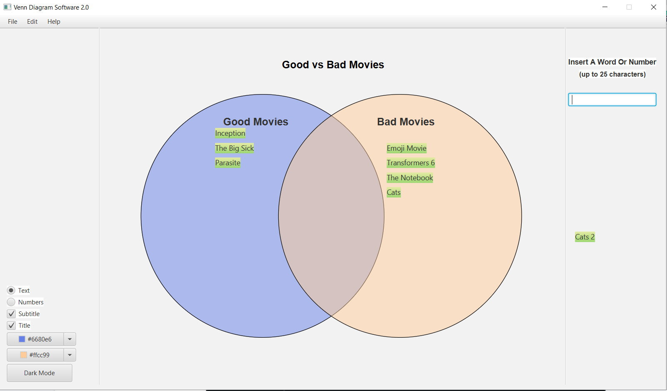

**3.2 Numbers/Quantitative Venn Diagram**

Venn diagrams can also be made to represent numbers. This option can be selected with the Numbers option in the left pane. In the image shown below, the Numbers option is used to enter percentages. All other customization options are available for the Venn diagram except for being able to use the right pane to add text.

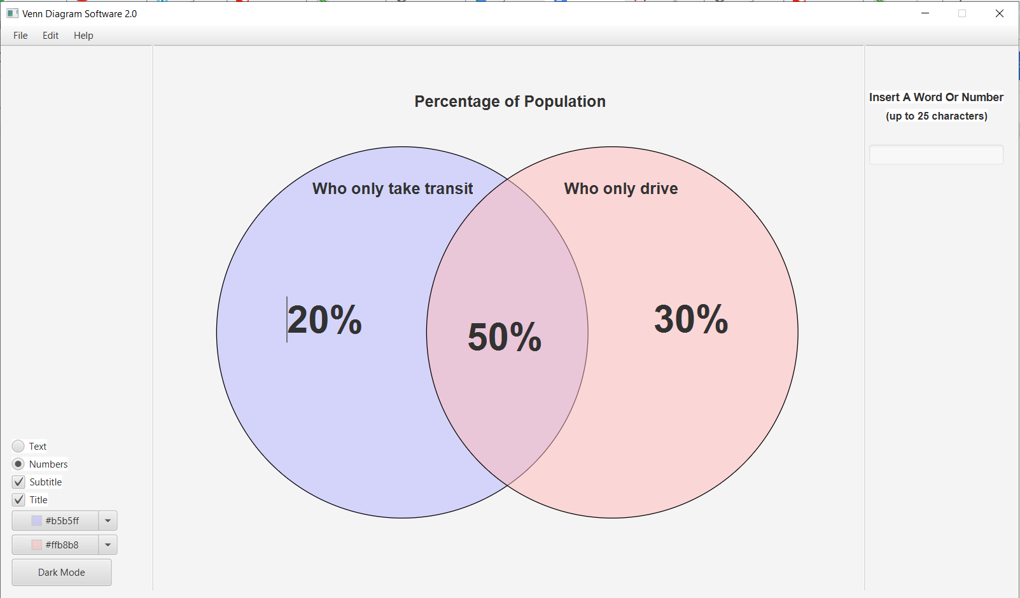

**4 Saving**

While making your Venn diagram, it can be saved by selecting the option in the upper toolbar.

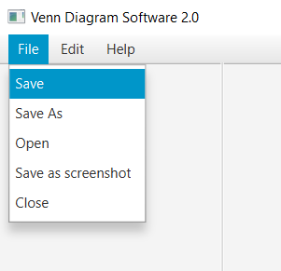

Then, the user must choose a name for the Venn diagram and save it in their drive.

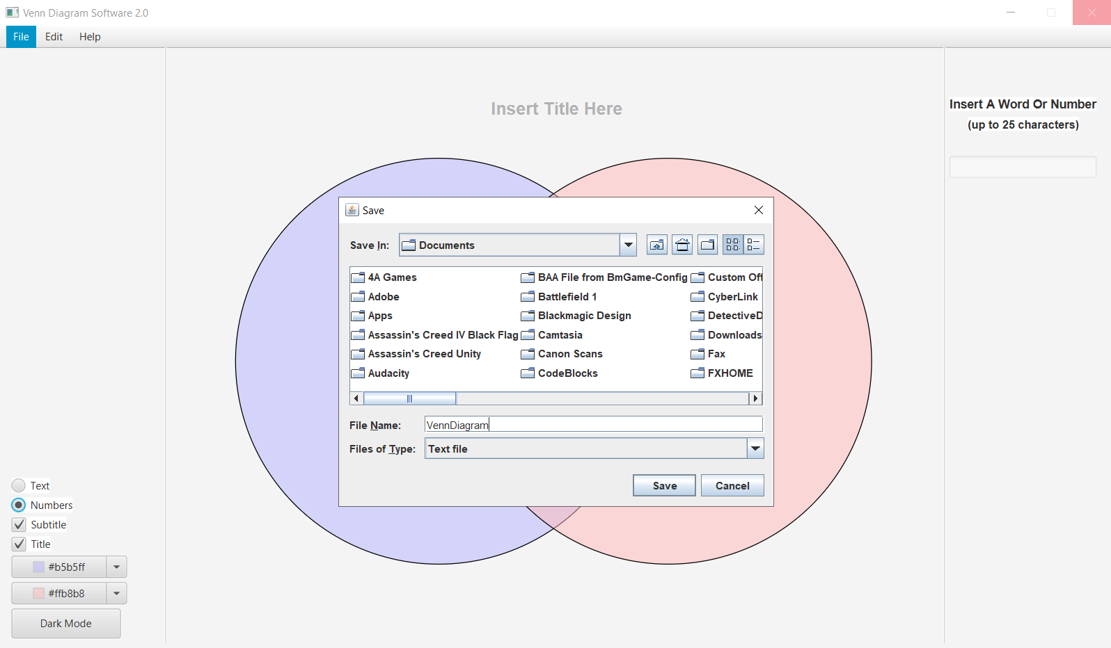

When opening a Venn Diagram the user simply chooses File > Open, and selects the text file saved earlier.

**5 Drag and Drop**

The way drag and drop works for placing text elements is that the user presses and holds the mouse while over the text element, and then moves the mouse over the Venn diagram, releasing the mouse at the place they want. The text element will then be removed from the right pane and placed onto the Venn diagram. The text is snapped onto the Venn, there is no animation. After the text elements are placed, they can be rearranged while still on the Venn diagram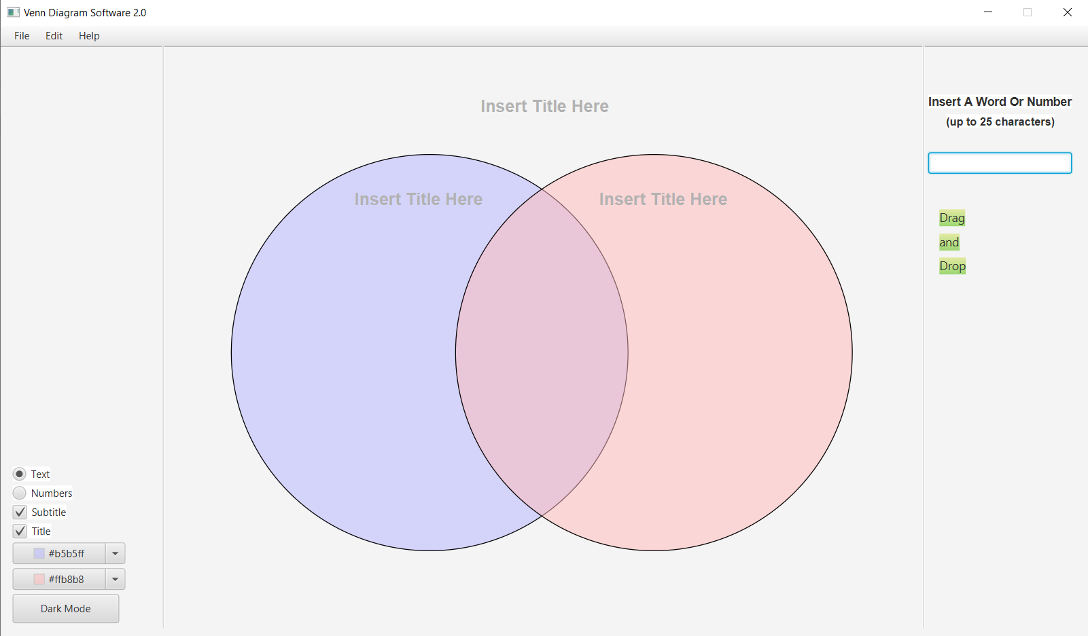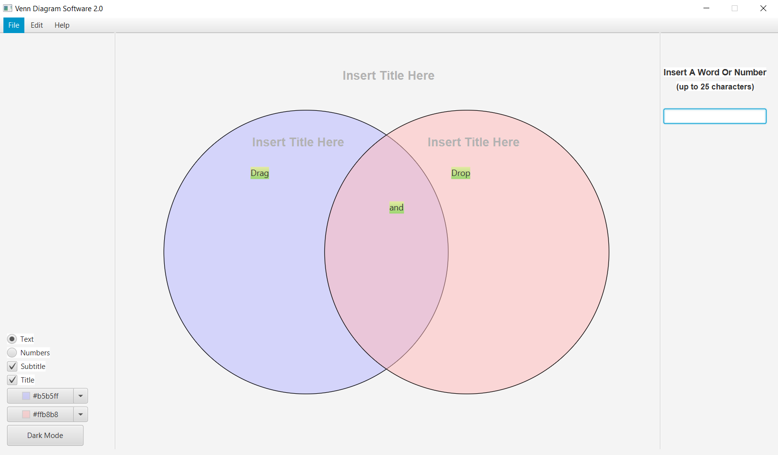

**Closing The Program**

To close the program the user can simply close the window, and a pop-up will ask if they are sure. If not, they can press cancel, otherwise they press Exit and the program closes.