Abstract - This document outlines the design, implementation, and functionality of Skynet, a business management application. The application is aimed small businesses with between 15 and 500 employees. Skynet integrates vendor, customer, warehouse, and inventory management, logistics, and cash register functions, and uses a machine learning model to recommend sales strategy. It is a simple, affordable, cloud-based option to allow the user to access their data from anywhere on any device.

I. **INTRODUCTION**

With most commerce shifting away from physical locations and moving online, management software has become necessary to businesses. This application is a cloud hosted business management application. The authors designed this software using python, MySQL, and Amazon Machine Learning to be offer a dependable platform to manage inventory, organize contacts, track logistics, make purchases, and forecast sales trends.

II. **LITERATURE SURVEY**

There are a few major client and business management applications on the market which are equipped to serve small business. Those applications are often filled with useful features, but may be overwhelming to non tech savvy users. We are planning to make this app for the user who is overwhelmed by the options and variability of the major players. This app will offer basic necessary features, customizable to the user’s needs, in a lean and affordable package. The app will centralize many of the logistics of inventory, vendor, and customer management while offering some of the more useful features like pricing and timing suggestions.

**III. PROJECT REQUIREMENTS**

A. **Hardware requirements** – internet connected device.

B. **Software Requirements -** internet browser

C. **Functional Requirements**

• The admin will be able to add/edit/delete tables the database

• The user will be able to securely login with two factor authorization

• The user will be alerted when inventory is low, incoming orders have impending delivery, and when a shipment is delivered.

• The user will be able to pull reports, upload and edit data through the interface

D. **Technical requirements**

• The application will be built using Django.

• Django is a framework for building web applications

• The database will be hosted in Amazon Web Services servers in a MySQL layout

• While developing the app we are going to use an agile workflow plan

• The interface will be built in React.js

• React.js is a JavaScript library for building One-Page web interfaces

E. **Usability Requirement**

• The application will be available from mobile devices

• The application will work with any browser

• The app will have simple UI so anyone can use it

IV. **ARCHITECTURE**

The implementation of the management software will have a front end, a back end, and a database. These are described below.

1. Frontend: Front end web development describes the portion of the app that end users directly interact with. It takes the raw data, in this case JSON, and converts it to a graphical user interface(GUI) through HTML, JavaScript, and CSS. We have used React to manage the design and implementation of the user/admin side using Bootstrap, and open-source design framework.
   1. React.JS is an open-source HTML ,CSS, and JavaScript framework for building single page applications.
2. Back End: Back-end development describes the practice of working on the server-side software. It translated between the frontend requests and the all the working which the end user cannot see. We have used Django to manage the logic and interaction with the database.
   1. Django is a free and open-source, Python-based web framework that follows the model–template–views (MTV) architectural pattern, which converts and executes python code as SQL queries.
   2. Django allows programmers to use object-oriented program to design and query a database
   3. 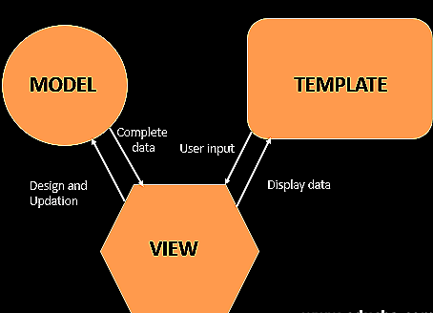The model represents the database, the view represents the user interface, and the template defines the static portions of the desired HTML.[2]
   4. Figure x outlines the design
3. Database: our database uses MySQL, a relational database structure which employs SQL to manage it.
   1. Our database is hosted using Amazon Warehouse Services, a free database hosting software.

V. **Goals**

* Small business owners and mangers (our target users) will have an easy to implement and use management system to increase their efficiency. They will be able to design their database to suit their product.
* The application will benefit users with non-integrated systems, little to now technical knowledge, and users with small technology budgets.
* The main goal of the application is, reduce busy work, eliminate communication errors and breakdown, integrate all aspects of a business into a centralized interface.
* The secondary goal is to reduce the busy work of employees to allow focus on value-add tasks.
* Users can directly communicate with supplier and customers by redirects from the GUI

VI. **ENTITY RELATIONSHIP DIAGRAM**

* An entity–relationship model (or ER model) describes interrelated things of interest in a specific domain of knowledge. A basic ER model is composed of entity types (which classify the things of interest) and specifies relationships that can exist between entities (instances of those entity types).[3]
* In Database design, the ER diagram is an abstract representation of the functions of a business.
* The relationships between entities(often referred to as tables) describes how the entities interact, leading to the relational database implementation

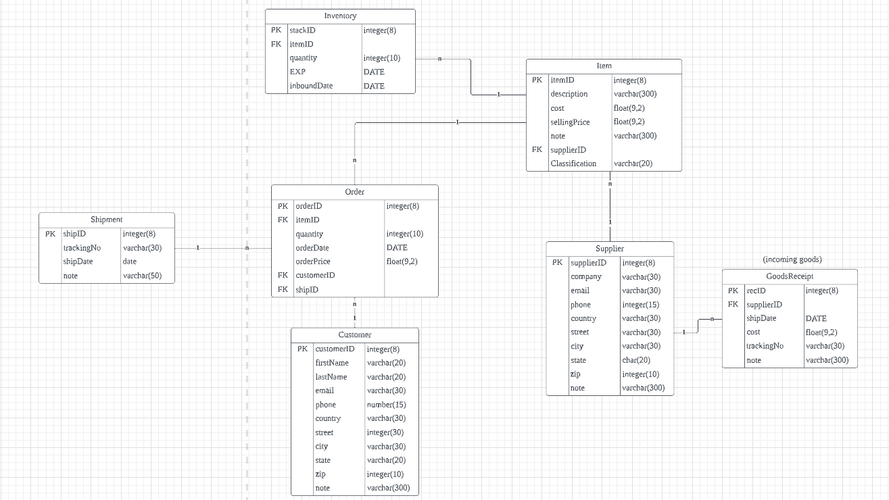

**VII. Workflow**

The following workflow chart represents the interaction of the application with all its separate parts.

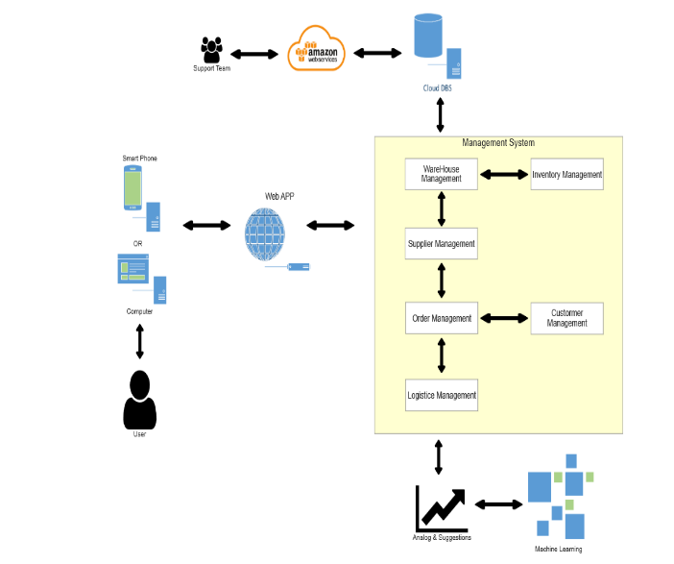

**VIII. FUTURE PLANS**

In the first portion of our capstone project, we focus on the basic functionality of the app. This includes, implementing and populating the database, designing the GUI, giving users the ability to add, edit, and delete tables and rows in their database, allowing users to filter their database on selected criteria.

In the second half of the project, we aim to improve the features by adding a machine learning sales recommendation, a cash register application to scan and total orders, two factor login verification, and automated shipment notification updates.

**IX. CONCLUSION**

We have outlined the main features and design of the Skynet application. In this project we aim to offer simple business management software for small business. Skynet is a tool that can help our users simplify, organize, and centralize their core functions. The app is not designed for large companies with the need and finances for more complex management.

X REFERENCES

[**https://en.wikipedia.org/wiki/Entity%E2%80%93relationship_model**](https://en.wikipedia.org/wiki/Entity%E2%80%93relationship_model)

<https://www.geeksforgeeks.org/django-project-mvt-structure/>