**INSTALLATION MANUAL**REQUIREMENTS:  
- Apache ant 1.9.4 ( [ant.apache.org](https://ant.apache.org) )  
- JDK 1.7 ( [www.oracle.com](http://www.oracle.com) )1. Unzip Apache Ant Binary Zip file to a directory   
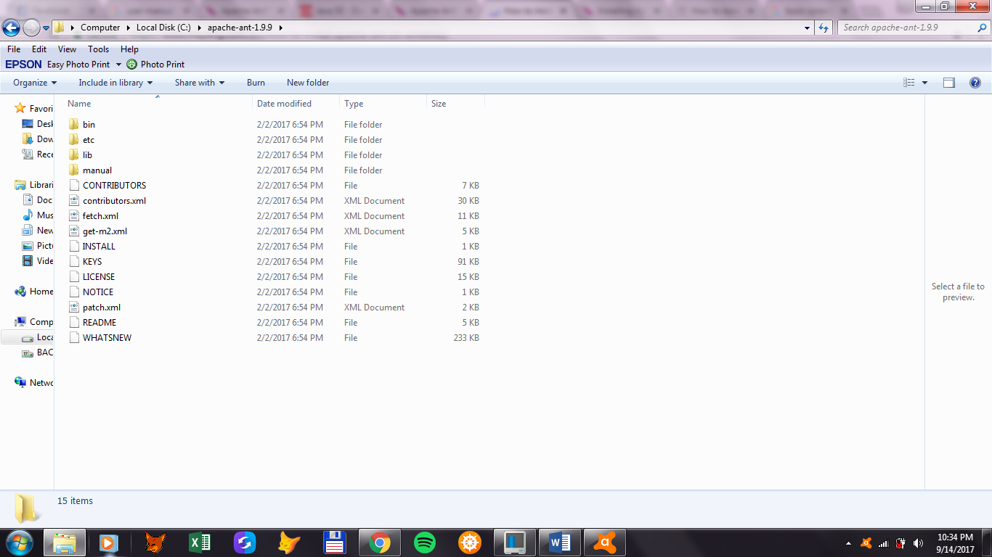

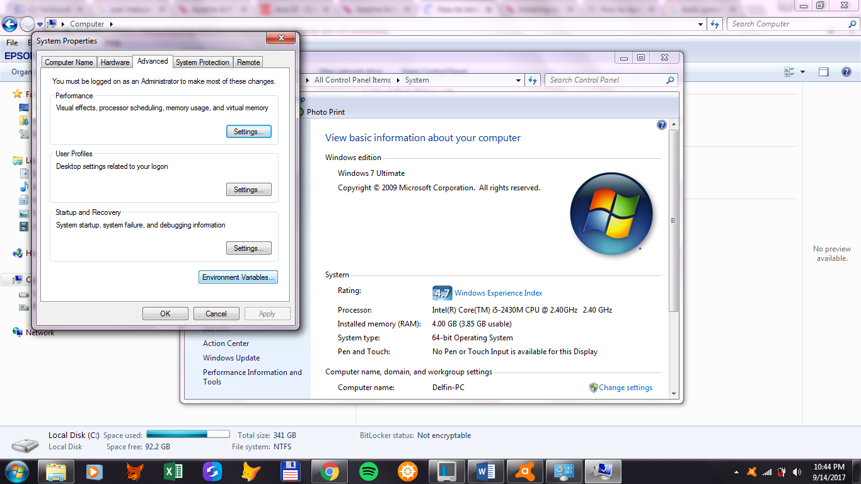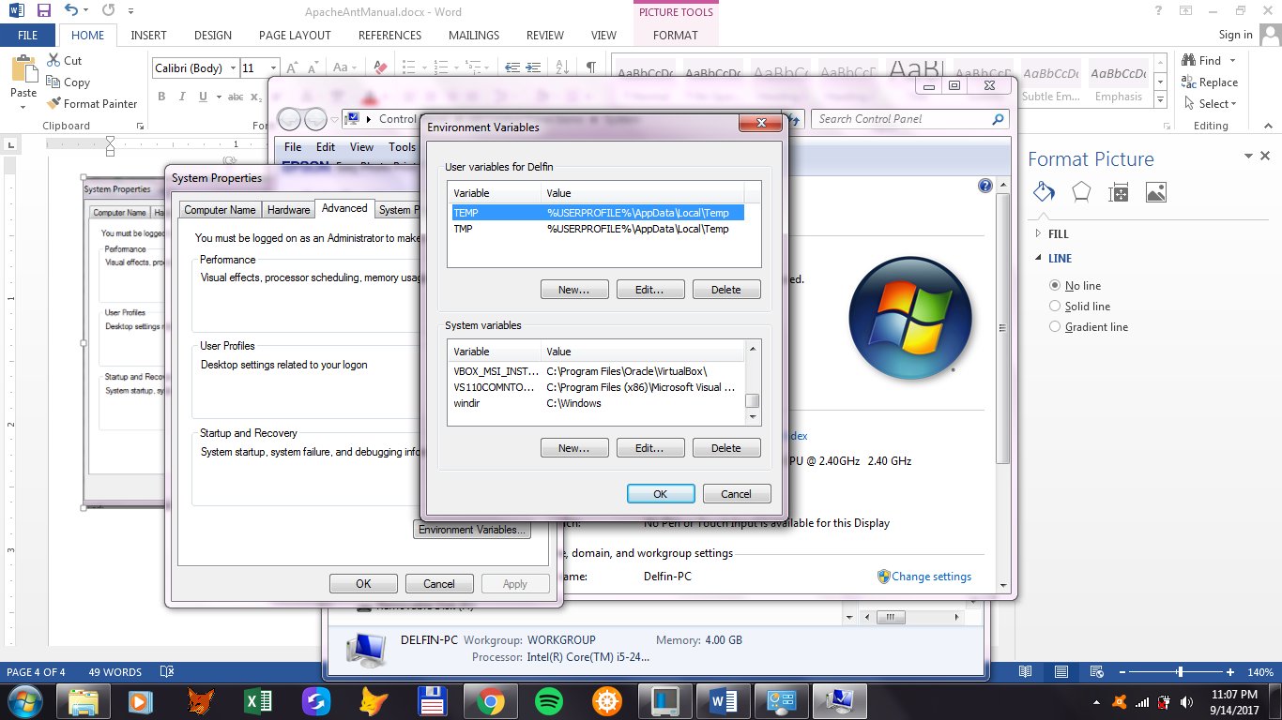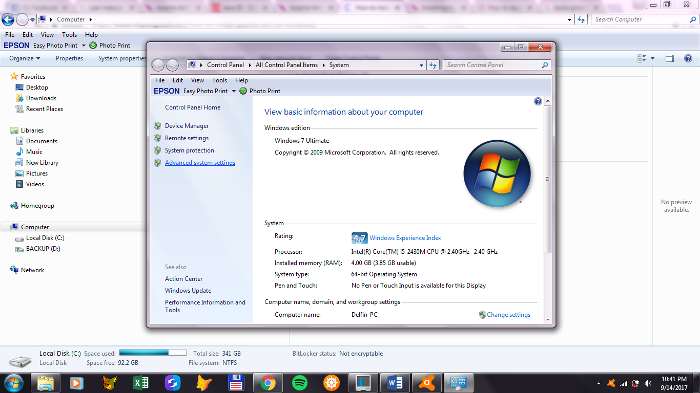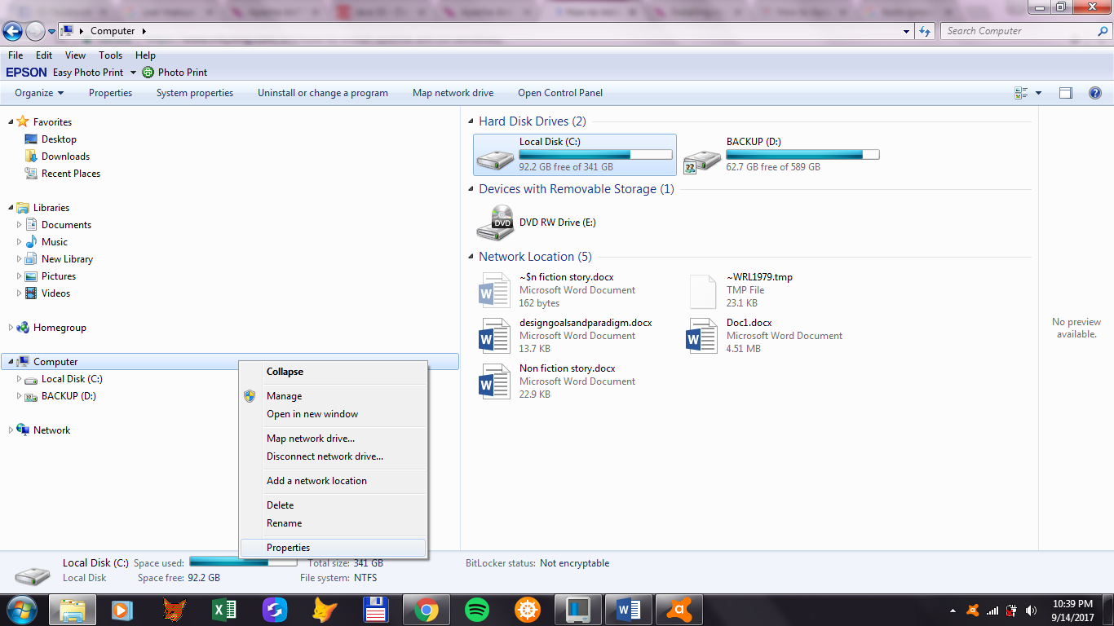  
  
  
  
  
  
  
  
  
  
2. Set Environment Variables



-Add a new Variable in Systems Variables:

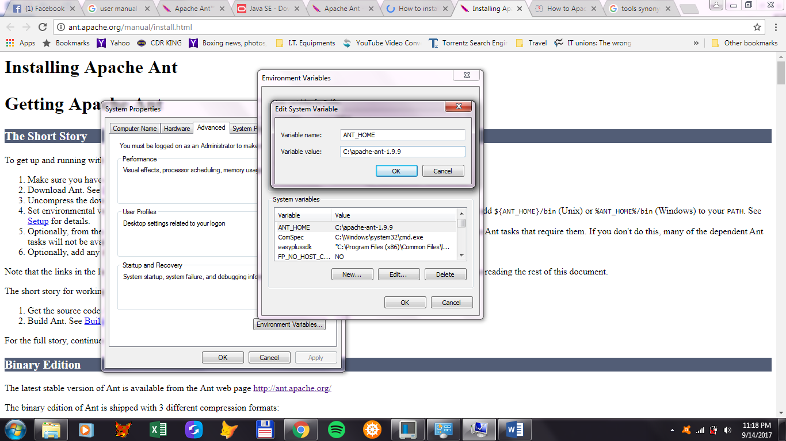-Set variable name to ANT_HOME   
to the directory you unzipped to

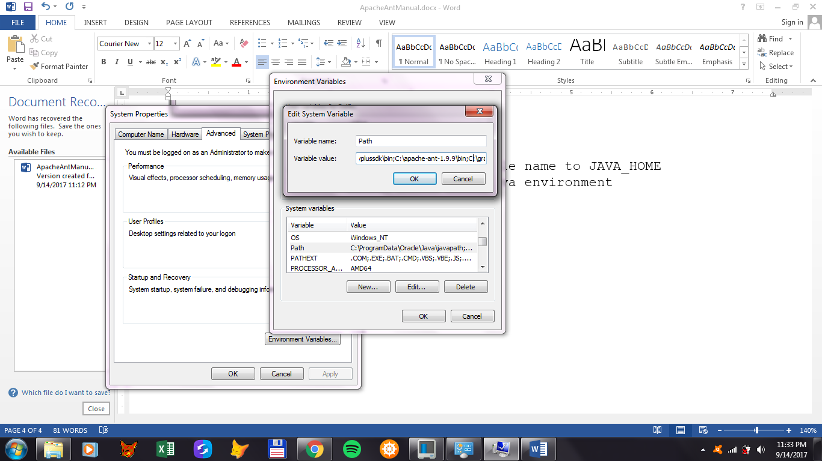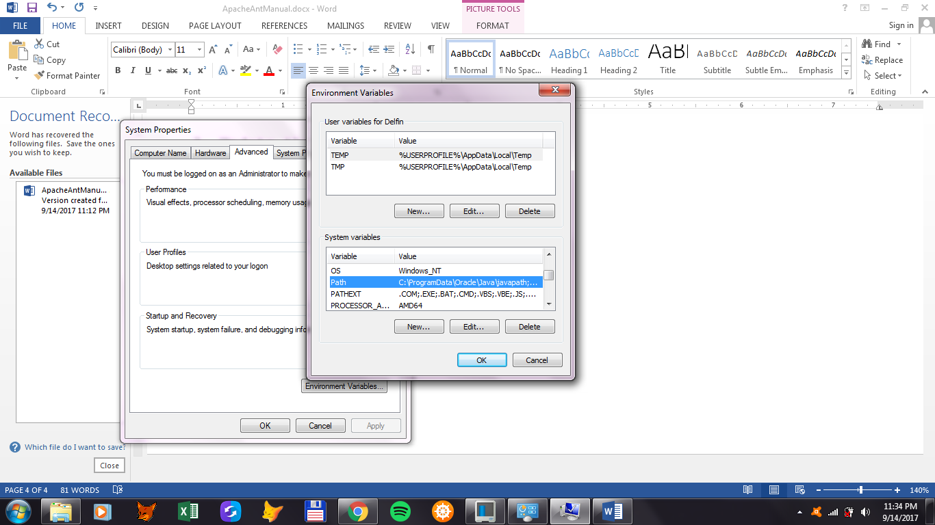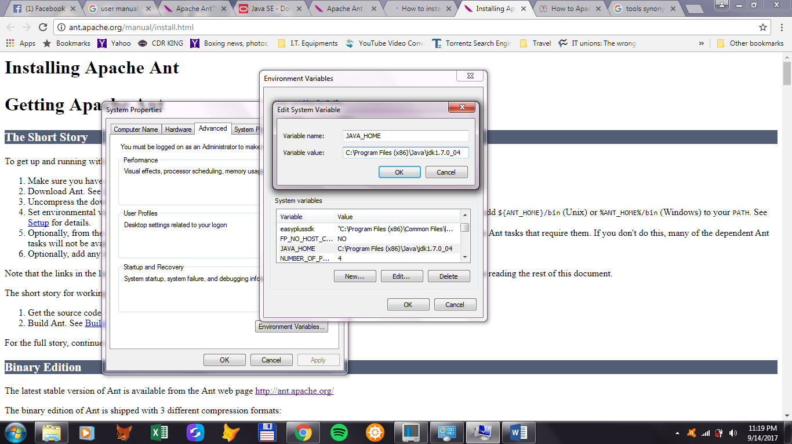-Set variable name to JAVA_HOME  
to your Java environment  
  
  
3. Update the Path Variable  
  
 -add the Apache Ant bin directory   
 to your path

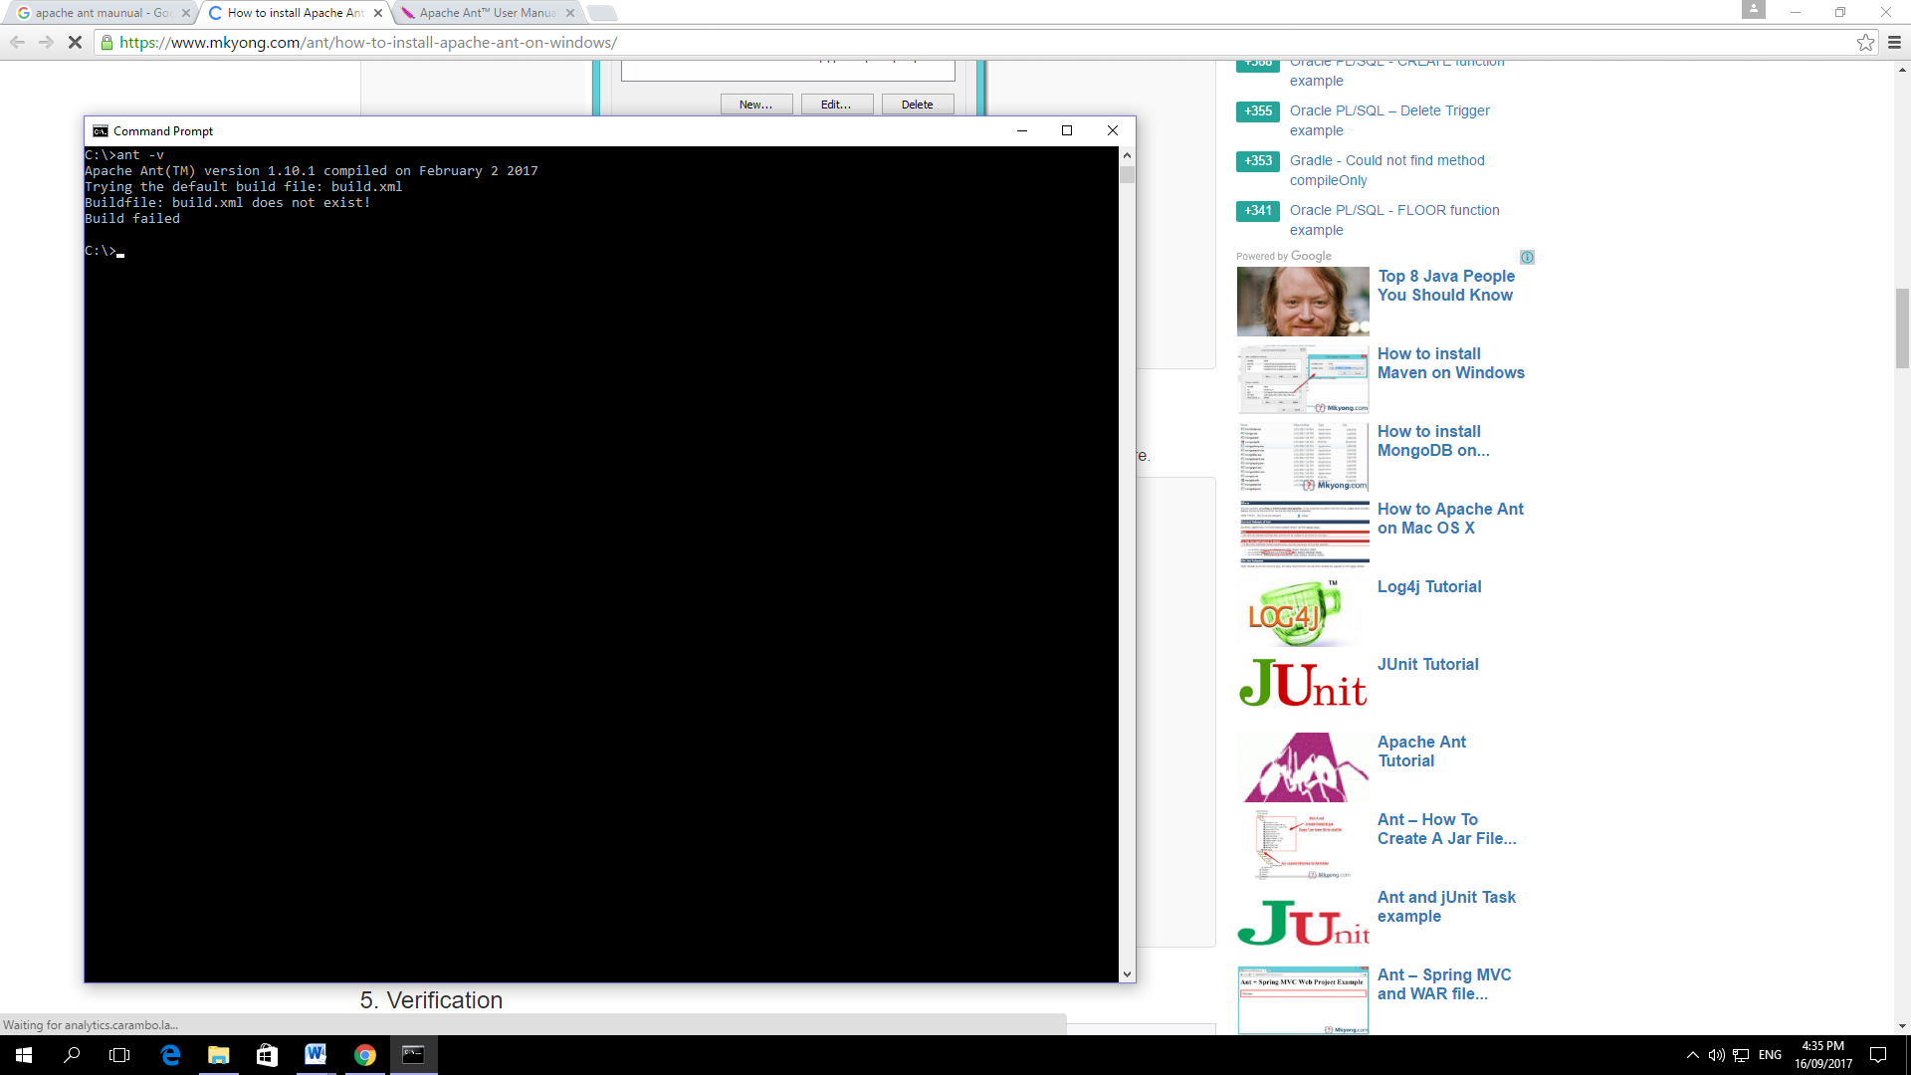4. To verify installation, go to the command line in any directory and input “ant -v”.

-note that the build file doesn’t exist   
 because you will create the build file manually