**USER MANUAL**

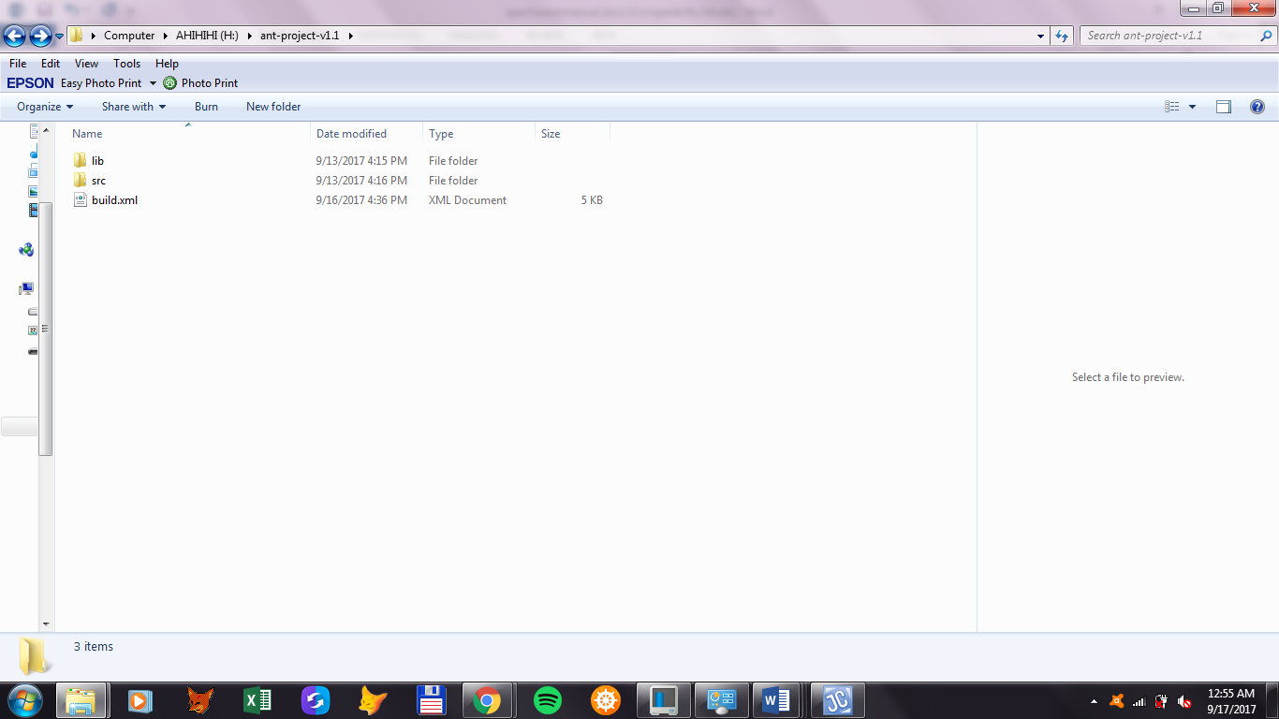In Apache Ant, the user will need to create their own directory that will contain the files "src" or the source folder that includes the source codes and "lib" or library which includes the jar files and the code coverage library needed for unit testing and code coverage, respectively. For this specific manual, a build script will be provided, which you can tailor to your own preferences later, that contains all the commands and configurations for your ant build. The Build file contains commands such as compiling, creating javadoc, creating jar file, unit testing, and code coverage test which Ant will use.  
  
  
SETUP :  
  
requirements :  
- jacoco (lib folder)  
- hamcrest-core-1.3.jar (lib folder)  
- junit-4.12.jar (lib folder)  
- main and test java files (src folder)   
- build.xml (you don’t have to write the xml file anymore because we already made it)

  
  
  
  
  
HOW TO USE THE COMMANDS:  
  
A. COMPILING   
 1. Open command prompt and change the directory to the file you created.  
 2. For compiling the main classes, enter the command “ant compile” and the   
 command will compile the main classes from the source folder.  
 3. For compiling the test classes, enter the command “ant test-compile” and it will   
 compile all test classes from the source folder.  
 4. Once you enter the compile command, it will create a build folder that contains  
 the compiled classes.

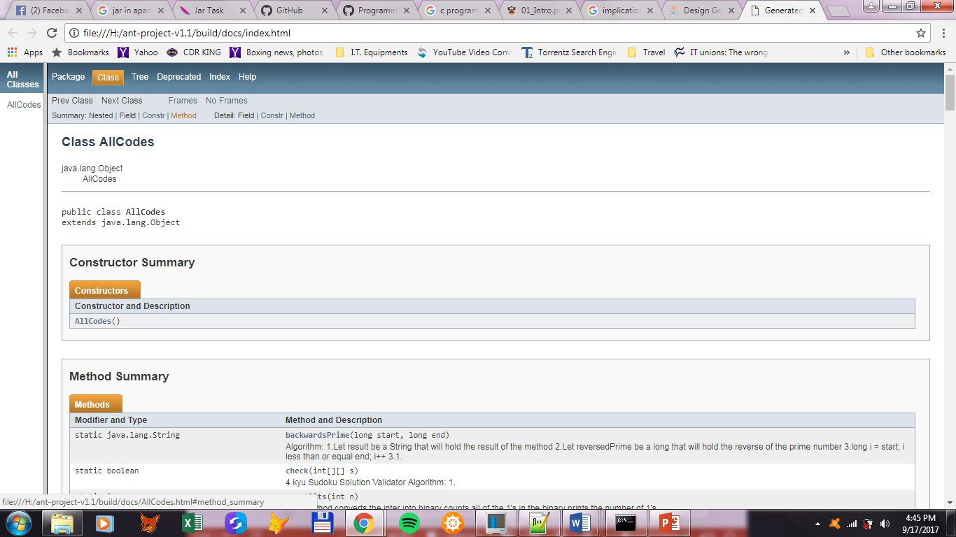  
  
B. JAVADOC  
 1. Open command prompt and change the directory to the file you created.  
 2. Enter the command “ant javadoc” and the command will create a docs file and  
 a links that shows the documentation created.  
  
C. JAR  
 1. Open command prompt and change the directory to the file you created.  
 2. Enter the command “ant jar” and the command will call the compile command   
 and the javadoc, then the generated files will be stored in a jar file.  
 3. Two jar files will be created in the build folder, one is for the classes and the other   
 is for the documentation.  
   
D. UNT TESTING  
 1. Open command prompt and change the directory to the file you created.  
 2. Enter the command “ant test”

3. It will generate the classes of your tests methods. It will also generate a text file that records your unit testing

Output of ant test

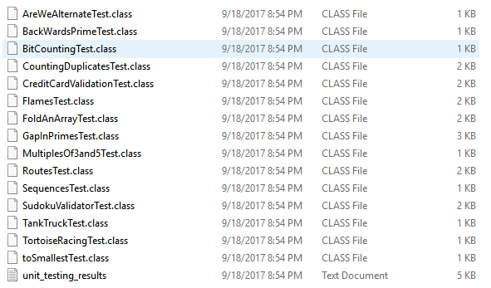

Sample text output of your unit testing

[junit] Running AreWeAlternateTest

[junit] Testsuite: AreWeAlternateTest

[junit] Tests run: 3, Failures: 0, Errors: 0, Skipped: 0, Time elapsed: 0.018 sec

[junit] Tests run: 3, Failures: 0, Errors: 0, Skipped: 0, Time elapsed: 0.018 sec

[junit]

[junit] Running BackWardsPrimeTest

[junit] Testsuite: BackWardsPrimeTest

[junit] Tests run: 2, Failures: 0, Errors: 0, Skipped: 0, Time elapsed: 0.002 sec

[junit] Tests run: 2, Failures: 0, Errors: 0, Skipped: 0, Time elapsed: 0.002 sec

E. CODE COVERAGE  
 1. Open command prompt and change the directory to the file you created.  
 2. Enter the command “ant report”

3. It will generate a report of your code coverage in html, xml and cvs format.

Output of ant report

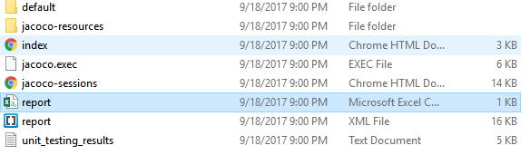

Output in html format

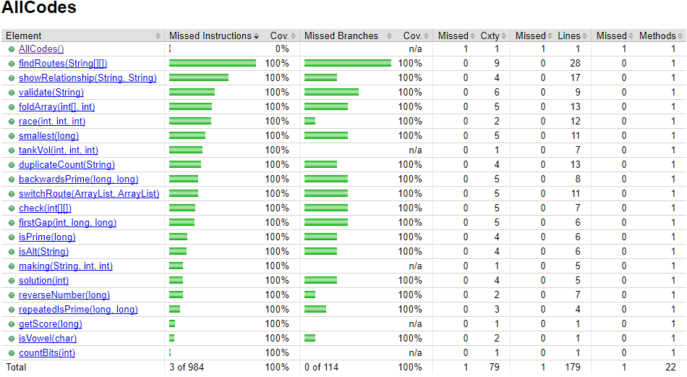

Output in csv format

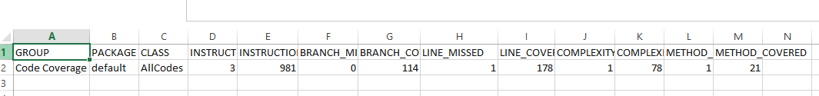

APPENDIX

AllCodes.Java

import java.util.*;

public class AllCodes {

/* PROBLEM: TOSMALLEST */

/**

*Algorithm:

*1.Declare long minimum, that will be used to store the lowest number possible

*2.Declare int index taht will hold the index of the lowest number in n

*3.Declare int moveToIndex, that will hold the index where you move the lowest number in n

*4.Declare String number that will hold the String form of n

*5.for int i = 0; i is less than length of number; increment i

*5.1.for int j=0; j is less than length of numberl increment j

*5.1.1.if i is not equal to j making(number, i, j) is less than minimum

*5.1.1.1. assign making(number, i, j) to minimum

*5.1.1.2. assign i to index

*5.1.1.3. assign j to moveToIndex

*6. return new long[]{minimum, index, moveToIndex}

*@param n is the number that you will need to rearrange to have the lowest number by moving only one number

*@return new long[] that will return the edited number, index of the smallest number and the index where you the smallest number

*/

public static long[] smallest(long n) {

long minimum = n;

int index = 0;

int moveToIndex = 0;

String number = String.valueOf(n);

for (int i=0; i<number.length(); i++) {

for (int j=0; j<number.length(); j++) {

if (i!=j && making(number, i, j) < minimum) {

minimum = making(number, i, j);

index = i;

moveToIndex = j;

}

}

}

return new long[]{minimum, index, moveToIndex};

}

/**

*Algorithm:

*1. Let sb be a StringBuilder and instantiate it

*2. Let c be a char that will hold the character at given index of sb

*3. delete the character of sb at given index

*4. insert c in sb at given moeToIndex

*5. Return Long.valueOf(sb.toString()

*@param number is the number to be edited

*@param index is the index where the smallest number in number is found

*@param moveToIndex is the index where you move the smallest number

*@return value of the string

*/

public static long making(String number, int index, int moveToIndex) {

StringBuilder sb = new StringBuilder(number);

char c = sb.charAt(index);

sb.deleteCharAt(index);

sb.insert(moveToIndex, c);

return Long.valueOf(sb.toString());

}

/* PROBLEM: TORTOISE */

/**

*Algorithm for race method

*1. Declare an int variable for hr, min , sec

*2.1 If V1 is less than or equal to V2, return null

*2.2 ELSE get the value of sec by subtracting

* V2 to V1 (v2-v1) then divide it to the product

* of 3600 and G (3600*g) 3600*g/(v2-v1)

*2.3 get the value of hr by dividing the value of

* second to 3600 (sec/3600)

*2.4 get the value of the new sec by subtracting

* the product of 3600 * hr (sec-3600*hr)

*2.5 get the value of min by diving sec to 60

* (sec/60)

*2.6 get the value of sec by subtracting sec to

* the product of 60 and min (sec - 60 * min)

*2.7 return the new array of hr,min,sec {hr,min,sec }

*

*@param v1 is the integer velocity of tortoise A

*@param v2 is the integer velocity of tortoise B

*@param g is the integer lead of tortoise A

*@return int[] of time {hr,min,sec} of how long B will catch A

**/

public static int[] race(int v1, int v2, int g) {

int hr = 0;

int min= 0;

int sec = 0;

if(v1 >= v2){

return null;

}

sec = 3600 * g / (v2 - v1);

hr = sec / 3600;

sec= sec - 3600 * hr;

min = sec / 60;

sec = sec - 60 * min;

System.out.print(new int[]{hr,min,sec});

return new int[]{hr,min,sec};

}

/* PROBLEM: TANKTRUCK */

/**

* Algorithm:

* 1. Declare double radius equivalent to the radius,divide the diameter by 2

* 2. Declare double radiusSquared equals to the value of the radius squared

* 3. Declare double heightSquared equivalent to the height squared

* 4. Declare double length equivalent to the maximum volume of the tank divided by area of the cylinder top

* 5. Declare double equivalent answer equivalent to the computed reamining value

* 6. Declare int result as answer

* 7. Return result

* @param h the height of the tank

* @param d the diameter of the tank

* @param vt the maximum volume of the tank

* @return result the remaining volume left in the tank

*/

public static int tankVol(int h, int d, int vt) {

double radius=1.0f*d/2;

double radiusSquared=Math.pow(radius,2);

double heightSquared=Math.pow(h,2);

double length=vt/(Math.PI*radiusSquared);

double answer=length*(radiusSquared*(Math.acos((radius-h)/radius))-(radius-h)*(Math.sqrt(2*radius*h-heightSquared)));

int result=(int)answer;

return result;

}

/* PROBLEM: SUKOKU VALIDATOR */

/**

*4 kyu Sudoku Solution Validator

*

*Algorithm:

* 1. Construct a loop for row and column of the two dimensional array

* 2. Declare a boolean variable and set it to true

* 3. Construct nested loops for the row and column of the two dimensional array

* 4. If there is an equal value in one row or a value that is equal to 0, set the variable to false

* 5. Return the variable

* @param s integer of the 2-D array

* @return a the validated answer solution

*/

public static boolean check(int[][] s) {

boolean a = true;

for (int i = 0; i < s.length; i++) {

for (int j = 0; j < s[i].length; j++) {

for(int k = j+1; k<s[i].length-1; k++) {

if(s[i][k]==s[i][j] || s[i][k]==0) {

a = false;

}

}

}

}

return a;

}

/* PROBLEM: STRING MIX*/

/**

* <p>

* Receives two string parameters which then puts them into a process that would later show the highest occurrence of each letter the appears

* more than twice.

* </p>

*

* Algorithm:

* <ul style="list-style-type:none">

* <li>1. Store the number of occurrence per character in two different integer array of the two strings.

* <li>2. Check if the number of occurrence per character is greater than the other.

* <ul style="list-style-type:none">

* <li>2.1 Concatenate "1:", "2:" or "=:", depends on which is higher, to a string array.

* <li>2.2 Keep on concatenating the letter until the number reaches it's occurrences.

* </ul>

* <li>3. Append the string array into one string and return then output.

* </ul>

*

* @param s1, String representation of the first sentence.

* @param s2, String representation of the second sentence.

* @return String, mixture of s1 and s2 that shows the occurrence of letters in both strings.

*/

public static String mix(String s1, String s2) {

char[] alphabet = new char[]{'a','b','c','d','e','f','g','h','i','j','k','l','m','n','o','p','q','r','s','t','u','v','w','x','y','z'};

char[] a = s1.replaceAll(" ", "").replaceAll("[^a-z]", "").toCharArray();

int[] aa = new int[26];

char[] b = s2.replaceAll(" ", "").replaceAll("[^a-z]", "").toCharArray();

int[] bb = new int[26];

String[] c = new String[26];

String d = "";

AllCodes newInstance = new AllCodes();

Arrays.sort(a);

Arrays.sort(b);

for(int i=0; i<a.length; i++) {

aa[a[i] - 'a']++;

}

for(int i=0; i<b.length; i++) {

bb[b[i] - 'a']++;

}

for(int i=0; i<26; i++) {

if(aa[i]>bb[i] && aa[i]>1) {

c[i] = "1:";

for(int j=0; j<aa[i]; j++) {

c[i] += alphabet[alphabet[i]-'a'];

}

} else if(aa[i]<bb[i] && bb[i]>1) {

c[i] = "2:";

for(int j=0; j<bb[i]; j++) {

c[i] += alphabet[alphabet[i]-'a'];

}

} else if(aa[i]==bb[i] && aa[i]>1 && bb[i]>1) {

c[i] = "=:";

for(int j=0; j<bb[i]; j++) {

c[i] += alphabet[alphabet[i]-'a'];

}

} else {

c[i]="";

}

}

Arrays.sort(c, newInstance.new StringSorter());

for(int i=0; i<c.length; i++) {

if(c[i]=="") {

break;

}

d += c[i]+"/";

}

return d = d=="" ? "" : d.substring(0, d.length()-1);

}//mix

/**

* A custom comparator meant to satisfy the sorting needs of the program. It first compares the strings own length

* and then compares them lexicographically.

*/

class StringSorter implements Comparator<String> {

public int compare(String s1, String s2) {

if (s1.length() < s2.length()) {

return 1;

}

if (s1.length() > s2.length()) {

return -1;

}

return s1.compareTo(s2);

}

}//Comparator

/* PROBLEM: SEQUENCES AND SERIES */

/**

* Solution for: Sequences and Series by BattleRattle

*

* @param n the number to be tested

* @return long the result of the tested number

*/

public static long getScore(long n) {

return (((n*(n+1)*50)/2));

}

/* PROBLEM: MULTIPLES OF 3 AND 5 */

/**

*6 kyu Muliples of 3 and 5

*

*Algorithm:

* 1. Declare an integer

* 2. Construct a loop that ends when the value of i is greater

* or equal to the number.

* 3. Check if i%3 is equal to 0 or i%5 is equal to zero

* 3.1 If true, sum = sum + i

* 4. Return sum

* @param number integer to be tested

* @return sum of the multiples of 3 and 5

*/

public static int solution(int number) {

int sum = 0;

for(int i = 0; i<number; i++){

if(i%3==0 || i%5==0){

sum += i;

}

}

return sum;

}

/* PROBLEM: GAPINPRIMES */

/**

* <p>

* Finds the first pair of prime numbers that corresponds to the given gap, and that has no prime numbers in between.

* </p>

*

* Algorithm:

* <ul style="list-style-type:none">

* <li>1. Start at the lower limit to the upper limit and check if it is prime.

* <ul style="list-style-type:none">

* <li>1.1 If the number is prime then check if the gap+1 is prime and if there's no prime numbers in between of them.

* <ul style="list-style-type:none">

* <li>1.1.1 If there's none then return the current pair.

* <li>1.1.2 Else, return null.

* </ul>

* </ul>

* </ul>

*

* @param gap, integer value of the wanted gap between to primes.

* @param lLimit, lower limit to which where to start the search.

* @param uLimit, upper limit to which where to stop the search.

* @return an array of long that has the value of the pair prime number.

*/

public static long[] firstGap(int gap, long lLimit, long uLimit) {

for(long i=lLimit; i<=uLimit; i++) {

if(isPrime(i)) {

long j = gap + i;

if (isPrime(j) && !repeatedIsPrime(i + 1, j - 1)) {

return new long[]{i, j};

}

}

}

return null;

}//firstGap

/**

* Checks if there's a prime number between a lower limit and a higher limit.

*

* @param x, lower limit

* @param y, upper limit

* @return boolean value of whether there's a prime number between x and y.

*/

public static boolean repeatedIsPrime(long x, long y) {

for(long i=x; i<=y; i++) {

if(isPrime(i)) {

return true;

}

}

return false;

}//repeatedIsPrime

/* PROBLEM: FOLDANARRAY */

/*

*Algorithm

*1. Declare an empty array dummy.

*2. While runs isn't equal to 0

* 2.1 Declare an integer value length equevalent to the legth of the array

* 2.2 If the given array is divisible by two, equate dummy to the length

* 2.2.1 Else equate dummy to length adn add 1

* 2.3 Divde the array into two, equate dummy to the result of adding the values of the two halves

* 2.4 If length of the dummy array is equal to halve the length of the array

* 2.4.1 Decrement runs by 1

* 2.4.2 Equate array to dummy

* 2.4.3 Return array

*@param

**/

public static int[] foldArray(int[] array, int runs){

int[] dummy=null;

while(!(runs==0)){

int length=array.length;

if(array.length%2==0){

dummy=new int[length/2];

}else{

dummy=new int[length/2+1];

}

for(int first=0,last =array.length-1; first<last&&!(first==last); first++,last--){

dummy[first]=array[first]+array[last];

}

if(array.length%2==1)dummy[dummy.length-1]=array[length/2];

runs--;

array=dummy;

}

return array;

}

/* PROBLEM: FLAMES */

/** Algorithm:

* 1. Declare initial variables that will hold for the values of the names' combination,

* its result, and count.

* 2. For every input, it should be in lowercase form

* 3. Declare a variable copy to hold the original letters of female input to use later

* 4. Use a for loop to check the length of the male string

* 4.1 Replace all the common letters of female string and male string to ""

* 5. Use a for loop to check the length of the female string (copy)

* 5.1 Replace all the common letters of male string and the original letters of female string (copy) to ""

* 6. Add the combined result of the previous loop and store it to the variable combined

* 7. Count the length of the result and store it to the variable count

* 8. Instead of cycling through all the letters, use modulo to determine the remainder and use it to count.

* 9. If result is greater than 6 or result is equal to 0, equate result to 6

* 10. Checks the result in the following array of strings

* @param male the string to be inputed for the male

* @param female the string to be inputed for the female

* @return the result for the flames

**/

public static String showRelationship(String male, String female) {

String combined = "";

int result = 0;

int count = 0;

female = female.toLowerCase();

male = male.toLowerCase();

String copy = female;

for(int x = 0; x < male.length(); x++){

female = female.replaceAll(String.valueOf(male.charAt(x)), "");

}

for(int x = 0; x < copy.length(); x++){

male = male.replaceAll(String.valueOf(copy.charAt(x)), "");

}

combined = male + female;

count = combined.length();

result = count%6;

if(result > 6 || result == 0){

result = 6;

}

String[] flames = {"Friendship", "Love", "Affection", "Marriage", "Enemies", "Siblings"};

return flames[result-1];

}

/* PROBLEM: DROOT */

/**

*Algorithm for digital_root method

*1. while the input integer is less than 9,

* do:

* get the value of n by adding the

* dividend of n and 10 (n/10) and

* the remainder of n modulo 10 ( n/10 + n % 10)

*2. if N is less than 9 , return the value of n

*@param n is the integer to be inputed

*@return n is the recursive sum of all digits

**/

public static int digital_root(int n) {

while(n > 9){

n = n/10 + n % 10;

}

return(n);

}

/* PROBLEM: CREDITCARDVALIDATION */

/**

* <p>

* Puts the given string through a number of processes which would then result into a boolean value

* that tells if it is a valid credit card number or not.

* </p>

*

* Algorithm:

* <ul style="list-style-type:none">

* <li>1. Get the numeric values of each character in cNum and store it in nNum.

* <li>2. Starting from the furthest right and going left by two's check if the doubled value of

* nNum[j] is greater than 9.

* <ul style="list-style-type:none">

* <li>2.1. True, nNum[j] will now be equal to nNum[j]*2-9.

* <li>2.2. False, nNum[j] will now be equal to nNum[j]*2.

* </ul>

* <li>3. Get the summation of all indexes of the array nNum and store it ti tSum.

* <li>4. Check if tSum%10==0.

* <ul style="list-style-type:none">

* <li>4.1. True, return true.

* <li>4.2. False, return false.

* </ul>

* </ul>

* @param cNum, String representation of the credit card number to be processed.

* @return Boolean value of whether the input cNum was valid or not.

*/

public static Boolean validate(String cNum) {

int tSum = 0;

int[] nNum = new int[cNum.length()];

for(int i=0; i<nNum.length; i++) {

nNum[i] = Character.getNumericValue(cNum.charAt(i));

}

for(int j=nNum.length-2; j>=0; j-=2) {

nNum[j] = nNum[j]*2>9 ? nNum[j]*2-9 : nNum[j]*2;

}

for(int k=0; k<nNum.length; k++) {

tSum += nNum[k];

}

return ((tSum%10)==0);

}//validate

/* PROBLEM: COUNTING DUPLICATES*/

public static int duplicateCount(String text) {

/**

* 1. Variable originaltext copies the orginaltext from the parameter

* 2. Text is then converted to its lower case

* 3. Create and initialize a stringbuilder to copy the text

* 4. Create and initialize a counter for a character

* 5. Create a loop that will check for the length of the stringbuilder

* 6. Create and initialize a char variable to check the first character of the string.

* 7. Check if the first character is not out of range, then delete and increment the count variable

* 8. If a character occurs more than once increment the count variable else display none is repeated.

*/

String originaltext=text;

text=text.toLowerCase();

StringBuilder sb = new StringBuilder(text);

int count2=0;

while(sb.length() != 0)

{

int count = 0;

char test = sb.charAt(0);

while(sb.indexOf(test+"") != -1)

{

sb.deleteCharAt(sb.indexOf(test+""));

count++;

}

if(count>1)

{

count2++;

//System.out.println(originaltext+"-> "+count2+" "+test+" occurs "+count+" times");

}

if(count==0)

{

//System.out.println("no characters repeats more than once");

}

}

return count2;

}

/* PROBLEM: COUNT THE SMILEYS */

/*

*Solution for Count The Smileys

*1. Check each index of the given array

*2. If the length of the string is 2

* 2.1 Check if the index contains the ff: ":", ";" and ")","D"

* 2.2 If yes, count + 1

*3. If the length of the string is 3

* 3.1 Check each of the index if it contains the ff: ":" ";" "-" "~" ")" "D"

* 3.2 If yes, count + 1

*

*@param list of the array that will contain the strings to be counted

*@return number of the smileys given in the array */

public static int countSmileys(List<String> arr) {

int count = 0;

for(int i=0; i< arr.size(); i++){

if(arr.get(i).length() == 2){

if((arr.get(i).indexOf(':') == 0 || arr.get(i).indexOf(';') == 0) && (arr.get(i).indexOf(')') == 1 || arr.get(i).indexOf('D') == 1)){

count++;

}

} else if(arr.get(i).length() == 3){

if((arr.get(i).indexOf(':') == 0 || arr.get(i).indexOf(';') == 0) && (arr.get(i).indexOf('-') == 1 || arr.get(i).indexOf('~') == 1) && (arr.get(i).indexOf(')') == 2 || arr.get(i).indexOf('D') == 2)){

count++;

}

}

}

return count;

}

/* PROBLEM: BITCOUNTING */

/**

* This method converts the inter into binary

* counts all of the 1's in the binary

* prints the number of 1's

* @param n This is the number to be tested

* @return int This returns the number of 1's in a binary

*/

public static int countBits(int n){

return Integer.bitCount(n);

}

/* PROBLEM: BACKWARDSPRIME */

/**

*Algorithm:

*1.Let result be a String that will hold the result of the method

*2.Let reversedPrime be a long that will hold the reverse of the prime number

*3.long i = start; i less than or equal end; i++

*3.1. if i is prime

*3.2. assign the reverse number of i to reversedPrime

*3.3. if reversedPrime is prime and i is not equal to reversedPrime

*3.3.1. result+=i+""

*4. return result.trim()

* @param start is the start of the number you will need to find a prime number

* @param end is the upper limit of the number you will need to find a prime number

* @return String result that is the concatitaion of all the primes from start to end

*/

public static String backwardsPrime(long start, long end) {

String result = "";

long reversedPrime= 0;

for(long i = start; i <= end; i++){

if(isPrime(i)){

reversedPrime = reverseNumber(i);

if(isPrime(reversedPrime) && !Long.toString(i).equals(new StringBuilder(Long.toString(reversedPrime)).toString())){

result += i+" ";

}

}

}

return result.trim();

}

/**

*Algorithm:

*1. if number modulo 2 is equal to 0

*1.1. return false

* else

*2.for(int i = 3; i*i less than or equal number; i+=2)

*2.1.if number modulo i is equal to 0

*2.1.1. return false

*3.return true

* @param number is the number that will be tested if it is prime

* @return boolean will return true if number is prime else false

*/

public static boolean isPrime(long number){

if(number%2 == 0){

return false;

}else{

for(int i = 3; i*i <= number; i+=2){

if(number%i == 0){

return false;

}

}

}

return true;

}

/**

*Algorithm:

*1.Let reversedNum be a long that will hold the reverse of num

*2.while num is not equal to 0

*2.1.Let remainder be a long that will hold the value of num modulo 10

*2.2.Assign reversedNum*10+remainder to reversedNum

*2.2.Assign num/10 to num

*3.return reversedNum

*@param num is the number to be reversed

*@return long reverseNumber is the reversed number of num

*/

public static long reverseNumber(long num){

long reversedNum = 0;

while(num != 0){

long remainder = num%10;

reversedNum = reversedNum*10+remainder;

num = num/10;

}

return reversedNum;

}

/* PROBLEM: ROUTES */

/**

* Solution for: 'Follow that spy' by adromil

* Algorithm:

* 1. Receive parameter value of routes

* 2. Declare String[] variable temp1, int variable counter, String variable temp3, boolean

* variable spyFollowed, ArrayList(String[]) variable oldRoute, ArrayList(String) variable

* newRoute

* 3. Copy the contents of routes to oldRoute

* 4. Add the values of first array of oldRoute to newRoute, then removes said array

* 5. While spyFollowed is false:

* 5.1 Copy first array of oldRoute to temp1

* 5.2 Compare temp1[1] String value to the first String value of newRoute

* 5.3 If String values are equal:

* 5.3.1 Insert temp1[0] value at index 0 of newRoute, remove array from oldROute, and increment counter by 1

* 5.3.2 Check if oldRoute is empty. If empty, set spyFollowed to true

* 5.3 If String values are not equal, increment counter by 1 and skip to next array

* 5.4 If counter is equal to the size of oldRoute (no match), proceed to switchRoute method

* 6. Add all values of newRoute to temp3

* 7. Return temp3

*

* @param routes the array of arrays that will contain the strings to be sorted

* @return String the sorted string

*/

public static String findRoutes(String[][] routes) {

String[] temp1; int counter=0; String temp3="";

boolean spyFollowed = false;

ArrayList<String[]> oldRoute = new ArrayList<String[]>();

ArrayList<String> newRoute = new ArrayList<String>(); // empty

for (String[] temp2 : routes) {

oldRoute.add(temp2);

}

temp1 = oldRoute.get(0);

newRoute.add(temp1[0]);

newRoute.add(temp1[1]);

oldRoute.remove(0);

try {

if (oldRoute.isEmpty()) { spyFollowed = true; }

while (!spyFollowed) {

for (int a=0; a<oldRoute.size(); a++) {

temp1 = oldRoute.get(a);

if (temp1[1].equalsIgnoreCase(newRoute.get(0))) {

newRoute.add(0, temp1[0]);

oldRoute.remove(a); counter=0;

if (oldRoute.isEmpty()) { // oldRoute empty

spyFollowed = true;

}

break;

} else if (counter == oldRoute.size()) { // no match, oldRoute !empty

newRoute = switchRoute(newRoute, oldRoute);

spyFollowed = true;

break;

} else {

counter++;

}

}

}

temp3 = newRoute.get(0);

for (int c=1; c<newRoute.size(); c++) {

temp3 += ", " + newRoute.get(c);

}

} catch (Exception e1) {

e1.printStackTrace();

}

return temp3;

}

/**

* Algorithm:

* 1. Receives parameter values of newRoute and oldRoute

* 2. Declare String[] variable temp4, boolean variable switchDone

* 3. While switchDone is false:

* 3.1 Copy first array of oldRoute to temp4

* 3.2 Compare temp4[0] to the last String value of newRoute

* 3.3 If String values are equal:

* 4.3.1 Insert temp4[1] value at the end of newRoute and remove array from oldRoute

* 4.3.2 Check if oldRoute is empty. If empty, set switchDone to true

* 3.4 If String values are not equal, skip to next array

* 4. Return newRoute

*

* @param newRoute the ArrayList(String) for sorted elements

* @param oldRoute the ArrayList(String[]) for unsorted elements

* @return ArrayList(String) the sorted ArrayList(String)

*/

public static ArrayList<String> switchRoute(ArrayList<String> newRoute, ArrayList<String[]> oldRoute) {

String[] temp4; boolean switchDone = false;

while (!switchDone) {

for (int b=0; b<oldRoute.size(); b++) {

temp4 = oldRoute.get(b);

if (temp4[0].equalsIgnoreCase(newRoute.get(newRoute.size()-1))) {

newRoute.add(temp4[1]);

oldRoute.remove(b);

if (oldRoute.isEmpty()) {

switchDone = true;

}

break;

}

}

}

return newRoute;

}

/* PROBLEM: AREWEALTERNATE? */

/*

*Algorithm:

*<ul>

*<li>1. Check the first character if its a vowel

*<li>2. Using a for loop check if every character is a vowel

*</ul>

*@param word is the string to be checked

*@return boolean will tell if its alternate

**/

public static boolean isAlt(String word)

{

boolean b = isVowel(word.charAt(0));

for (int i = 1; i < word.length(); i++)

{

b = !b;

if (b != isVowel(word.charAt(i)))

return false;

}

return true;

}

static boolean isVowel(char ch)

{

return "AEIOUaeiou".indexOf(ch) != -1;

}

}