Introduction to wireless and mobile networking Hw6

張舜淇 B06501059, 楊淳富 B06502164, 吳昇峻 B06502087

# Basic D2D Topology

## A figure of the described topology

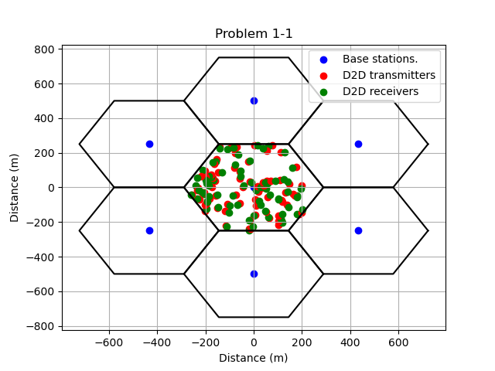

Fig. 1. A figure of the described topology where the blue dots is Base stations, the red dots is D2D transmitters and the green dots is D2D receivers.

## Figures of CDF to SINR

In this problem we use the Received power and SINR equations as shown below.

|  |  |  |
| --- | --- | --- |
|  | PR = g(d)*PT*GT*GR | (1) |
|  |  |  |
|  | g(d) = $\frac{{(h_{t}h_{r})}^{2}}{d^{4}}$ | (2) |
|  |  |  |
|  | SINR = $\frac{P_{s}}{P_{i}{+P}_{n}}$ | (3) |
|  |  |  |
|  | Pn = k*Tn*B | (4) |
|  |  |  |

CDF of a specific SINR is the total number of MS whose SINR is smaller than the specific SINR divided by total number of MS.

|  |  |  |
| --- | --- | --- |
|  | CDF = $\frac{\# of MS who has smaller SINR}{total \# of MS}$ | (5) |
|  |  |  |

### A figure of CDF to uplink SINR (in dB)

Parameters for uplink :

PT = -30 dB ; GT = GR = 14 dB ; $h_{t}$ = 1.5 m ; $h_{r}$ = 51.5 m

k = 1.38*1023 ; Tn = 300K ; B = 10 MHz

There are 75 pairs of mobile devices. For 1-2-1, d is the distance between each transmitter of the pair and the center BS. Also for uplink case, interference is not considered, so $P_{i}$ does not exist in SINR equation.

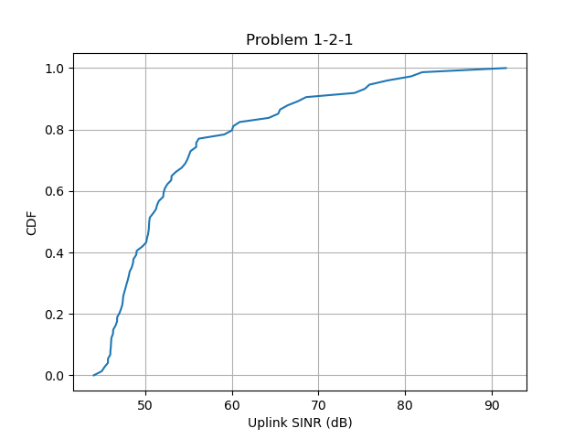

Fig. 2. A figure with uplink SINR (in dB) as x-axis and CDF as y-axis..

### A figure of CDF to downlink SINR (in dB)

Parameters for downlink :

PT = -7 dB ; GT = GR = 14 dB ; $h_{t}$ = 51.5 m ; $h_{r}$ = 1.5 m

k = 1.38*1023 ; Tn = 300K ; B = 10 MHz

There are 75 pairs of mobile devices. For 1-2-2, d is the distance between each receiver of the pair and the center BS. Also for downlink case, interference is calculated as the received power from the six adjacent cell’s BS.

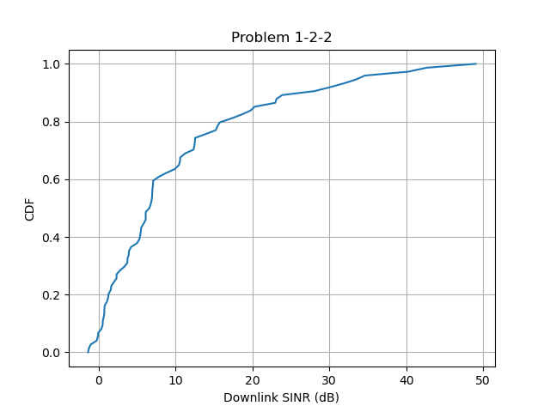

Fig. 3. A figure with downlink SINR (in dB) as x-axis and CDF as y-axis.

## DL throughput of the system according to 1-2

In this problem, we use Shannon capacity as shown in equation (6) to calculate the throughput.

|  |  |  |
| --- | --- | --- |
|  | C = B*log2(1 + SINR) | (6) |

The throughput of DL is the sum of 75 Shannon Capacity of the receiver. From the results shown below, we can know that the distance between transmitter and receiver of the 75 pairs do not influence the DL throughput.

d = 20 : throughput = 37695595.71 Bits/s

d = 300 : throughput = 39002074.32 Bits/s

## A figure of CDF to D2D SINR

In this problem we use the same formula as problem *II,* which are equation (1) to (5).However the parameters are different.

Parameters for D2D :

PT = -30 dB ; GT = GR = 14 dB ; $h_{t}$ = 1.5 m ; $h_{r}$ = 1.5 m ;

d = 20 m

k = 1.38*1023 ; Tn = 300K ; B = 10 MHz

There are 75 pairs of mobile devices. For this subproblem, d is the distance between each transmitter and receiver of the pair, which is set by 20 (Fig. 4) and 300 (Fig. 5).

The interference of an receiver is the sum of the received power from the other 74 transmitter.

From the results in Fig. 4 and Fig. 5 we can know that the tendency is same no matter d equals to 20 or 300. However when d is larger, SINR of D2D is lower.

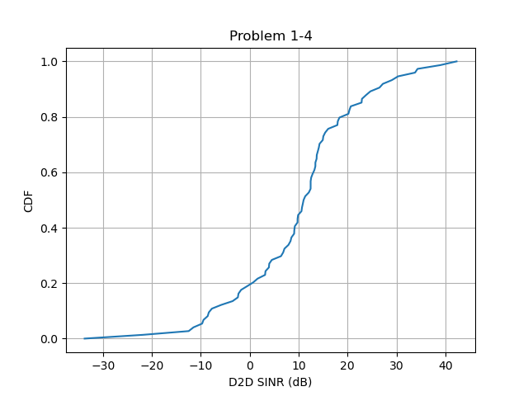

Fig. 4. A figure with D2D SINR as x-axis and CDF as y-axis when d = 20 m

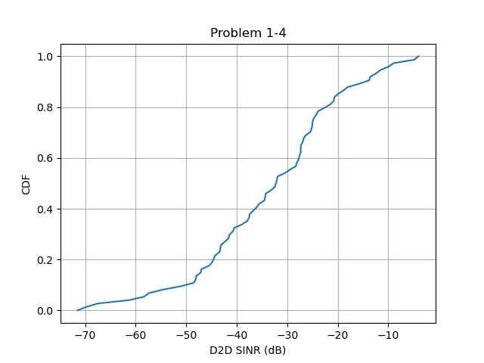

Fig. 5. A figure with D2D SINR as x-axis and CDF as y-axis when d = 300 m

## Throughput of the system according to 1-4

In this problem we use the same method as problem 1-3. From the results shown below we can know that when the transmitter and receiver of the 75 pairs are close, which is when d is smaller, D2D throughput is bigger.

d = 20 : Throughput = 3110241919.72 Bits/s

d = 300 : Throughput = 17155006.79 Bits/s

## A figure with system throughput to number of D2D pairs

Fig. 6 is a figure with system throughput to number of D2D pairs when d = 20. Fig. 7 is a figure with system throughput to number of D2D pairs when d = 300. From Fig. 6 we can observe that the system throughput increase when the number of D2D pairs increase. However, there is no relevance between system throughput and the number of D2D pairs from Fig. 7.

When d = 20, the distance between transmitter and receiver is small, and the SINR of each D2D pair is big. Hence the more the number of D2D pairs are, the bigger the system throughput is. However, when d = 300, the distance between transmitter and receiver is too big and that leads to the big interference as shown in Fig.5. Due to the interference which leads SINR to be small and leads to small Shannon capacity, a system with more D2D pairs does not have a better performance of system throughput.

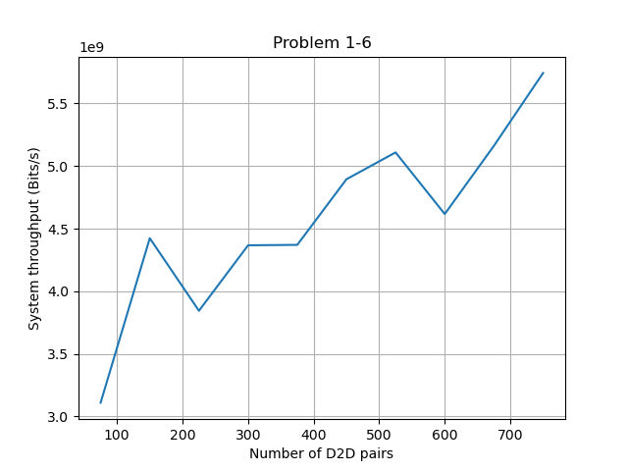

Fig. 6. A figure with the number of D2D pairs as x-axis and the system throughput as y-axis when d = 20 m

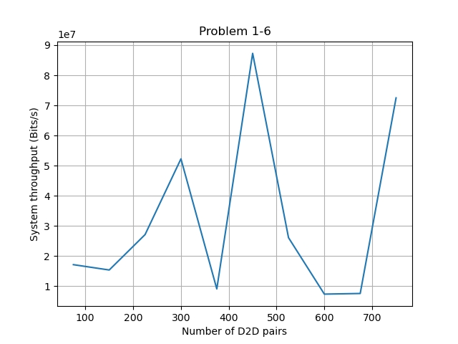

Fig. 7. A figure with the number of D2D pairs as x-axis and the system throughput as y-axis when d = 300

## When does D2D perform better than cellular?

When the transmitter and receiver of the 75 pairs are close, which is when d is smaller, D2D transmission method performs better than cellular transmission method. However, when the transmitter and receiver of the 75 pairs are far, cellular transmission method performs better than D2D transmission method. The result can be proved in problem 1-3 and problem 1-5.

# Traffic in D2D

## A figure of bit loss probability to arrival rate through up- and downlink

For problem 2-1, the arrival rate is the Poisson distribution of 100000, 500000, 1000000, 1500000, 2000000 bps. When the data transmission for downlink is bigger than the BS’s capacity, the extra packet will be stored in BS’s buffer. When the data transmission for uplink is bigger than the MS’s capacity, the extra packet will be stored in MS’s buffer. When the buffer is full loaded, the packet losses. Buffer for BS is 15 M and buffer for MS is 0.5 M.

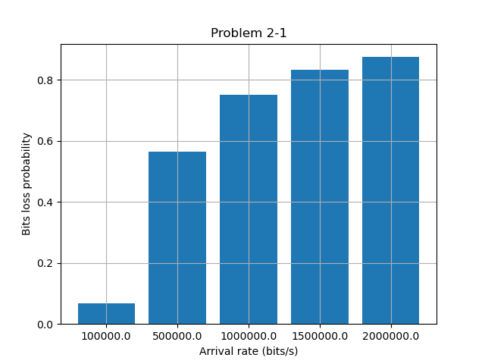

Fig. 8. A figure with arrival rate as x-axis and bit loss probability as y-axis when the data is transmitted through conventional uplink and downlink when d = 20m

## A figure of bit loss probability to arrival rate through D2D

For problem 2-2, the arrival rate is the Poisson distribution of 100000, 500000, 1000000, 1500000, 2000000 bps. When the data transmission is bigger than the D2D transmitter’s capacity, the extra packet will be stored in the buffer. However, when the buffer is full loaded, the packet losses. Buffers for both transmitter is 0.5 M.

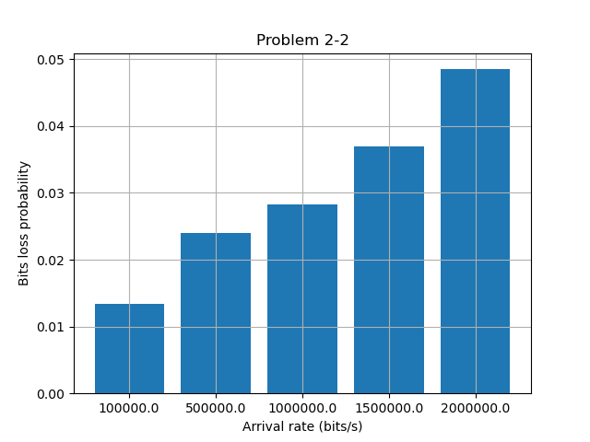

Fig. 9. A figure with arrival rate as x-axis and bit loss probability as y-axis when the data is transmitted through D2D when d = 20 m

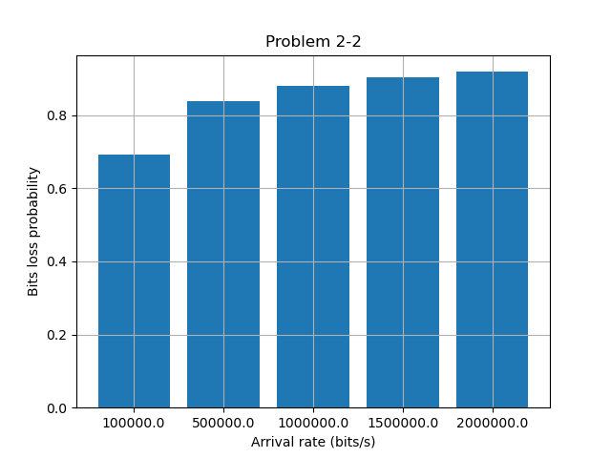

Fig. 10. A figure with arrival rate as x-axis and bit loss probability as y-axis when the data is transmitted through D2D when d = 300 m

## Statement and explanation of the observations from the results in 2-1 and 2-2

The bits loss probability for uplink and downlink transmission method is bigger than for D2D transmission. The bigger the distance between transmitter and receiver is, the worse the SINR is. Thus, the Shannon capacity is worse. For up- and downlink transmission, the distance between BS and MS is larger than through D2D (d = 20 m), so the bits loss probability is bigger.

For D2D transmission, when we change the distance d from 20 m to 300 m, the bits loss probability is shown in Fig. 10. Compare Fig. 9 to Fig. 10 we can find out that for d = 300 m case, the bits loss probability is larger. It corresponds to the results.

## Other factors that could affect the performance of cellular and D2D transmission

The size of buffer also plays an important roll for bits loss probability. In Fig. 11, the buffer size of BS is changed from 15*106 to 15*1012, the bits loss probability decreases. In Fig. 12, the buffer size of D2D transmitter is changed from 0.5*106 to 0.5*101, the bits loss probability increases.

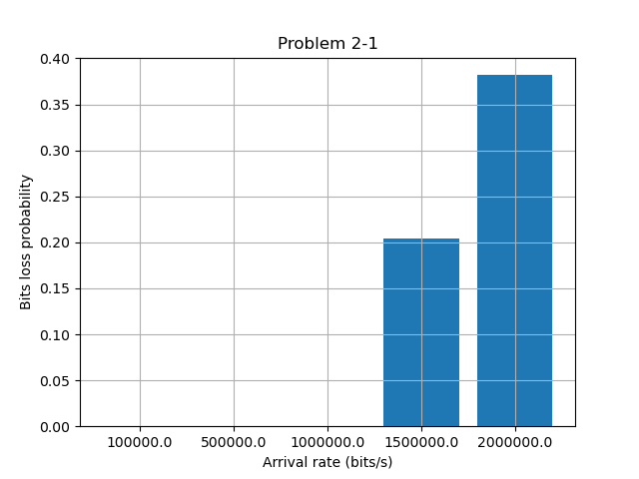

Fig. 11. A figure with arrival rate as x-axis and bit loss probability as y-axis when the data is transmitted through conventional uplink and downlink when

d = 20 m and buffer = 15*1012 rather than 15*106

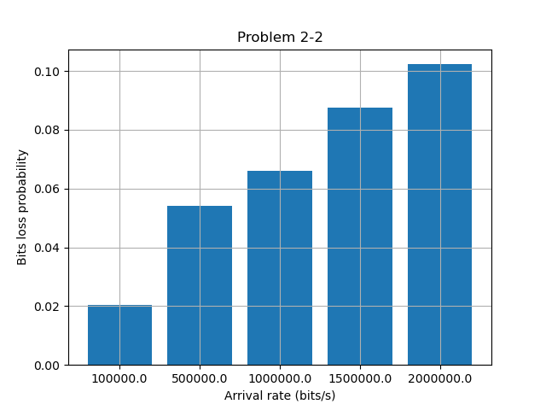

Fig. 12. A figure with arrival rate as x-axis and bit loss probability as y-axis when the data is transmitted through D2D when d = 20 m and buffer = 0.5*101 rather than 0.5*106

## What to do to mitigate the bit loss probability when different D2D transmitters have different data arrival rate

From the conclusion we have got in problem 2-3 and 2-4, larger the buffer size of the transmitter and lower the distance between transmitter and receiver can mitigate the bit loss probability.

References

1. Lilin Fan, Zhengnan Dong, and Peiyan Yuan, “The Capacity of Device-to-Device Communication

Underlaying Cellular Networks With Relay Links,” *IEEE Access* 5:16840-16846, September 2017.

1. Hung-Yu Wei, *Lecture 2: Wireless PHY and Radio Propagation Model.* National Taiwan University