Angioedema Evidence Atlas
What the primary evidence says about angioedema mechanism and nosology
Analysis report, 2 October 2026 | Caryn Upton, UCT Lung Institute

How to read this. This is a reading of 622 studies, about 5,300 extracted result rows and 433 patients with individual-level data. The 493 mined studies were extracted by AI and 94 per cent of their numeric values have been verified against their own source quotes; the remainder are isolated as unverifiable. Treat everything here as hypothesis-generating, not as a finished systematic review. Strong claims below rest either on the original traceable rows or on patterns too large to be artefacts of extraction error.

1. At a glance
The dataset does not support the tidy picture that current angioedema nosology presents. The DANCE scheme (Reshef et al, 2024) sorts recurrent angioedema into five mechanistic bins, and the implicit promise of that scheme is that each bin is defined by a mechanism you can, in principle, measure. When you line the primary evidence up against that promise, only one bin holds its weight. For hereditary angioedema with C1-inhibitor deficiency the bradykinin story is secure: you have the pathway lesion, contact-system activation, the mediator, the response to C1-INH replacement and the response to icatibant during attacks. Everywhere else the mechanistic claim is carried far more by treatment response and analogy than by anyone having measured the mediator at the time of the swelling.
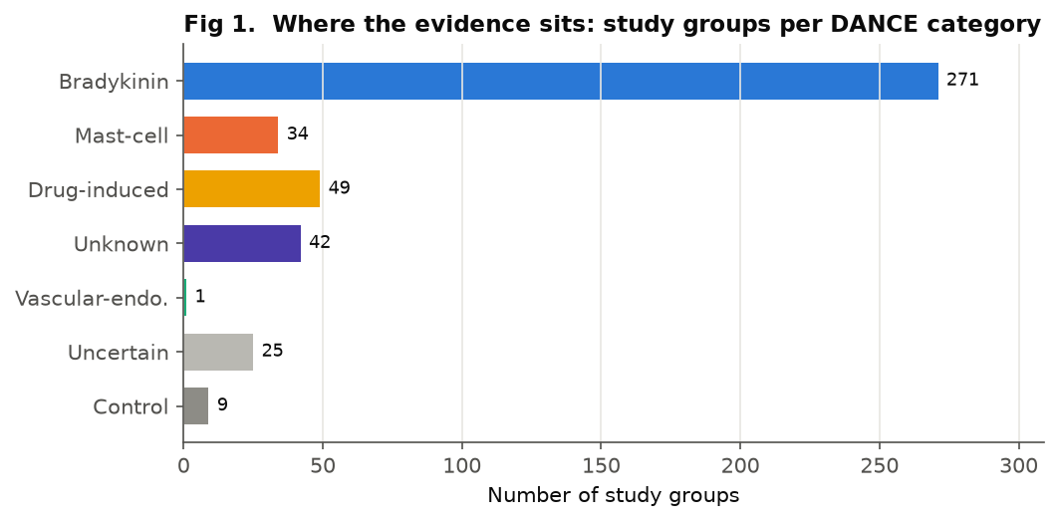
Figure 1. The evidence is heavily concentrated in bradykinin-mediated angioedema. Counts are distinct study groups, not studies.

The dataset in numbers
Metric | Value
Studies | 622
Study groups | 431
Lab-result rows | 1176
Clinical-outcome rows | 1715
Genetic findings | 394
Diagnostic-accuracy tables | 146
Individual patients (IPD) | 433
Numeric values QC-checked | 3120
Verified (pass/confirmed/derived) | 2939
Corrected (wrong) | 22
Unverifiable | 159
Table 1. Contents of the Angioedema Evidence Atlas as analysed for this report.

2. The single most important thing the data says
The field has one well-evidenced bradykinin disease and a large penumbra of conditions that are called bradykinin-mediated, or mast-cell-mediated, largely because they behave as if they were, not because the mechanism has been demonstrated in them. The verdicts in Figure 2 are generated by a fixed causal-chain rubric, not assigned by hand, and they are deliberately severe: a subtype whose entire case rests on a kallikrein-pathway drug having worked can never score secure, however confident the guidelines are.
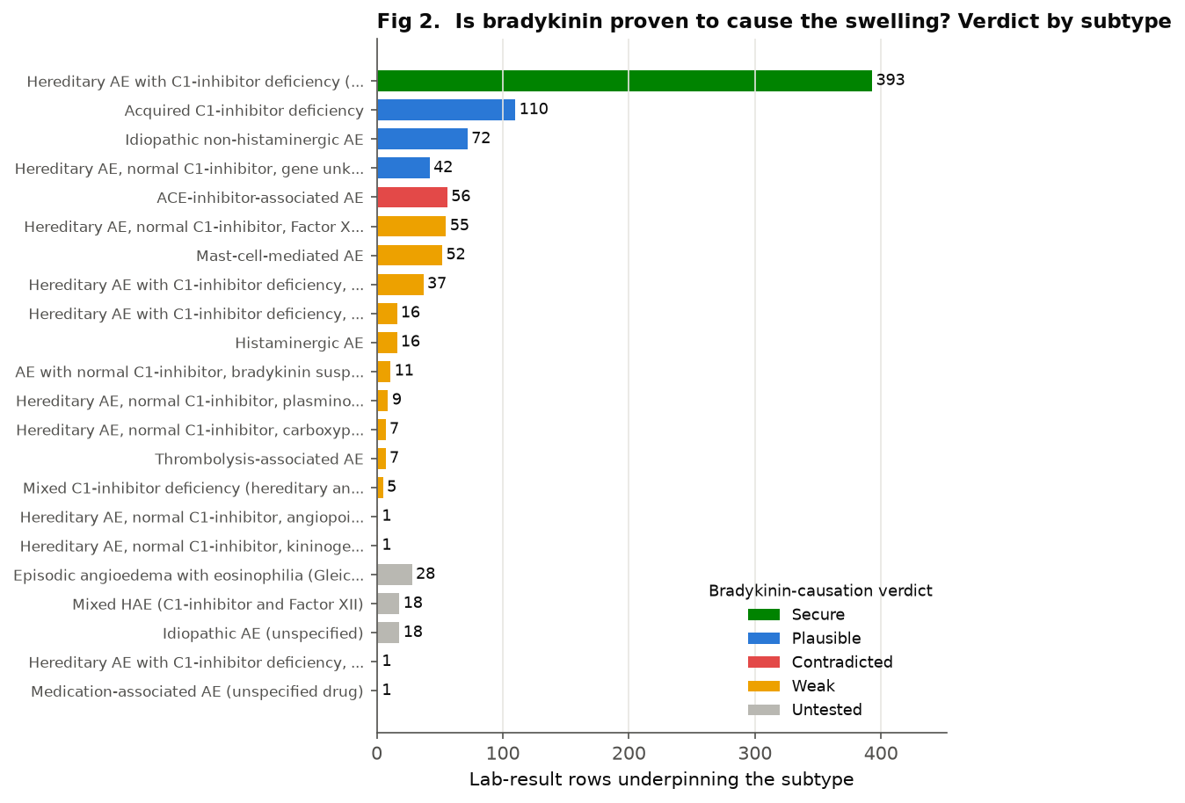
Figure 2. Bradykinin-causation verdict per subtype. Bar length is the volume of laboratory evidence; colour is the verdict. Only HAE with C1-inhibitor deficiency reaches secure.
Figure 3 shows why, link by link. The rubric tests eight causal links, from the pathway lesion (L1) through contact-system activation (L2), the mediator measured (L3), the mediator measured during an attack (L4), the endothelial axis (L5), icatibant response (L6), upstream blockade (L7) and independent replication (L8). The green columns thin out sharply at L4 and at L6/L7, where green becomes the pale blue of treatment-inference rather than direct measurement.
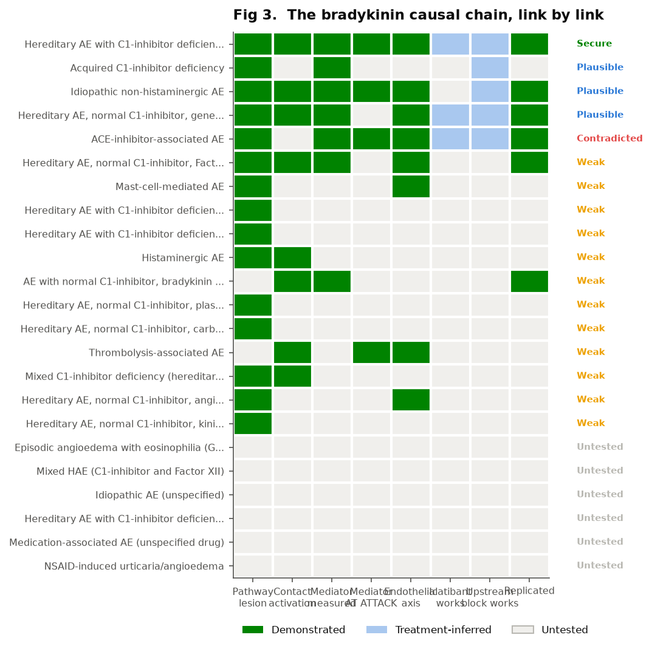
Figure 3. The bradykinin causal chain. Green is directly demonstrated, pale blue is inferred from treatment response only, grey is untested. The chain is complete only for HAE with C1-inhibitor deficiency.

3. The attack-time measurement gap
This is the pocket worth dwelling on, because it reframes much of the rest. Bradykinin has a plasma half-life of seconds to a very few minutes. Any claim that bradykinin caused a given episode, to be direct rather than inferential, needs the mediator (or a tight surrogate such as cleaved high-molecular-weight kininogen) measured in a sample drawn during an attack, against the same patient in remission and against controls. When you filter the dataset for rows that actually represent attack-time mediator measurement, outside HAE with C1-inhibitor deficiency the cupboard is close to bare.
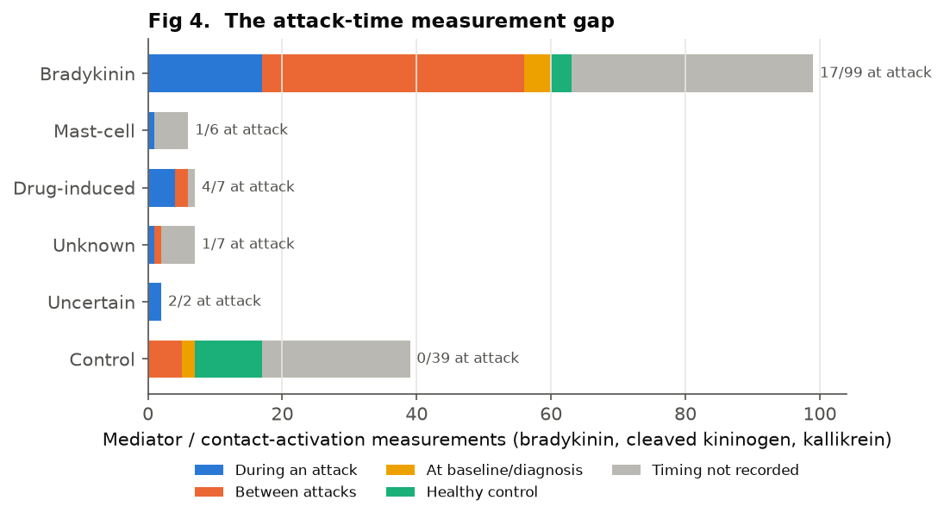
Figure 4. Of the mediator and contact-activation measurements, only a small minority were taken during an attack, even in bradykinin-mediated angioedema (17 of 99). Outside it, attack-time sampling is almost absent.
The pattern holds across the whole laboratory dataset, not just the mediator subset. Most measurements are remission, baseline, or have no recorded timing at all (Figure 5). The clinical consequence is direct: the entire therapeutic logic of giving a bradykinin-targeted drug to a patient with normal-C1INH or idiopathic non-histaminergic angioedema rests on an inference that has rarely been tested at source. The drugs sometimes work, which is real evidence, but treatment response conflates two different claims: that bradykinin was the mediator, and that the B2 receptor was somewhere in the causal path.
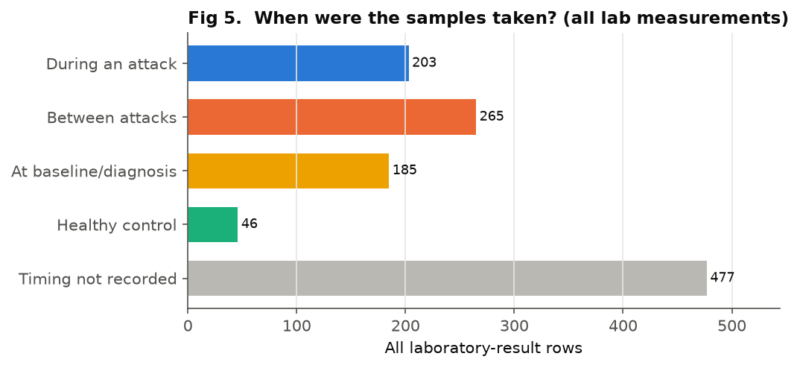
Figure 5. Sample timing across all 1,176 laboratory-result rows. Attack-time sampling is the exception, not the rule.

4. Cleaved kininogen is not the clean biomarker it is presented as
Cleaved high-molecular-weight kininogen is held up as the readout of contact-system activation and therefore as the bradykinin fingerprint. The atlas data do not let it carry that weight. Of 63 cleaved-kininogen measurements, 18 are in control or comparison groups, and the great majority of rows, cases and controls alike, have no extractable direction (Figure 7). In other words, the primary data in this collection do not actually demonstrate that a cross-sectional cleaved-kininogen level separates a bradykinin swelling from a mast-cell one or from a healthy control. A marker that is measured in the comparison groups as readily as in the cases, and whose direction the literature so often leaves unstated, is not yet doing discriminating work.
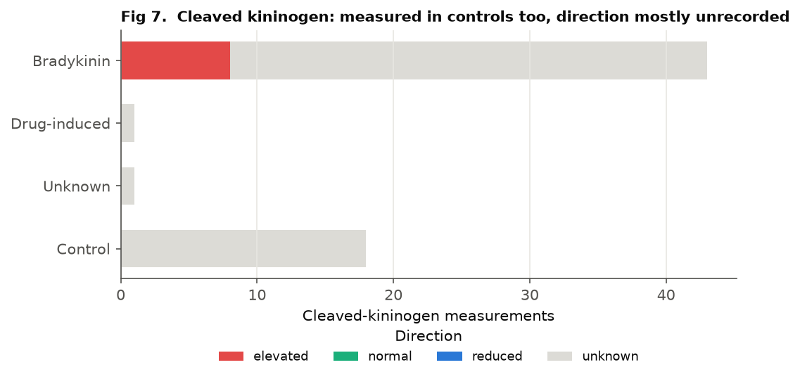
Figure 7. Cleaved-kininogen measurements by category. It is measured in controls about as often as in cases, and most rows carry no recorded direction, so these data cannot show it discriminates.
What might work is the within-patient attack-versus-remission change, and that is exactly the comparison almost nobody has the samples to make. That gap is the first real meta-analysis this dataset could support. More broadly, the direction of the headline biomarkers is recorded far less often than their mere presence (Figure 6), which is the measurement habit that lets a normal result pass unnoticed.
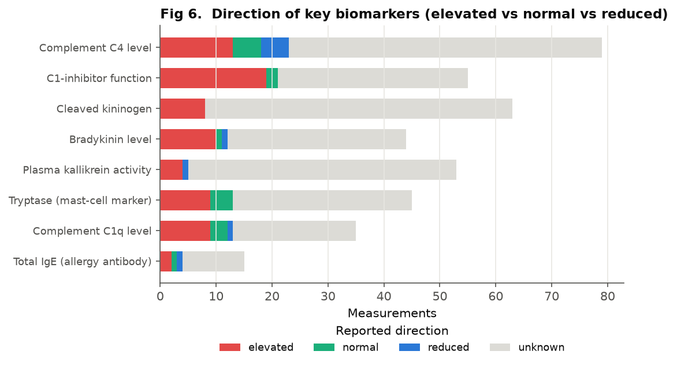
Figure 6. Reported direction of the key biomarkers. For most tests, direction is unknown far more often than it is elevated, normal or reduced.

5. The normal-biomarker trap
Early in the build the scoring counted a biomarker as supporting bradykinin whenever it had been measured, regardless of the result. That let histaminergic angioedema score as having bradykinin evidence on the strength of a bradykinin level that was, in fact, normal during the attack. That is backwards: a normal mediator measured at the right time is evidence against, or at least not for. The rubric now counts only elevated or quantified non-normal values toward the causal chain, and several conditions that looked weakly bradykinin-supported collapsed to untested once normal results stopped masquerading as positive ones. The general lesson applies well beyond this dataset: a measured biomarker and a supportive biomarker are different things, and a surprising amount of mechanistic literature elides the two.

6. ACE-inhibitor angioedema contradicts its own simple story
ACEI-associated angioedema is the textbook bradykinin disease, taught as such because ACE degrades bradykinin and blocking ACE should raise it. The rubric marks this one contradicted, and the reason is specific rather than alarming: the randomised trials of icatibant (and ecallantide) in acute ACEI angioedema were negative. If B2-receptor blockade does not resolve the attack, then bradykinin acting at B2 is not straightforwardly the proximate cause, however compelling the upstream pharmacology looks. The clean mechanistic drug trial undercut the clean mechanistic hypothesis. This is why the verdict logic reserves contradicted for a controlled efficacy failure of a mechanism-targeting drug, not for an individual non-responder or a side-effect. DANCE's decision to file ACEI under drug-induced rather than bradykinin-mediated looks, in this light, like better judgement than the older teaching.

7. The circularity problem in the clinical criteria
When the DANCE clinical discriminators are mapped against what the primary data can actually test, most turn out to be close to untestable, because the case definitions are circular. Histaminergic angioedema is in large part defined by its response to antihistamines; you then cannot use antihistamine response as independent evidence about its mechanism without arguing in a circle. The same trap catches idiopathic non-histaminergic angioedema, defined by the absence of that response. The criteria sort patients efficiently, but they sort them by the very features you would want to use as an independent test, so they cannot validate the mechanistic claim attached to them. This is not a flaw in the extraction. It is a flaw in the nosology that the extraction makes visible.

8. Data quality, and the layer you should not trust yet
Across all 3,120 numeric values checked, 94 per cent are verified against their own source quote (Figure 8). That is reassuring in aggregate, but the error is not spread evenly. The genetic findings are the least reliable layer by a wide margin: most of the corrections landed there, from variant tables in PDFs where columns scrambled on extraction and a carrier count or allele frequency ended up attached to the wrong variant (Figure 9, Table 3). I would not run any analysis on the genetic rows without a human pass. The newer normal-C1INH genes each rest on one or two reports, and placing angiopoietin-1 in the bradykinin bin is an assumption, not a finding, since it acts on the vessel wall rather than the kinin pathway.
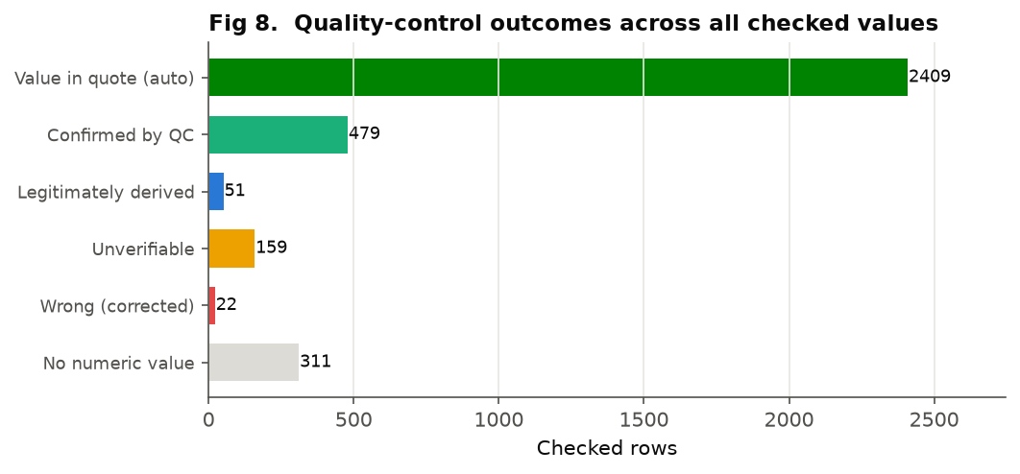
Figure 8. Quality-control outcomes across all checked values. The large pass and confirmed blocks reflect values found in, or supported by, their own source quote.
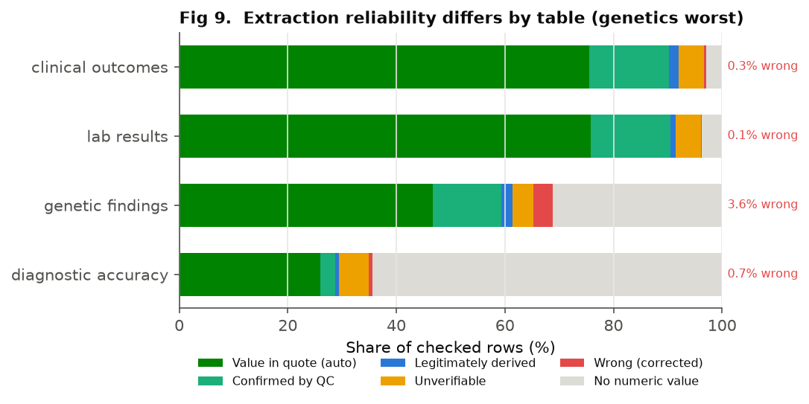
Figure 9. Extraction reliability by table. Genetic findings carry by far the highest wrong rate; laboratory results are the most reliable.

Verdicts and quality in full
Subtype | DANCE | Verdict | Lab rows | Studies
ACE-inhibitor-associated AE | AE-DI | CONTRADICTED | 56 | 43
Acquired C1-inhibitor deficiency | AE-BK | PLAUSIBLE | 110 | 54
Idiopathic non-histaminergic AE | AE-UNK | PLAUSIBLE | 72 | 40
Hereditary AE, normal C1-inhibitor, gene unknown | AE-BK | PLAUSIBLE | 42 | 44
Hereditary AE with C1-inhibitor deficiency (type unspecified) | AE-BK | SECURE | 393 | 244
Episodic angioedema with eosinophilia (Gleich syndrome) | AE-UNK | UNTESTED | 28 | 5
Mixed HAE (C1-inhibitor and Factor XII) | AE-BK | UNTESTED | 18 | 1
Idiopathic AE (unspecified) | AE-UNK | UNTESTED | 18 | 14
Hereditary AE with C1-inhibitor deficiency, type 2 | AE-BK | UNTESTED | 1 | 1
Medication-associated AE (unspecified drug) | AE-DI | UNTESTED | 1 | 11
Mixed acute angioedema | AE-UNK | UNTESTED | 0 | 1
Bradykinin-mediated AE (unspecified) | AE-BK | UNTESTED | 0 | 1
Drug-induced AE (unspecified) | AE-DI | UNTESTED | 0 | 0
Hereditary AE, normal C1-inhibitor, DAB2IP mutation | AE-BK | UNTESTED | 0 | 2
Hereditary AE, normal C1-inhibitor, HS3ST6 mutation | AE-BK | UNTESTED | 0 | 1
Hereditary AE, normal C1-inhibitor, myoferlin mutation | AE-BK | UNTESTED | 0 | 1
Historical HAE (unconfirmed by modern criteria) | AE-BK | UNTESTED | 0 | 1
NSAID-induced urticaria/angioedema | AE-DI | UNTESTED | 0 | 4
Single-NSAID urticaria/angioedema | AE-DI | UNTESTED | 0 | 0
Hereditary AE, normal C1-inhibitor, Factor XII mutation | AE-BK | WEAK | 55 | 39
Mast-cell-mediated AE | AE-MC | WEAK | 52 | 28
Hereditary AE with C1-inhibitor deficiency, type 1 | AE-BK | WEAK | 37 | 11
Hereditary AE with C1-inhibitor deficiency, type 2 | AE-BK | WEAK | 16 | 7
Histaminergic AE | AE-MC | WEAK | 16 | 14
AE with normal C1-inhibitor, bradykinin suspected | AE-BK | WEAK | 11 | 2
Hereditary AE, normal C1-inhibitor, plasminogen mutation | AE-BK | WEAK | 9 | 9
Hereditary AE, normal C1-inhibitor, carboxypeptidase N1 mutation | AE-BK | WEAK | 7 | 2
Thrombolysis-associated AE | AE-DI | WEAK | 7 | 4
Mixed C1-inhibitor deficiency (hereditary and acquired) | AE-BK | WEAK | 5 | 2
Hereditary AE, normal C1-inhibitor, angiopoietin-1 mutation | AE-VE | WEAK | 1 | 3
Hereditary AE, normal C1-inhibitor, kininogen-1 mutation | AE-BK | WEAK | 1 | 3
Table 2. Full bradykinin-causation verdicts per subtype, with the evidence volume behind each.
table | PASS_AUTO | CONFIRMED | DERIVED | UNVERIFIABLE | WRONG | NA_QUALITATIVE
clinical_outcomes | 1295 | 253 | 30 | 81 | 6 | 50
diagnostic_accuracy | 38 | 4 | 1 | 8 | 1 | 94
genetic_findings | 184 | 50 | 8 | 15 | 14 | 123
lab_results | 892 | 172 | 12 | 55 | 1 | 44
Table 3. Quality-control status by table. Note the 14 corrected values concentrated in genetic findings.

9. Where the evidence is thinnest, and why that is the opportunity
The vascular-endothelial bin is almost empty (one group), which tells you it is a category defined ahead of its evidence. The unknown-cause bin is large and genuinely unknown rather than lazily labelled. Across the whole set the pattern is consistent: the volume of literature tracks the availability of a test, not the prevalence of the disease. HAE with C1-inhibitor deficiency is over-represented because C4 and C1-INH assays made it studyable decades ago (Figures 10 and 13). The conditions without a cheap mediator assay are under-studied.
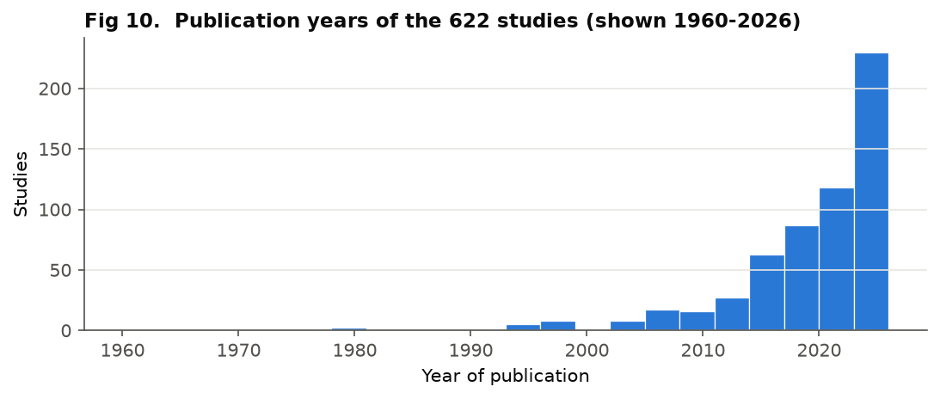
Figure 10. Publication years. The literature grows with assay availability and drug development, not with disease burden.
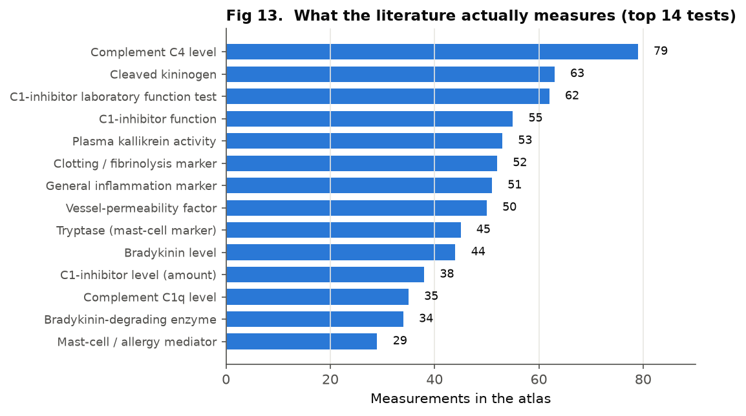
Figure 13. What the literature actually measures. Complement and C1-inhibitor assays dominate; direct mediator measurement is comparatively rare.
The individual-patient records tell the same story of concentration: 367 of 433 patients sit in the bradykinin bin (Figure 11). Where age at onset is recorded, the bradykinin and drug-induced groups separate in the expected direction, with drug-induced onset shifted markedly later into adulthood, consistent with exposure-driven disease (Figure 12). The diagnostic-accuracy literature, where it exists, clusters at high specificity but variable sensitivity, which fits a field built around confirmatory complement tests rather than screening ones (Figure 14).
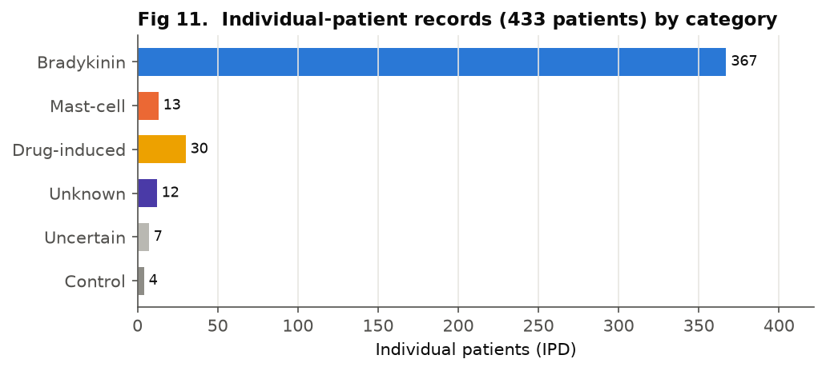
Figure 11. Individual-patient records by category. The IPD is even more concentrated in bradykinin disease than the group-level data.
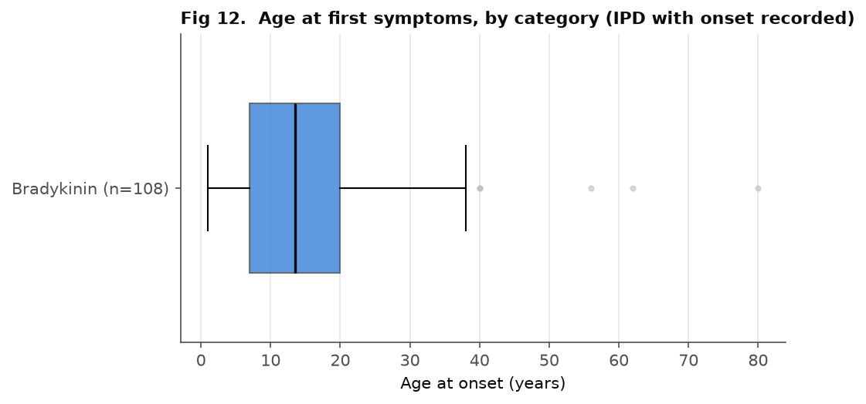
Figure 12. Age at first symptoms in the IPD. Drug-induced angioedema onsets later, as an exposure-driven condition should.
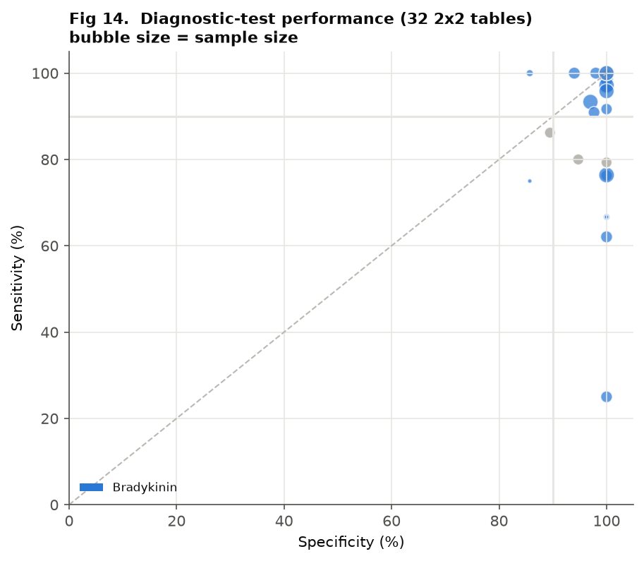
Figure 14. Diagnostic-test performance from 32 reconstructed 2x2 tables. Points cluster towards high specificity; sensitivity is more variable.

10. Hypotheses the data most clearly licence
Three hypotheses follow directly from the patterns above, and the first is testable now on the quality-controlled subset you already hold.
- Cross-sectional contact-system markers will fail to discriminate. Paired attack-versus-remission sampling, not a single cleaved-kininogen level, is what will separate bradykinin from mast-cell angioedema. The atlas cannot currently show the cross-sectional marker discriminates, and that absence is itself the finding.
- Many normal-C1INH bradykinin diagnoses rest on treatment response alone. A meaningful fraction would not survive attack-time measurement. These are the subtypes sitting at weak or plausible in Figure 2 with no green at L4.
- The DANCE clinical criteria cannot be mechanistically validated against the current literature. Definitional circularity, not missing data, is the obstacle. New prospective sampling designed to break the circularity is the only way through.
The honest summary: the dataset confirms one mechanism securely, exposes that most of the others are inferred rather than demonstrated, and points to a specific, achievable study, paired attack-versus-remission cleaved kininogen and bradykinin across subtypes, that the existing literature has conspicuously failed to do.

Methods in brief. Studies were migrated to a relational model (studies > cohorts > groups > result tables) preserving the reported-versus-mapped diagnosis split. Diagnoses were mapped to DANCE categories via an editable codebook. The bradykinin verdict is derived by a fixed eight-link causal-chain rubric that privileges direct attack-time measurement over treatment inference and treats a controlled efficacy failure of a mechanism-targeting drug as contradicting. Numeric values were checked against their verbatim source quotes, deterministically and then by adjudication; wrong values are corrected in the analysis tables and unverifiable ones isolated. Figures are generated directly from the analysis tables.

