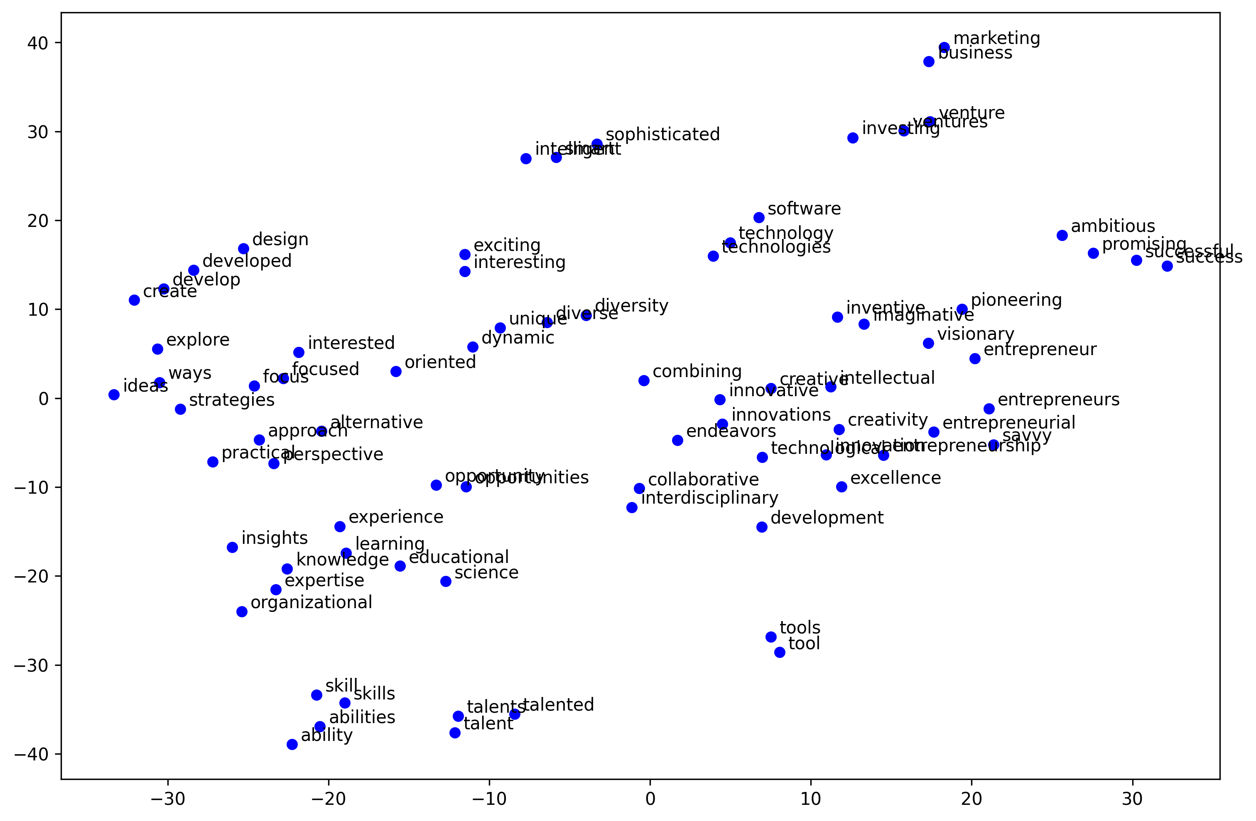

The t-SNE visualization reveals several distinct clusters in the word embeddings, showing clear semantic relationships between terms. Notable clusters include a skill-related group in the lower portion (skills, ability, talent), a business cluster in the upper region (marketing, business, venture), and an innovation-focused cluster in the middle (innovative, creativity, entrepreneurial). Some words appear as outliers, with "tools" and "tool" positioned distinctly in the lower right quadrant, while "marketing" and "business" stand notably separated in the upper portion. Words with similar meanings are consistently positioned close together, such as "skills/skill," "talent/talented," and "technology/technologies," demonstrating strong semantic relationships. Based on these clear semantic groupings and logical word relationships, the quality of the dictionary appears to be high, as it successfully captures meaningful semantic similarities and differences between terms while maintaining appropriate distances between distinct concepts.