Carys Zhao - Summative Assignment Results

1. I chose Strategic Management Journal (SMJ) to represent the Strategy subdiscipline and Personnel Psychology (PPsych) to represent the Organizational Behavior subdiscipline. I downloaded 635 abstracts from SMJ and 314 abstracts from PPsych.
2. I defined a clean_abstract function that includes a clause for removing common copyright phrases based on five different patterns. In the same function, I also included a clause to remove any rows without actual abstracts and a clause to remove prefixes such as “abstract” and “research summary”.
3. I applied two approaches for obtaining the embedding vectors for abstracts. The first is tf-idf, which is using TfidfVectorizer() from sklearn to convert abstracts into numerical representations.The second is using openAI through personal API key. I applied the gpt-4o-mini model and called get_openai_embedding(text), which sends each abstract to openAI’s API and returns a dense vector representation. These embedding vectors are then used to train machine learning models.
4. I trained two supervised machine learning models, which are Random Forest (RF) Classifier and Support Vector Machine (SVM), trained both by tf-idf and openAI. For RF trained by tf-idf, accuracy is .91, weighted average precision is .92, and weighted average recall is .91. For SVM trained by tf-idf, accuracy is .96, weighted average precision is .96, and weighted average recall is .96. For RF trained by openAI, accuracy is .91, weighted average precision is .92, and weighted average recall is .91. For SVM trained by openAI, accuracy is .97, weighted average precision is .97, and weighted average recall is .97. Taking together, the SVM model trained by openAI is the best performing model.

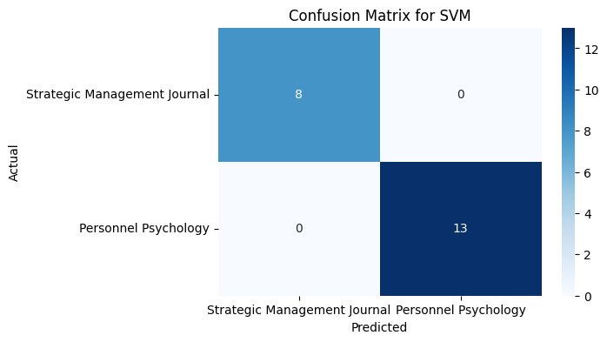

A total of 22 JOM abstracts were coded (A prior testing tried to download 20 abstracts but two of them did not actually provide abstracts). The overall accuracy for the current testing is 1.00. Based on the confusion matrix, the model predictions did not contain misclassifications. Through multiple testings, I find that the misclassification occurrences are likely due to the ambiguity of the subject or range restriction. For example, JOM contains research advice papers that fall out of the two categories, or papers about “status” could be classified into either domain if solely based on the abstract.