pilot_results

# Sample

The sample has the following characteristics

Only people are included who indicated on CloudResearch they do not have a special diet (vegetarian, flexitarian, etc.). People eat meat on average NA days a week.

[1] NA

|  | Overall (N=100) |
| --- | --- |
| **gender** |  |
| male | 56 (56.0%) |
| female | 43 (43.0%) |
| non-binary | 0 (0%) |
| prefer not to say | 1 (1.0%) |
| **age** |  |
| Mean (SD) | 38.9 (12.0) |
| Median [Min, Max] | 36.0 [18.0, 67.0] |
| **Number of adults** |  |
| Mean (SD) | 2.52 (4.07) |
| Median [Min, Max] | 2.00 [1.00, 42.0] |
| Missing | 1 (1.0%) |
| **Number of children** |  |
| Mean (SD) | 0.660 (0.934) |
| Median [Min, Max] | 0 [0, 4.00] |
| **Education** |  |
| No formal education | 0 (0%) |
| Less than a high school diploma | 0 (0%) |
| High school graduate or equivalent (i.e. GED) | 18 (18.0%) |
| Some college, but no degree | 12 (12.0%) |
| Associate degree (i.e. AA, AS) | 8 (8.0%) |
| Bachelor's degree (i.e. BA, AB, BS) | 50 (50.0%) |
| Master's degree (i.e. MA, MS, MEng, etc.) | 8 (8.0%) |
| Professional degree (i.e. MD, DDS, DVM, LLB, JD) | 2 (2.0%) |
| Doctorate degree (i.e. PhD, EdD) | 1 (1.0%) |
| Missing | 1 (1.0%) |
| **Income** |  |
| Less than $10,000 | 1 (1.0%) |
| $10,000 - $19,999 | 2 (2.0%) |
| $20,000 - $29,999 | 12 (12.0%) |
| $30,000 - $39,999 | 8 (8.0%) |
| $40,000 - $49,999 | 4 (4.0%) |
| $50,000 - $59,999 | 9 (9.0%) |
| $60,000 - $69,999 | 9 (9.0%) |
| $70,000 - $79,999 | 11 (11.0%) |
| $80,000 - $89,999 | 4 (4.0%) |
| $90,000 - $99,999 | 7 (7.0%) |
| $100,000 - $149,999 | 19 (19.0%) |
| $150,000 or more | 14 (14.0%) |

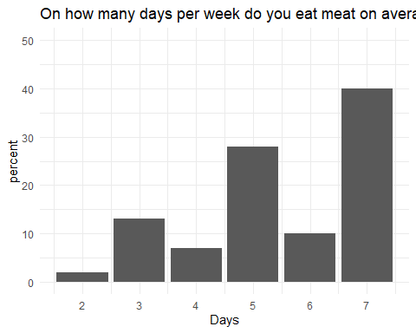

# Analysis

* shop_today: bought today, expires today
* shop_3: bought today, expiry 3 days
* fr_today: bought before, expires today
* fr_3: bought before, expiry 3 days

There is a significant main effect from the repeated measures ANOVA.

Correlation table of behaviour measures

|  | shop_today | fr_3 | shop_3 | fr_today |
| --- | --- | --- | --- | --- |
| shop_today | 1.0000000 | 0.6045666 | 0.5189384 | 0.7188826 |
| fr_3 | 0.6045666 | 1.0000000 | 0.6361732 | 0.7272853 |
| shop_3 | 0.5189384 | 0.6361732 | 1.0000000 | 0.4940849 |
| fr_today | 0.7188826 | 0.7272853 | 0.4940849 | 1.0000000 |

Mean and Standard Deviation of Scores by Behaviour

| behaviour | mean | sd |
| --- | --- | --- |
| Fridge 3 days: expires in 3 days | 5.89 | 1.87 |
| Fridge 3 days: expires today | 5.51 | 2.07 |
| Shop today: expires in 3 days | 6.32 | 1.43 |
| Shop today: expires today | 5.81 | 1.98 |

ANOVA output

|  | Sum Sq | Mean Sq | NumDF | DenDF | F value | Pr(>F) |
| --- | --- | --- | --- | --- | --- | --- |
| storage | 13.3225 | 13.3225 | 1 | 297 | 9.9993872 | 0.0017279 |
| expiry | 19.8025 | 19.8025 | 1 | 297 | 14.8630411 | 0.0001417 |
| storage:expiry | 0.4225 | 0.4225 | 1 | 297 | 0.3171132 | 0.5737725 |

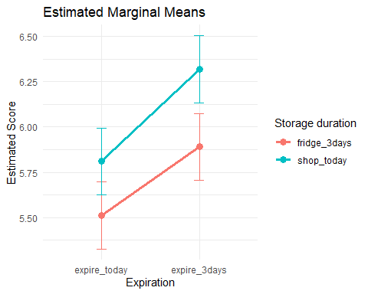

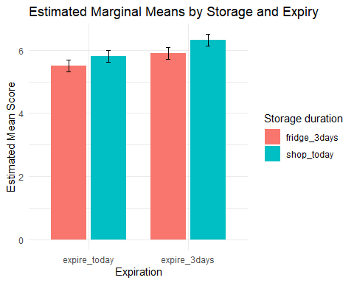

Type III Analysis of Variance Table with Satterthwaite's method  
 Sum Sq Mean Sq NumDF DenDF F value Pr(>F)   
storage 13.3225 13.3225 1 297 9.9994 0.0017279 **   
expiry 19.8025 19.8025 1 297 14.8630 0.0001417 ***  
cap_all 0.0796 0.0796 1 96 0.0597 0.8074536   
opp_all 0.0038 0.0038 1 96 0.0029 0.9575191   
mot_all 12.5288 12.5288 1 96 9.4036 0.0028131 **   
storage:expiry 0.4225 0.4225 1 297 0.3171 0.5737725   
---  
Signif. codes: 0 '***' 0.001 '**' 0.01 '*' 0.05 '.' 0.1 ' ' 1

Linear mixed model fit by REML. t-tests use Satterthwaite's method [  
lmerModLmerTest]  
Formula: score ~ storage * expiry + cap_all + opp_all + mot_all + (1 | id)  
 Data: long_bsub  
  
REML criterion at convergence: 1444.1  
  
Scaled residuals:   
 Min 1Q Median 3Q Max   
-3.1275 -0.2945 0.1163 0.4006 2.9599   
  
Random effects:  
 Groups Name Variance Std.Dev.  
 id (Intercept) 1.748 1.322   
 Residual 1.332 1.154   
Number of obs: 400, groups: id, 100  
  
Fixed effects:  
 Estimate Std. Error df t value Pr(>|t|)   
(Intercept) 2.68280 1.45490 95.99999 1.844 0.068271 .   
storage1 -0.18250 0.05771 297.00000 -3.162 0.001728 **   
expiry1 0.22250 0.05771 297.00000 3.855 0.000142 ***  
cap_all -0.05793 0.23703 95.99999 -0.244 0.807454   
opp_all 0.01261 0.23612 96.00000 0.053 0.957519   
mot_all 0.58866 0.19196 96.00000 3.067 0.002813 **   
storage1:expiry1 -0.03250 0.05771 297.00000 -0.563 0.573773   
---  
Signif. codes: 0 '***' 0.001 '**' 0.01 '*' 0.05 '.' 0.1 ' ' 1  
  
Correlation of Fixed Effects:  
 (Intr) storg1 expry1 cap_ll opp_ll mot_ll  
storage1 0.000   
expiry1 0.000 0.000   
cap_all -0.720 0.000 0.000   
opp_all -0.383 0.000 0.000 -0.077   
mot_all -0.113 0.000 0.000 0.083 -0.718   
strg1:xpry1 0.000 0.000 0.000 0.000 0.000 0.000

# behaviour frequencies

mean frequencies (1 (almost) never - 5 very often) for behaviours:

1. How often do you eat beef that was frozen at home?
2. How often does beef go unused before it reaches its expiry date?
3. How often do you find beef in the freezer that you have to throw out?

Summary of Reported Beef-Related Behaviours

| behaviour | mean | sd | n |
| --- | --- | --- | --- |
| How often do you eat beef that was frozen at home? | 3.89 | 1.01 | 100 |
| How often do you find beef in the freezer that you have to throw out? | 1.78 | 0.93 | 100 |
| How often does beef go unused before it reaches its expiry date? | 1.92 | 0.91 | 100 |

# COM-B determinants

## Capabilities

cap_1 cap_2 cap_3 cap_4 cap_5 cap_6 cap_7 cap_all  
cap_1 1.00 -0.32 0.45 0.23 -0.28 -0.16 0.01 NA  
cap_2 -0.32 1.00 -0.04 -0.06 0.28 0.24 0.03 NA  
cap_3 0.45 -0.04 1.00 0.25 -0.19 -0.02 -0.01 NA  
cap_4 0.23 -0.06 0.25 1.00 -0.41 -0.07 -0.08 NA  
cap_5 -0.28 0.28 -0.19 -0.41 1.00 0.43 0.22 NA  
cap_6 -0.16 0.24 -0.02 -0.07 0.43 1.00 -0.04 NA  
cap_7 0.01 0.03 -0.01 -0.08 0.22 -0.04 1.00 NA  
cap_all NA NA NA NA NA NA NA 1

raw_alpha std.alpha G6(smc) average_r S/N ase mean sd  
 0.577475 0.5942677 0.6866281 0.1547521 1.464679 0.06134268 3.009643 0.7809091  
 median_r  
 0.1484783

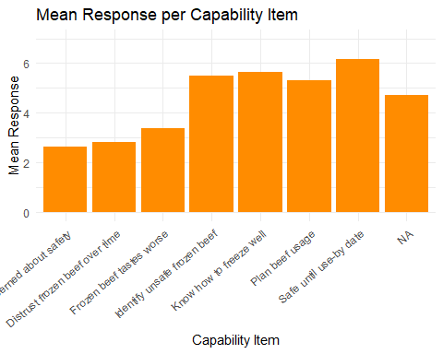

## Opportunity

opp_1 opp_2 opp_3 opp_4 opp_all  
opp_1 1.00 0.45 0.33 0.51 0.80  
opp_2 0.45 1.00 0.49 0.62 0.77  
opp_3 0.33 0.49 1.00 0.54 0.73  
opp_4 0.51 0.62 0.54 1.00 0.79  
opp_all 0.80 0.77 0.73 0.79 1.00

raw_alpha std.alpha G6(smc) average_r S/N ase mean sd  
 0.83042 0.8834342 0.9633812 0.6025073 7.578849 0.02525849 6.06 0.882003  
 median_r  
 0.5778455

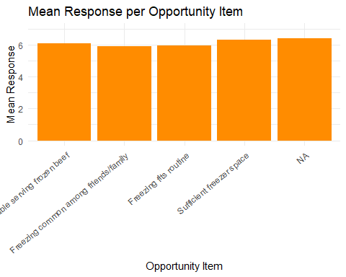

## Motivation

mot_1 mot_2 mot_3 mot_4 mot_5 mot_6 mot_all  
mot_1 1.00 0.64 0.50 0.62 0.47 0.53 0.93  
mot_2 0.64 1.00 0.36 0.61 0.39 0.53 0.93  
mot_3 0.50 0.36 1.00 0.25 0.89 0.28 0.86  
mot_4 0.62 0.61 0.25 1.00 0.24 0.67 0.95  
mot_5 0.47 0.39 0.89 0.24 1.00 0.30 0.92  
mot_6 0.53 0.53 0.28 0.67 0.30 1.00 0.79  
mot_all 0.93 0.93 0.86 0.95 0.92 0.79 1.00

Warning in cor.smooth(model): Matrix was not positive definite, smoothing was  
done

Warning in cor.smooth(r): Matrix was not positive definite, smoothing was done

Warning in log(det(m.inv.r)): NaNs produced

In smc, smcs > 1 were set to 1.0  
In smc, smcs > 1 were set to 1.0  
In smc, smcs > 1 were set to 1.0  
In smc, smcs > 1 were set to 1.0

In smc, smcs < 0 were set to .0

In smc, smcs > 1 were set to 1.0  
In smc, smcs > 1 were set to 1.0

In smc, smcs < 0 were set to .0

In smc, smcs > 1 were set to 1.0  
In smc, smcs > 1 were set to 1.0

raw_alpha std.alpha G6(smc) average_r S/N ase mean sd  
 0.9169664 0.9139412 0.9236545 0.6027234 10.61996 0.01351862 5.748333 1.085434  
 median_r  
 0.6137686

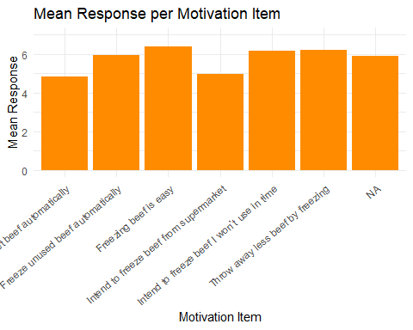

Answers to: “What is the maximum amount of time beef can be kept in the freezer and still be safe to eat?”

correct answer is indefinitely

# Create a factor with new labels replacing 1-5  
df$Q26_factor <- factor(df$Q26, levels = 1:5,  
 labels = c(  
 "Less than 1 month",  
 "1-2 months",  
 "3-6 months",  
 "1 year",  
 "Indefinitely"  
 )  
)  
  
table(df$Q26_factor)

Less than 1 month 1-2 months 3-6 months 1 year   
 12 16 46 20   
 Indefinitely   
 6