pilot_results

# Analysis

2 storage duration:

* fridge_3days: beef has been in fridge for 3 days
* shop_today: beef was bought today

2 expiration:

* expire_today: beef expires today
* expire_3days: beef expires in 3 days

Mean and Standard Deviation of Scores by Behaviour

| behaviour | mean | sd |
| --- | --- | --- |
| Fridge 3 days: expires in 3 days | 5.89 | 1.87 |
| Fridge 3 days: expires today | 5.51 | 2.07 |
| Shop today: expires in 3 days | 6.32 | 1.43 |
| Shop today: expires today | 5.81 | 1.98 |

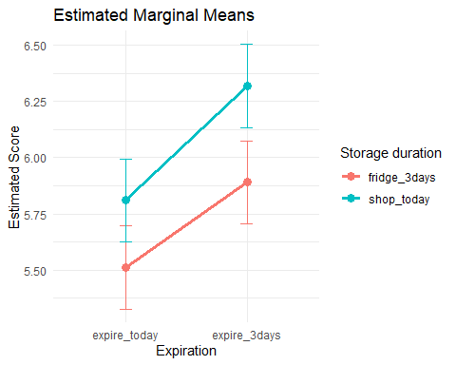Anova output

|  | Sum Sq | Mean Sq | NumDF | DenDF | F value | Pr(>F) |
| --- | --- | --- | --- | --- | --- | --- |
| storage | 13.3225 | 13.3225 | 1 | 297 | 9.9993872 | **0.0017279** |
| expiry | 19.8025 | 19.8025 | 1 | 297 | 14.8630411 | **0.0001417** |
| storage:expiry | 0.4225 | 0.4225 | 1 | 297 | 0.3171132 | 0.5737725 |

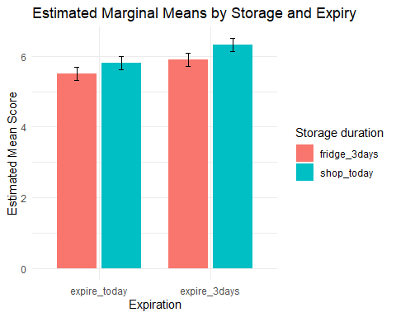

ANOVA:

Type III Analysis of Variance Table with Satterthwaite's method  
 Sum Sq Mean Sq NumDF DenDF F value Pr(>F)   
storage 13.3225 13.3225 1 297 9.9994 0.0017279 **   
expiry 19.8025 19.8025 1 297 14.8630 0.0001417 ***  
cap_all 0.0796 0.0796 1 96 0.0597 0.8074536   
opp_all 0.0038 0.0038 1 96 0.0029 0.9575191   
mot_all 12.5288 12.5288 1 96 9.4036 0.0028131 **   
storage:expiry 0.4225 0.4225 1 297 0.3171 0.5737725   
---  
Signif. codes: 0 '***' 0.001 '**' 0.01 '*' 0.05 '.' 0.1 ' ' 1

Regression:  
Fixed effects:  
 Estimate Std. Error df t value Pr(>|t|)   
(Intercept) 2.68280 1.45490 95.99999 1.844 0.068271 .   
storage1 -0.18250 0.05771 297.00000 -3.162 0.001728 **   
expiry1 0.22250 0.05771 297.00000 3.855 0.000142 ***  
cap_all -0.05793 0.23703 95.99999 -0.244 0.807454   
opp_all 0.01261 0.23612 96.00000 0.053 0.957519   
mot_all 0.58866 0.19196 96.00000 3.067 0.002813 **   
storage1:expiry1 -0.03250 0.05771 297.00000 -0.563 0.573773   
---  
Signif. codes: 0 '***' 0.001 '**' 0.01 '*' 0.05 '.' 0.1 ' ' 1