pilot_results

# Sample

The sample has the following characteristics

Only people are included who indicated on CloudResearch they do not have a special diet (vegetarian, flexitarian, etc.). People eat meat on average 5.51 days a week.

|  | Overall (N=100) |
| --- | --- |
| **gender** |  |
| male | 56 (56.0%) |
| female | 43 (43.0%) |
| non-binary | 0 (0%) |
| prefer not to say | 1 (1.0%) |
| **age** |  |
| Mean (SD) | 38.9 (12.0) |
| Median [Min, Max] | 36.0 [18.0, 67.0] |
| **Number of adults** |  |
| Mean (SD) | 2.52 (4.07) |
| Median [Min, Max] | 2.00 [1.00, 42.0] |
| Missing | 1 (1.0%) |
| **Number of children** |  |
| Mean (SD) | 0.660 (0.934) |
| Median [Min, Max] | 0 [0, 4.00] |
| **Education** |  |
| No formal education | 0 (0%) |
| Less than a high school diploma | 0 (0%) |
| High school graduate or equivalent (i.e. GED) | 18 (18.0%) |
| Some college, but no degree | 12 (12.0%) |
| Associate degree (i.e. AA, AS) | 8 (8.0%) |
| Bachelor's degree (i.e. BA, AB, BS) | 50 (50.0%) |
| Master's degree (i.e. MA, MS, MEng, etc.) | 8 (8.0%) |
| Professional degree (i.e. MD, DDS, DVM, LLB, JD) | 2 (2.0%) |
| Doctorate degree (i.e. PhD, EdD) | 1 (1.0%) |
| Missing | 1 (1.0%) |
| **Income** |  |
| Less than $10,000 | 1 (1.0%) |
| $10,000 - $19,999 | 2 (2.0%) |
| $20,000 - $29,999 | 12 (12.0%) |
| $30,000 - $39,999 | 8 (8.0%) |
| $40,000 - $49,999 | 4 (4.0%) |
| $50,000 - $59,999 | 9 (9.0%) |
| $60,000 - $69,999 | 9 (9.0%) |
| $70,000 - $79,999 | 11 (11.0%) |
| $80,000 - $89,999 | 4 (4.0%) |
| $90,000 - $99,999 | 7 (7.0%) |
| $100,000 - $149,999 | 19 (19.0%) |
| $150,000 or more | 14 (14.0%) |

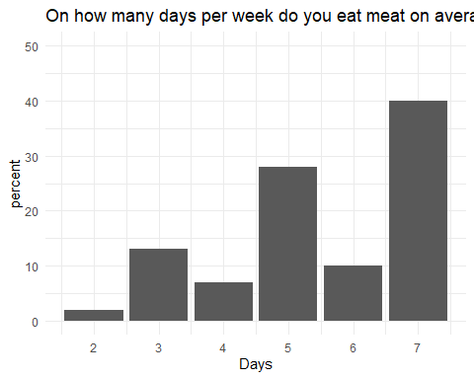

# Analysis

* shop_today: bought today, expires today
* shop_3: bought today, expiry 3 days
* fr_today: bought before, expires today
* fr_3: bought before, expiry 3 days

There is a significant main effect from the repeated measures ANOVA.

Correlation table of behaviour measures

|  | shop_today | fr_3 | shop_3 | fr_today |
| --- | --- | --- | --- | --- |
| shop_today | 1.0000000 | 0.6045666 | 0.5189384 | 0.7188826 |
| fr_3 | 0.6045666 | 1.0000000 | 0.6361732 | 0.7272853 |
| shop_3 | 0.5189384 | 0.6361732 | 1.0000000 | 0.4940849 |
| fr_today | 0.7188826 | 0.7272853 | 0.4940849 | 1.0000000 |

Mean and Standard Deviation of Scores by Behaviour

| behaviour | mean | sd |
| --- | --- | --- |
| Fridge 3 days: expires in 3 days | 5.89 | 1.87 |
| Fridge 3 days: expires today | 5.51 | 2.07 |
| Shop today: expires in 3 days | 6.32 | 1.43 |
| Shop today: expires today | 5.81 | 1.98 |

ANOVA output

| term | sumsq | meansq | NumDF | DenDF | statistic | p.value |
| --- | --- | --- | --- | --- | --- | --- |
| behaviour | 33.5475 | 11.1825 | 3 | 297 | 8.39318 | **2.26e-05** |

pairwise comparisons

| contrast | estimate | SE | df | t.ratio | p.value |
| --- | --- | --- | --- | --- | --- |
| fr_3 - fr_today | 0.38 | 0.163238 | 297 | 2.3278899 | 0.0940515 |
| fr_3 - shop_3 | -0.43 | 0.163238 | 297 | -2.6341911 | **0.0437660** |
| fr_3 - shop_today | 0.08 | 0.163238 | 297 | 0.4900821 | 0.9612658 |
| fr_today - shop_3 | -0.81 | 0.163238 | 297 | -4.9620810 | **0.0000070** |
| fr_today - shop_today | -0.30 | 0.163238 | 297 | -1.8378078 | 0.2577066 |
| shop_3 - shop_today | 0.51 | 0.163238 | 297 | 3.1242732 | **0.0105070** |

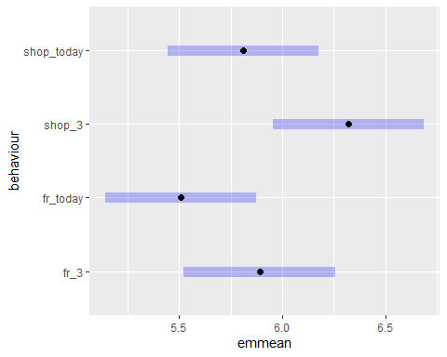

# behaviour frequencies

mean frequencies (1 (almost) never - 5 very often) for behaviours

| behaviour | mean | sd | n |
| --- | --- | --- | --- |
| How often do you eat beef that was frozen at home? | 3.89 | 1.01 | 100 |
| How often do you find beef in the freezer that you have to throw out? | 1.78 | 0.93 | 100 |
| How often does beef go unused before it reaches its expiry date? | 1.92 | 0.91 | 100 |

# COM-B determinants

## Capabilities

cap_1 cap_2 cap_3 cap_4 cap_5 cap_6 cap_7  
cap_1 1.00 -0.32 0.45 0.23 -0.28 -0.16 0.01  
cap_2 -0.32 1.00 -0.04 -0.06 0.28 0.24 0.03  
cap_3 0.45 -0.04 1.00 0.25 -0.19 -0.02 -0.01  
cap_4 0.23 -0.06 0.25 1.00 -0.41 -0.07 -0.08  
cap_5 -0.28 0.28 -0.19 -0.41 1.00 0.43 0.22  
cap_6 -0.16 0.24 -0.02 -0.07 0.43 1.00 -0.04  
cap_7 0.01 0.03 -0.01 -0.08 0.22 -0.04 1.00

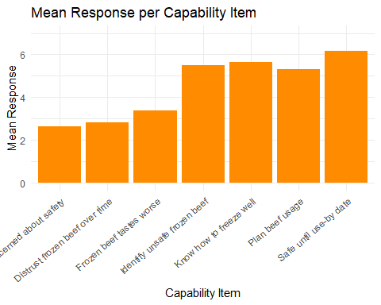

## Opportunity

opp_1 opp_2 opp_3 opp_4  
opp_1 1.00 0.45 0.33 0.51  
opp_2 0.45 1.00 0.49 0.62  
opp_3 0.33 0.49 1.00 0.54  
opp_4 0.51 0.62 0.54 1.00

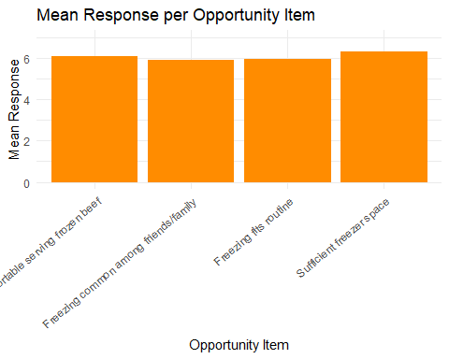

## 

## Motivation

mot_1 mot_2 mot_3 mot_4 mot_5 mot_6  
mot_1 1.00 0.64 0.50 0.62 0.47 0.53  
mot_2 0.64 1.00 0.36 0.61 0.39 0.53  
mot_3 0.50 0.36 1.00 0.25 0.89 0.28  
mot_4 0.62 0.61 0.25 1.00 0.24 0.67  
mot_5 0.47 0.39 0.89 0.24 1.00 0.30  
mot_6 0.53 0.53 0.28 0.67 0.30 1.00

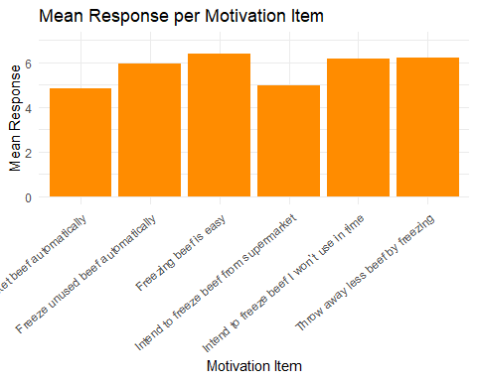

Answers to: “What is the maximum amount of time beef can be kept in the freezer and still be safe to eat?”

correct answer is indefinitely

|  |  |
| --- | --- |
| Less than 1 month | 12 |
| 1-2 months | 16 |
| 3-6 months | 46 |
| 1 year | 20 |
| Indefinitely | 6 |