Contents
Business Analytics 1
Introduction/Business Problem 1
The audience 1
The problem 1
Data analytics 1
Data collection 1
- Data source 1
- -How we will use the data 2
Data cleaning and data preparation 2
Data understanding 2
- Relation between collision and weather condition 4
- Relation between collision and road condition 5
- Relation between collision and light condition 5
- Relation between collision and time 6
- Type of the locations 6
Modeling 6
Result 8
Discussion 8
Conclusion 8

Business Analytics

Introduction/Business Problem
John has been living in Seattle for all his life, he was born, raised and even went to university there. After he graduated he met his most significant one, Vanessa, who agreed to be his wife. Two years after their marriage, Nicolas, their first son was born. The family was living the best of life when unfortunately Nicolas was hit by a car at an intersection while riding a bicycle. The injury wasn’t severe enough to threat his life but a permanent disability will result. Nonetheless, instead of complaining about his fate, he decided to create a foundation which goal is to help cyclists victim from injury by providing emotional support and money to help for the medical expenses. In his last attempt to help that community he hires a data scientist to help prepare a report to be send to the town hall about the necessity to guarantee the safety of any people on cycles.

The audience
The representant of the city, the mayor particularly also the inhabitants of Seattle in the need of more streets accident-free especially for young students and young people who can’t afford a car or prefer using bicycles for transportation.

The problem
Reduce collision between cars and cycles in the streets of Seattle.

Data analytics

Data collection

Data source
For this work we will use the Washington State Department of Transportation Annual Collision Data Summary Reports to obtain information about Seattle’s Collision. This Dataset provide all the information about collision in the streets of Seattle from 2004 to today.
All the collisions are given a code which corresponds to the severity of the collision, the date of the accident also the conditions in that day. We can pinpoint where the collision happened via the latitude and longitude while having the possibility to assess the party involves. Additionally, a description of the collision is added.(A preview of the dataset).
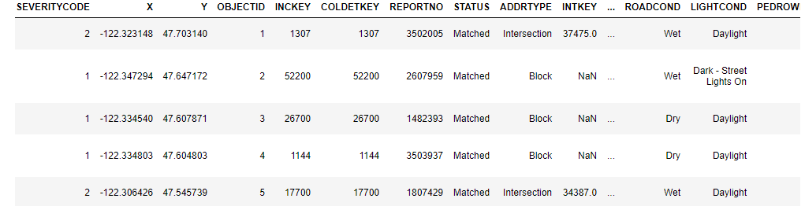

-How we will use the data
From the Data set we will isolate all the accidents that involve a car and a unicycle, bicycle, tricycle. We will try to find the relation between the collisions with light, weather, and road conditions. Also we will look at the location of the different accident and search for all possible correlation.

Data cleaning and data preparation
In order to clean or dataset our process will be really simple for this projects , there are several missing observations for differents variables in that dataset. We need to delete those variables which include ( lack of attention from both parties and speeding for example). Next, we select only the observations and the variables needed i.e, we only consider the collisions where a car hit a monocycle,bicycle and a tricycle.

Data understanding
At first, we need a map of Seattle where we going to plot every collisions where a cycle is involved.We are looking for a relation between the location and every collision, if the accidents are concentrated in some streets,a county….That way we could focalize in a point in particular and search for other correlation. We are looking where everything happened to understand why it happened.
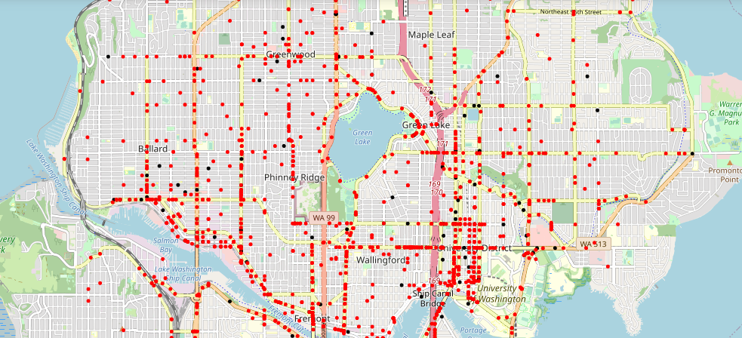
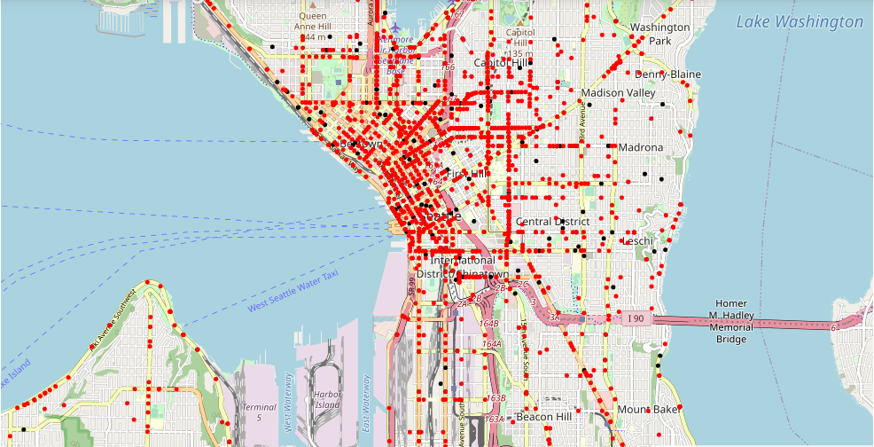

We find out the collisions are all over Seattle but there a huge concentration near Central District and there are also other areas with high concentration. We plot the accidents that resulted to an injury in red while the minor one are black. For a sample of 4626 observations(collisions), 88% ended with a injury and 12% are property damage. Therefore, we know that when a car hit a cycle in the city of Seattle more than 8 times out of 10,the city registered a new injury. Nonetheless, we have no information if there is a repetition of incident maybe there are just one time event, hence we need another plot that show where collisions are repeated.
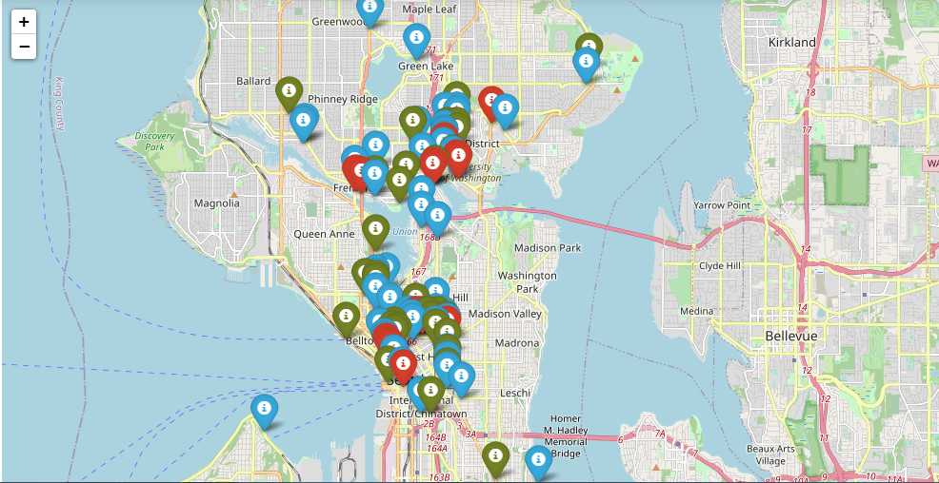
In red we have the location of collosions registered more than 10 times,in green a collision occurred more than 6 times but less than 9 and in blue we have collision happening 5 times in the same spot over the years. (We didn’t plot collision account less tan 5 times because we just consider 5 is the amount for which a special consideration in the area in question is necessary). With this map we have new informations; more accidents are in First Hill area specially in East Pine Street,2nd Avenue,12th Avenue and in The Northeast area we are talking about Roosevelt Way Northeast, University Way Northeast for example.
Now we know the location for must collisions we most search for the factors that caused them to begin with.

Relation between collision and weather condition

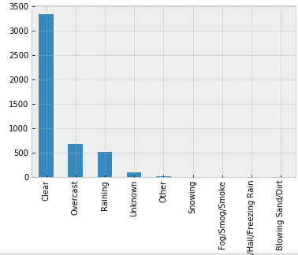

When the weather is bad there is usually less visibility that’s why every drivers are in the guard in those moments. But based on the dataset must incidents occurred when the weather was in perfect condition.There’s seems to be no reason at all that explained this amount of collisions if we considered the weather condition.

Relation between collision and road condition
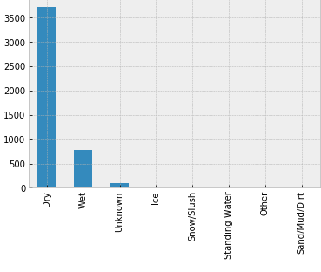
The road 8 times out of 10 weren’t wet so we can put aside slipping or any bad condition to explain the accidents.

Relation between collision and light condition
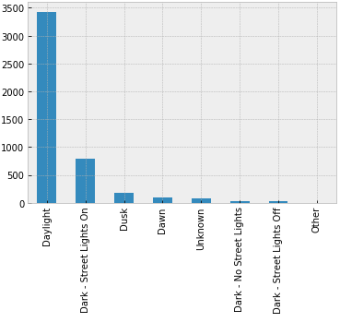
Again we can’t point out out the visibility to explain the accidents,yet we lacking information to estimate the cause of the collisions if they were due to a lack of attention and if the driver or the cyclist where under the influence of drugs or alcohol.Additionally, the dataset point out it wasn’t the fault of inattention either. The last thing remaining to check is the degree of congestion in the city, it might be possible, depending of the time of the day we could register more collision.

Relation between collision and time
Out of 4626 observation we have 4094 labeled data that indicate the time(morning and afternoon). 68% of the total (about 27788 collisions) happened in the afternoon while the rest (32%) are in the morning.Based on the data, you are 2 times more likely to have an accident riding a cycle in the afternoon in the city of Seattle than doing the same thing in the morning

Type of the locations
We just discover you have a higher probability to have an accident in the city of Seattle in the afternoon and we know where those accidents happened ,furthermore, we also have information about those locations. 57% of collisions (about 2637) occurred at an intersection while the rest at a block.

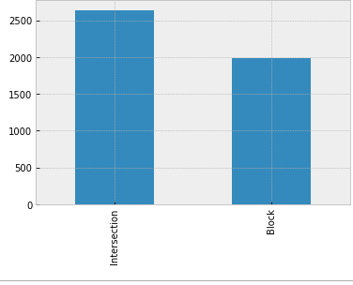
To end this project we just need a model that can predict the collisions and there severity

Modeling
We will build a KNN models based on 3 independents variable to predict the collions. The firsts variables are the latitude and the longitude and the last one is the type of the collision (if it is a intersection or a block). The type will be a dummy variable where intersection=1 and block=0
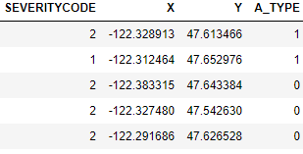
-We will have like to estimate the times in this model but we lacking information to convert into timespan.
For our model the number of neighbors K is the core deciding factor .It is a hyperparameter that you neeed to choose at the time of the modeling. Research has shown that no optimal number of neighbors suits all kind of data sets. Each dataset has it’s own requirements
Our first step is to divide the dataset in a training set that we can analyse and a test set for evaluation. Our test size will be 30% of the selected dataset. After we must find the neighbors with the higher accuracy.
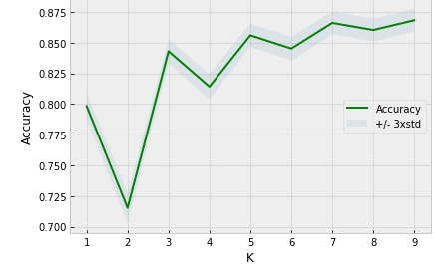
Then we construct our model

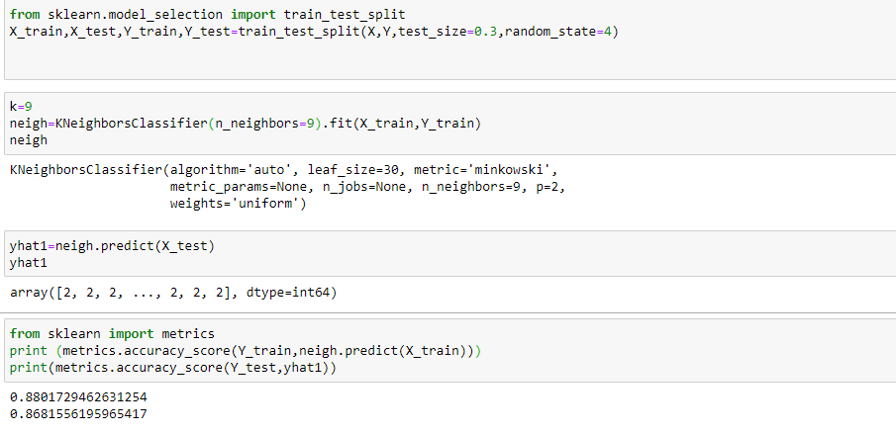

Result
The collisions are more related to the location than any other factors. They specially happened when the condition were perferct: daylight, road in good conditions and weather was nice.But we notice most of them occurred in the afternoon. We are missing to much data to make estimation with speed and lack of attention.Nonetheless,intersections represent a real danger for the cycles.

Discussion
We recommend to limit the circulation in the afternoon for any person riding a monocycle,bicyle,tricycle.Additionaly, we suggest the city block some streets from them such as East Pine Street,2nd Avenue,12th Avenue,Roosevelt Way Northeast.If that not possible, give them a exclusive access for a certain period of time. In that decision, our model with 86% accuracy can help predict future collision and there severity and prevent most of the accident given the location.

Conclusion
In our report about Seattle collision we discover how some factors affected the number of accident in that city. Two of them particularly, latitude and longitude, create a map where it possible to comprehend the gravity of the situation. That is the reason why we build a model with them at the center to evaluate and reduce those accidents. In the discussion panel, we offer some advices for the city to prevent them.

