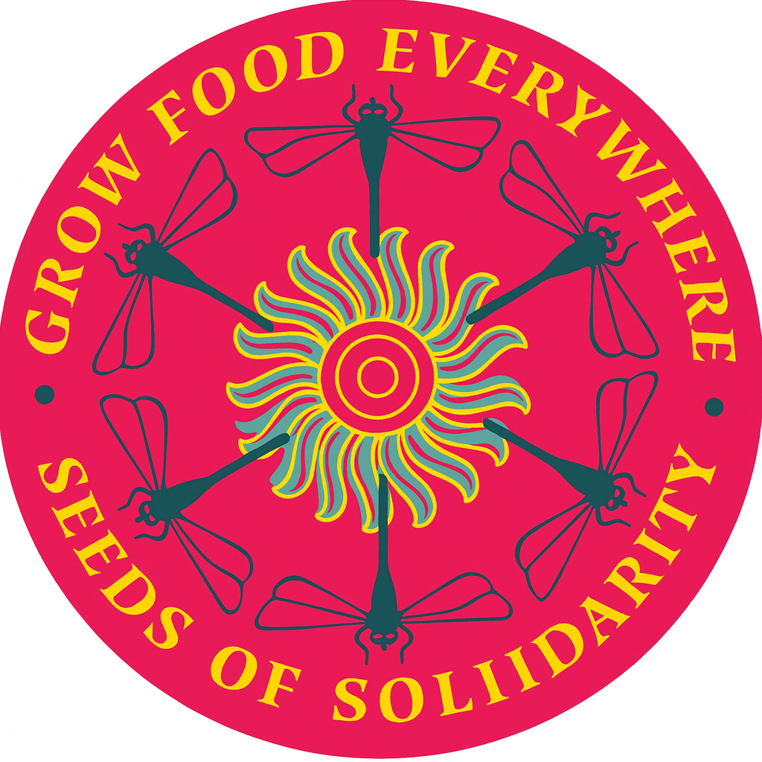

Seeds of Solidarity

INFO 2380 Website Development 2025 Fall

Web Development Case Study

Orlando Nico Rosario

10/26/2025

Table of Contents

**1.0 Introduction and Project Overview** 3

**2.0 Initial Site Analysis & Recommendations** 4

**3.0 Site Planning Documents** 6

**4.0 Development Process** 9

**5.0 Final Website Link** 10

**6.0 Reflection** 10

**1.0 Introduction and Project Overview**

Summary

Seeds of Solidarity is a nonprofit farm that specializes in educating people on sustainable agriculture practices based in Orange, MA. Created by Ricky Baruc and Deb Habib, the organization offers workshops and resources for individuals or groups interested in gardening, understanding soil health and using renewable energy. Seeds of Solidarity hosts events and agricultural festivals to celebrate harvests and where like- minded people come together to educate and share with one another. Hands on learning and practical skills development is the heart of this organization with self-sufficiency being at the core of the learner. Overall, Seeds of Solidary works to educate and empower new growers in their agricultural interests.

Target Audience

Seeds of Solidarity targets experienced and novice growers who want to expand on their skillset in the agricultural field. Seeds of Solidarity’s mission centers around ‘educating and empowering people in sustainable agriculture and renewable living’ expanding upon the theology of self sustainability with food and resources. Whether the audience is part of the community, students, educators, or families, everyone is called to ‘grow food everywhere’ while reducing waste and reconnecting with the land they live off of. Education is a core value of the organization with programs tailored to youth groups, activists, and educators. Additionally, there are women-only groups and justice related groups centered around global socio-political issues as well as human rights. As a nonprofit, Seeds of Solidarity relies heavily on donors and individuals to fund their work. Donors who value sustainability, justice, and community empowerment are called upon to look into the organization and see if their values are shared with those of Seeds of Solidarity.

Insights and Considerations

Understanding Seeds of Solidarity and their core values shaped the way the website was designed and developed. Maintaining a minimalistic, yet impactful website helps push the ‘go green’ narrative. Seeds is community driven, meaning that people and the community keep the organization going. To help visualize that, heavy emphasis is place onto becoming part of the community via their newsletters, programs, and media content. Giving back to the earth and reusing instead of wasting pushes a more maintainable, healthy future. A large issue with the old site was the overuse of plain text and unstructured information and media. This was taken into consideration and repaired upon within the project via the more balanced pages and looks.

**2.0 Initial Site Analysis and Recommendations**

Initial Analysis

Overall, the site seems poorly organized and orientated. Most of the page is center aligned making reading harder for the end user. Additionally, there is very hard to understand hierarchy with many different bolded areas and colored phrases. When skimming, way too many things stick out and this makes it harder for the reader to funnel their attention to the important parts of the page or what the creator deems most relevant.  
The page itself is majorly in the center of the screen, which allows easier reading and augmentation for mobile users (or split screen desktop users), however this makes pictures and bigger text blocks harder to correlate relevant text or photos. The large white text box at the bottom of the page is another identifier of poor development practices.

This website features a navigation toolbar at the top of the page with dropdowns for relevant or correlating pages on the website. This personally feels great and is a bit responsive with user hover however lacks transition and seems super abrupt. The homepage links, however, are scattered across the page and not in an organized manner which can delay or turn away a user from using a function on the site. There is a search bar at the top that automatically directs to relevant content however does not feature an indexed drop down that shows where you will go. This drops you into a ‘most-likely’ result, or ‘Nothing Found’ if none.

The homepage is halfway organized with cascades of relevant information being present but not organized in an efficient manner. With varying blocks of bold, colored, and regular print, it can be difficult to find the information you are looking for. This home page seems more of a public board for information presentation more than a structured web page. This can be beneficial for common users to get new information in their knowledge bases (their minds) but for new users is too much at once and can be very confusing.

All website content is contained with a fixed space that is centered to the screen. This is a quick and easy way to have dynamic site adjustability according to the user’s browser window or mobile applications. All links and toolbars function the same as well with no animations being present, so no bugs or display issues.

Recommendations for Change

Various aspects of the page can be improved upon to make the page easier to use and navigate for old and new users. To start, congregated links and paragraphs need to be organized throughout each page to set a standard hierarchy in play. Piggybacking off of that, headers and sub-headers need to be defined and designed properly throughout each page for easier navigation.

The use of containers that center all text and images to the center of the screen allows for easier read access to mobile device and adjusted browser tabs. The center aligned text makes all text harder to read and needs to be removed and/or realigned for proper site design. Photo collages make the website feel more comfortable and organized but congregating them to specific sections or one larger collage might be easier for end users.

**3.0 Site Planning Documents**

Site Maps

The Site Map was developed by congregating certain navigation fields into groups and labeling them accordingly. By doing so the congregated pages received drop downs with corresponding pages and lengthy titles were shortened. Education was changed to programs as it was more relating to all of the drop down elements.

Wireframes

These wireframes where developed with a simplistic user friendly design approach that made each interaction responsive and modern. By mixing the perfect amount of text with media and other content, users get a hearty, well rounded page that relays all information needed without being too text heavy. Media and hyperlink use is mostly consolidated to specific areas on each page to center certain information points that users can access.

Mockups

Each mockup design pattern used various greens and forest-y like color schemes to keep content consistent and clean. Each hue is balanced and relates to one another to have pages seem organized and brand colors set with specific vibes in place. Personally I believe that making your brand is important to site and organization success especially if they are customer facing, where all user interaction drives the effort.

**4.0 Development Process**

Over the course of the 5 or so weeks that we were tasked on developing our websites, mine specifically was a very fruitful process. I built a full structured site with 7 navigatable pages that were all interlinked and responsive. Ensuring that I used clean, semantic code and a heavily organized stylesheet, I was able to present my full website with a just as clean backend as the frontend. Each page has a consistent header, navigation bar, and footer for structured page flow. Its semantic structure used the proper tags for accessibility but mainly readability and organization.

The single stylesheet was well organized and labeled for backend readability and potential scalability. Grids and flexboxes kept layouts consistent across various display widths and ensured site responsiveness. I tried to make interactivity a big part of the site with media, cards, and buttons change or animate with clicks or hovers. A carousel was added for a media collage, a form for mailing list sign up, and embedded Google Maps, all making the site better for the end user. Alt text was added for accessibility and internal/external links used strategically across all pages.

Implementing the carousel and maintaining image grids consistently proved to be quite difficult (especially since I know very little JS) but nonetheless it was not impossible. By using chrome dev tools for the Google Maps integration, and stack overflow and general searches JS help I was able to get each of these aspects working effectively. By the end of Week 7 the entire site was operational, presentable, and accurately represents my design and development goals.

**5.0 Final Website Link**

Below is my landing home page that accesses the other pages via the main navigation.

<https://ceweb2.uml.edu/Orlando_Rosario1/SeedsOfSolidarity/home.html>

**6.0 Reflection**

Overall this whole process has been quite the ride. From learning basic design considerations and concepts to actually developing and deploying the website, there was a lot learned throughout the process.

One, I’m not a fan of JavaScript, still doesn’t make too much sense to me. I’d rather full stack a .NET web app with blazer instead but that’s also more application based than website based. Two, I’ve never been too creative so the design process was the hardest for me. Developing the wireframes took heavy reference from other modern page developments and wireframe examples. Three, I’m colorblind, specifically red-green colorblind and picking a ‘go green’ type of website and having to go through all those various color families was difficult in itself but luckily, I had resources at home to help me out with that. Lastly, the development process itself was fun. Fine tuning specific attributes and elements to match the wireframes was the easiest part to me, using percentages and various values (other than rem, still not clear on rem and em) to match the blueprint of the site was nice.

This was a great learning experience for me, and I will definitely be exploring creating my own website in the future, full stack with an actual purchased domain.