**Website Planning Document**

Local Weather Service

Author: Cassie White

**Site Purpose**

To deliver up-to-date and reliable weather information for the cities of Franklin, Greenville, and Springville

**Target Audience**

Local residence of these three cities age range from 18-80 in years. Specifically residence looking for storm alerts, summer heat updates, and daily weather updates for outdoor activities or travel trips.

**Site Map**

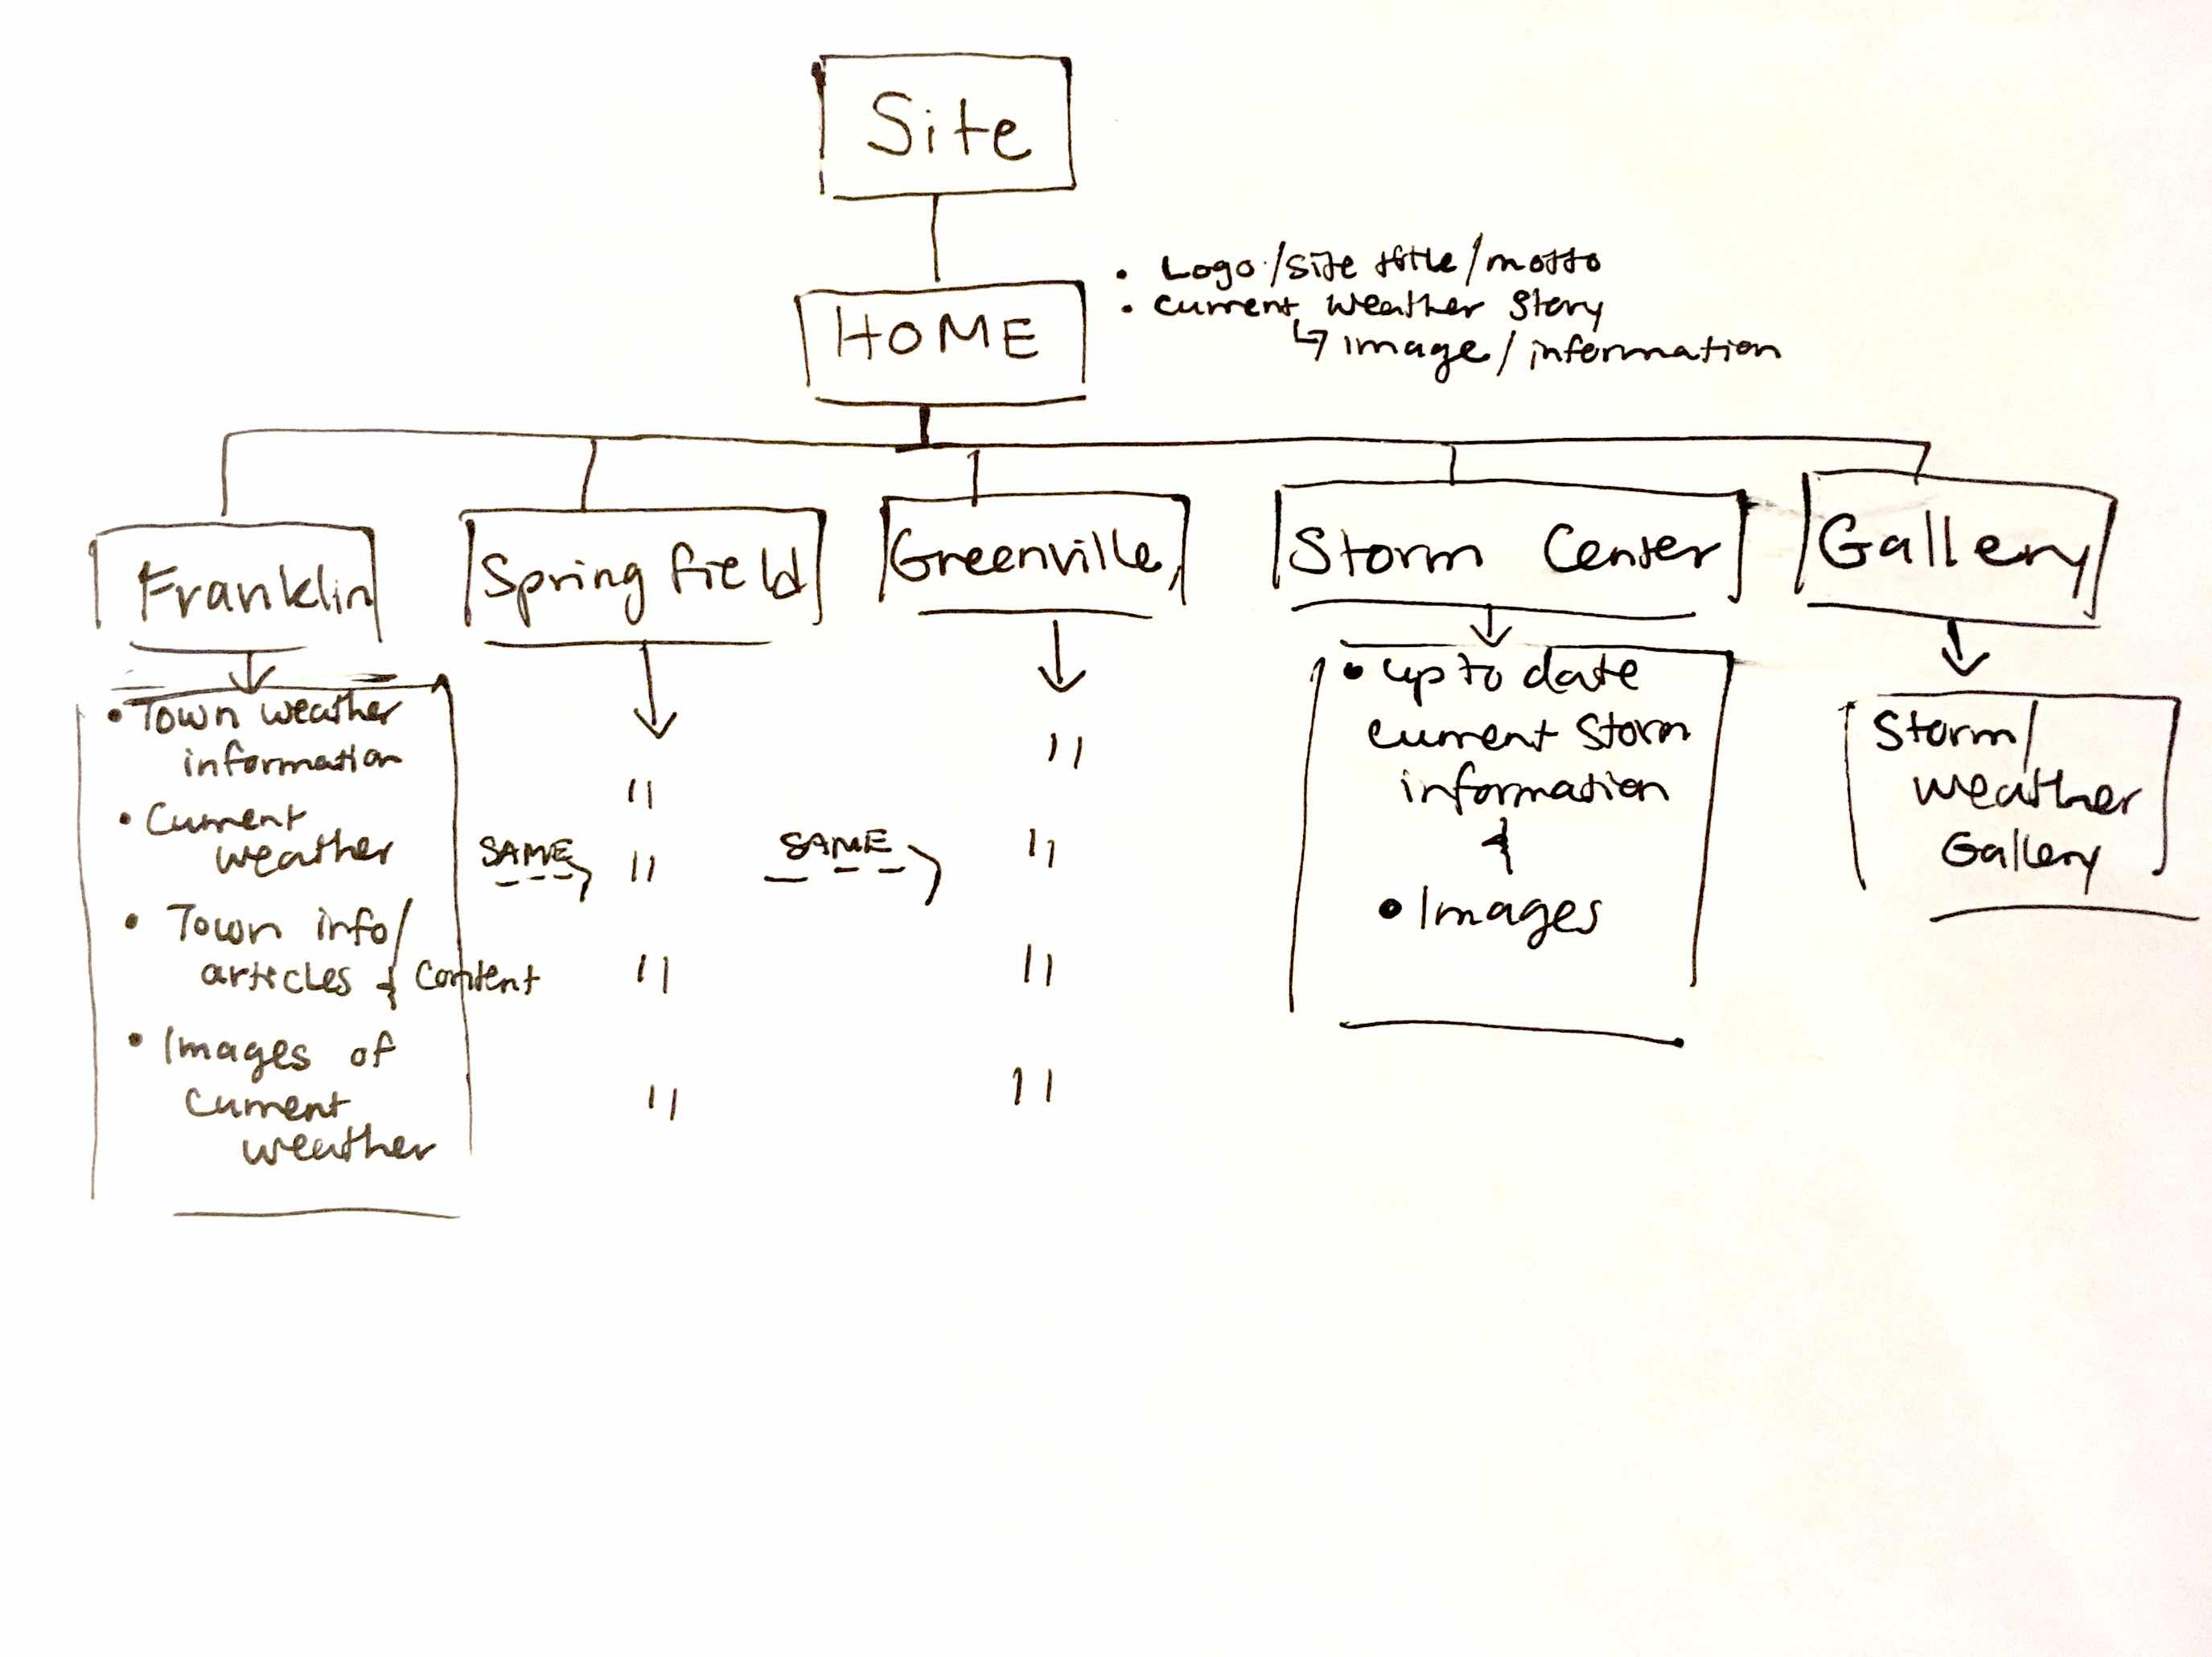

**Color Scheme**

Main Color: Navy Blue

Background: White

Text: Darker Blue

Headings: Deep Orange

Navigation: Gold

[Palette Color Link](http://paletton.com/palette.php?uid=33B0u0kkWkOaJvbg3pIpRfVvkaA)

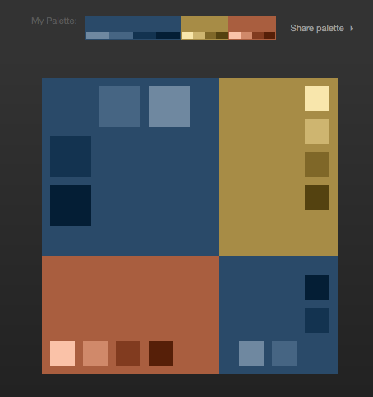

**Typography**

Headings:

Neue Haas Grotesk (San Serif)

Main Text:

Stempel Garamond (Serif)

**Wire-Frame Sketches**

Large-Wide Screen (Desktop)

Medium (Tablet)

Small (Smart Phone)