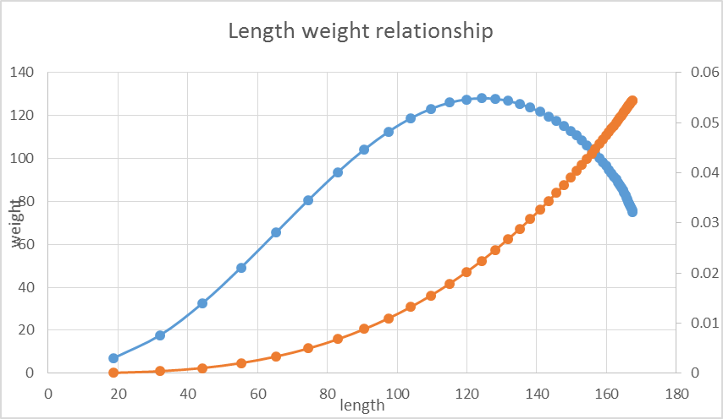
Orange = what it should be
Blue = output from the @report mean_weight
Note the difference in scale too

