1. Slides with 1 Product

* 1st Template

* 2nd Template

* 3rd Template

1. Slides with 2 Products

* 1st Template

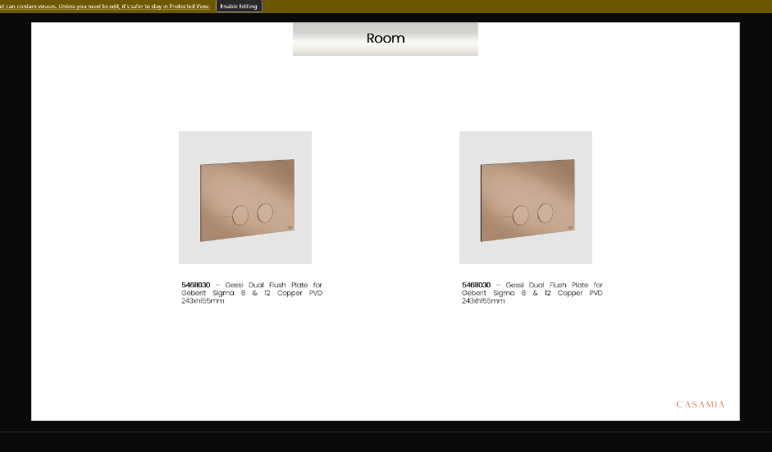

* 2nd Template

* 3rd Template

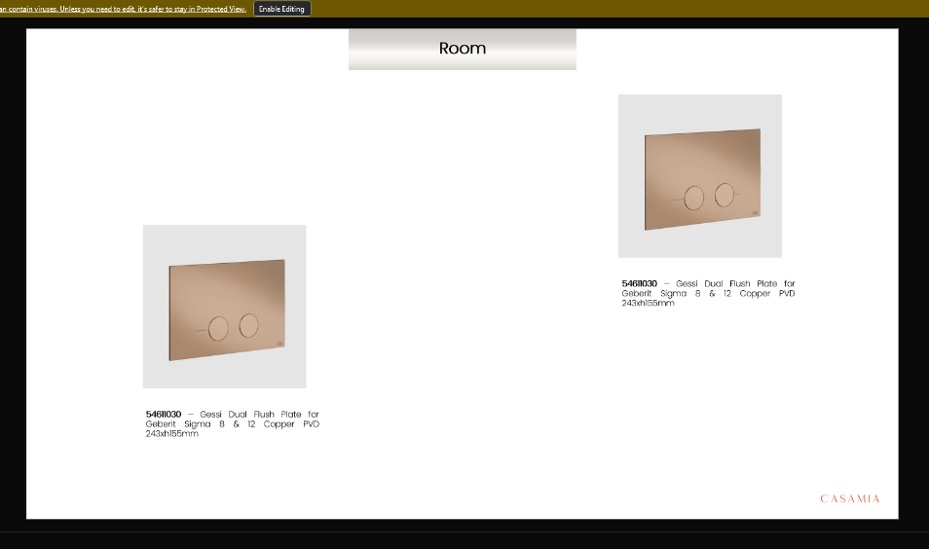

1. Slides with 3 Products

* 1st Template

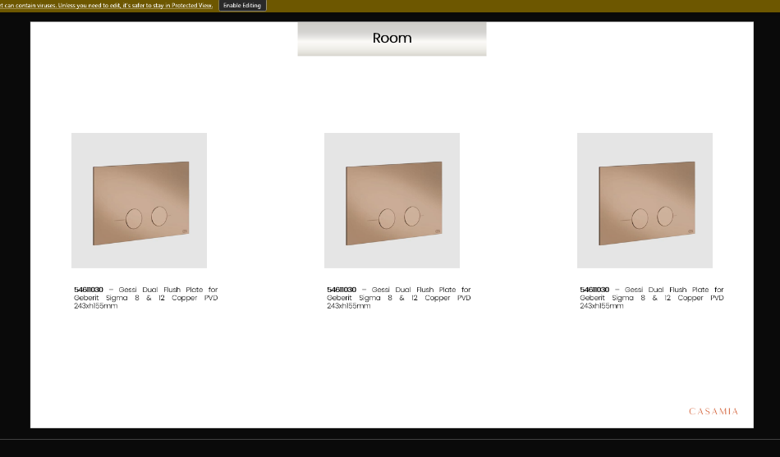

* 2nd Template

* 3rd Template

1. Slides with 4 Products

* 1st Template

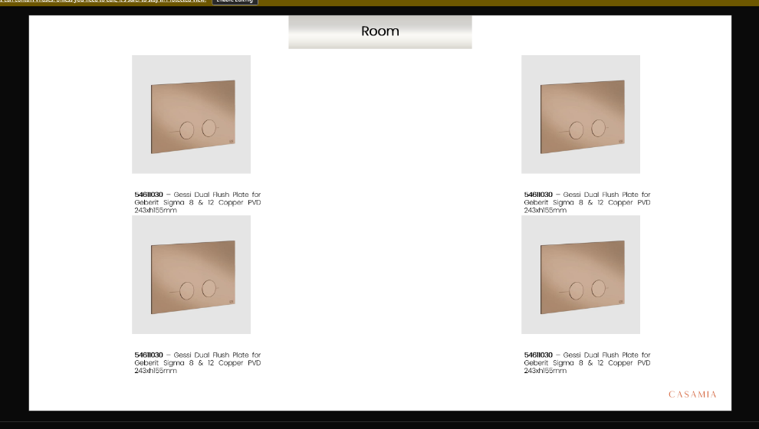

* 2nd Template

* 3rd Template

1. Slides with 5 Products

* 1st Template

* 2nd Template

1. Slides with 6 Products

* 1st Template

1. Slides with 7 Products

* 1st Template

