

International School

**Capstone Project 1**

CMU-SE 450

**Database Design**

**Version 1.2**

**Date: 20/10/2022**

**Craft Village Pollution Monitor System**

**Submitted by**

**Van Cong Le Ca**

**Hua Hoang Phuc**

**Nguyen Thanh Trung**

**Bui Duc huy**

**PROJECT INFORMATION**

|  |  |  |  |
| --- | --- | --- | --- |
| **Project acronym** |  | | |
| **Project Title** |  | | |
| **Start Date** |  | **End Date** |  |
| **Lead Institution** | International School, Duy Tan University | | |
| **Project Mentor** |  | | |
| **Scrum master / Project Leader & contact details** |  | | |
| **Partner Organization** |  | | |
| **Project Web URL** |  | | |
| **Team members** | Name | Email | Tel |
|  |  |  |  |
|  |  |  |  |
|  |  |  |  |
|  |  |  |  |
|  |  |  |  |

REVISION HISTORY

| **Version** | **Date** | **Comments** | **Author** | **Approval** |
| --- | --- | --- | --- | --- |
| 1.0 | 18/09/2022 | Create location entities | Hua Hoang Phuc | Hua Hoang Phuc |
| 1.1 | 02/10/2022 | Create user system | Hua Hoang Phuc | Hua Hoang Phuc |
| 1.2 | 20/10/2022 | Create survey system | Hua Hoang Phuc | Hua Hoang Phuc |

**Document Approval**

The following signatures are required for approval of this document

|  |  |  |
| --- | --- | --- |
| (name) *Mentor* |  | Date: |
| (name) *Team member* |  | Date: |
| *Team member* |  | Date: |
| *Team member* |  | Date: |
| *Team member* |  | Date: |
| *Team member* |  | Date: |

Contents

1. Introduction: 6

1.1. Purpose: 6

1.2. Goal: 6

1.3. Scope: 6

1.4. Definitions, Acronyms and Abbreviations: 7

2. Database Design for Sprint 1: 7

2.1. Table Overview: 7

2.2. Entity Relationship Diagram: 8

2.3. Table Relationship Diagram: 9

2.4. Detail 9

3. Database Design for Sprint 2: 11

3.1. Table Overview: 11

3.2. Entity Relationship Diagram: 12

3.3. Table Relationship Diagram: 13

3.4. Detail 14

4. Database Design for Sprint 3: 20

4.1. Table Overview: 20

4.2. Entity Relationship Diagram: 22

4.3. Table Relationship Diagram: 23

4.4. Detail 24

5. Database design for sprint 4 30

5.1. Table Overview 30

5.2. Entity Relationship Diagram 32

5.3. Table Relationship Diagram 32

5.4. Detail 33

6. Database design for sprint 5 40

6.1. Table Overview 40

6.2. Entity Relationship Diagram: 41

6.3. Table Relationship Diagram: 42

6.4. Detail 43

1. **Introduction:**
   1. **Purpose:**

Place information system’s database design document describes structure of database and file structure of system. Database Design document will introduce all attribute the System that will help developer and tester base on this design to implement and test.

* 1. **Goal:**

To create database tables most accurate.

* 1. **Scope:**
* This Database Design Document provides the basic for “Craft Village Pollution Monitor System” Database design.
* It defines the database that will support the “Craft Village Pollution Monitor System” Data Model.
* It describes both logical and physical definition, non-functional issues, and the database interfaces; storage aspects are defined in the physical database design sections.
* The following topics are covered in this document:
* Assumptions and decisions on database design.
* Entity-mapping.
* Table column definitions.
* Primary, unique and foreign key definitions.
* Column and row level validation rules (check constraints).
* Rule for populating specific columns (sequences, derivations, demoralized (column)).
* Interfaces and dependencies with other components.
* Data access description.
* The database design for “Craft Village Pollution Monitor System” is composed of definitions for database objects derived by mapping entities to tables attributes to columns, unique identifiers to unique keys and relationship to foreign keys.
* During design, these initial definitions are enhanced to support the functionality described in the functional specification/ user stories and defined in the primary and supporting modules of the application high level design.
  1. **Definitions, Acronyms and Abbreviations:**

|  |  |  |
| --- | --- | --- |
| **Abbreviations** | **Description** | **Comment** |
| PK/FK | Primary/ Foreign Key | Use to indicate a file is a Primary or Foreign key in a table |
| ERD | Entity Relationship Diagram | Show the relationship between entities in the system |
| Auto | Auto increment | Auto increment |

1. **Database Design for Sprint 1:**
   1. **Table Overview:**

|  |  |  |
| --- | --- | --- |
| **No** | **Table name** | **Short Description** |
| 1 | AD_COUNTRY | This table contains the information about countries. |
| 2 | AD_PROVINCE | This table contains the information about provinces |
| 3 | AD_DISTRICT | This table contains the information about districts |
| 4 | AD_WARD | This table contains the information about wards |
| 5 | VILLAGE | This table contains the information about craft villages. |

* 1. **Entity Relationship Diagram:**

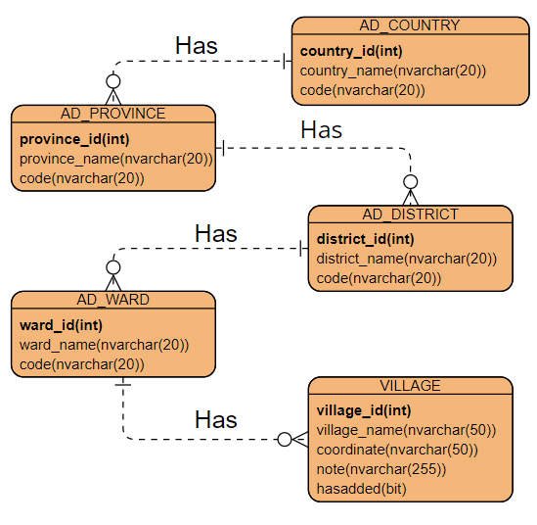

* 1. **Table Relationship Diagram:**

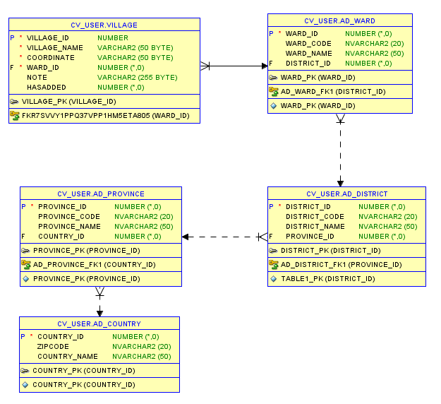

* 1. **Detail**
     1. **AD_COUNTRY**

**This includes the attribute:**

|  |  |  |  |  |  |
| --- | --- | --- | --- | --- | --- |
| **Attributes** | **Datatype** | **Null** | **Key** | **Default** | **Extra** |
| Country_id | int | Not | PK |  | Auto |
| Country_name | nvarchar(50) | Not |  |  |  |
| code | nvarchar(20) | Allow |  |  |  |

* + 1. **AD_PROVINCE**

**This includes the attribute:**

|  |  |  |  |  |  |
| --- | --- | --- | --- | --- | --- |
| **Attributes** | **Datatype** | **Null** | **Key** | **Default** | **Extra** |
| Province_id | Int | Not | PK |  | Auto |
| Province_name | nvarchar(50) | Not |  |  |  |
| code | nvarchar(20) | Allow |  |  |  |
| Country_id | Int | Not | FK |  |  |

* + 1. **AD_DISTRICT**

**This includes the attribute:**

|  |  |  |  |  |  |
| --- | --- | --- | --- | --- | --- |
| **Attributes** | **Datatype** | **Null** | **Key** | **Default** | **Extra** |
| District_id | Int | Not | PK |  | Auto |
| District_name | Nvarchar(50) | Not |  |  |  |
| Code | Nvarchar(20) | Allow |  |  |  |
| Province_id | Int | Not | FK |  |  |

* + 1. **AD_WARD**

**This includes the attribute:**

|  |  |  |  |  |  |
| --- | --- | --- | --- | --- | --- |
| **Attributes** | **Datatype** | **Null** | **Key** | **Default** | **Extra** |
| ward_id | Int | Not | PK |  | Auto |
| ward_name | Nvarchar(50) | Not |  |  |  |
| Code | Nvarchar(20) | Allow |  |  |  |
| district_id | Int | Not | FK |  |  |

* + 1. **VILLAGE**

**This includes the attribute:**

|  |  |  |  |  |  |
| --- | --- | --- | --- | --- | --- |
| **Attributes** | **Datatype** | **Null** | **Key** | **Default** | **Extra** |
| village_id | Int | Not | PK |  | Auto |
| village_name | Nvarchar(50) | Not |  |  |  |
| Coordinate | Nvarchar(50) | Not |  |  |  |
| Note | Nvarchar(255) | Allow |  |  |  |
| Hasadded | Bit | Not |  | 0 |  |
| ward_id | Int | Not | FK |  |  |

1. **Database Design for Sprint 2:**
   1. **Table Overview:**

|  |  |  |
| --- | --- | --- |
| **No** | **Table name** | **Short Description** |
| 1 | UR_USER | This table shows all information of user |
| 2 | UR_ROLE | This table contains the roles |
| 3 | USER_ROLE | This table shows the roles of users |
| 4 | UR_SESSION | This table saves the sessions |

* 1. **Entity Relationship Diagram:**

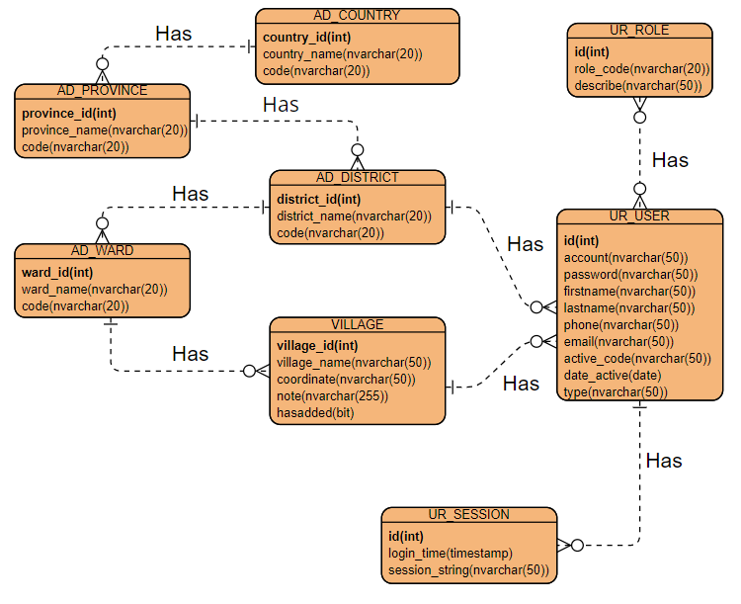

* 1. **Table Relationship Diagram:**

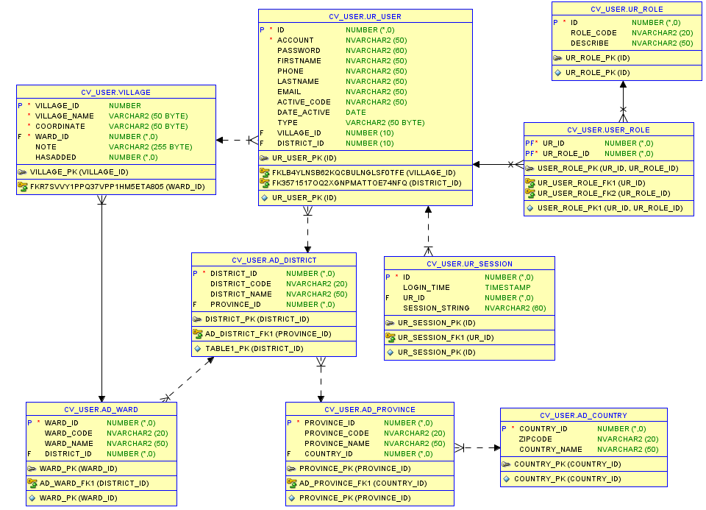

* 1. **Detail**
     1. **UR_USER**

**This includes the attribute:**

|  |  |  |  |  |  |
| --- | --- | --- | --- | --- | --- |
| **Attributes** | **Datatype** | **Null** | **Key** | **Default** | **Extra** |
| Id | int(11) | Not | PK |  | Auto |
| Account | Nvarchar(50) | Not |  |  |  |
| password | Nvarchar(50) | Not |  |  |  |
| Firstname | Nvarhcar(50 | Not |  |  |  |
| Lastname | Nvarchar(50) | Not |  |  |  |
| Phone | Nvarchar(50) | Not |  |  |  |
| Active_code | Nvarchar(50) | Not |  |  |  |
| Date_active | Timestamp | Not |  |  |  |
| District_id | Int | Allow | FK |  |  |
| Village_id | Int | Allow | FK |  |  |

* + 1. **UR_ROLE**

**This includes the attribute:**

|  |  |  |  |  |  |
| --- | --- | --- | --- | --- | --- |
| **Attributes** | **Datatype** | **Null** | **Key** | **Default** | **Extra** |
| Id | int | Not | PK |  | Auto |
| Role_code | Nvarchar(20) | Not |  |  |  |
| Describe | Nvarchar(50) | Allow |  |  |  |

* + 1. **USER_ROLE**

**This includes the attribute:**

|  |  |  |  |  |  |
| --- | --- | --- | --- | --- | --- |
| **Attributes** | **Datatype** | **Null** | **Key** | **Default** | **Extra** |
| Ur_id | Int | Not | PK, FK |  |  |
| Ur_role_id | Int | Not | PK, FK |  |  |

* + 1. **UR_SESSION**

**This includes the attribute:**

|  |  |  |  |  |  |
| --- | --- | --- | --- | --- | --- |
| **Attributes** | **Datatype** | **Null** | **Key** | **Default** | **Extra** |
| Id | Int | Not | PK |  | Auto |
| Login_time | Timestamp | Not |  |  |  |
| Session_string | Nvarchar(50) | Not |  |  |  |
| Ur_id | Int | Not | FK |  |  |

1. **Database Design for Sprint 3:** 
   1. **Table Overview:**

|  |  |  |
| --- | --- | --- |
| **No** | **Table name** | **Short Description** |
| 1 | TEMP_VILLAGE | This table saves temp village data |
| 2 | USER_SURVEY | This table contains the role of admin in website |
| 3 | SR_IMG | This table contains info of image |
| 4 | SR_ACTIVE | This table contains active campaign |
| 5 | SR_SURVEY | This table contains campaign |
| 6 | SR_SURVEY_QUESTION | This table contains the questions |
| 7 | SR_SURVEY_QUESTION_ANSWER | This table contains the answers |

* 1. **Entity Relationship Diagram:**

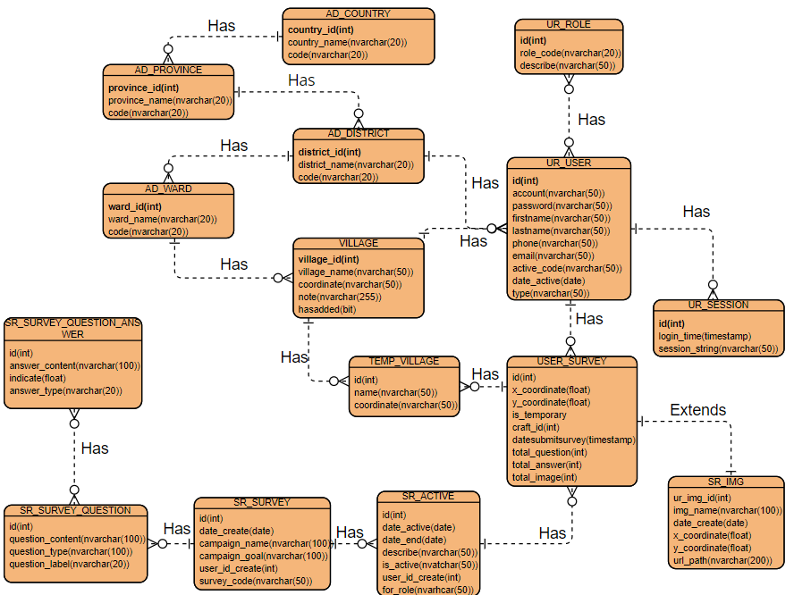

* 1. **Table Relationship Diagram:**

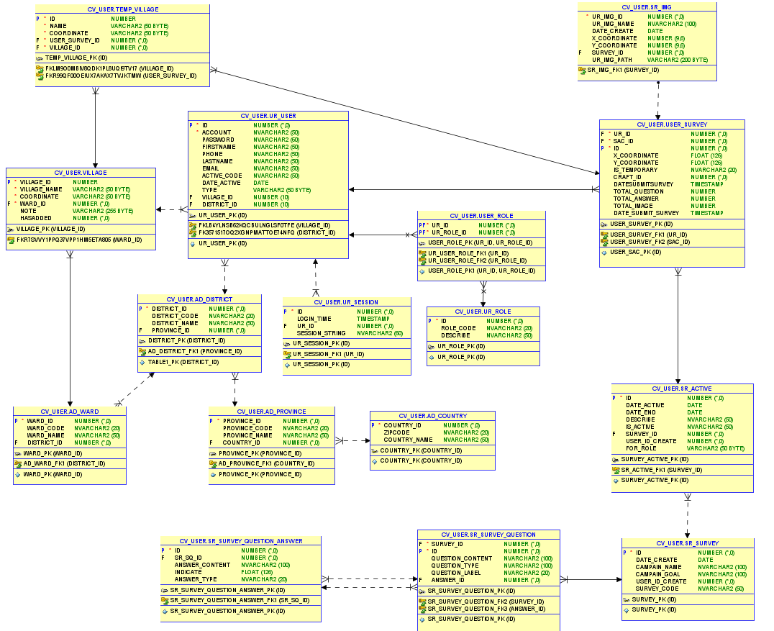

* 1. **Detail** 
     1. **TEMP_VILLAGE**

**This includes the attribute:**

|  |  |  |  |  |  |
| --- | --- | --- | --- | --- | --- |
| **Attributes** | **Datatype** | **Null** | **Key** | **Default** | **Extra** |
| id | int | Not | PK |  | Auto |
| name | varchar(50) | Not |  |  |  |
| coordinate | varchar(50) | Not |  |  |  |
| User_survey_id | int | Not | FK |  |  |
| Village_id | Int | Not | FK |  |  |

* + 1. **USER_SURVEY**

**This includes the attribute:**

|  |  |  |  |  |  |
| --- | --- | --- | --- | --- | --- |
| **Attributes** | **Datatype** | **Null** | **Key** | **Default** | **Extra** |
| Id | Int | Not | PK |  | Auto |
| X_coordinate | float | Not |  |  |  |
| Y_coordinate | Float | Not |  |  |  |
| Is_temporary | Nvarchar(20) | Not |  |  |  |
| Craft_id | Int | Not |  |  |  |
| Datesubmitsurvey | Date | Not |  |  |  |
| Total_question | Int | Not |  |  |  |
| Total_answer | Int | Not |  |  |  |
| Total_image | Int | Not |  |  |  |
| Ur_id | Int | Not | FK |  |  |
| Sac_id | Int | Not | FK |  |  |

* + 1. **SR_IMG**

**This includes the attribute:**

|  |  |  |  |  |  |
| --- | --- | --- | --- | --- | --- |
| **Attributes** | **Datatype** | **Null** | **Key** | **Default** | **Extra** |
| Ur_img_id | Int | Not | PK |  | Auto |
| Ur_img_name | Nvarchar(100) | Not |  |  |  |
| Date_create | Date | Not |  |  |  |
| X_coordinate | Float | Not |  |  |  |
| Y_coordinate | Float | Not |  |  |  |
| Ur_img_path | Varchar(200) | Not |  |  |  |
| Survey_id | Int | Not | FK |  |  |

* + 1. **SR_ACTIVE**

**This includes the attribute:**

|  |  |  |  |  |  |
| --- | --- | --- | --- | --- | --- |
| **Attributes** | **Datatype** | **Null** | **Key** | **Default** | **Extra** |
| id | Int | Not | PK |  | Auto |
| Date_active | Date | Not |  |  |  |
| Date_end | Date | Not |  |  |  |
| Describe | Nvarchar(50) | Not |  |  |  |
| Is_active | Nvarchar(50) | Not |  |  |  |
| User_id_create | Int | Not |  |  |  |
| For_role | Varchar(50) | Not |  |  |  |
| Survey_id | Int | Not | FK |  |  |

* + 1. **SR_SURVEY**

**This includes the attribute:**

|  |  |  |  |  |  |
| --- | --- | --- | --- | --- | --- |
| **Attributes** | **Datatype** | **Null** | **Key** | **Default** | **Extra** |
| id | Int | Not | PK |  | Auto |
| Date_create | Date | Not |  |  |  |
| Campaign_name | Nvarchar(100) | Not |  |  |  |
| Campaign_goal | Nvarchar(100) | Not |  |  |  |
| User_id_create | Int | Not |  |  |  |
| Survey_code | Nvarchar(50) | Not |  |  |  |

* + 1. **SR_SURVEY_QUESTION**

**This includes the attribute:**

|  |  |  |  |  |  |
| --- | --- | --- | --- | --- | --- |
| **Attributes** | **Datatype** | **Null** | **Key** | **Default** | **Extra** |
| id | Int | Not | PK |  | Auto |
| Question_content | Nvarchar(100) | Not |  |  |  |
| Question_type | Nvarchar(100) | Not |  |  |  |
| Question_label | Nvarchar(20) | Not |  |  |  |
| Survey_id | Int | Not | FK |  |  |
| Answer_id | Int | Not | FK |  |  |

* + 1. **SR_SURVEY_QUESTION_ANSWER**

**This includes the attribute:**

|  |  |  |  |  |  |
| --- | --- | --- | --- | --- | --- |
| **Attributes** | **Datatype** | **Null** | **Key** | **Default** | **Extra** |
| id | Int | Not | PK |  | Auto |
| Answer_content | Nvarchar(100) | Not |  |  |  |
| Answer_type | Nvarchar(20) | Not |  |  |  |
| Indicate | Float | Not |  |  |  |
| Sr_sq_id | Int | Not | FK |  |  |