

International School

**Capstone Project 1**

CMU-SE 450/CMU-IS 450/CMU-CS450

**Architecture Design**

**Version 1.1**

**Date: 20/10/2022**

**Craft Village Pollution Monitor System**

**Submitted by**

**Van Cong Le Ca**

**Hua Hoang Phuc**

**Nguyen Thanh Trung**

**Bui Duc huy**

**PROJECT INFORMATION**

|  |  |  |  |
| --- | --- | --- | --- |
| **Project acronym** | CVPMS | | |
| **Project Title** | Craft Village Pollution Monitor System | | |
| **Start Date** | 22/08/2022 | **End Date** | 07/12/2022 |
| **Lead Institution** | International School, Duy Tan University | | |
| **Project Mentor** | Ph.D. Thanh Binh, Nguyen | | |
| **Scrum master / Project Leader & contact details** | Ca, Van Cong Le  *Email:* cascabusiness@gmail.com  *Tel:* 0352707895 | | |
| **Partner Organization** |  | | |
| **Project Web URL** |  | | |
| **Team members** | **Name** | **Email** | **Tel** |
| 25211207666 | Ca, Van Cong Le | [cascabusiness@gmail.com](http://cascabusiness@gmail.com) | 0352707895 |
| 25211215894 | Huy, Bui Duc | [duchuyltt122@gmail.com](http://duchuyltt122@gmail.com) | 0818648090 |
| 25211204084 | Phuc, Hua Hoang | [phuchuho0402@gmail.com](http://phuchuho0402@gmail.com) | 0905639682 |
| 25211215133 | Trung, Nguyen Thanh | [nguyenttrung2601@gmail.com](http://nguyenttrung2601@gmail.com) | 0774496838 |

DOCUMENT NAME

|  |  |  |  |
| --- | --- | --- | --- |
| **Document Title** | Architecture Document | | |
| **Author(s)** | All team members | | |
| **Date** | 17/10/2022 | **File Name** | C1SE.06_Architecture_v1.1.docx |

**REVISION HISTORY**

| **Version** | **Date** | **Comments** | **Author** | **Approval** |
| --- | --- | --- | --- | --- |
| 1.0 | 21/08/2022 | Initial Release | All team members |  |
| 1.1 | 17/10/2022 | Update C&C, Module View diagrams | Huy |  |
|  |  |  |  |  |

**Document Approval**

|  |  |  |
| --- | --- | --- |
| Ph.D. Thanh Binh, Nguyen *Mentor* |  | Date: |
| Ca, Van Cong Le *Team member* |  | Date: |
| Huy, Bui Duc *Team member* |  | Date: |
| Phuc, Hua Hoang *Team member* |  | Date: |
| Trung, Nguyen Thanh *Team member* |  | Date: |

Contents

1. Introduction 6

1.1 Purpose 6

2. Project Overview 6

2.1 Business needs 6

2.2 Proposed solution 6

2.3 Business drivers 6

2.4 Project goal 7

3. Architectural drivers 8

3.1 Functional requirements 8

3.2 Business constraints 9

3.3 Technical constraints 9

3.4 Quality Attribute 9

3.5 Contex Diagram 12

4. C&C view 12

5. Module view 14

6. Allocation view 15

1. **Introduction** 
   1. **Purpose**

This document will cover the following information:

* Brief description of the project (project overview, business goals, general constrains about technical and business problems).
* Architectural drivers (functional requirements, quality attributes and constraints).
* Architectural design (C&C View type, Module View type, Allocation View type).

1. **Project Overview** 
   1. **Business needs**

* Desiring to help people have more awareness of pollution from craft villages, a system that will allow people to submit data of craft village and keep track its pollution status.
* A system that will provide the user the abilities such as take a survey, include the image of the pollution, view survey history, etc.
* An AI system will also provide the application to analyze the pollution based on the user's provided image.
* The system should also give the administrator the ability to manage their user and data.
  1. **Proposed solution**

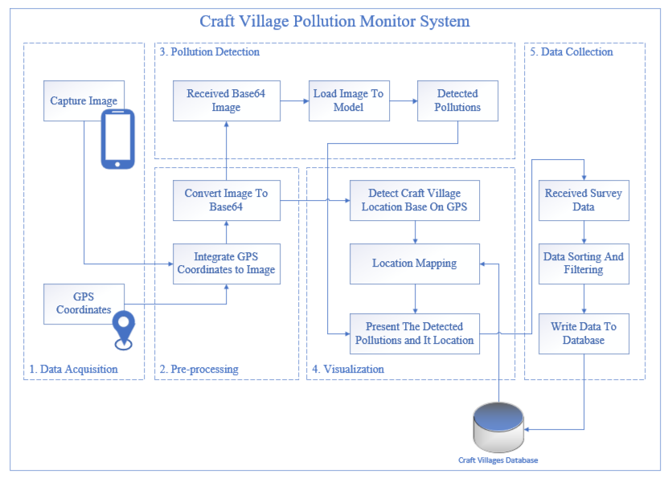

**Figure 2.2.** *Craft Village Pollution Monitor System*

Our team will wrap around the above problems and help everyone monitor and resolve the pollution problems from their craft village area more effectively. Some aspects that will make our system that the people will find much more effective:

* Our system will help everyone to monitor your local craft village despite where your location. This means whether you stay in a big city or a small village at the top of the mountain our system will still function.
* Our system will provide a function that lets people make an instant report to the local environment department.
* Our system will detect all kinds of pollution instead of focusing on some specific kinds. This will help to collect a variety of data that could help people to a bigger picture about their pollution levels in the area.
* Our system will have an AI that will take images from people then analyzes the image to know what kind of pollution the user is facing and the result will be automatically filled into the form which will be sent directly to the local environment department to resolve the problem. This is so easy to use that even an elementary school child can do and it also reduces a massive amount of the cumbersome and bureaucratic process that people have to go through.
* Our system is also integrated with location-based technology to detect the location of the pollution and layout the data on the map for the user to monitor.
  1. **Business drivers**

Based on the business needs and business solution our team decides to make a Craft Village Pollution Monitor System.

* 1. **Project goal**

The goal of the project is to build a Craft Village Pollution Monitor System (CVPMS) within the budget of $5000 and deliver on time by the end of December of 2022.

1. **Architectural drivers** 
   1. **Functional requirements**

|  |  |  |
| --- | --- | --- |
| Functional ID | Functional Name | Description |
| 01 | Login | Use username/password to login into the system, can use the function of the system. |
| 02 | Logout | Use logout the system after final work, to security information. |
| 03 | Register | Use register myself an account |
|  |  |  |
|  |  |  |
|  |  |  |
|  | Delete information customer | Admin will ban any the information of user, so that when user violate the terms in “Term of service” page. |

* 1. **Business constraints**
* Project begins from Aug 22nd, 2022 to Dec 07th, 2018. After delivery, the team will rectify defects in the deliverable (no additional functionalities or features).
* Resource availability is defined below: 22/08 – 07/12 with 4 members.
* Product follows Mentor's requirement.
  1. **Technical constraints**
* **Technical to develop**
  + Language: Java (Spring Boot), Dart (Flutter), Python (Flask, FastAI)
  + Develop tool: Visual Studio Code, SpringToolSuite4
  + Version Control System: Git/GitHub
  + Database Management System: Oracle SQL Developer
* **Environment**
  + Operation systems: Microsoft Windows, MacOS, Android, iOS
  1. **Quality Attribute**

|  |  |
| --- | --- |
| **Scenario** | **A1** |
| **Attribute concern** | **Downtime of system** |
| **Description** | The operating time of the system should be 95% to have time for backup data, maintenance and repair. |
| **Source** | Internal to system |
| **Stimulus** | System pause |
| **Artifact** | System |
| **Environment** | The system works normally |
| **Response** | Be temporarily unavailable while backup data, maintenance and repair are being effected |
| **Response Measure** | Uptime of the system should be 95%, downtime is about 1.2 hours per day |

**Table 3.4.1.** *Quality Attributes: Availability*

|  |  |
| --- | --- |
| **Scenario** | **P2** |
| **Attribute concern** | **The latency of initiating transactions** |
| **Description** | Users initiate transactions under normal operations. The system processes the transactions with latency less than 5 seconds. |
| **Source** | Users |
| **Stimulus** | Initiate transactions |
| **Artifact** | System |
| **Environment** | Under normal operations |
| **Response** | Transactions are processed |
| **Response Measure** | With latency less than 5 seconds |

**Table 3.4.2.** *Quality Attributes: Performance*

|  |  |
| --- | --- |
| **Scenario** | **P3** |
| **Attribute concern** | **The throughput of the system** |
| **Description** | At peak load, the system is able to complete 100 normalized transactions per second. |
| **Source** | Internal to system |
| **Stimulus** | Multiple transactions at the same time |
| **Artifact** | System |
| **Environment** | Peak load |
| **Response** | Throughput |
| **Response Measure** | Throughput is 100 transactions per second |

**Table 3.4.3.** *Quality Attributes: Performance*

|  |  |
| --- | --- |
| **Scenario** | **U4** |
| **Attribute concern** | **Using effectively** |
| **Description** | Craft Village Pollution Monitor can be easy for end-users to create a report after 10 minutes using. |
| **Source** | End-users |
| **Stimulus** | Create a report |
| **Artifact** | System |
| **Environment** | The system work normally |
| **Response** | Easy to use |
| **Response Measure** | Easy to use after 10 minutes using |

**Table 3.4.4.** *Quality Attributes: Usability*

* 1. **Context Diagram**

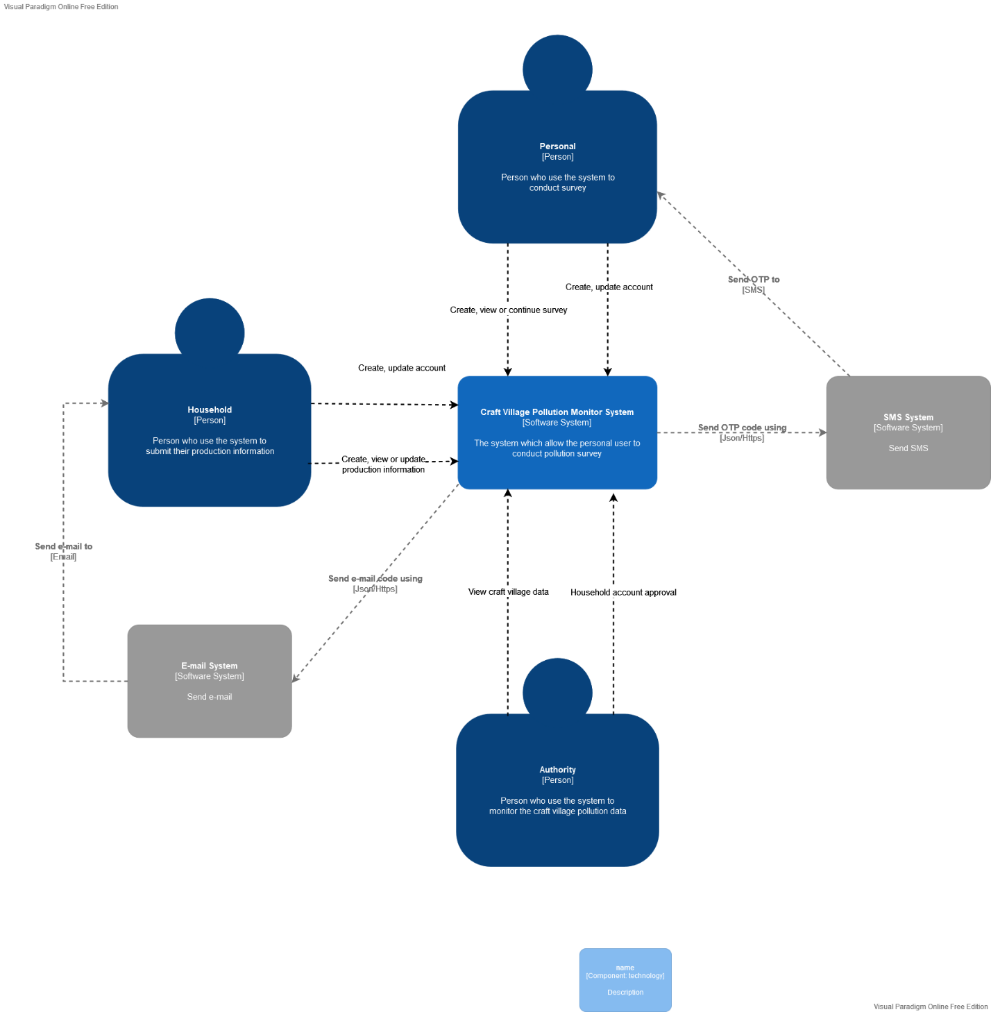

**Figure 3.5.1.** System Context Diagram Overview

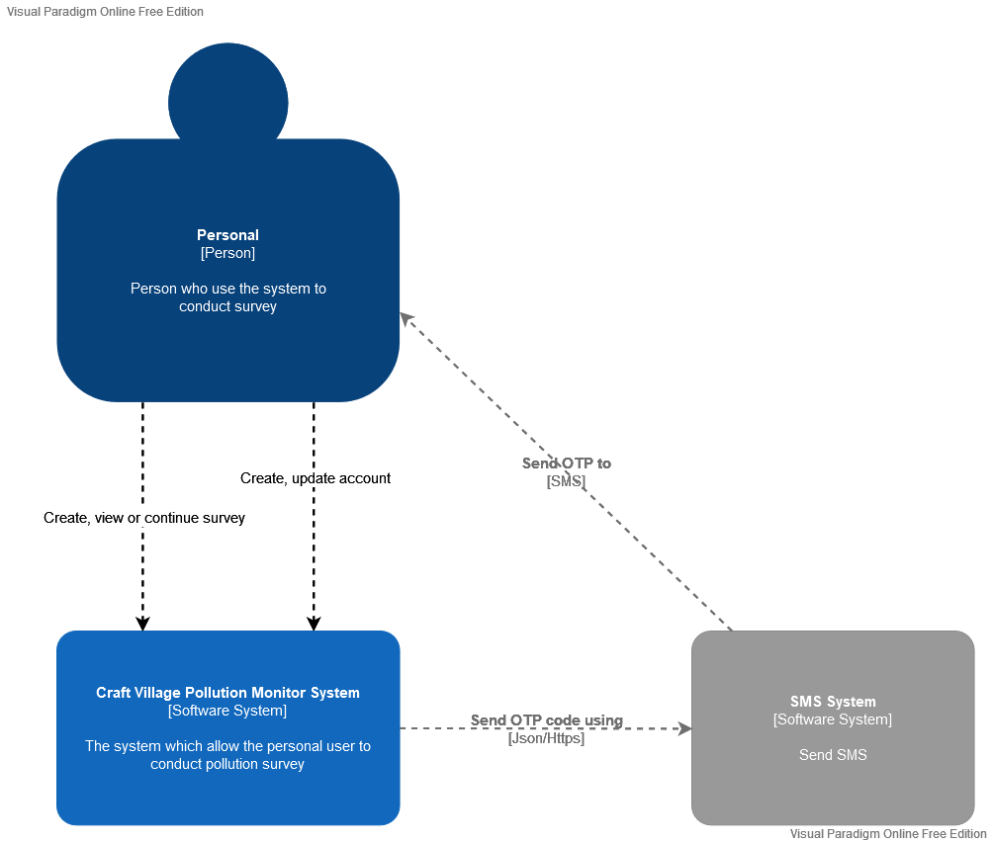

**Figure 3.5.2.** Personal System Context Diagram

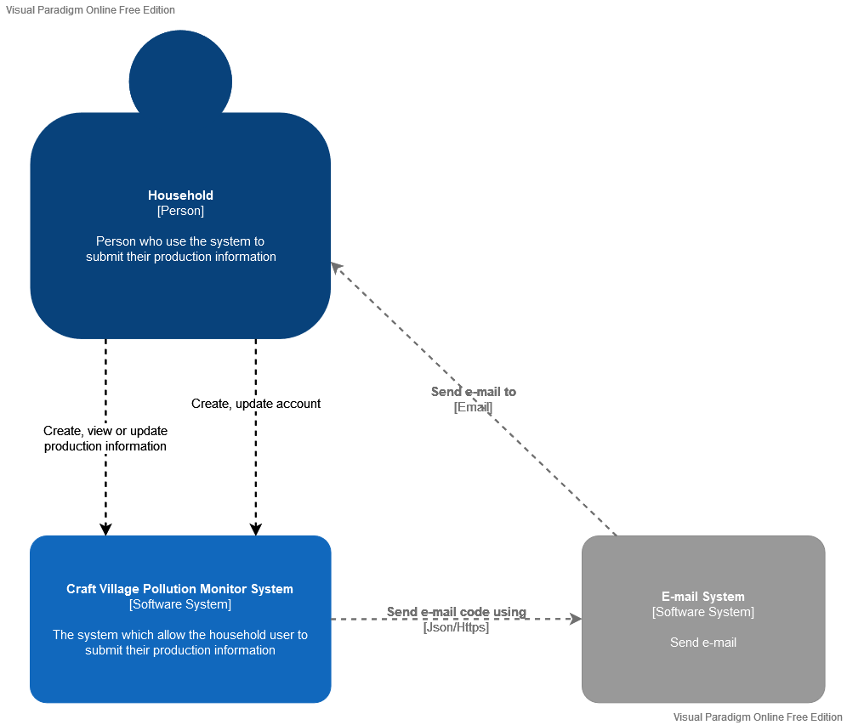

**Figure 3.5.3.** Household System Context Diagram

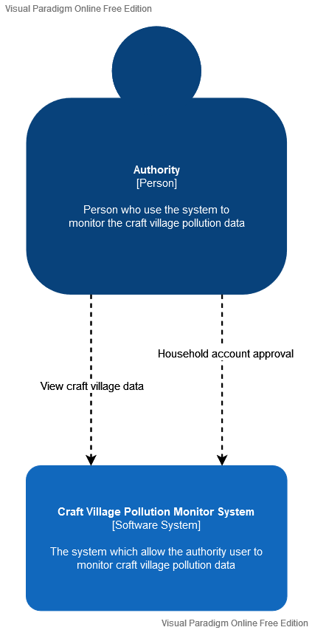

**Figure 3.5.4.** Authority System Context Diagram

**System context description:**

* The personal user, they can:
* Create anew survey;
* View previous survey;
* Continue unfinished survey;
* Create a new account using their personal phone number;
* The household, they can:
* Submit their production information;
* View previous submission
* Update their production information
* Create a new account using their personal email;
* The authority, they can:
* View craft village’s data (village production information, pollution status, etc);
* Give an approval for new household account.

1. **C&C view**

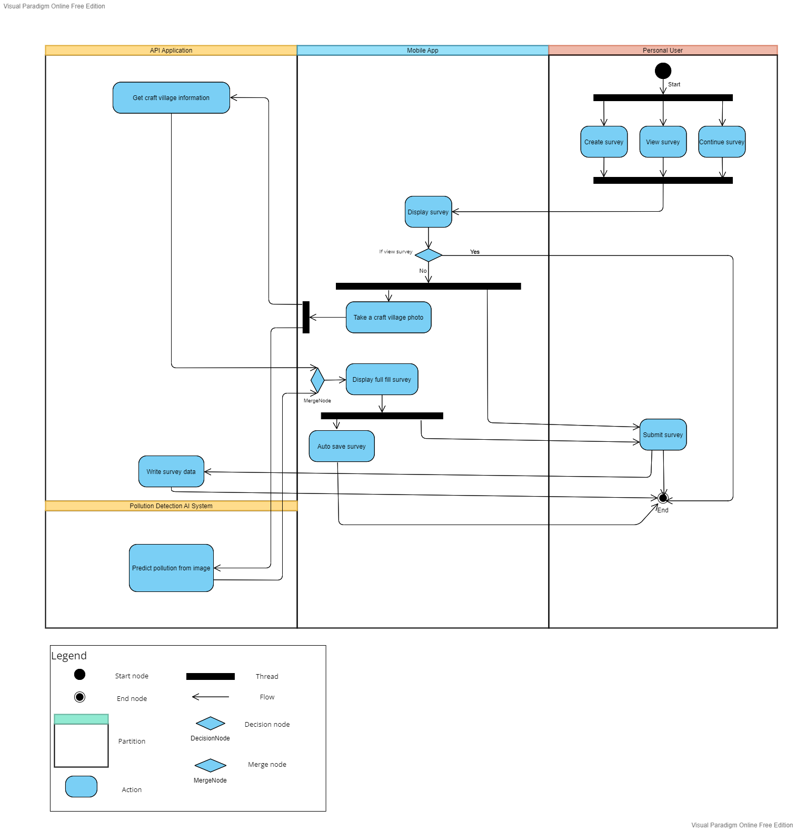

**Figure 4.1.** Component & connector view (Personal)

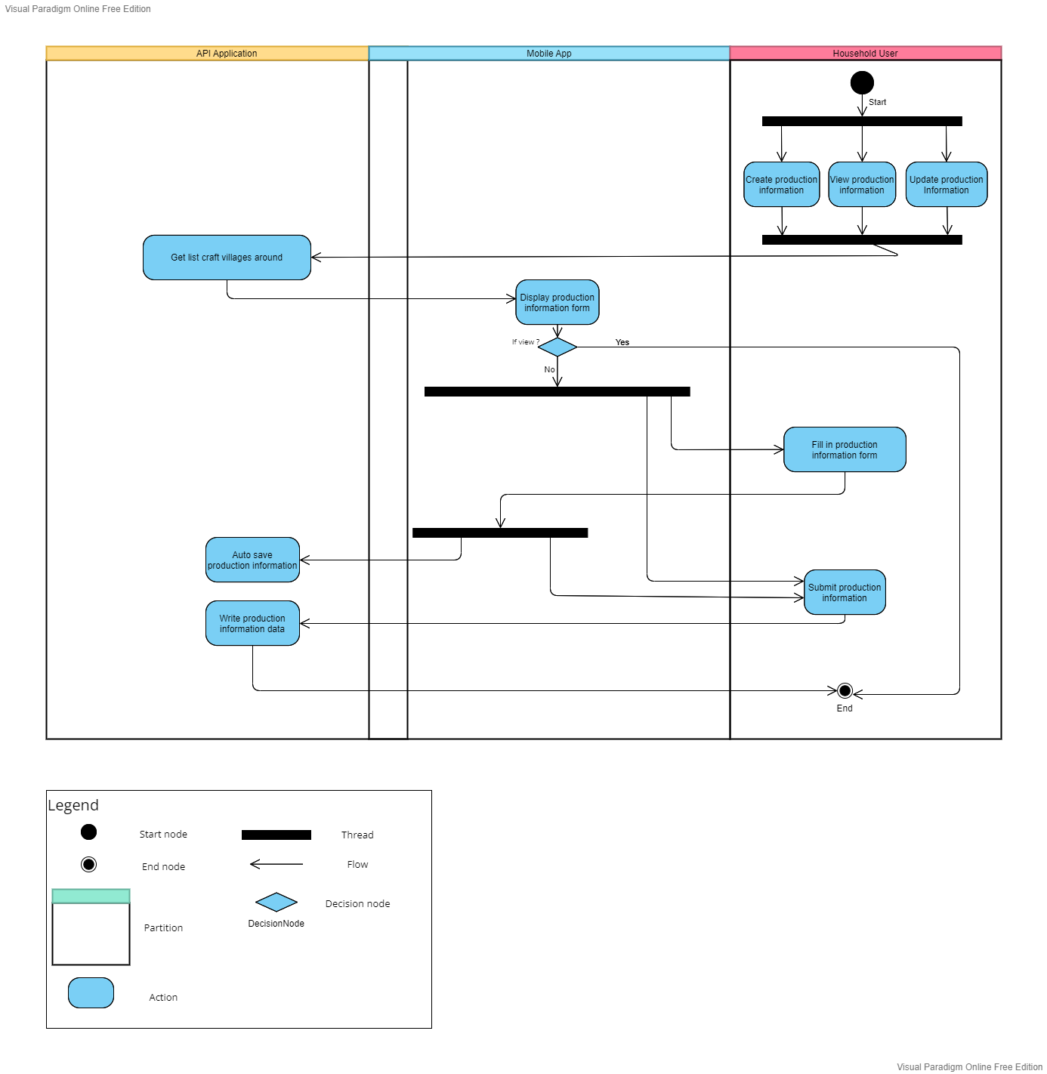

**Figure 4.2.** Component & connector view (Household)

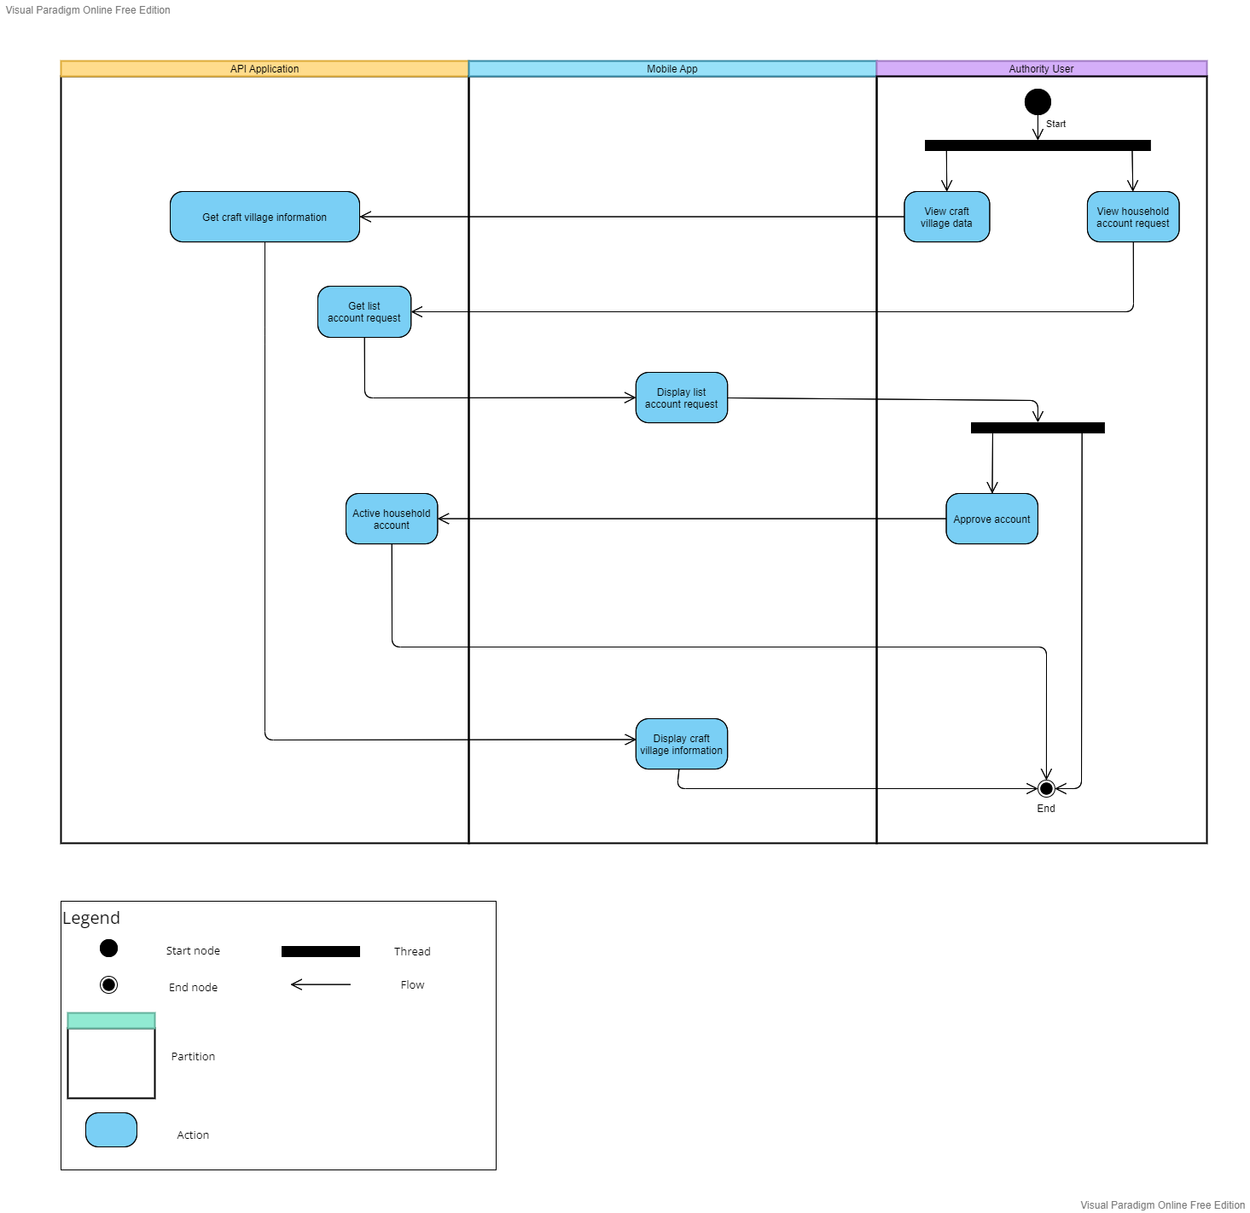

**Figure 4.3.** Component & connector view (Authority)

**Prose:**

2. **Module view**

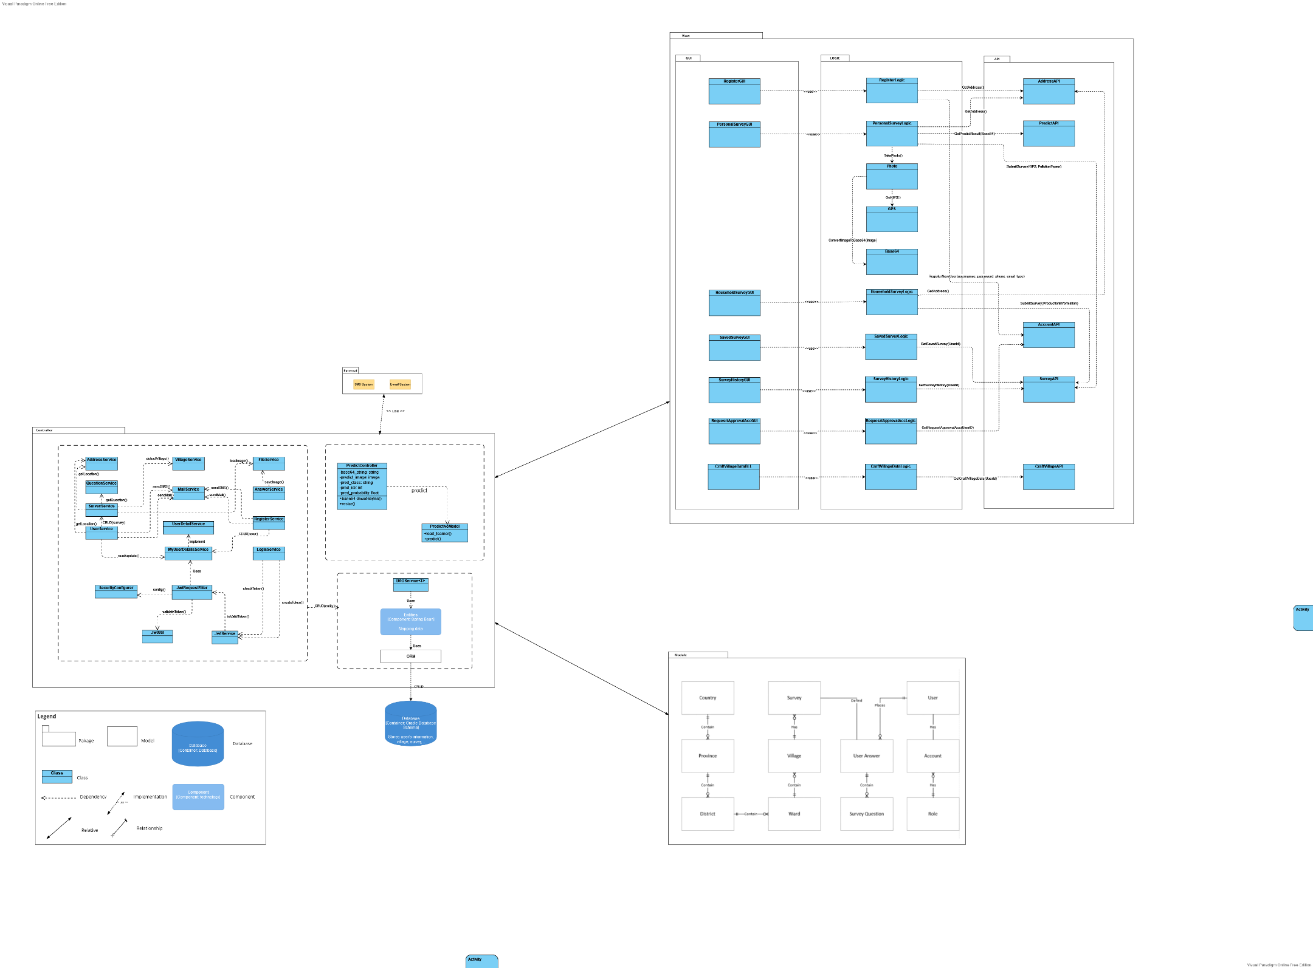

**Figure 5.** *Module view*

1. **Allocation view**

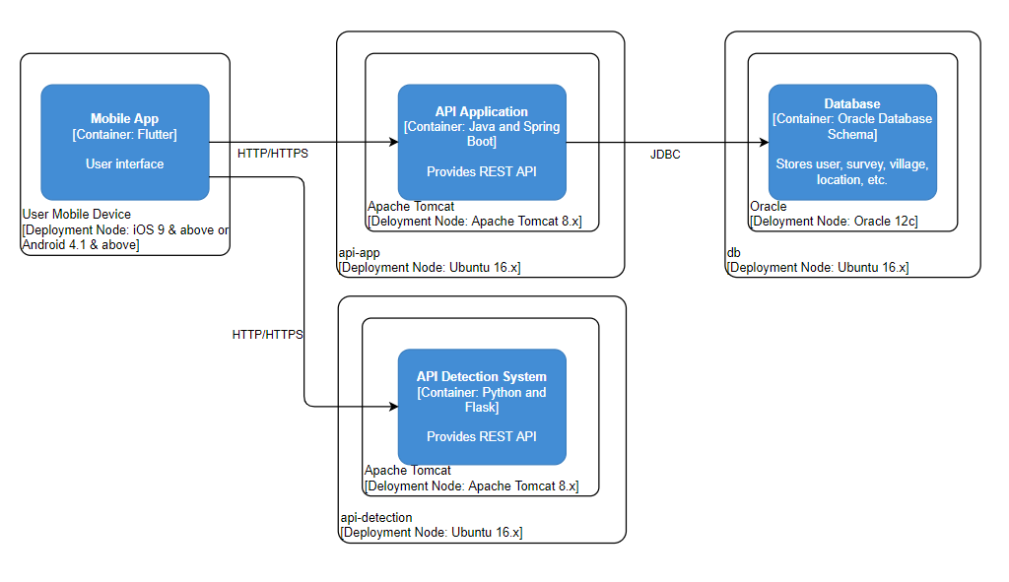

**Figure 6.** Allocation view

**Prose**: