|  |  |
| --- | --- |
|  | CartLogic Basic |
|  | [Document Version 1.0]  http://www.capturit.com/images/logo.jpg |

|  |
| --- |
| **[CartLogic Basic User Manual**] |
| CartLogic Basic is a Windows Mobile 6.x application for managing cart inventory and transaction (Removals and Delivery, etc.). CartLogic Reader uses an open file format (CSV) to provide flexible integration with any back office inventory or customer management solution. This manual provides instructions for using Capturit CartLogic Reader including installation, import and export workflow and other available options. |

Document Revision History

|  |  |  |  |  |
| --- | --- | --- | --- | --- |
| Version | Date | Author | Revision Description | |
| 0.1 | 7.31.2011 | Joe Bennett | Draft Release |
| 0.2 | 8.22.2012 | Joe Bennett | Draft Release Clean Grammar, Change branding and add GPS info. |
| 0.3 | 8.28.2012 | Joe  Bennett | Revise with new screenshots from system changes. |
| 0.4 | 10.16.2012 | Joe Bennett | Revise with new screenshots, added RFID write function and Google Earth KML export |
| 0.5 | 1.4.2013 | Joe Bennett | Added Appendix A & B |
| 0.6 | 4.1.2013 | Joe Bennett | Changed formatting for warning\info boxes and rewrite of install instructions. |
| 0.7 | 6.17.2013 | Eric Crippin | Updated MRO file transfer steps and CartLogic screen shots. |
| 0.8 | 6.17.2013 | Joe Bennett | Updated Title, Update handheld in figure 7, changed screenshot for RMO Appendix, changes name of export file. |
| 0.9 | 6.18.2013 | Joe Bennett | Add configuration information for Cart Size and Type. Change several screenshots |
| 1.0 | 8.1.2013 | Joe Bennett | Added appendix for CartLogic Advanced manual file transfer |

Table of Contents

1 Getting Started 2

2 Importing Customer Tickets 8

3 Complete a Cart Ticket 12

4 Exporting Completed Tickets 14

5 Data management 16

6 RFID Battery and GPS Configuration 19

7 Write RFID Tags 19

8 Add new Cart Size and Type 20

A. Appendix: Upgrading CartLogic 22

B. Appendix: CartLogic Basic and Advanced Workflow 24

C. Appendix: MRO CartLogic Workflow 27

## Getting Started

Capturit CartLogic Reader is a Windows Mobile, Window CE, Intermec CN3 and ATID 870 compatible application for Cart Services management including deliveries, exchanges and removals. The instructions below provide detailed steps and requirements for installation, customer import, cart transactions, and customer export options. *Note throughout this document, screen views may be different depending on the reader model you are using (i.e. ATID 870 or Intermec CN3). All functions will be similar for both units.*

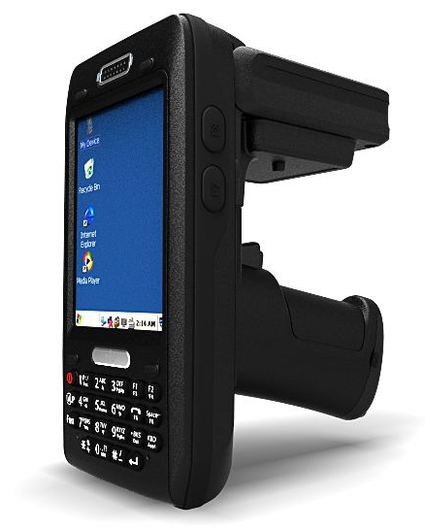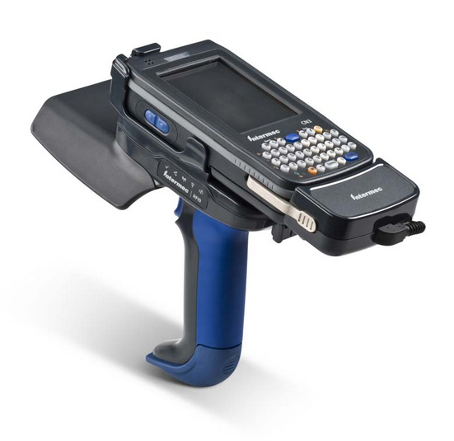

ATID 870 Intermec CN3 with IP30

### Install CartLogic Reader Installation files for all prerequisites are included with CartLogic Reader. Capturit CartLogic Reader requires:

* + 1. *Prerequisites* for Intermec CN3:

1. Windows Mobile Device Center
2. *SQL Server compact edition* for Windows Mobile
3. *Windows Mobile .NET compact version 3.5*.
4. Optional for GPS enabled *Intermec Handhelds* the *Location Services Developer Kit (IDLLSRK_WM6.cab)*
   * 1. *Prerequisites* for ATID 870:
5. Windows Mobile Device Center
6. SQL Server compact edition for Windows CE

* + 1. **Connect** the Handheld device to a Windows Computer using the provided USB cable.

NOTE: When first connecting a handheld device to a computer *Windows Mobile Device Center* will initiate a partnership and connection wizard. Follow the instruction on the screen to complete the connection or check the handheld device manual for further instructions.

* + 1. **Copy** the installation folder *(CartLogic)* to the Handheld.
       1. **Right** Click on the folder select copy.
       2. **Navigate** to the root directory “\” of the handheld.



* + - 1. **Right Click** & **Select** paste.

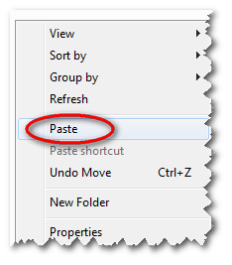 

* + 1. On the handheld **navigate** to the newly pasted installation folder *(CartLogic)*
       1. **Click** on the Start Menu and choose Programs:
       2. **Click** on File Explorer for the Intermec or My Device for ATID.

 

* + - 1. **For Intermec (Windows Mobile) Click** on Show and select my *My Device*

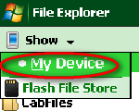

* + - 1. **Find** and **Click** on the *CartLogic* folder.
    1. **Intermec Install:** install each application in the following order for the Intermec (for ATID see next section):
       1. Windows .Net Compact Edition Framework *(NETCFv35.wm.armv4i.cab)*
       2. SQL Server Compact Edition *(sqlce.phone.wce5.armv4i.CAB)*
       3. Capturit CartLogic Reader *(CartLogic Installer.CAB)*
       4. ***Optional with GPS hardware*** *Services Developer Kit (IDLLSRK_WM6.cab)*
    2. **ATID Install:** 
       1. From the *CartLogic* folder (copied to handheld in step 1.1.5). **Click** on Install.
       2. When prompted **Click** ok to install SQL Compact Edition.

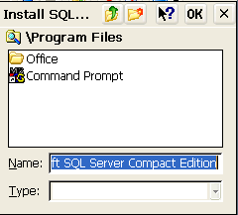

When installing Windows Mobile applications use the default option of device. This will help improve application performance by writing directly to device memory.

### Capturit CartLogic Reader Quick Reference

The following provides a quick reference for Capturit CartLogic Reader. For specific and detailed actions and configurations options review other sections of this manual.

* + 1. From the Start menu or Desktop **Click** on Capturit CartLogic Reader shortcut.

* + 1. Review the Quick Reference Windows below to see options and commands:

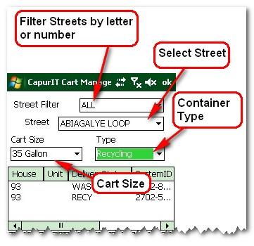

**Figure 1. CartLogic Reader Filters**

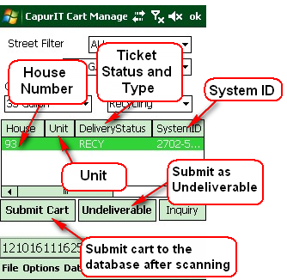

**Figure 2 CartLogic Reader Selection and Commands**

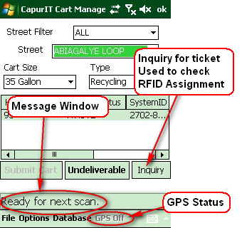

**Figure 3 Inquiry, GPS and Message Window**

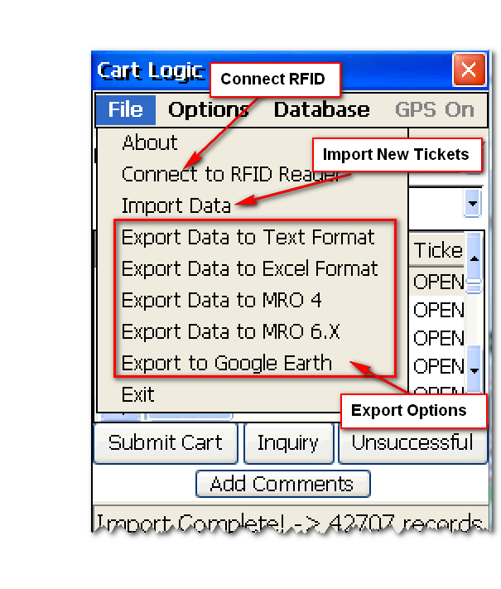

**Figure 4 File Menu**

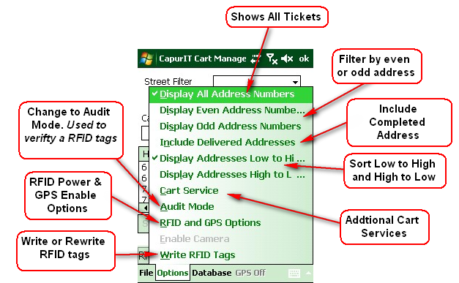

**Figure 5 Options Menu**

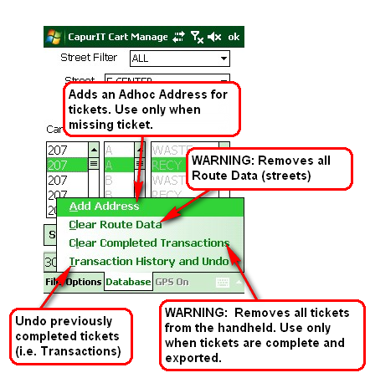

**Figure 6 Database Menu**

## Importing Customer Tickets

CartLogic Reader uses a comma separated value file in a txt or csv format to import new tickets. The import file can be named anything to meet the service needs. All import files should be placed in the *New Tickets* folder of the handheld prior to importing

The file should contain headings and corresponding record values in the following order: *Street, House, TicketStatus, UnitNumber* and *SystemID*. Street is the address street name, House is the address number and UnitNumber is the unit or apartment number. TicketStatus contains the type of ticket to be completed (i.e. Swap, Delivery, Removal, etc.). This value will vary depending on workflow needs and “back office” software used to manage customers.

Finally, the SystemID is reserved for a unique value connecting ticket records to the external systems (i.e. Routeman Office). This value should come from external systems, databases or spreadsheets. It should be uniquely assigned based on cart management needs. By using a common data format CartLogic Reader enables integrating cart data with a diversity of external systems or back office software. This data exchange requires using SystemID. It must be a unique and shared id for each record (primary to foreign key) to provide consistency with back office software. See figure 7 below:



**Figure 7 Integration using SystemID**

Below is an example import file:

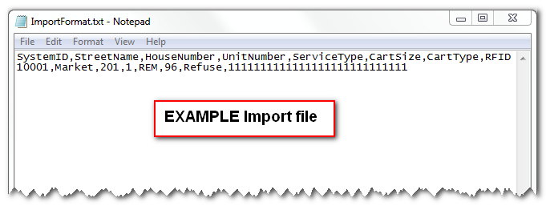

**Figure 8 Import file**

Use a csv format to have the best compatibility with spreadsheet programs like Microsoft Office Excel, Libre Office or Google Docs.

### Manually prepare a file for import:

### Note: manual preparation is not need when using a compatible back office program like CartLogic Advanced, AMCS ELEMOS-MRO, or other compatible systems.

* + 1. **Open** the provided import.csv template in a spreadsheet program. (After installation is complete the import.csv file can be found in the *New Tickets* folder on the handheld).
    2. **Copy or Type** data from source to the import template columns:

1. *Street* = Address Street name
2. House = Address number
3. *TicketStatus* = type of Ticket (Delivery, Swap and

Removals). Should follow the values needed for back

office software.

1. *SystemID* = unique ID from external system, needed to

import tickets when completed back into the external

system.

1. CartSize: size of cart (i.e. 35, 64, and 96). Must be configured on the handheld.
2. CartType: type of cart (i.e. Refuse and Recycling)

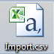

* + 1. **Save** file as *import.csv*

### Copy <name here>.csv to handheld

* + 1. **Right Click** *import.csv* and select *copy***.**
    2. **Navigate** to the Handheld root directory from *Computer* (Windows 7) or *My Computer* (Windows XP) then **Right Click** on *New Ticket* folder and select **Paste**.

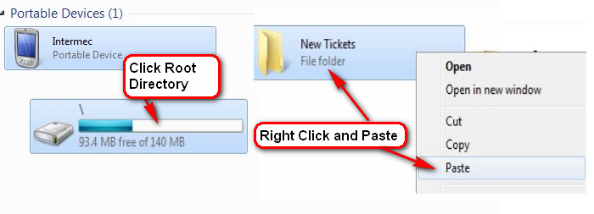

* + 1. **Open** *CartLogic Reader* on the Handheld and **Click** file and *Import Data*.

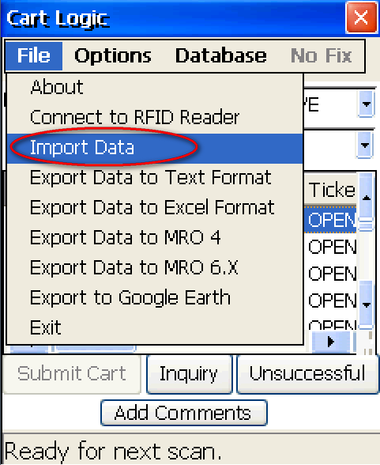

**Progress bar** indicates data is loading:



**CartLogic Reader** message will show when complete:



## Complete a Cart Ticket

* 1. **Open** *Cart Management* on the handheld.
  2. **Use** the Street Filter and Street to find the needed ticket.

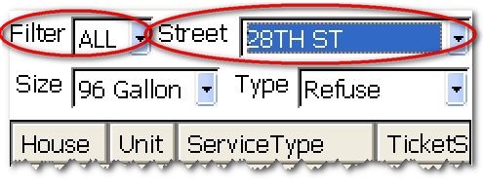

* 1. **Next**, choose the cart *Type*

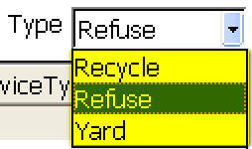

* 1. **Next**, choose Cart *Size*

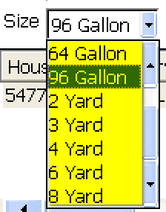

* 1. **Select** the *Cart Ticket*

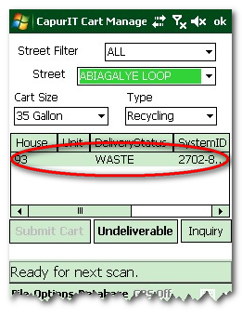

* 1. **Scan** the Cart (point the scanner and pull the trigger)

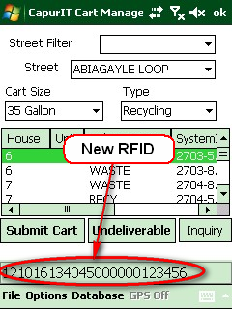

Use the File >> Connect to the RFID Reader option if reader is not functioning.

* 1. **Verify** the Cart was scanned properly from the message window.
  2. **Click**, the *Submit Cart* button.
  3. **Note** Message window displays *Ready for next Scan* **or** if the RFID tag is already assigned to another address a popup message will display allowing reassignment.

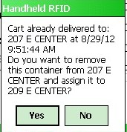

## Exporting Completed Tickets

Ticket export completes the cart services record and should be done quickly after field work to ensure accurate data management. Each export file (export.csv) is placed in the *Completed Tickets* folder of the handheld’s root directory. There are several export option to include, Excel (CSV), MyRoute Office (MRO) and Google Earth time stamp file (KML). After creating the export file it should be copied and renamed to a network or desktop location for any need back office processing.

* 1. **Open** Capturit CartLogic Reader.
  2. **Click** File and **Select** *Export Data to Excel Format* or *Export to Text Format*. Eachexport will be given a unique name (i.e Export_1.csv, Export_2.csv, etc …)

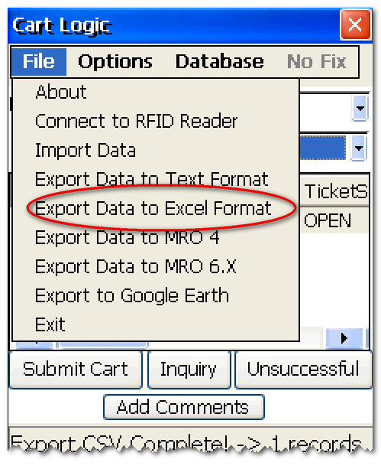

* 1. **Navigate** to the Handheld root directory from *Computer* (Windows 7) or *My Computer* (Windows XP) and open the *Completed Tickets* folder.



* 1. From the *Completed Tickets* folder **Copy** the export file to a processing folder on the connected computer.
  2. **Export to Google Earth:**
     1. Must have Google Earth installed to use. Can be downloaded at <http://earth.google.com>
     2. **Click** onFile and Export *to Google Earth*.
     3. **Note** a warning will appear for tickets completed without a GPS coordinate.

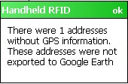

* + 1. **Locate** the *Export.kml* in the *Completed Tickets* folder. 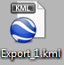
    2. **Copy** to desktop or network folder, **Double-click** to open in *Google Earth.*

## Data management

Capturit CartLogic Reader Database menu provides three actions: 1) Add Address; 2) Clear Route Data; 3) Clear Completed Transactions. Add Address provides a method to create a new ticket missing from the import file. This option should be used with caution as new “ad hoc tickets” do not contain a SystemID values for back office integration. Clear Route Data and Clear Completed Transactions will remove current ticket records (i.e. import.csv) from Capturit CartLogic Reader.

* 1. **Add Address:**
     1. **Click** on Database and **Select** *Add Address*
     2. **Type** *Street Name* and **Click** *Add Street*
     3. **Select** *Street Name*

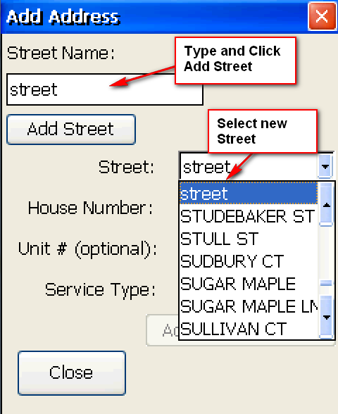

* + 1. **Type** House *Number* and **Click** *Add House Number*

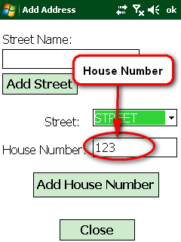

Warning: Export all tickets before Clearing Transactions or Route Data.



* 1. **Clear Completed Transactions:**
     1. **Click** on Database and **Select** *Clear Completed Transactions*

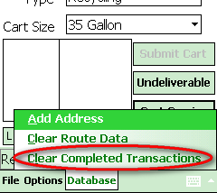

* + 1. Confirm clear by **Clicking** on *Yes*

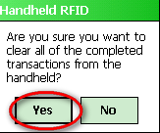

* 1. **Clear Route Data:**
     1. **Click** on Database and **Select** *Clear Route Data*
     2. Confirm clear by **Clicking** on *Yes*
  2. **Transaction History and Undo:**
     1. From CartLogic Reader **Click** on *Transaction History and Undo*

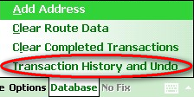

* + 1. From Transaction History window **Select** the correct record.
    2. Next, **Click** Remove*/Undo Transaction*.

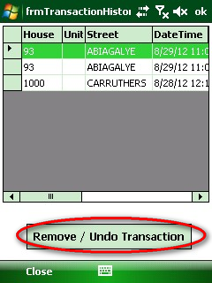

## RFID Battery and GPS Configuration

Capturit CartLogic Reader provides options to reduce the battery power of the RFID reader when not in use. Also for Intermec units with GPS hardware and all ATID870s CartLogic Reader provides latitude and longitude data for field transaction (i.e. Swaps, Removals, etc..). The steps below describe how to setup and configure these options when needed.

* 1. Adjusting battery settings:
     1. From CartLogic Reader **Click** on RFID and GPS Options
     2. **Select** RFID Power (%) drop down menu to adjust power use.
  2. Enable GPS settings:
     1. From CartLogic Reader **Click** on *RFID and GPS Options*
     2. **Check** on Enable GPS
     3. **Click** on *Get Current Location*
     4. **Review** GPS Status as On plus current Latitude and Longitude.

## Write RFID Tags

The write RFID Tags under Options provides a tool to write or rewrite RFID Tag information. This tool should be used with caution. There is no way to retrieve tag information once it has been written over.

Warning: writing RFID Tags will remove any existing information on the tag.



* 1. **Click** on Options an select Write RFID Tags.

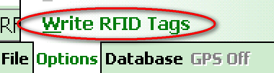

* 1. From the Write RFID window **type** in the new *Cart Serial Number* and **Click** *Write Cart* or **Pull** the RFID reader trigger.
  2. **Note** the *Status* message box will show successful writes. And one will be added to the *Tags Written* counter.

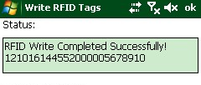

Turn Down the RFID Power % or isolate the Cart from other carts if multiple tags are found.

## Add new Cart Size and Type

CartLogic provides this option to add and remove new Cart size and types.

* 1. **Click** on *Database* and select *Configure Cart Sizes and Type*.

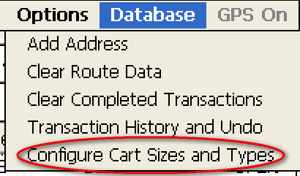

* 1. In the Cart Size and Type configuration window, **Select** use Select dropdown to choose *Sizes or Type*.

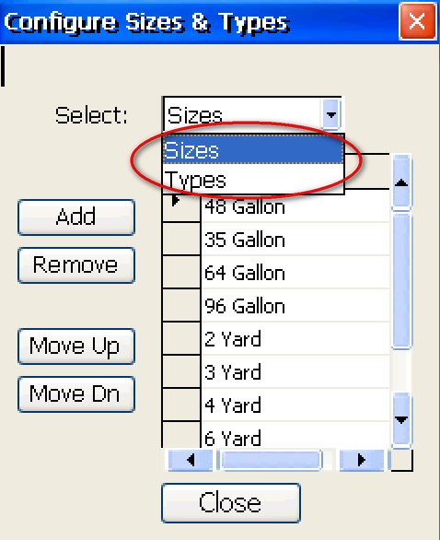

* 1. **Click** add, and in the Add Size or Type window **Type** the needed size or type.

8.4 When complete **Click** *Close* to return to the *Service Ticket Window*.

## Appendix: Upgrading CartLogic

As fixes and new features to CartLogic Handheld are released it is important to upgrade to the latest version in order to maintain a good experience with the software. You must uninstall an older version of CartLogic before installing a new version. Below are general instructions for upgrading CartLogic Handheld:

* 1. **Connect** the handheld to a computer using the provided USB or Docking station. You must have Windows Mobile Device Center installed.

Need to have Windows Mobile Device Center Installed to communicate with a desktop computer.

* 1. On the Handheld **Click** on the windows mobile start menu 
  2. **Click** on Settings



* 1. **Click** on Remove Programs



* 1. From the Remove Programs menu choose *CartLogic Manager Installer*, **Click** yes to remove.

(Note: older versions are called CapurIT Cart Manager Installer)

* 1. After removing the old version, copy the new version to the handheld:
     1. **Navigate** to the new version **Right Click** and **Choose** Copy.
     2. **Navigate** to the root directory “/” of the handheld.



* + 1. **Right Click** & **Select** paste.
    2. On the handheld **navigate** to the installation folder *(CartLogic)*
    3. **Click** on the Start Menu and choose Programs:
    4. **Click** on File Explorer



* + 1. **Click** on Show and select my *My Device*



* + 1. **Find** and **Click** on *CartLogic*
    2. **Choose** to install on Device.

## Appendix: CartLogic Basic and Advanced Workflow

CartLogic Basic can be used with Cascade Cart Solutions *CartLogic Advanced to* manage your cart inventories in a web based solution. The steps below detail exporting new service tickets from CartLogic Advanced, copying them to a reader and importing into the CartLogic Basic handheld reader application.

Login to CartLogic Advanced:

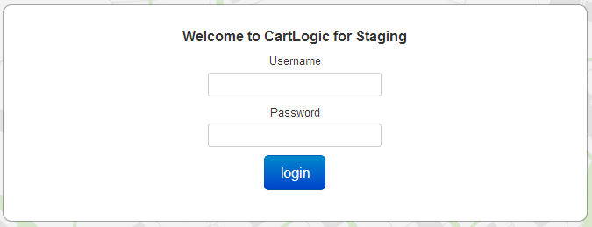

1. From the Ticket Reports download page:
   1. **Select** the dropdown menus to build a CartLogic report.

**Example:** Show *Requested* tickets for *ALL* services, and *ALL* cart type(s,) and ALLgallon cart(s)



1. To view Tickets **Click** the **Go** button  at the right of the report builder.
2. **Download** a CartLogic Basic (i.e. Handheld) report by **Clicking** on the download button. The file will go into the Chrome browser download folder.

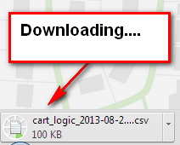

1. **Copy** the CartLogic Basic file to the handheld reader by:
   1. After the download is complete, **Click** the down arrow next to the CartLogic ticket file.

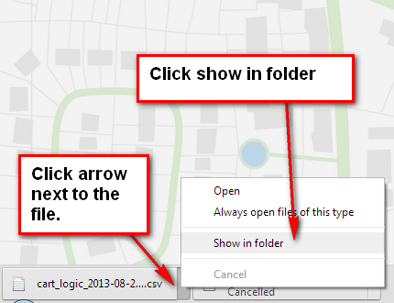

* 1. **Select** show in folder to bring up the download folder with the new ticket file.
     1. **Right** Click the file **<name here>.csv** and select *copy***.**
     2. If not already connected, **Connect** the handheld reader to the PC.
     3. **Navigate** to the Handheld root directory from *Computer* (Windows 7) or *My Computer* (Windows XP) then **Right Click** on *New Ticket* folder and select **Paste**. **Note:** *the portable device will appear differently depending on your device model (i.e. ATID 870 or Intermect CN3)*



* + 1. **Open** *CartLogic Reader* on the Handheld and **Click** file and *Import Data*.



**Progress bar** indicates data is loading:



**CartLogic Reader** message will show when complete:



## Appendix: MRO CartLogic Workflow

The instructions below provide general steps for **Preprocessing** and **Postprocessing** Cart Tickets with *AMCS MyRouteOffice* and CartLogic Handheld.

**GENERAL WORK FLOW:**



Cart Logic Export Report must be setup to export Cart Tickets for the handheld. NOTE: In AMCS MyRoute Office Cart tasks (Delivery, Collection, etc..) are labeled Container Jobs. CartLogic calls these Cart Tickets.

1. **Export Report from MyRouteOffice (i.e. Preprocess):** 
   1. **Open** and **Login** to MRO
   2. **Click** on the *Reporting Sector*



* 1. **Click** on Cart Management Reports and Click once on *CartLogic Export Report*

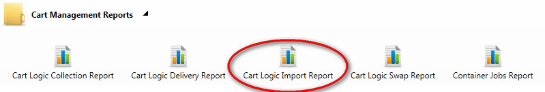

* 1. In the *Report Parameters* Window **Click OK**.

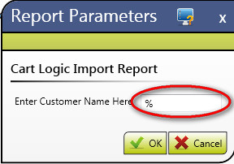

* 1. In the *Report Viewer* window **Click** on the Save button 
  2. **Choose** *CSV (comma delimited)*

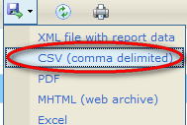

* 1. Select *Save* in the *File Download* Window.

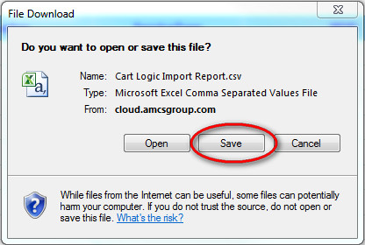

* 1. In the *Save As* window navigate to the Computer’s Desktop (or other folder location).
  2. In the drop down *Save as Type* **Choose** *All Files*



* 1. **Click** Save.
  2. You are now ready to import the file to CartLogic. **See Section 2.2** above for detail instructions on importing the CartLogic Import Report.csv file. Follow **Section 3** above to complete a ticket for Field Work.

1. **Update MyRoute Office (i.e. Postprocess)**
   1. **Connect** Handheld to a computer
   2. **Open** CartLogic on the Handheld
   3. **Click** File and **Choose** Export *Data to MRO 6.X*

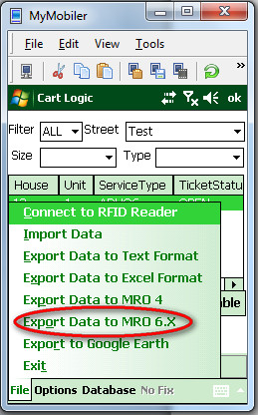

* 1. From the Desktop Computer. **Navigate** to the *Completed* tickets folder on the handheld. (Hint: go to Computer\< Your Handheld Name>\\\Completed Tickets)
  2. **Right Click** on the *ExportMRO_<SERVICETYPE>_timestamp_device.txt*, select *Cut*

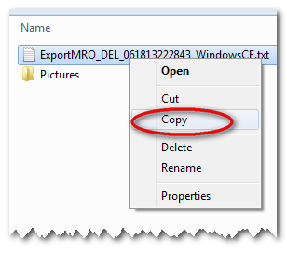

Note: Each export saves a unique file name with the prefix ExportMRO, followed by the service type (i.e. DEL for deliver), a timestamp and finally the device name. For example: ExportMRO_DEL_06181322843_WindowsCE.txt

* 1. **Navigate** to the Computer’s Desktop (or other folder location) and **Paste** the export file.
  2. ****Open** MyRoute Office (MRO) and **Click** on *Collection Customer Sector*
  3. **Click** on *Container Import*
  4. **Choose** *ScanMan Bin Creation File* for Collections and *ScanMan Bin Linking File* for Deliveries.
     1. For *ScanMan Bin Linking File*, Set imported records to: *Available*
  5. **Click** on *Test Import*, in the open window **Navigate** to and **Select** the *ExportMRO_<SERVICETYPE>_timestamp_device.txt* file **Click** open
  6. After testing, **Click** on *Live Import,* in the open window **Navigate** to and **Select** the *ExportMRO_<SERVICETYPE>_timestamp_device.txt* file **Click** open.
  7. **Verify** the new Cart RFID is linked to the Customer:
     1. In the *Collection Customer* sector  **Click** on Customers menu.
     2. In S*earch for* input box**Type** the name of customer or site address and apply the appropriate *against* and *conditions* (e.g. against = Customer/Account, condition = Contains).
     3. **Click**  the search the button
     4. Select the customer account and verify the Container Items where imported correctly.
  8. **Complete** the Container Jobs:
     1. **Click** on Container Jobs.
     2. **Select** each job that has been completed and Click *Complete*.

