
MULUNGUSHI UNIVERSIT
School of Engineering and Technology

ACTIVITY 2 (TWO)

Name: ………………………………. Cascious Nyambe
Student ID ………………………….. 202409245
Program …………………………….. Computer Science
Year ………………………………… Third (3)
Course: …………................................ Advanced Databases
Course Code ………………………… ICT 371
Lecturer ……………………………... Mr Kaluba

PART A
CREATE TABLE sales_orders (
order_id INTEGER PRIMARY KEY,
customer_name VARCHAR(60),
product_name VARCHAR(60),
quantity INTEGER,
unit_price NUMERIC(10,2),
discount_amount NUMERIC(10,2),
delivery_fee NUMERIC(10,2)
);

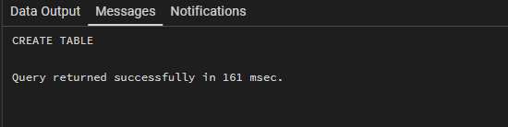

PART B

INSERT INTO sales_orders (order_id, customer_name, product_name, quantity, unit_price, discount_amount, delivery_fee)
VALUES
(1001, 'James Banda', 'Computer Mouse', 2, 150.00, 20.00, 30.00),
(1002, 'Mary Mainza', 'Keyboard', 3, 250.00, 50.00, 30.00),
(1003, 'Isaac Mulenga', 'Laptop Bag', 1, 450.00, 25.00, 40.00),
(1004, 'Jane Mubita', 'USB Flash Disk', 5, 120.00, 30.00, 20.00);

SELECT * FROM sales_orders;
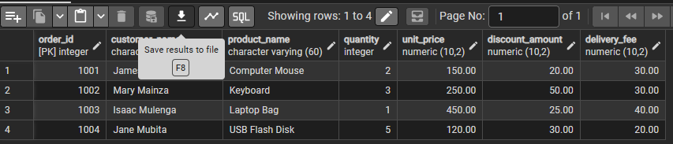

PART C
DO $$
DECLARE
v_order_id INTEGER;
v_customer_name VARCHAR(60);
v_product_name VARCHAR(60);
v_quantity INTEGER;
v_unit_price NUMERIC(10,2);
v_discount_amount NUMERIC(10,2);
v_delivery_fee NUMERIC(10,2);
v_subtotal NUMERIC(10,2);
v_amount_after_discount NUMERIC(10,2);
v_final_amount NUMERIC(10,2);
BEGIN
SELECT order_id, customer_name, product_name, quantity,
unit_price, discount_amount, delivery_fee
INTO v_order_id, v_customer_name, v_product_name, v_quantity,
v_unit_price, v_discount_amount, v_delivery_fee
FROM sales_orders
WHERE order_id = 1002;

v_subtotal := v_quantity * v_unit_price;
v_amount_after_discount := v_subtotal - v_discount_amount;
v_final_amount := v_amount_after_discount + v_delivery_fee;

RAISE NOTICE 'Order Number: %', v_order_id;
RAISE NOTICE 'Customer Name: %', v_customer_name;
RAISE NOTICE 'Product: %', v_product_name;
RAISE NOTICE 'Quantity: %', v_quantity;
RAISE NOTICE 'Unit Price: K %', v_unit_price;
RAISE NOTICE 'Subtotal: K %', v_subtotal;
RAISE NOTICE 'Discount: K %', v_discount_amount;
RAISE NOTICE 'Delivery Fee: K %', v_delivery_fee;
RAISE NOTICE 'Final Amount: K %', v_final_amount;
END $$ LANGUAGE plpgsql;
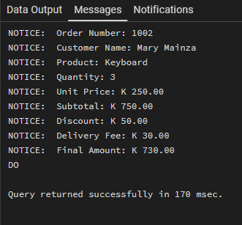

TASK 1
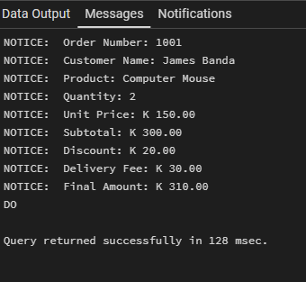

TASK 2
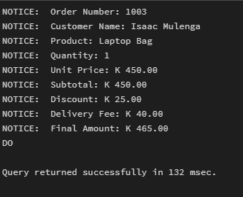

TASK 3 - 6
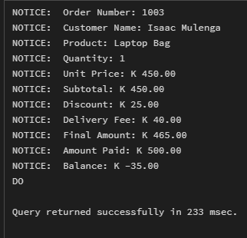

TASK 7
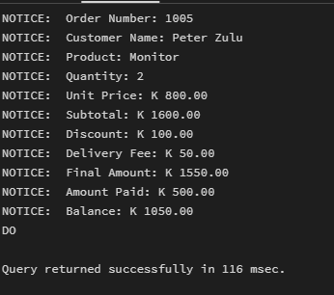

Business Scenario 1 – Hotel Bill Calculation

CREATE TABLE hotel_stays (
stay_id INTEGER PRIMARY KEY,
guest_name VARCHAR(60),
number_of_nights INTEGER,
room_rate NUMERIC(10,2),
discount_amount NUMERIC(10,2),
service_charge NUMERIC(10,2)
);
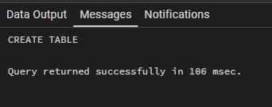

INSERT INTO hotel_stays VALUES
(1, 'Michael Chanda', 3, 500.00, 100.00, 50.00),
(2, 'Sarah Mwale', 2, 700.00, 80.00, 60.00),
(3, 'David Lungu', 5, 450.00, 150.00, 75.00),
(4, 'Ruth Sakala', 1, 900.00, 50.00, 40.00);
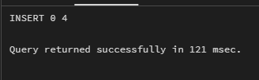

SELECT * FROM hotel_stays;
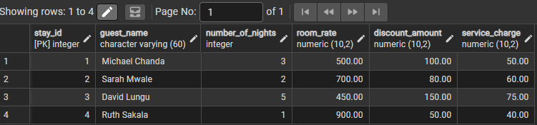

Anonymous Block

DO $$
DECLARE
v_stay_id INTEGER;
v_guest_name VARCHAR(60);
v_nights INTEGER;
v_rate NUMERIC(10,2);
v_discount NUMERIC(10,2);
v_service NUMERIC(10,2);
v_room_cost NUMERIC(10,2);
v_after_discount NUMERIC(10,2);
v_final_bill NUMERIC(10,2);
BEGIN
SELECT stay_id, guest_name, number_of_nights, room_rate,
discount_amount, service_charge
INTO v_stay_id, v_guest_name, v_nights, v_rate, v_discount, v_service
FROM hotel_stays
WHERE stay_id = 3;

v_room_cost := v_nights * v_rate;
v_after_discount := v_room_cost - v_discount;
v_final_bill := v_after_discount + v_service;

RAISE NOTICE 'Stay ID: %', v_stay_id;
RAISE NOTICE 'Guest Name: %', v_guest_name;
RAISE NOTICE 'Number of Nights: %', v_nights;
RAISE NOTICE 'Room Rate: K %', v_rate;
RAISE NOTICE 'Room Cost: K %', v_room_cost;
RAISE NOTICE 'Discount: K %', v_discount;
RAISE NOTICE 'Amount After Discount: K %', v_after_discount;
RAISE NOTICE 'Service Charge: K %', v_service;
RAISE NOTICE 'Final Bill: K %', v_final_bill;
END $$ LANGUAGE plpgsql;
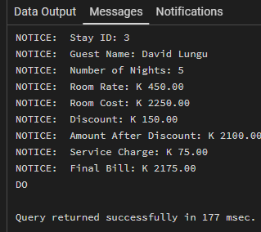

Business Scenario 2

CREATE TABLE student_fees (
student_number VARCHAR(20) PRIMARY KEY,
student_name VARCHAR(60),
tuition_fee NUMERIC(10,2),
registration_fee NUMERIC(10,2),
accommodation_fee NUMERIC(10,2),
amount_paid NUMERIC(10,2)
);
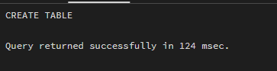

INSERT INTO student_fees VALUES
('STU001', 'Brian Halubanza', 12000.00, 500.00, 3000.00, 10000.00),
('STU002', 'Mainess Mulwanda', 15000.00, 500.00, 3500.00, 19000.00),
('STU003', 'Heri Siwiti', 11000.00, 500.00, 2500.00, 8000.00),
('STU004', 'Cletus Gwebela', 13000.00, 500.00, 3000.00, 16500.00);
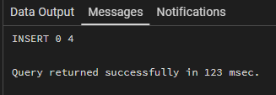

SELECT * FROM student_fees;
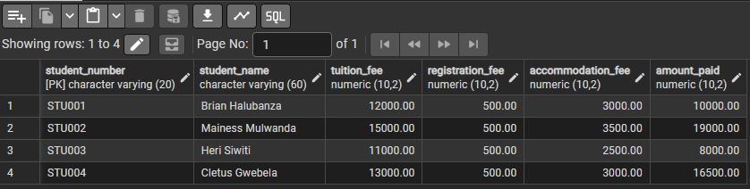

SELECT * FROM student_fees;

Anonymous Block
DO $$
DECLARE
v_student_no VARCHAR(20);
v_student_name VARCHAR(60);
v_tuition NUMERIC(10,2);
v_registration NUMERIC(10,2);
v_accommodation NUMERIC(10,2);
v_paid NUMERIC(10,2);
v_total NUMERIC(10,2);
v_balance NUMERIC(10,2);
BEGIN
SELECT student_number, student_name, tuition_fee,
registration_fee, accommodation_fee, amount_paid
INTO v_student_no, v_student_name, v_tuition, v_registration,
v_accommodation, v_paid
FROM student_fees
WHERE student_number = 'STU003';

v_total := v_tuition + v_registration + v_accommodation;
v_balance := v_total - v_paid;

RAISE NOTICE 'Student Number: %', v_student_no;
RAISE NOTICE 'Student Name: %', v_student_name;
RAISE NOTICE 'Tuition Fee: K %', v_tuition;
RAISE NOTICE 'Registration Fee: K %', v_registration;
RAISE NOTICE 'Accommodation Fee: K %', v_accommodation;
RAISE NOTICE 'Total Fees: K %', v_total;
RAISE NOTICE 'Amount Paid: K %', v_paid;
RAISE NOTICE 'Balance: K %', v_balance;
END $$ LANGUAGE plpgsql;
