

MSP430AFE253 Development Board

(CL-MSPDB-AFE)

User Guide

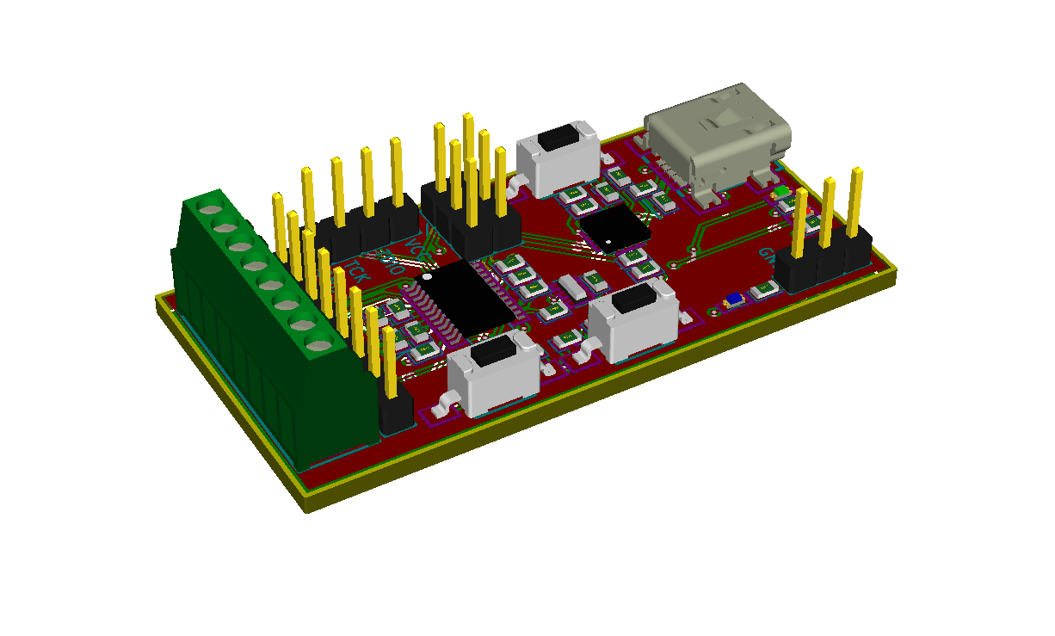

Table of Contents

1 Revision History 3

2 Features 3

3 Board Features 4

3.1 Mini USB Connector 4

3.2 External Power Connector 4

3.3 Analog Connections 5

3.4 GPIO Header 5

3.5 3.3V Jumper 6

3.6 TX & RX Jumper 6

3.7 Spy-by-Wire Debug Header 6

3.8 Reset Pushbutton 6

3.9 Blue User LED 6

3.10 User Switch 1 7

3.11 User Switch 2 7

3.12 UART RX LED 7

3.13 UART TX LED 7

4 Schematic 8

5 Board Layout 9

5.1 Silkscreen Top 9

5.2 Top Copper 10

5.3 Bottom Copper 11

5.4 Silkscreen Bottom 12

6 Bill of Materials 13

# Revision History

|  |  |  |
| --- | --- | --- |
| **Date** | **Revision** | **Change** |
| 2014-Aug-13 | 1.0 | First Release |

# Features

* Texas Instruments MSP430AFE253 with 2kB Flash and 512 bytes of RAM, plus 24-bit A/D
* 3.68MHz Ceramic Resonator
* 8-position 100-mil pitch screw terminal block for 3 differential analog inputs, Vref and ground
* 8-position 100-mil pitch male pin header for easy access to 6 GPIO pins, power and ground
* Mini USB connector supplies 5V power and access to virtual com port for serial
* On-board USB-to-serial converter IC for easy serial port communication and 3.3V supply
* 1 pushbutton for hardware reset of the MSP430 MCU
* 2 pushbuttons for user input
* Texas Instruments’ Spy-Bi-Wire debug interface via 4-pin 100-mil pitch male pin header
* Blue LED for application-defined visual feedback
* RX and TX LED’s for visual feedback of USB-to-serial converter communication activity
* 1x3 x 100-mil pitch male pin header for external 3.3V power input and ground
* 2 removable jumpers for isolating the RX/TX lines from the USB-to-serial converter IC
* USB-to-serial converter can be completely removed from the circuit via 3 removable jumpers; one for UART RX, one for UART TX and one for the 3.3V supply. Allows verification of ultra-low power consumption features of your application on the MSP430. Alternatively, provides easy connection of other TTL UART hardware, such as GPS, Bluetooth modules, etc.

# Board Features

MSP430AFE253

FTDI FT230XQ

USB-to-Serial

Blue

User LED

User

Switch 2

User

Switch 1

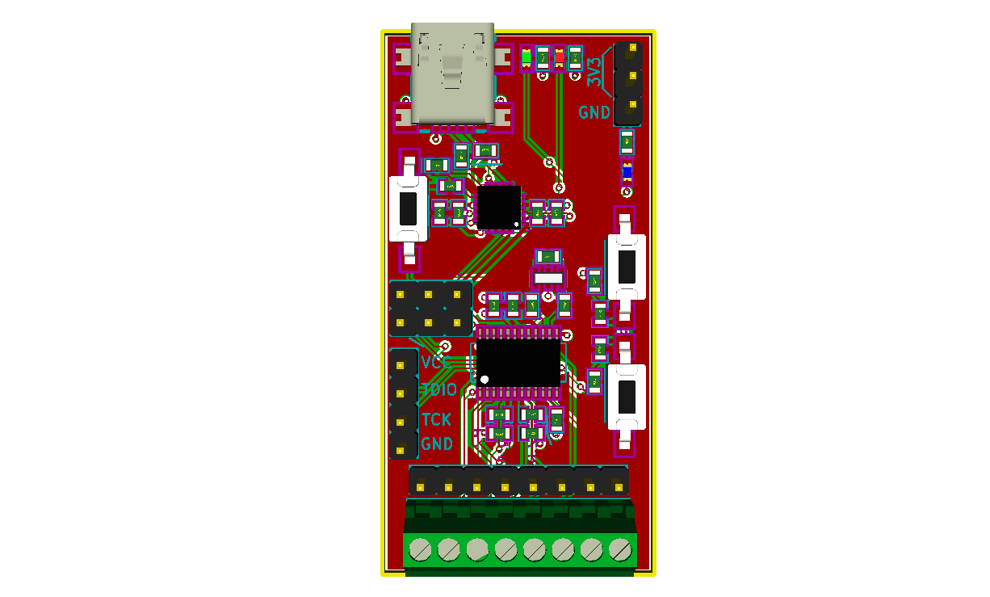

RX LED

TX LED

3.3V Power

& Ground

TX/RX/3.3V

Jumpers

Hardware

Reset

(3) 24-bit Differential

A/D Converter Inputs

A/D Reference Voltage

and A/D Ground

Mini USB

Connector

Spi-Bi-Wire

Debug

Header

GPIO Breakout,

3.3V Power

and Ground

## Mini USB Connector

The mini USB connector (J1) provides a serial interface via the FTDI FT230XQ USB-to-Serial converter IC. Additionally this chip provides the 3.3V regulated supply from the 5V supplied by the USB port.

The UART RX and TX lines from the FT230XQ go directly to the MSP430AFE253 through removable jumpers. This allows a means of disconnecting the FT230XQ chip from the MSP430AFE253 UART in case other UART hardware needs to be connected (i.e. UART display, GPS chip, etc). These jumpers are labeled in the silkscreen on the back of the MSP430AFE253 Development Board.

The regulated 3.3V power from the FT230XQ can also be disconnected via jumper (P2). This allows a means of using an alternate power supply without back feeding into the FT230XQ chip. This is especially important when trying to achieve the lowest possible power consumption (i.e. battery-powered applications, etc.). This jumper is labeled in the silkscreen on the back of the MSP430AFE253 Development Board.

## External Power Connector

The external power connector (P1) is a 100-mil pitch male pin header and provides a means of connecting a battery or other external power source. There are two pins provided for 3.3V and one pin for Ground, as some battery connectors skip a position between the positive and negative terminals.

## Analog Connections

The 8-postion screw terminal block (TB1) offers an easy method of connecting external analog sensors, such as current transformers, voltage taps, temperature sensors, pressure sensors, strain gauges and other high-sensitivity wheatstone bridge outputs to the 24-bit analog-to-digital front end. The terminal block pinout is as follows:



Analog Reference Ground

Analog Voltage Reference

Channel 2 - Negative

Channel 2 - Positive

Channel 1 - Positive

Channel 1 - Negative

Channel 0 - Negative

Channel 0 - Positive

## GPIO Header

The GPIO header (P) provides a means of utilizing other GPIO pins or other unused peripherals on the MSP430AFE253. Refer to the MSP430AFE253 datasheet and family user guide for GPIO pin functionality and peripheral availability.



P1.1

P1.5

P1.6

P2.0

P2.6

P2.7

3.3V

GND

## 3.3V Jumper

The 3.3V jumper (P2) provides a means of disconnecting the regulated 3.3V supply output from the FT230XQ. This allows use of an alternate power supply without back feeding into the FT230XQ chip. This is especially important when trying to achieve the lowest possible power consumption (i.e. battery-powered applications, etc.). This jumper is labeled in the silkscreen on the back of the MSP430AFE253 Development Board.



3.3V Jumper

## TX & RX Jumper

The RX and TX jumpers (P4 and P5 respectively) provide a means of disconnecting the FT230XQ UART lines in case other UART hardware needs to be connected (i.e. UART display, GPS chip, etc). This is especially important when trying to achieve the lowest possible power consumption (i.e. battery-powered applications, etc.). These jumpers are labeled in the silkscreen on the back of the MSP430AFE253 Development Board.



RX Jumper

TX Jumper

## Spy-by-Wire Debug Header

The Spy-by-Wire Debug Header (P3) provides a means of connecting a debugger (e.g. [MSP-FET430UIF](http://www.ti.com/tool/msp-fet430uif)) for program load and debug.



GND

SBWTCK

SBWTDIO

VCC (3.3V)

## Reset Pushbutton

The reset pushbutton (SW3) provides ready access the MSP430AFE253 Reset pin. Pressing this will give a hard reset to the MSP430AFE253.

## Blue User LED

The blue user led (D3) is connected to P1.7 and is available as an application-defined method of visual feedback.

## User Switch 1

User switch 1 (SW1) is connected to P1.2 and is available as an application-defined method of tactile user input.

## User Switch 2

User switch 2 (SW2) is connected to P1.0 and is available as an application-defined method of tactile user input.

## UART RX LED

A red UART RX LED (D) has been provided which blinks whenever data is being received on the FT230XQ UART RX pin.

## UART TX LED

A green UART TX LED (D) has been provided which blinks whenever data is being transmitted on the FT230XQ UART TX pin.

# Schematic



# Board Layout

## Silkscreen Top



## Top Copper



## Bottom Copper



## Silkscreen Bottom



# Bill of Materials

