
Entity Research
Car Accidents
Topic Only - Foundation Map
Prepared by Case Engine
April 27, 2026

Executive Summary
This map captures the entity universe for Car Accidents at Topic Only scope. Foundation map - jurisdiction-agnostic; every Location and Extension build inherits from this.
Counts
- 51 entities (target: 40-50)
- 10 clusters (target: 8-15)
- 5 bridge entities (target: 4-6)
Tier distribution
- Tier 1 (core, vector strength >= 0.80): 16 entities
- Tier 2 (major, 0.60-0.79): 20 entities
- Tier 3 (supporting, 0.40-0.59): 15 entities
Localization
- Coverage: 0% jurisdictional-named (expected at Topic Only)
- Supplement: not triggered, not applicable at this scope
Learnings & Insights
- Domain leaning: top 3 entity types are Legal Concept (11), Damages Category (9), Insurance Concept (6) - 51% of all entities. The domain is most heavily Legal Concept.
- Largest cluster: Damages & Compensation (9 entities) - the gravitational center of this practice area.
- Central bridge: Negligence spans 3 clusters (Liability Framework + Causes of Accidents + Evidence & Proof). Central legal theory that ties fault determination to accident causes and evidentiary standards
- Top-heavy distribution (31% Tier 1) - strong consensus on a small set of core entities; downstream content can lean hard on Tier 1.
- Score consensus: Tier 1 mean vector strength 0.87, Tier 2 0.70, Tier 3 0.51.
- Bridge composition: all 5 bridges are Tier 1 - the topical graph reconverges on the most prominent entities.
What does this mean?
- The practice area is balanced across multiple subject types. No single category dominates - top three are legal concept, damages category, insurance concept. Content can range broadly without feeling off-topic.
- The biggest theme in this domain is Damages & Compensation - more entities than any other cluster (9). Audiences expect a real conversation about this; if your content skips it, you're missing the gravitational center.
- Negligence is the connective tissue across the whole practice area. It ties together Liability Framework, Causes of Accidents and Evidence & Proof. If your content explains it well, you're educating AND linking related topics in one move.
- The core ideas are tightly defined. There's strong consensus on what matters most. That means content can lean confidently on the same handful of central concepts - you don't need to invent novel angles, you need to explain the well-known ones better than competitors.
- The connectors are the most prominent ideas. Coverage of the bridge entities does double duty - explains the central concepts AND ties related topics together. Highest-leverage content lives here.

Vector Space Visualization
Entities plotted radially - cluster determines angle, vector strength determines distance from center. Bridges highlighted with gold border.
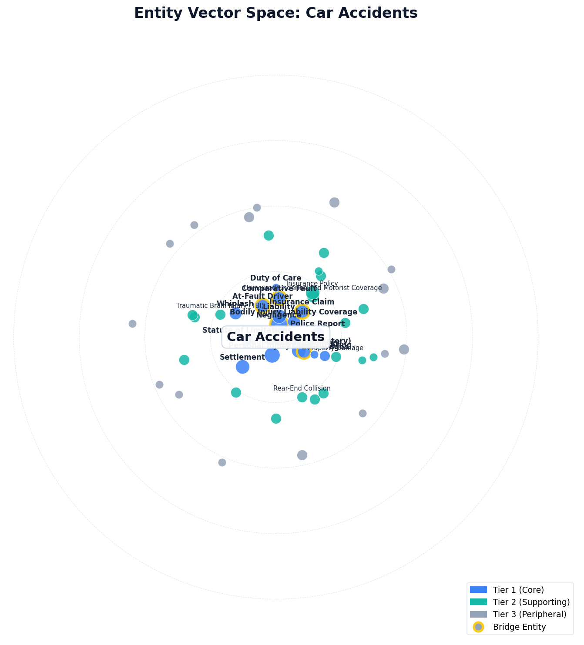
Tier 1 - Core Entities
Central to the practice area; appears in nearly every episode at every scope.
Entity | Type | Vec Str | Prom | Rel | Pop | Cluster | Bridge
Negligence | Legal Concept | 0.950 | 1.00 | 0.95 | 0.85 | Liability Framework | *
Personal Injury Claim | Case Type | 0.930 | 0.98 | 0.92 | 0.82 | Case Types & Claims | -
Liability | Legal Concept | 0.920 | 0.97 | 0.90 | 0.84 | Liability Framework | -
Bodily Injury Liability Coverage | Insurance Concept | 0.910 | 0.95 | 0.90 | 0.85 | Insurance System | -
Damages (Compensatory) | Damages Category | 0.900 | 0.95 | 0.88 | 0.82 | Damages & Compensation | -
Statute of Limitations | Statute Regulation | 0.890 | 0.92 | 0.90 | 0.82 | Regulatory & Government | -
Medical Expenses | Damages Category | 0.880 | 0.92 | 0.88 | 0.80 | Damages & Compensation | *
At-Fault Driver | Liable Party | 0.870 | 0.92 | 0.85 | 0.80 | Liable Parties | *
Insurance Claim | Legal Concept | 0.860 | 0.90 | 0.85 | 0.80 | Insurance System | *
Comparative Fault | Legal Concept | 0.850 | 0.90 | 0.85 | 0.75 | Liability Framework | *
Pain and Suffering | Damages Category | 0.840 | 0.88 | 0.82 | 0.78 | Damages & Compensation | -
Police Report | Evidence Type | 0.840 | 0.88 | 0.84 | 0.76 | Evidence & Proof | -
Settlement | Legal Concept | 0.830 | 0.88 | 0.80 | 0.78 | Settlement & Resolution Process | -
Whiplash | Medical Injury Term | 0.820 | 0.85 | 0.82 | 0.78 | Medical & Injury | -
Duty of Care | Legal Concept | 0.810 | 0.88 | 0.78 | 0.72 | Liability Framework | -
Lost Wages | Damages Category | 0.800 | 0.85 | 0.78 | 0.74 | Damages & Compensation | -
Tier 2 - Major Entities
Important; appears in most episodes.
Entity | Type | Vec Str | Prom | Rel | Pop | Cluster | Bridge
Uninsured/Underinsured Motorist Coverage | Insurance Concept | 0.790 | 0.82 | 0.78 | 0.74 | Insurance System | -
Insurance Policy | Insurance Concept | 0.780 | 0.82 | 0.76 | 0.72 | Insurance System | -
Traumatic Brain Injury (TBI) | Medical Injury Term | 0.770 | 0.80 | 0.78 | 0.70 | Medical & Injury | -
Property Damage | Damages Category | 0.760 | 0.80 | 0.75 | 0.70 | Damages & Compensation | -
Rear-End Collision | Cause Of Accident | 0.750 | 0.78 | 0.75 | 0.70 | Causes of Accidents | -
Demand Letter | Legal Concept | 0.740 | 0.78 | 0.72 | 0.68 | Settlement & Resolution Process | -
Medical Records | Evidence Type | 0.730 | 0.76 | 0.74 | 0.66 | Evidence & Proof | -
Distracted Driving | Cause Of Accident | 0.720 | 0.75 | 0.72 | 0.68 | Causes of Accidents | -
Drunk Driving (DUI/DWI) | Cause Of Accident | 0.720 | 0.74 | 0.72 | 0.68 | Causes of Accidents | -
Personal Injury Protection (PIP) | Insurance Concept | 0.710 | 0.74 | 0.70 | 0.66 | Insurance System | -
No-Fault Insurance | Insurance Concept | 0.700 | 0.72 | 0.70 | 0.66 | Insurance System | -
Wrongful Death | Case Type | 0.690 | 0.72 | 0.68 | 0.64 | Case Types & Claims | -
Spinal Cord Injury | Medical Injury Term | 0.680 | 0.72 | 0.68 | 0.60 | Medical & Injury | -
Expert Witness | Credential Role | 0.670 | 0.70 | 0.66 | 0.64 | Evidence & Proof | -
Punitive Damages | Damages Category | 0.660 | 0.70 | 0.65 | 0.60 | Damages & Compensation | -
Accident Reconstruction | Evidence Type | 0.650 | 0.68 | 0.65 | 0.60 | Evidence & Proof | -
Minimum Coverage Requirements | Statute Regulation | 0.640 | 0.68 | 0.62 | 0.58 | Regulatory & Government | -
Subrogation | Insurance Concept | 0.630 | 0.66 | 0.62 | 0.58 | Insurance System | -
Loss of Consortium | Damages Category | 0.620 | 0.66 | 0.60 | 0.56 | Damages & Compensation | -
Vicarious Liability | Legal Concept | 0.610 | 0.65 | 0.60 | 0.55 | Liability Framework | -
Tier 3 - Supporting Entities
Niche / specialized; appears where relevant.
Entity | Type | Vec Str | Prom | Rel | Pop | Cluster | Bridge
Diminished Value | Damages Category | 0.580 | 0.60 | 0.58 | 0.54 | Damages & Compensation | -
NHTSA | Government Agency | 0.570 | 0.60 | 0.56 | 0.52 | Regulatory & Government | -
Texting While Driving | Cause Of Accident | 0.560 | 0.58 | 0.56 | 0.54 | Causes of Accidents | -
Life Care Plan | Evidence Type | 0.550 | 0.58 | 0.54 | 0.50 | Evidence & Proof | -
Hit-and-Run | Case Type | 0.540 | 0.56 | 0.54 | 0.50 | Case Types & Claims | -
Negligent Entrustment | Legal Concept | 0.530 | 0.56 | 0.52 | 0.48 | Liability Framework | -
Discovery Rule | Statute Regulation | 0.520 | 0.55 | 0.50 | 0.48 | Regulatory & Government | -
Loss of Earning Capacity | Damages Category | 0.510 | 0.54 | 0.50 | 0.46 | Damages & Compensation | -
Contributory Negligence | Legal Concept | 0.500 | 0.54 | 0.48 | 0.44 | Liability Framework | -
Dashcam Footage | Evidence Type | 0.490 | 0.52 | 0.48 | 0.44 | Evidence & Proof | -
Mediation | Legal Concept | 0.480 | 0.50 | 0.48 | 0.44 | Settlement & Resolution Process | -
Vehicle Manufacturer | Liable Party | 0.470 | 0.50 | 0.46 | 0.42 | Liable Parties | -
Government Entity (Road Maintenance) | Liable Party | 0.460 | 0.48 | 0.46 | 0.42 | Liable Parties | -
Soft Tissue Injury | Medical Injury Term | 0.450 | 0.48 | 0.44 | 0.40 | Medical & Injury | -
Insurance Adjuster | Credential Role | 0.440 | 0.46 | 0.44 | 0.40 | Insurance System | -
Cluster Architecture
10 contextual layers slice this practice area. Each cluster represents one way the domain is sliced; together they form the topical map.
Liability Framework
- Negligence (Tier 1, bridge)
- Liability (Tier 1)
- Comparative Fault (Tier 1, bridge)
- Duty of Care (Tier 1)
- Vicarious Liability (Tier 2)
- Contributory Negligence (Tier 3)
- Negligent Entrustment (Tier 3)
Damages & Compensation
- Damages (Compensatory) (Tier 1)
- Medical Expenses (Tier 1, bridge)
- Pain and Suffering (Tier 1)
- Lost Wages (Tier 1)
- Property Damage (Tier 2)
- Punitive Damages (Tier 2)
- Loss of Consortium (Tier 2)
- Diminished Value (Tier 3)
- Loss of Earning Capacity (Tier 3)
Insurance System
- Bodily Injury Liability Coverage (Tier 1)
- Insurance Claim (Tier 1, bridge)
- Uninsured/Underinsured Motorist Coverage (Tier 2)
- Insurance Policy (Tier 2)
- Personal Injury Protection (PIP) (Tier 2)
- No-Fault Insurance (Tier 2)
- Subrogation (Tier 2)
- Minimum Coverage Requirements (Tier 2)
- Insurance Adjuster (Tier 3)
Settlement & Resolution Process
- Settlement (Tier 1)
- Demand Letter (Tier 2)
- Mediation (Tier 3)
Medical & Injury
- Whiplash (Tier 1)
- Traumatic Brain Injury (TBI) (Tier 2)
- Spinal Cord Injury (Tier 2)
- Soft Tissue Injury (Tier 3)
Causes of Accidents
- Rear-End Collision (Tier 2)
- Distracted Driving (Tier 2)
- Drunk Driving (DUI/DWI) (Tier 2)
- Texting While Driving (Tier 3)
Evidence & Proof
- Police Report (Tier 1)
- Medical Records (Tier 2)
- Accident Reconstruction (Tier 2)
- Life Care Plan (Tier 3)
- Dashcam Footage (Tier 3)
Liable Parties
- At-Fault Driver (Tier 1, bridge)
- Vehicle Manufacturer (Tier 3)
- Government Entity (Road Maintenance) (Tier 3)
Case Types & Claims
- Personal Injury Claim (Tier 1)
- Wrongful Death (Tier 2)
- Hit-and-Run (Tier 3)
Regulatory & Government
- Statute of Limitations (Tier 1)
- Minimum Coverage Requirements (Tier 2)
- Discovery Rule (Tier 3)
- NHTSA (Tier 3)
Bridge Entities
Bridges connect multiple clusters and carry the highest authority value because they are where the topical graph reconverges.
Bridge | Tier | Connects | Connections
Negligence | T1 | Liability Framework + Causes of Accidents + Evidence & Proof | 3
Insurance Claim | T1 | Insurance System + Damages & Compensation + Settlement & Resolution Process | 3
Medical Expenses | T1 | Damages & Compensation + Medical & Injury + Evidence & Proof | 3
At-Fault Driver | T1 | Liable Parties + Liability Framework + Evidence & Proof | 3
Comparative Fault | T1 | Liability Framework + Settlement & Resolution Process + Insurance System | 3
Localization Summary
This map is at Topic Only scope - jurisdiction-agnostic by design. No location-specific entities are forced. When this map is inherited by a Location or Extension build, locally-strong entities (named police departments, local hospitals, state-specific statutes/forms) enter via the localization-coverage evaluation step.
Coverage at this scope: 0% jurisdictional-named (expected). Supplement: not triggered.
Inheritance Notes
This Topic Only map is the foundation that every Location and Extension cascade reads first. When building below this scope:
- Carry forward Tier 1 + Tier 2 entities that are jurisdiction-neutral
- Add entities unique to the jurisdiction (named police departments, local hospitals, state-specific statutes/forms)
- Don't re-score universal entities

