Andy, Case, and Shu
CP307 Project Report
Knapsack problems are NP-Complete, meaning there is no way to solve them quickly (in polynomial time) that we know of. However, this doesn’t mean one solution can’t be faster than another. Due to its relative ease of implementation, the first thing our group tried was a brute-force solution. This would take a given list of items with names and weight/value pairs as well as a “maximum capacity” of the hypothetical knapsack and, essentially, generate all possible valid sets of items. It would then simply select the set with the best score from there and returning it, guaranteeing an optimal solution. However, this method had an exponential time complexity and contained no attempts to eliminate impossible solutions or avoid performing the same sub-problems more than once. This meant that it struggled even on data sets as large as 20 items. This would obviously not be sufficient.
The optimized version uses dynamic programming and significantly reduces the time it takes for a brute-force solution. The horizontal axis of the table is capacity c (0 <= c <= limit) and the vertical axis contains each element in the problem set with the original order they have in the file. Firstly we set the left-most column with 0s because no element can be added to a backpack that has at most 0 weight. Then for the first row, we compare the weight of the first element in the problem set with each c and fill it in the position if weight <= c. For the rest elements, we need to do more computations. For each [index of element][c](starting at second row, second column), if the weight of the element is less or equal to c, then we compare the profits we gain in the following two cases:
- Including the element: profit = profit of element + [index of element-1][c-weight of element]
- Not including the element: profit = [index of element-1][c]
Then we compare the two values and keep the larger one in the current position. And if the weight of the element is larger than c, then we simply use the result of the function which calculates the profit of not including the element. In this way, each position in the table contains the best case and thus the best combination of all the items is in the right-down corner of the table.
After the table is completed, we want to get the answer set. We start at the right-down corner which contains the best profit and uses two variables to keep track with the total value and weight. We compare it with the profit right above it(current row-1, same column). If the two profits are the same, it shows that the element in the current row is not used, thus we do not add it to the answer set. If the two profits are different, then we add the element in the current row and subtract its value and weight from the total value and weight. Then we go to position (current row-1, capacity limit-modified total weight). We continue with the same process and stops after finishing with the 2nd row. There is nothing above the first row to compare with, so instead of continuing the process with the first row, we just check if the total value has become 0 at this point. If it is 0, then we have added all the element to the answer set and there is no point to add the first element. If it is not 0, then we add the first element to complete the answer set.
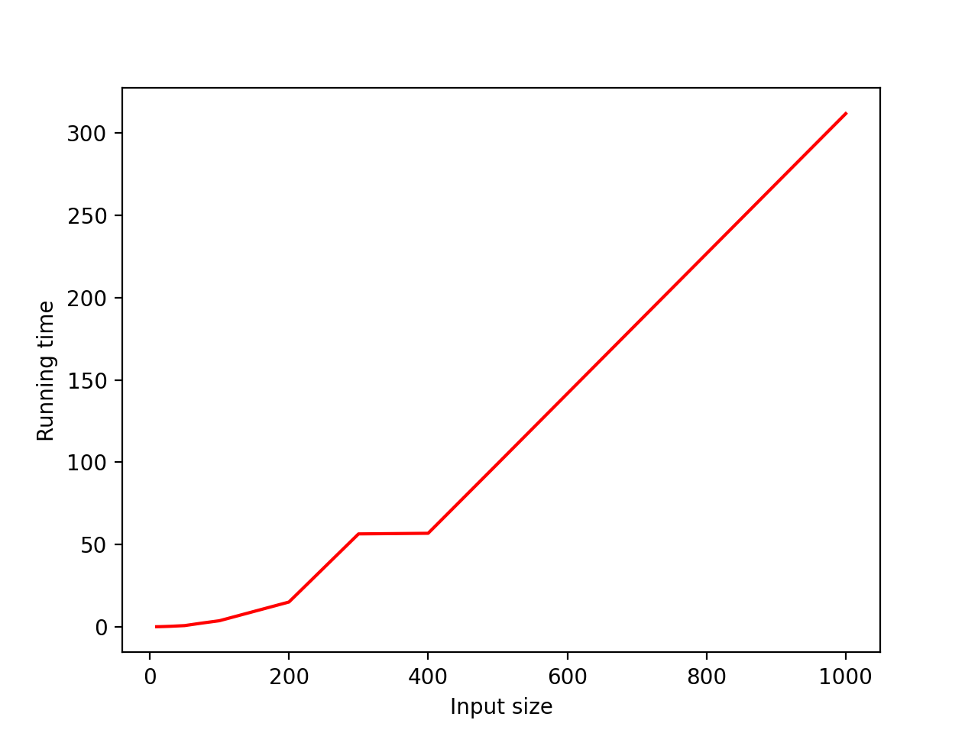Figure 1: A graph showing input size vs. running time for our optimized solution

Extension: Low vs high level programming languages and their impact on performance.
Although an efficient algorithmic solution was the goal of this project, there are additional ways to cut down on a program’s runtime. Python, the language our submitted solution was written in, is an interpreted language, meaning that the work of transforming beautiful, human-readable python code into something your computer can understand at the lowest level is done in real time by a program (the interpreter). Python is by no means a slow language, but it is by no means the fastest either. That title would go to machine code, not as much a programming language as a way for a computer to turn “instructions” into real, physical operations involving hardware like memory. Python, with it’s interpreted structuring, has a roundabout process by which it becomes instructions. C, on the other hand, is an example of a language with a very clear relationship to it’s assembly instructions. C is compiled, meaning a program (in my case, the GNU C Compiler) converts the C instructions into assembly ones and stores them in an executable file. Even if I were to delete all traces of the C language from my laptop, it would still know what to do with this file. With this in mind, I decided to implement a solution in Python as well as in C and compare their results.
This table shows my raw data, showing the relative performance of the same brute-force algorithm in two different languages (great steps were taken to make sure the implementations were as similar as possible).
Avg # of Items | C | Python
10 | 0.002990s | 0.004155s
15 | 0.128407s | 0.319898s
20 | 94.774249s | 303.294555s
The graph below shows the data graphed on a line plot. As you can see, the C version consistently outperforms the Python one by a factor of around 2-3. However, as is expected, algorithmic complexity is still king, and the exponential nature of the problem makes sure the two implementations grow at similar rates.
Figure 2: Number of items versus running time for a C and Python version of the same program

Due to the difficulties of writing two programs at once, I wasn’t able to finish upgrading both programs while ensuring they stayed similar enough to compare fairly. However, due to how nicely our optimized Python solution lends itself to a large malloc’d table in C, I’m sure the performance differential would only increase. If you want more information, you can browse through the code on my GitHub, which contains our submitted solution, my C solution, my Python solution which was designed to mirror the C one, and more. The link is github.com/CaseRegan/CP307.

