

COCA COLA VENDING MACHINE

TEACHER: Diana-Irena Pop

STUDENT: Casian-Cristi Cristian

GROUP:30412

SPECIFICATION

Design a Coca Cola vending machine. The price is 1 leu. 5-, 10- and 50-bani coins are accepted. The system is equipped with 5 photocells:

F0- for the 5 bani coin;

F1- for the 10 bani coin;

F2- for the 50 bani coin;

F3- for rejecting currency (other than those accepted) or foreign bodies;

F4- for currency accepted signal.

If there is no Coca Cola then no coin type (FS) is accepted. The total amount is checked and the coins are returned if the amount is not complete (RM). Re-release the rest, if any.

Signals are generated and signaled for the acceptance of a coin (AM), the total (AT) and the release of Coca Cola.

TABLE OF CONTENTS:

CHAPTER 1: DESIGN

1.1 Black Box

1.2 Control and Execution Unit

1.2.1 Block Diagram for first breakdown

1.2.2 State diagram of Control Unit

1.2.3 Establishing the resources (EU)

1.3 State diagram of Control Unit

CHAPTER 2: JUSTIFICATION FOR THE CHOSEN SOLUTION

CHAPTER 3: USER MANUAL

CHAPTER 4: FUTURE DEVELOPMENTS

CHAPTER 5: BIBLIOGRAPHY

CHAPTER 1: DESIGN

1.1 Black Box

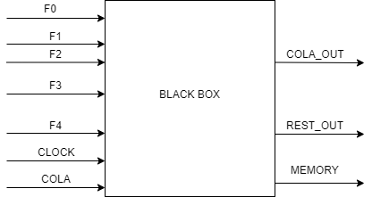

Here we have the black box of the machine, where I put all the inputs that I need, and the outputs. I will start by describe what means every input and output. First of all, we have F0, F1, F2 which represents 5 bani coin, 10 bani coin and 50 bani coin. F3 and F4 are inputs for reject and accept currency. We have a clock as input, cola which is the button for giving the coca cola if we have enough money in the machine and rest which is for giving us restore if appropriate. Memory is the output to see how much money we have in the machine, if we have enough money, we activate cola_out to give us the coca cola and if we need to get restore, we’ll get from rest_out.

1.2 Control and Execution Unit

The system's black box must be further decomposed in order to find implementable components. We will do a top-down break down of the problem until we get to known circuits, and then we will implement bottom-up.

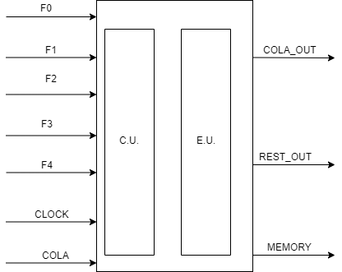

The first break down of any system is one in which we will differentiate between the control logic in the system and the system resources. The control logic is represented by the Control Unit (CU) and the resources are represented by the Execution Unit (EU).

1.2.1 Block Diagram for first breakdown

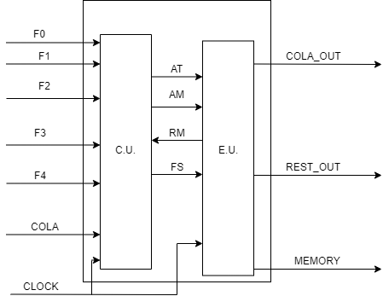

AT- Signal for acceptance of all coins

AM- Signal for accepting a currency

RM- Check the total amount and return the coins if the amount is not complete

FS- No currency is accepted.

1.2.2 State diagram of Control Unit

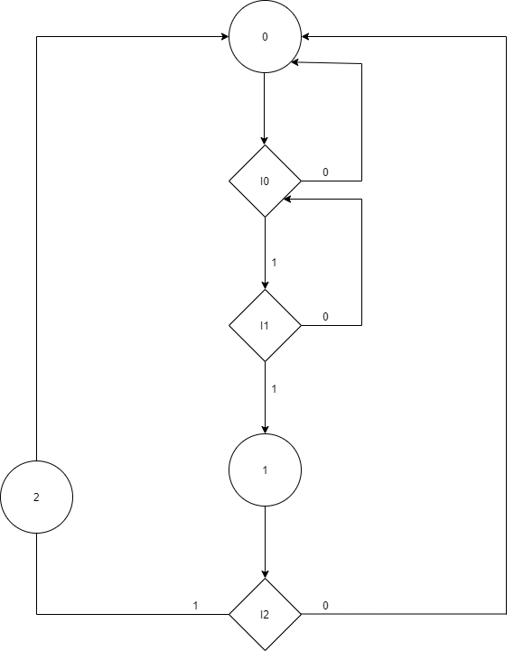

0- is the initial state I1-select the coca cola

I0- verifying the amount of money 0- coca cola doesn't exist

0- there are not enough money 1- coca cola exist

1- there are enough money

1-Gives the coca cola

I2-offers change 2- giving the change

0- don’t offer

1- offer

1.2.3 Establishing the resources (EU)

1.COUNTER_50

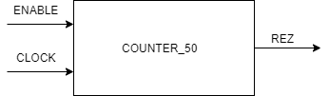

Here we have a counter which if the enable is one, we add the value fifty to the variable else, if the enable is zero the variable takes the value 0. At the end “rez” take the value of the variable.

2.COUNTER_10

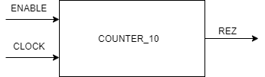

Here we have a counter which if the enable is one, we add the value ten to the variable else, if the enable is zero the variable takes the value 0. At the end “rez” take the value of the variable.

3.COUNTER_5

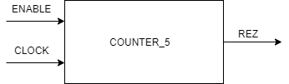

Here we have a counter which if the enable is one, we add the value five to the variable else, if the enable is zero the variable takes the value 0. At the end “rez” take the value of the variable.

4.SUM

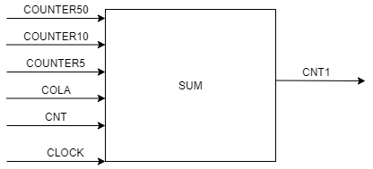

Here we are making the sum between all the currency we added before until we press the cola button. If cnt is greater or equal with one hundred, the output takes the value zero.

5.REST

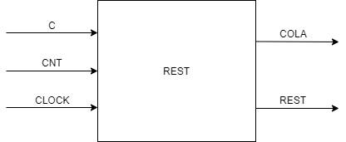

Here we are making the rest. If we have more than one hundred bani in the machine we will get the change. If we have the coca cola in the machine and the sum is greater than 100, in output rest we will put the change which is cnt minus one hundred and the output cola will be one, otherwise if the sum isn’t greater than 100 or we don’t have the coca cola in the machine, the output cola will be 0.

CHAPTER 2: JUSTIFICATION FOR THE CHOSEN SOLUTION

I consider that my solution is the one close to reality because in a coca cola machine you put coins and it automatically calculates the amount you have in the machine. If the coins do not match the required type, they will be automatically rejected. Once you have entered all the accepted coins, you have a button that, if you have the necessary amount to purchase the desired product, will give it to you and at in the same time will give you the rest, if necessary.

CHAPTER 3: USER MANUAL

VHDL is a hardware description language used in electronic design automation to describe digital and mixed signal systems such as integrated circuits. VHDL can also be used as a general use of parallel programming language, being one of the most used hardware description languages.

Now, let’s talk about what my project does. First of all I’m going to talk about inputs and outputs. F0, F1 and F2 are inputs for currency 50, 10 and 5 bani. F3 and F4 are inputs for reject and accept currency, cola is the button for generate the coca cola and rest for generate the rest. In memory we store information about how much money we have in the machine. Cola_out is the output for cola that is giving us if we have enough money and rest_out for giving the change if that’s the case.

Verify_50, verify_10 and verify_5 are signals for verifying if the currency added is one of this three inputs, F0, F1 or F2. Cnt and cnt1 are signals too but which count each currency that I introduced.

I made five components, three of them are for counting those 3 types of currency 50, 10 and 5 bani. One component is for making the sum of the after we count how many currencies of fifty, ten and five we have. And the last component is for the change.

Let’s describe now how the machine is working. You put the currency in the automata and it is verified: if it is one of those three type it will be accepted and count it. We are doing this until we have no more currency to add. After this we press the cola button to and we have minimum 100 bani in the machine we will receive a coca cola and the change, if we don’t have enough money, the whole money that we put in the machine we’ll get back.

CHAPTER 4: FUTURE DEVELOPMENTS

For this machine, the only thing that I would add is a button to buy more than one coca cola at the same time. For example, if I want to buy two coca colas and you add 200 bani to be an option to buy both not only one.

CHAPTER 5: BIBLIOGRAPHY

Lab resources (DSD and LD)

DSD lectures