**CHAPTER 3**

**Research Methodology**

*3.1 Research Design*

In order to aid the problem in handling and tracking of digital research paper copies made by the students, instructors, and research writers of Bukidnon State University, interviews and efficient sampling method must be conducted. Analyzing and evaluating system output through the statistical tool to produce an efficient system that meets to their needs.

*3.2 Research Locale*

This study will be conducted in Bukidnon State University which is located at Malaybalay City, in the province of Bukidnon, Northern Mindanao, Philippines. The main target of this study is the Research Unit to compile all the research papers made by the alumni, students, and teachers of Bukidnon State University.

*3.3 Sampling Method*

As stated by Salkind (2010), the stratified sampling method is widely used statistics method for a third party system with no overlapping groups. This study used stratified sampling method because all papers focused on best statistical method. Since this research is trying to pursue plagiarism, researchers must conduct statistical method to handle plagiarism detection and display the overall result of the submitted articles. In plagiarism detection, the researcher commonly encountered on how to measure the percentage of plagiarism and on the other hand, researchers used the stratified sampling method because this study was consists of different groups which is no overlapping issues.

*3.4 Process Model*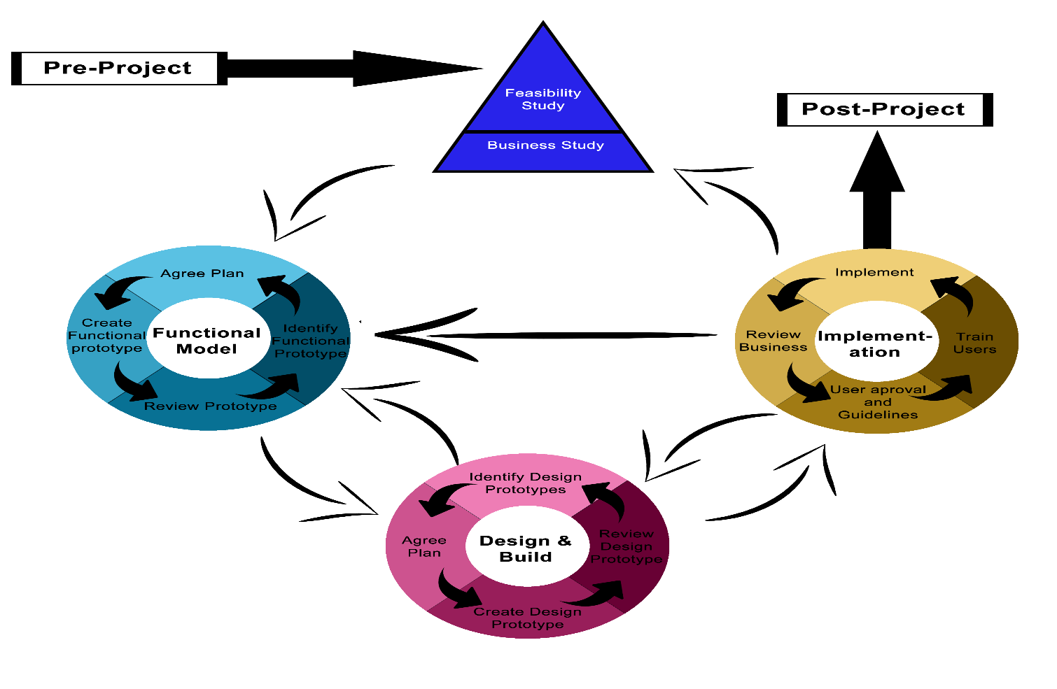

**Figure 3.4** *Dynamic System Development Method Process Model*

Dynamic System Development Method (DSDM) process model provides best practice, frameworks, and controls in Rapid Application Development (RAD) (Stapleton, 2007). This methodology was used by the researchers as a basis to derive the lifecycle of this system (Figure 3.1).

The researcher comes up with the idea of using the DSDM process model because it consists of a framework which shows different phases of this model and how those phases relate to each other. As shown in the figure above, this process model has four main phases: Feasibility, Functional, Design & Build, and Implementation. These are preceded by the Pre-Project phase and followed by the Post-Project phase, giving six phases in total. The benefit of this kind of process model is that the individual will only focus on their specific area and it is iterative, incremental approach that is largely based on the RAD methodology, unlike waterfall model which is relatively linear sequential design approach.

*3.5 Requirements Analysis*

*3.6 System and Software Design*

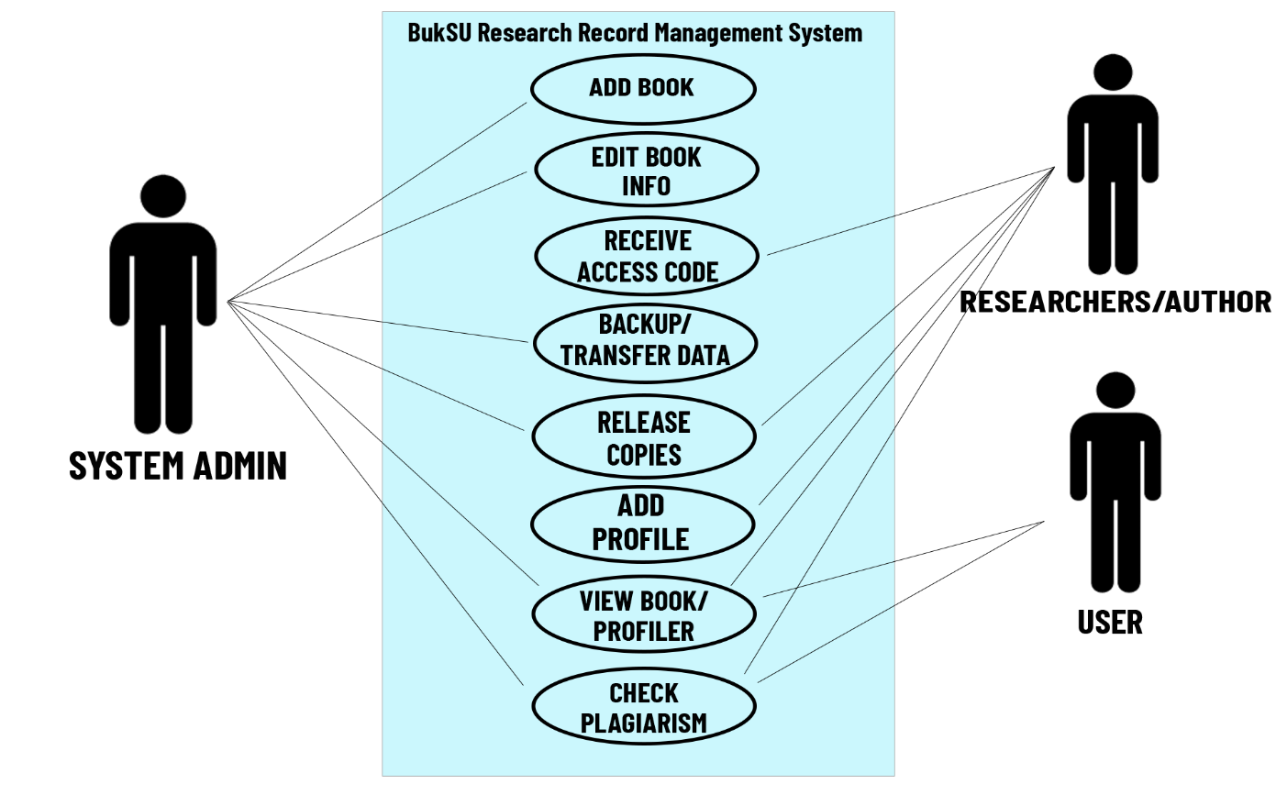

**Figure 3.6.1** *BukSU RRMS Use Case Diagram*

The figure above shows the list of actions and events typically defining the interactions between different individual or user and the system to achieve a goal. It also shows the boundaries and limitations of the system administrator, researcher/author, and user of the system itself.

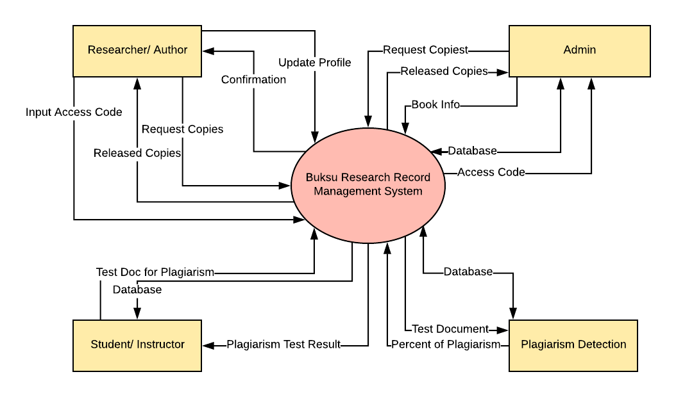

**Figure 3.6.2** *BukSU RRMS Context Diagram*

The context diagram above shows the endpoints lays the system boundaries. As illustrated, there are four external entities – researcher/author, admin, user and plagiarism detection that handled different processes of the system. It shows the give-and-take processes of the system.

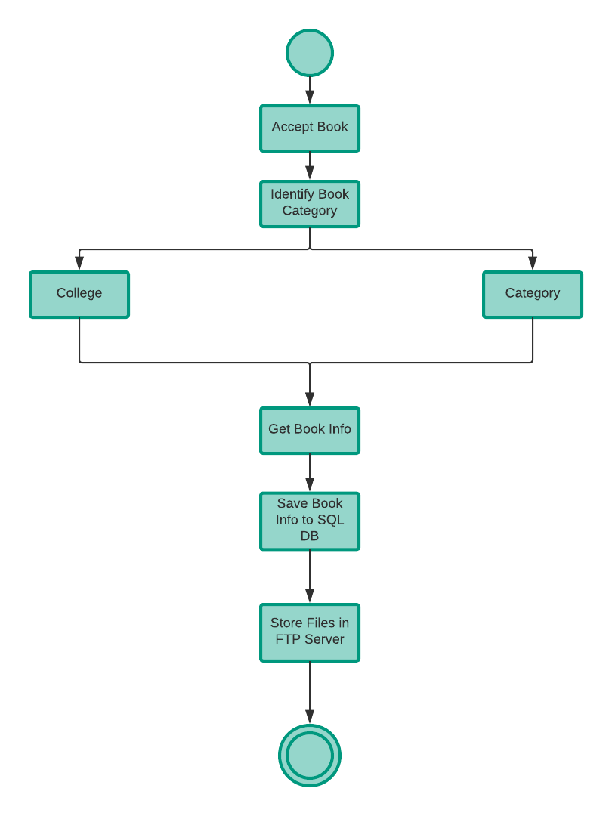

**Figure 3.6.3** *Adding of Books Activity Diagram*

Figure 3.6.3 shows how to add books to this system. In submitting a book, the system will identify the book category specifically which college it belongs and what will be its categories such as general science and the like. After the categorizing of the book, the system will get the information of the book then save the information gathered to the SQL database and store the file in FTP server.

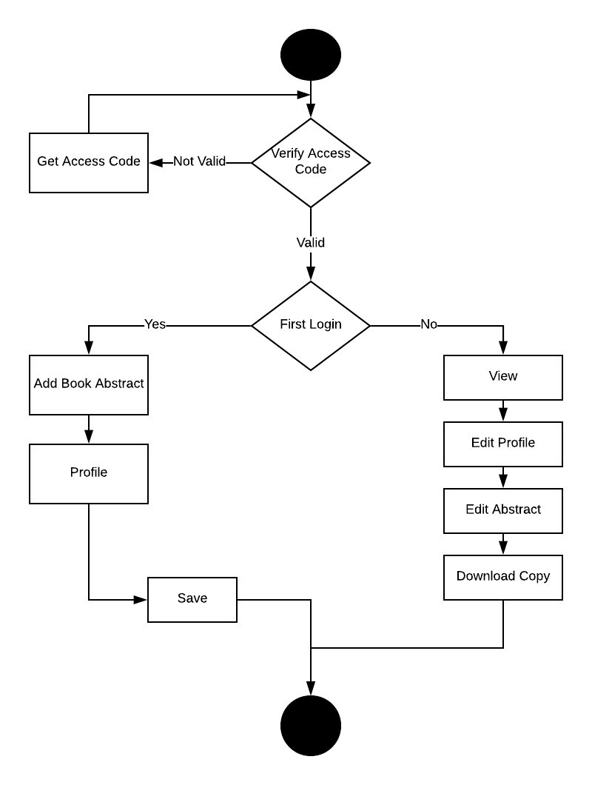

**Figure 3.6.4** *Research Updating Profile Activity Diagram*

As shown in the figure above (Figure 3.5.1), it illustrates the procedures on how to update profile in this system. The researcher/author must enter the access code provided by the system followed by the verification. If the system verifies that the access code was valid, it will check if it is the first-time logging in or not. Log in for the first time in this system will go to the adding of book abstract followed by the profile then save to the database. Otherwise, the system will allow the researcher/author to view, edit their own profile, edit the abstract, and download copy of their own book.

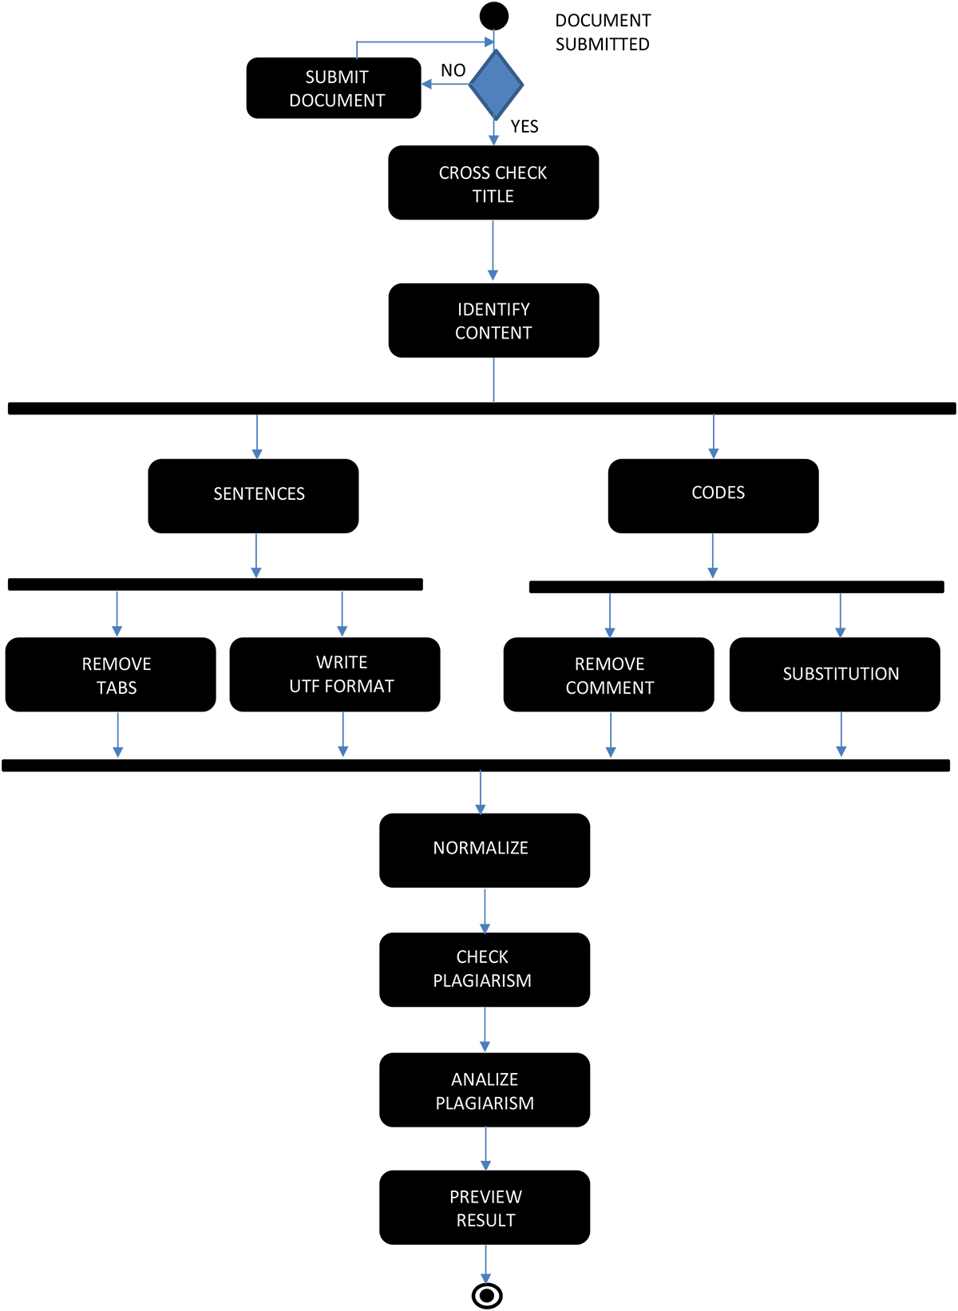

**Figure 3.6.5** *Plagiarism Detection Activity Diagram*

The figure shown above is the activity diagram of plagiarism detection in this system locally. The system will check if the document was already submitted or not. If the system was already submitted, the system will check the title and identify the content. The two kinds of data that the system will check are the codes and sentences. Both kinds of data will be simplified. In sentences, the system will remove the tabs and write UTF format while in codes, it will remove the comments and substitution. After that, normalization will be required then proceed to the checking of plagiarism. The system will then analyze the plagiarism and provide the result to the user.

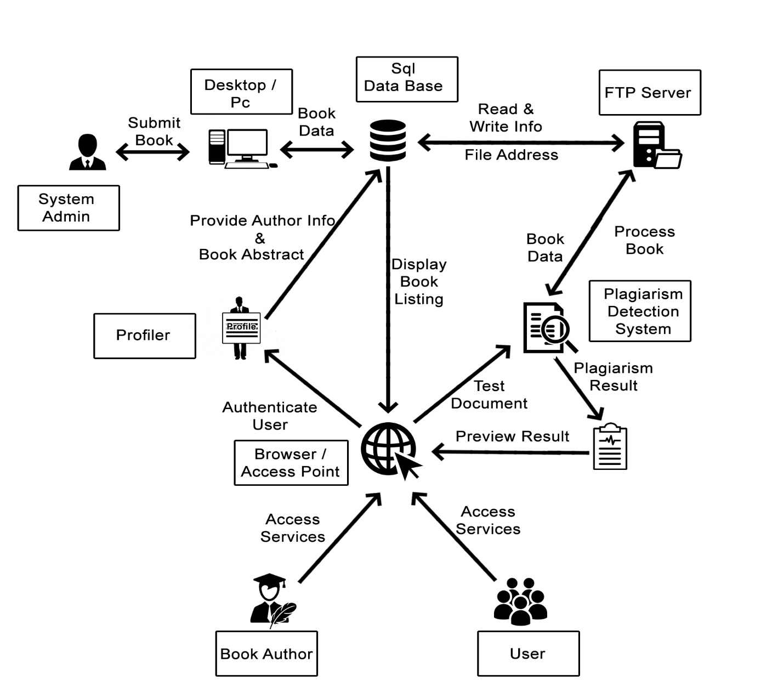

**Figure 3.6.6** *BukSU RRMS Physical Architecture*

Figure 3.6.6 shown above is the complete physical layout of the BukSU Research Record Management System and its components in a schema. This illustration shows the relationship of one component to another.