

**Bukidnon State University**

**Malaybalay City Province of Bukidnon**

**College of Arts and Sciences**

**“MASTER DOCUMENT REGISTER”**

**For Bukidnon State University**

*Researchers:*

Cabudoy, Jay Louwelle E.

Fabre, Karl Anthony P.

Handugan, Remar B.

**In Partial Fulfillment of the Requirement of the Course**

**IT PROF 14 – Capstone Project 2**

**Second Semester, SY 2017 – 2018**

**Abstract**

This Documents and Records focuses on the concept of University Document Controller (UDC) and University Document and Records Controller (UDRC) and how adoption of Master Document Register System (MRDS). The research focuses on the factors of perceived efficiency and on the costs that exist in the Bukidnon State University. More specifically this Document and Records is a qualitative exploratory case study which aim is to examine the attitudes of individuals who are working in In Bukidnon State University that possess an MDRS. In order to acquire this deeper understanding the data collection methods that were used were the in person semi structured interviews and the observation during the research was examined how the perceived efficiency and the costs in the University. The analysis of the collected data shown that the specific individuals in the specific organization are benefited by the MDRS and that their work is improved and Existed.

**Acknowledgements**

We would like to express our special thanks of gratitude to our Capstone Adviser, Ms. Melody C. Ravelo who never lose hope on us, for the support and help we receive from her in developing the system regarding to Bukidnon State University Quality Management System (QMS) the “Master Document Register” as she guide and empower as with knowledge about the technicalities we are applying into our system, cheering us in every achievement we made in the process of development of the system and spreading positivity so that we will not mind about quitting. As well to our panels Mr. Sales G. Aribe, Mrs. Jennifer P. Timbal, and Ms. Ruffel Himalao for the acceptance of the proposed Capstone project and for the feedbacks and comments in every defend that made our system more presentable, functional and more sensible for user satisfaction. They are the one who give us opportunity to conduct a Capstone project as an evaluation of our learnings and a major requirement for our Course. Special thanks to Mr. Reymart Bello a Faculty of College of Arts and Sciences under the Natural Science Department in Bukidnon State University. He is our study Statistician and helps us get statistic results of our survey regarding to our study and the development of our Capstone project. Acknowledgement also for Mr. Marvin Cimacio, our co-IT classmate for helping us on implementing system functions on our developed system. We acknowledge also our ever supportive parents who gave financial support, moral support and the amazing chances they’ve given us over the years. Lastly, Great thanks to our ever loving God who strengthened us surviving the hardships we had meet during the development and conducting the study. We are grateful you’re always there for us. Life may rough, but Life must go on.

**Table of Contents**

Abstract ………………………………………………………………………..i

Acknowledgements…………………………………………………………….ii

Chapter 1 Introduction…………………………………………………………iii

General/Specific Objective……………………………………….........9

Scope and Limitations…………………………………………………10

Conceptual Framework………………………………………………..10

Significant of the Study………………………………………………..11

Definition of Terms……………………………………………………12

Chapter 2 Related Literature………………………………………………......15

Chapter 3 Methodology …………………………………………………….....22

Research Design…………………………………………………….....23

Research Locale…………………………………………………….....23

Requirements Analysis……………………………………………….. 23

Functional Requirements……………………………………………... 23

Chapter 4 Results and Discussions…………………………………………… 25

Presentation, Analysis and Interpretation of Data……………………. 25

System Screen Shoot…………………………………………………...38

User Feedback………………………………………………………….48

User Ecosystem………………………………………………………...51

Chapter 5 Summary, Conclusion and Recommendation………………………52

Summary…………………………………………………………….....52

Conclusion……………………………………………………………...52

Recommendation……………………………………………………….53

Appendices……………………………………………………………..53

Appendix 1. References……………………………………......54

Appendix 2. Survey Questioner………………………………..54

Appendix 3. Proponents Biography……………………………57

Appendix 4. System Codes……………………………………63

Publishable Paper………………………………………………137

Plagiarism Test result………..…………………………………156

**Chapter 1**

**INTRODUCTION**

Every organization had difficulties on managing their documents and records. The way how they compile it into their filers and categorizing each whether it is record or document? Whether it is an Internal or External Document? These are some problems in every organization we would like to take actions because who knows about those things? Especially there are no guidelines for them to follow, there are some system software that is capable on keeping documents and records electronically such as Microsoft Excel where you manually List down all documents and records comes into the organization. This study aims to help Documents and Records Controller (DCRC) to manage their documents and records in every organization who is capable of keeping it. The main purpose of the development of this system is to help documents and records controller on managing it, viewing and monitoring internal and external generated documents and to enable them to keep in track about the records they registered on its inactivity date. There are two types of Documents which are categorized as “Internal and External Documents.” Internal Documents, this are the documents that are released and issued from the organization while External Documents are those documents that are released and issued by another organization into the organization. Sometimes DCRC commit mistakes on registering it for some reasons they think that there is Active and Inactive Documents but in registering documents it is called “Validity of Documents” which is the document is called whether “current or obsolete” then Records there it is the “Retention Period” which means the Active and Inactive Date of Record. Documents are filed and keep into the organization for some reasons more likely for proofs and for audit. Technicalities on registering documents and records will be included on the development of the system so that DCRC will familiarized the process of registering documents and records specially in terms of International Organization for Standardization (ISO).

Document and Records must be kept separately and organized so that DCRC can easily find it in the filer where they compiled their documents and records. With the help of the system that we will be developing, they can keep in track on which or where filer they compiled their documents and records by viewing its Masterlist and search its specific Document Title or Record Title depends on the user what it wanted to view.

According to Urs Raas, an author of the journal “Electronic record keeping- more than electronic document keeping,” he stated in his abstract that “Information and communication technology rapidly developed over the past decade and provided the means to easily capture, store and distribute documents in vast quantities and at an ever‐increasing speed. And it includes electronic record keeping where how developers combines traditional record management practices with electronic document management features to create an electronic recordkeeping system.” The feature of his Electronic record keeping is based on the traditional management practices and he applied it into his system development because he wanted something new and innovative in terms in record keeping which is more likely what we wanted to develop. Urs Raas developed its system on record keeping but we want to combine the keeping of documents and records in 1 system software that makes the system with 2 in 1 feature that can keep both documents and records.

Another journal from the University of Nottingham in United Kingdom tackles about the “Storing information and keeping good records” it is about keeping track and searches on located sources of documents and records where it can help end user to keep in touch and aware about the documents and records that they registered. They included technicalities on searching like if they have the system we will be developing then they will be searching for sure the titles of documents and records first because it is important to know whether the documents and records are issued or not in the organization. They also included in their journal about the importance of viewing registered records as we all wanted to know its availability and we also wanted to have printouts about those things we’ve searched for notes purposes because sometimes we forgot. That’s why we like to include the printing option in our system so that end user can have printouts on documents and records registered in the system for usability purpose.

A journal from University of South Australia they conducted a study too about the technicalities of “Document control and Record management.” First, they tackle about the purpose of their study which is to control document and manage record in their University in accordance of one of their Documents and Records Control Unit (DRCU) for their business system requirements. It includes document creation, document review, updating the documents, identification of documents, prevention of unintended use of obsolete documents, and document approval prior to issue. They included major technicalities on keeping documents and records which are “Document control” where it is the process established in this procedure to define controls needed for the management, “Records management” where it is ‘the efficient and systematic control of the creation, receipt, maintenance, use and disposal of records, including processes for capturing and maintaining evidence of and information about business activities and transactions in the form of records’ and the “Retention Period” which is a specified period for which a record must be kept before it may be destroyed. We can use their technicalities on document control and record management in developing our system so that the system will pass the ISO.

Another study conducted by Lynn Kime entitled “Record keeping as a form of Risk Management” he stated in his introduction “Record keeping may time consuming but it is really important to do especially in his business in agriculture, there are insurance companies, lender and government agencies are requiring better and more accurate records. Lynn Kime is not only concern about his business and how he was doing his record keeping but he wanted to share what is the importance of record keeping especially other organization would like to know the records they have in exchange for their service. For example in our University, we have lots of organization partners commonly DepEd, some Educational Assistance organizations and etc. They need to know the records we have in our University which is related to them so that they can give/render their service in our University and without those records, they can’t give/render their service because there is no records for them to base. That’s how Record keeping as a form of Risk Management.

It is really important to keep documents and records especially those are the things which is usually used as information bases. It is also important to know the technicalities on document and records management especially for ISO purposes. By the development of the system, we will assure that it will help each DCRC to control documents will and manage records in a proper and standard way.

**General Objective**

This study aims to develop a system software/Application using VB.Net Platform with MySql database that will help every documents and records controller(DCRC) to register documents and records electronically in a proper and in standard manner, a system that will give real time notification on records inactivity date, and to help them ease on searching registered documents and records that is issued in their organization with applied document control and record management technicalities for ISO purposes.

**Specific Objective**

1. To design a system software using VB.net Platform with MySql database that can be used by a Bukidnon State University for controlling documents and records that can also update documents and records, monitors documents and records details and can give real time notification of records’ inactivity date.
2. To implement the system software in Bukidnon State University, especially at the CAS Documents and Records Control Unit (DRCU).
3. To evaluate the system whether it is attainable, functional, applicable and useful.

**Scope and Limitations**

The study focuses on creating a system software/application for Bukidnon State University Quality Management System (QMS) document and records management. We will be developing a system that can register documents and records with technical applied on document control and records management. The system can monitor/view registered documents and records for easy searching of files and enable user to print registered documents or records depends on what it wanted to print. The system can also notify DCRC about the inactive records on its Retention period.

**Conceptual Framework**

|  |  |  |
| --- | --- | --- |
| Input | Process | Output |
| * Internal Documents details * External Documents details * Active Records details * Search Documents and Records in the Home Menu. | * input document details, choose whether it is Internal or External Documents. * input record details. add some information about its active and inactive date. * Check whether the fields are empty. If fields are empty then display error message. * Update input data on document and records register. * Delete registered document and records data. * check records Inactive date | * Register successful message on document and record register. * Error message. * Viewing of registered documents and records * Viewing of Archived records. * System can print documents and records in the view form. * System provides Real time notification of record inactivity. * View Documents and record list via search. |

**Significance of the Study**

The importance of the development of this system is to help Documents and Records Controller (DCRC) in controlling documents and managing records in a proper way of keeping and it will also help them on registering the documents whether it is internal or external and records with applied standard technicalities for ISO purposes. It can also monitor/view then search registered documents and records in the system as a referral for the actual filer of documents and records so that they can find the files they been searching let user to print registered documents or records depends on what it wanted to print. The development of the system is to fill the needs of each DCRC in keeping documents and records in prior to ISO. Each DCRC can create simple documents and records management list electronically, but the question is “Is it qualified for the ISO?.” DCRC must also familiarize the technicalities of keeping documents and records and must learn their responsibilities on maintaining documents and archiving inactive records in the organization. These are the main reason why we will be creating/develop this system. It is also for the welfare of controlling documents and managing records in the called organization.

**Definition of Terms**

**Organization**

**Documents-** a piece of written, printed, or electronic matter that provides information or evidence or that serves as an official record.

**Internal Document-** Documents that are created by the organization itself.

**External Document-**Documents come from partner organization, any documents that are not made by the organization itself.

**DCRC-** Documents and records controller, they are responsible on keeping documents and records management.

**DRCU-** Documents and Records Controller Unit, a place or office where documents and records controller work.

**Validity-** validity of documents whether it is current or obsolete.

**Current-** Current controlled documents are those required produced as determined by the needs of the safety management system.

**Obsolete-** Obsolete controlled documents are those which are no longer required, replaced or superseded as determined by the needs of the safety management system. Obsolete documents may be identified as part of the review process and shall be removed from the website and appropriately archived to prevent unintended use. Archived documents must be retained and accessible for system evaluation and legal purposes.

**Records-** information created, received, and maintained as evidence and information by an organization or person, in pursuance of legal obligations or in the transaction of business.

**Record Management-** ensuring that business activity records of evidential quality are created, managed and disposed of in accordance with legal requirements.

**Retention Period-** a specified period for which a record must be kept before it may be destroyed.

**ISO-** The International Organization for Standardization (**ISO**) is an international standard-setting body composed of representatives from various national standards organizations.

**MasterList-** List of all registered documents and records,

**Filer-** form of storage where documents and records are kept.

**Record Keeping-** the maintenance of a history of one's activities, as financial dealings, by entering data in ledgers or journals, putting documents in files, etc.

**Document Control-** – the process established in this procedure to define controls needed for the management

**Risk Management-** the forecasting and evaluation of financial risks together with the identification of procedures to avoid or minimize their impact.

**VB.Net-** is a multi-paradigm, object-oriented programming language, implemented on the .**NET** Framework. Microsoft launched **VB**.**NET** in 2002 as the successor to its original **Visual Basic** language.

**MySql-** MySQL is an open source relational database management system ([RDBMS](http://searchsqlserver.techtarget.com/definition/relational-database-management-system)) based on Structured Query Language ([SQL](http://searchsqlserver.techtarget.com/definition/SQL)). A database handler.

**A controlled document or record** – any document for which distribution and status are required to be kept current by the issuer to ensure that authorised holders or users have the most up to date version available.

**Notification**- action of notifying someone or something.

**CHAPTER 2**

**RELATED LITERATURE**

The study was conducted by [Scott Dawson](https://www.thecoresolution.com/author/scott)(2014) the study is all about Document Control in ISO 9001:2008. those responsible for managing their organization’s QMS to design a document control process that is simple to use, easy to monitor and effective to prevent the use of incorrect documentation , companies often invest heavily in dedicated staff, detailed procedures and specialized software programs to keep control of their QMS and other business documents. Auditors (internal and external) also pay particular attention to document control disciplines resulting in frequent audit non-conformance (it is commonly reported that document control generates the most non-conformance in and ISO9001 QMS). The researcher showed the important of document and records compilation of the internal and external document from the university and also the records and categorized whether it is active or inactive.

Another study is conducted by [Dorseyl](https://www.dorseymetrology.com/) (2015) the study was all about ISO Quality Management System Document Control. Effective ISO Quality Management System Document Control ensures that employees and staff have all the information they need to perform their tasks efficiently. The documented and controlled Quality Manual, Standard Operating Procedures, Work Instructions and forms serve as the guideline across all functions of the business. The maintenance and management of this information is vital to being able to create quality goods and services that ultimately satisfy the Customers. It insures that only the most current and relevant information is available in order to avoid errors that will disrupt the flow of everyday business and cause customers to doubt the company’s ability to perform effectively. This study in Dorseyl was all about to manage of business in there company to how to manage and what is flow of their company but in our system they have an access in master document and records to evaluate the internal and external audit.

## 

## Another study was conducted by Wellbeing (2013) the study is all about Document Control & Record Management. All documentation that is used or introduced to the Safety & Wellbeing website forms part of the university safety management system. This documentation is maintained in a controlled electronic format and only current versions of documentation are made available on the website. Where workplaces have established local websites/SharePoint team sites, the Safety & Wellbeing website link shall be provided for local employees to ensure accessibility to current and reliable system documentation. Researchers showed the importance of the Documents and records management this document was maintained by electronic format to be safety of all documents.

## 

## This study was conduc­­ted by Petter Oland (2017) the study all about **ISO 9001 document control**. ISO 9001:2008 requires an organization establish, document, implement, and maintain a quality management system and continually improve its effectiveness. QMS documentation includes: a documented quality policy and quality objectives; a quality manual, documented procedures; documents needed for effective planning, operation and control of processes; and certain other records required by the international standard. The standard also specifically requires a documented procedure be established, documented, implemented and maintained. The Researcher was to aim to keep all the records and we have a master copy of the document to refer to finalized and approved print out bearing original signature or electronic versions that are uploaded and registered in the maintained by the DCRC locate in every department in the university.

## This study is conducted by [Isaac Patturajan](https://www.linkedin.com/in/isaac-patturajan-95b18a16) (2015) this all about Document Control as per ISO 9001. These Companies often invest heavily in dedicated staff, detailed procedures and specialized software programs to keep control of their QMS and other business documents. Researcher was to keep the control and document process and also to show the detailed procedure and internal and external audit.

## Another study conducted by Kristal Jewell (2014) this all about the Quality Record Procedure. Our Quality Assurance Department ensures that records are established and maintained to provide evidence of conformity to requirements and of the effective operation of the quality management system. Records remain legible, readily identifiable and retrievable. This procedure defines the controls needed for the document code; date registered, document type, revision history, revision number, and distribution List of records.

## This study conducted by Walter Mansfield (2013) his study was all About Documents and Records. Documents and Records is an essential component of the Quality System. As a matter of fact, it is the backbone of the quality system documents communicates the policies and procedures that should be followed at each test site this is important for assuring consistency and accuracy at the test site.

## 

## This study was conducted by Laura Millar (2014) the study was Document and Data Control Procedure. All QMS documents have a consecutive Revision No. and a Revision date which are shown in the document footer. All documents start at Revision: 1. whenever there is a change to document, the revision number is advanced by one, the revision date of that document is changed to the date of the change and the reason for the change is noted in the change history.

## Another study was conducted by Jocelyn M. Francisco (2016) his study all about Control of Documents and Records. Document controller or the originating department shall determine the necessary distribution that will be indicated in the distribution list. The document shall be reviewed against the Document Master list by the Document Controller to check any affected document/s. For new documents which are not yet in the master list, shall be temporarily noted and be reflected in the next issue. Updating of the Document Master list shall be done every six (6) months. All documents current revision status shall be identified in the master list and shall be used as a guide to prevent unintended use of obsolete document.

## Another study conducted by Andrew Griffin (2010) the study all about Document Control and Records Management Process Description. The processes discussed are intended to be independent of whether documents or records are processed using old or new technologies. Many documents today are only processed as electronic files. In addition, many reviews and approvals are done in electronic workflows, where the progress of the document is managed in an electronic system. His study was some of the File was an electronic workflows start at the creation of the document and continue until it is declared a record.

According to Walter Mansfield (2013) the study all about the Electronic Records Management System an electronic document which has been declared as a corporate record Information created, received and maintained as evidence and information by an organization or person, in pursuance of legal obligations or in the transaction of business. In these study record is a document which has been declared as a formal record of the University.

## Another study conducted to [John Nolan](https://advisera.com/9001academy/blog/author/johnnolan/)(2015) Analysis of measuring and monitoring requirements in ISO 9001:2015. Whether you are trying to drive down the number of customer complaints, as you can see in this previous article: [Handling customer satisfaction with code of conduct and complaints procedure](https://advisera.com/9001academy/?p=1330&icn=free-blog-9001&ici=bottom-handling-customer-satisfaction-with-code-of-conduct-and-complaints-procedure-txt), or any other issue within your QMS, the more accurate and detailed evidence you have to do this, the more effective your QMS will be. Therefore, we can see that accurately and efficiently planning, resourcing, and capturing accurate evidence from all strands of your QMS is critical to your ability to meet customer [requirements](https://advisera.com/9001academy/?p=822&icn=paid-document-9001-customer-requirement-review-checklist&ici=bottom-requirements-txt) and demonstrate continual improvement. In this Case we gathering the data in Our Costumer Client wish could our user the user will be sending the data its ether internal or external Documents/Records and the UDRC will be segregate the Data and will be assign into what Document Title or Document Code and then what filler.

## 

## This Study was conducted by Konstantinos Manikas (2015) Records Management and Electronic Records Management. The problem is the Information Security. Such systems are in danger of humans disasters and it is very strategic to ensure the safety of the data. In the Master thesis will be examined Records Management and Electronic Records Management. In order to avoid possible misunderstanding it is necessary to clarify that in this work ERM and RM are used for the same purpose. The only thing that changes is the ink and the computers. We have the same data but in different forms. Furthermore, it is essential to clarify that the study focuses in the perceived efficiency because the research does not apply percentage metrics. The qualitative method that is selected offers the opportunity to interview the participants, to take their experiences, to interpret the meaning of the collected data and to observe the process.

## 

## According to NSHA Records Management Guide for Research Records (2015) administrative records are common to all organizations and fall into several categories: human resources, finance, materiel management and information management. With the exception of personnel and financial records, most administrative information has a short life cycle. Retention periods for personnel and financial records are set by NSHA Departments of Finance and People Services. These departments are the Offices of Primary Responsibility for finance and personnel records. They are responsible for retaining the records for their full life cycle to ensure that all audit, legal and fiscal requirements are met. The administrative records must not be intermingled and stored with operational records. They must be kept separate documents.

**CHAPTER 3**

**Methodology**

In order to achieve the objective of this study, literature review, questionnaire and interviews are conducted in order to review the effectiveness and acceptance of the Master document Register Management System for BukSU-QMS. There are a few studies conducted around the University reviewing the benefits and adopting the `Master document Register management system. These studies proceedings are analysed in details for their benefits. Data collected from questionnaire and interviews will be compared against these reports to analyse the differences in the perception in adopting these systems.

***Research Design***

In this study the researcher was able to used of information-gathering tools to collect the data for this study.The group have gathered the survey questioners as baseline from BUKSU employees regarding their level of participation and benefit from the systems’ develop and professional development activities available in Record Controller. There are five offices participated in the survey: Data Center, Library, Department of Dean's Office, OSS, Registrar Office and Finance Unit. This design is used to have a more detailed or thorough information researching for the research paper. Its aim is to obtain information concerning the current status of Document Filing and Management and to describe what changes could be applied with respect to the current situation.

This design is particularly important in the field of instructional technology. When making an automated system, there isn't any way to reverse the changes that happen. Because of this research design, the researcher was able to know what changes occur within time goes by because of the existing system.

***Research Locale***

This study is located at Malaybalay City, the capital and the first city in the province of Bukidnon located in Northern Mindanao. This study will be conducted at Bukidnon State University for the Quality Management System. The current Quality Management System is adopting a manual process of registering and filing their document and records.

***Requirements Analysis***

Bukidnon State University (BUKSU)“Master Document Register” needs to include documented information required by the ISO 9001:2015 standard and documented information determined necessary for the effectiveness of the MDR. This procedure applies to all quality management system records and is to be followed by all personnel where appropriate. Quality records are generated and maintained by the departments responsible for their creation. For electronic records back up procedures are established employees are responsible for backing up their data. As we consult and instructed by our panels, they instructed us to use College of Arts and Sciences data information in documents and records for the testing of the system functionality.

***Functional Requirement***

Requirement for Master Documents Register is to equip with *log in* account to protect as security function. The aim of our system is to organize the file from internal to external documents electronically. The users will input the data before registering it into the system so that they will be able to monitor and keep track into the documents and records they are managing. Each document should be organize based on the filer assigned and do not disjoin into another document type.

**CHAPTER 4**

**RESULTS AND DISCUSSIONS**

To implement the document quality policy and quality objectives of the QMS quality manual, documented procedures, documents needed for effective planning, operation and control of processes and certain other records required by the international standard , specifically requires a documented procedure be established, documented and maintained.

This Chapter showed the result of what the certain process contributed to the organization’s QMS; to easy allocate all the files and to keep all the Records and Documents.

**Presentation, Analysis and Interpretation of Data**

This chapter presents the findings, analysis and interpretation of data gathered whose main objective is to found out the expecteations and perception of all Document Controller in even objective is to found out the expectations and perception of all Document Controller in every offices.

The researchers sought to answer the following questions about the functionality, usability, efficiency, reliability and protability of the system.

**Functionality question no. 1:** The system provides information about documents & records.

**Functionality question no. 2:** The system provides alert notification when the records is inactive

**Functionality question no. 3:** Overall, the system is helpful and useful

**Usability question no. 1:** It is easy to perform its function

**Usability question no. 2:** It is easy to learn how to use the system

**Usability question no. 3:** Command buttons are clear

**Usability question no. 4:** It is easy to operate and control

**Efficiency question no. 1:** The software's response time is appropriate

**Efficiency question no. 2:** The software's execution time is appropriate

**Reliability question no. 1:** The system provides precise and real time notifications

**Reliability question no. 2:** Use of the system is relevant to the purpose and user needs

**Reliability question no. 3 :** Information is error free, functional and reliable

**Portability question no. 1:** It is easy to adapt in different environment

**Portability question no. 2:**It is easy to replace another program

1.1  **Functionality**

**Table 1**

**Respondents’ Assessments as to Functionality** 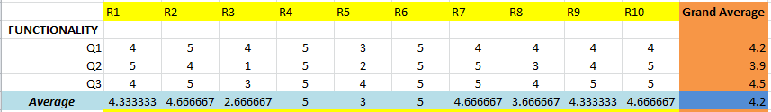 Table 1 presents the respondents’ assessment as to functionality for the system.

It can be gleaned from the data that all the funcionality were interpreted by the 10 respondents as high extent.These are Functionality Q1 (Grand Average = 4.2); Q2 (Grand Average = 3.9); Q3 (Grand Average = 4.5) and overall ratings of every respondents is (Grand Avereage = 4.2).

1.2 **Usability**

**Table 2**

**Respondents’ Assessments as to Usability**

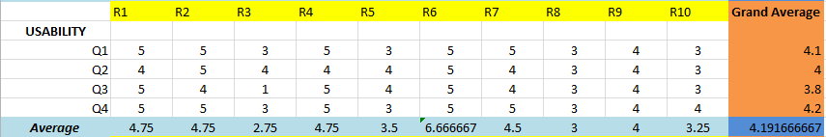

Table 2 presents the respondents’ assessment as to usability for the system.

It can be gleaned from the data that all the usablity were interpreted by the 10 respondents as high extent. These are Usability Q1 (GA = 4.1); Q2 (GA = 4); Q3 (GA = 3.8); Q4 (GA = 4.2) and overall ratings of every respondents is (GA = 4.19).

1.3 **Efficiency**

**Table 3**

**Respondents’ Assesssments as to Efficiency**

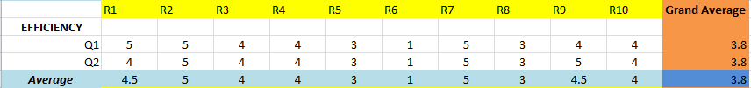

Table 3 presents the respondents’ assssment as to efficiency for the system.

It can be gleaned from the data that all the usability were interpreted by the 10 responents as not really high extent. These are Efficiency Q1 (GA = 3.8); Q2 (GA = 3.8); overall ratings by every respondents is (GA = 3.8).

1.4 **Reliablity**

**Table 4**

**Respondents’ Assessments as to Reliability**

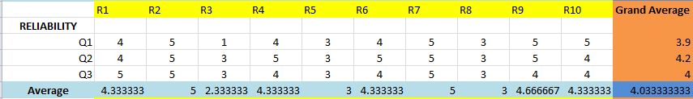

Table 4 presents the respondents’ assessment as to reliability for the system.

It can be gleaned from the data that all the reliability were interpreted by the 10 respondents as high extent. These are Reliablity Q1 (GA = 3.9); Q2 (GA = 4.2); (GA = 4); and overall ratings by every respondents is (GA = 4.03).

1.5 **Portability**

**Table 5**

**Respondents’ Assessments as to Portability**

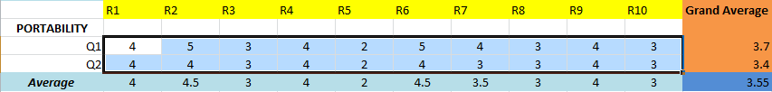

Table 5 presents the respondents’ assessment as to portability for the system.

It can be gleaned from the data that all the reliability were interpreted by the 10 respondents as low extent. These are Portability Q1 (GA = 3.7); Q2 (GA = 3.4); and overall rating by every respondents is (GA = 3.55).

**Legend**

**Mean Range Levels of Acceptability Symbol**

4.21 – 5.00 Strongly AgreeSA

3.41 – 4.20 Agree HA

2.61 – 3.40 Undecided U

1.81 – 2.60 Disagree D

1.00 – 1.80 Strongly Disagree SD

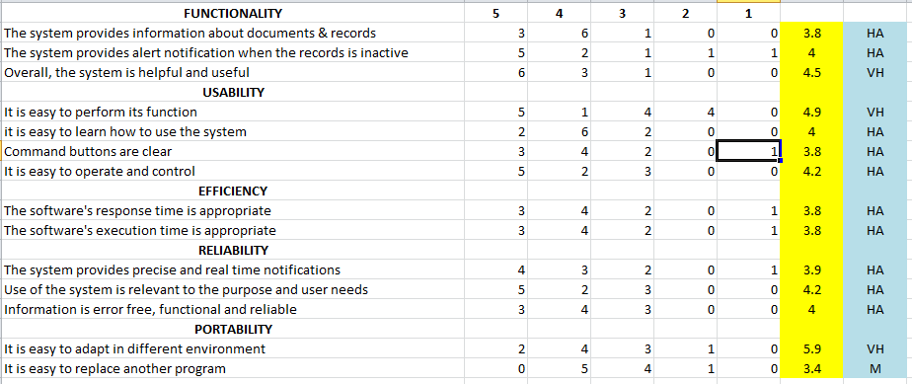

The overall computed weighted mean of 3.95 were interpreted the respondents is high extent as to Functionality, Usability, Efficiency, Reliability and Portabilit

**Statistical Analysis**

**1.1 General Linear Model**

|  |  |  |
| --- | --- | --- |
| **Notes** | | |
| Output Created | | 10-MAR-2018 07:00:20 |
| Comments | |  |
| Input | Data | D:\statistical jobs\karl fabre\fabre.sav |
| Active Dataset | DataSet0 |
| Filter | <none> |
| Weight | <none> |
| Split File | <none> |
| N of Rows in Working Data File | 14 |
| Missing Value Handling | Definition of Missing | User-defined missing values are treated as missing. |
| Cases Used | Statistics are based on all cases with valid data for all variables in the model. |
| Syntax | | GLM VAR00001 VAR00002 VAR00003 VAR00004 VAR00005 VAR00006 VAR00007 VAR00008 VAR00009 VAR00010  /WSFACTOR=factor1 10 Polynomial  /METHOD=SSTYPE(3)  /CRITERIA=ALPHA(.05)  /WSDESIGN=factor1. |
| Resources | Processor Time | 00:00:00.05 |
| Elapsed Time | 00:00:00.08 |

|  |  |
| --- | --- |
| **Within-Subjects Factors** | |
| Measure: MEASURE_1 | |
| factor1 | Dependent Variable |
| 1 | VAR00001 |
| 2 | VAR00002 |
| 3 | VAR00003 |
| 4 | VAR00004 |
| 5 | VAR00005 |
| 6 | VAR00006 |
| 7 | VAR00007 |
| 8 | VAR00008 |
| 9 | VAR00009 |
| 10 | VAR00010 |

|  |  |  |  |  |  |  |
| --- | --- | --- | --- | --- | --- | --- |
| **Multivariate Testsa** | | | | | | |
| Effect | | Value | F | Hypothesis df | Error df | Sig. |
| factor1 | Pillai's Trace | .987 | 42.987b | 9.000 | 5.000 | .000 |
| Wilks' Lambda | .013 | 42.987b | 9.000 | 5.000 | .000 |
| Hotelling's Trace | 77.377 | 42.987b | 9.000 | 5.000 | .000 |
| Roy's Largest Root | 77.377 | 42.987b | 9.000 | 5.000 | .000 |

|  |
| --- |
| a. Design: Intercept  Within Subjects Design: factor1 |
| b. Exact statistic |

|  |  |  |  |  |  |
| --- | --- | --- | --- | --- | --- |
| **Mauchly's Test of Sphericitya** | | | | | |
| Measure: MEASURE_1 | | | | | |
| Within Subjects Effect | Mauchly's W | Approx. Chi-Square | df | Sig. | Epsilonb |
| Greenhouse-Geisser |
| factor1 | .000 | 93.538 | 44 | .000 | .354 |

|  |  |  |  |  |  |  |  |  |
| --- | --- | --- | --- | --- | --- | --- | --- | --- |
| **Mauchly's Test of Sphericitya** | | | | | | | | |
| Measure: MEASURE_1 | | | | | | | | |
| Within Subjects Effect | | | Epsilon | | | | | |
| Huynh-Feldt | | | Lower-bound | | |
| factor1 | | | .483 | | | .111 | | |
| Tests the null hypothesis that the error covariance matrix of the orthonormalized transformed dependent variables is proportional to an identity matrix.a | | | | | | | | |
| a. Design: Intercept  Within Subjects Design: factor1 | | | | | | | | |
| b. May be used to adjust the degrees of freedom for the averaged tests of significance. Corrected tests are displayed in the Tests of Within-Subjects Effects table. | | | | | | | | |
| **Tests of Within-Subjects Effects** | | | | | | | | |
| Measure: MEASURE_1 | | | | | | | | |
| Source | | Type III Sum of Squares | | df | Mean Square | | F | Sig. |
| factor1 | Sphericity Assumed | 63.750 | | 9 | 7.083 | | 12.643 | .000 |
| Greenhouse-Geisser | 63.750 | | 3.190 | 19.985 | | 12.643 | .000 |
| Huynh-Feldt | 63.750 | | 4.348 | 14.661 | | 12.643 | .000 |
| Lower-bound | 63.750 | | 1.000 | 63.750 | | 12.643 | .004 |
| Error(factor1) | Sphericity Assumed | 65.550 | | 117 | .560 | |  |  |
| Greenhouse-Geisser | 65.550 | | 41.468 | 1.581 | |  |  |
| Huynh-Feldt | 65.550 | | 56.528 | 1.160 | |  |  |
| Lower-bound | 65.550 | | 13.000 | 5.042 | |  |  |

|  |  |  |  |  |  |  |
| --- | --- | --- | --- | --- | --- | --- |
| **Tests of Within-Subjects Contrasts** | | | | | | |
| Measure: MEASURE_1 | | | | | | |
| Source | factor1 | Type III Sum of Squares | df | Mean Square | F | Sig. |
| factor1 | Linear | 1.420 | 1 | 1.420 | 2.365 | .148 |
| Quadratic | 3.550 | 1 | 3.550 | 6.006 | .029 |
| Cubic | 3.128 | 1 | 3.128 | 11.107 | .005 |
| Order 4 | .106 | 1 | .106 | .120 | .735 |
| Order 5 | 2.554 | 1 | 2.554 | 13.439 | .003 |
| Order 6 | 7.037 | 1 | 7.037 | 15.064 | .002 |
| Order 7 | .378 | 1 | .378 | 1.777 | .205 |
| Order 8 | 38.093 | 1 | 38.093 | 72.733 | .000 |
| Order 9 | 7.484 | 1 | 7.484 | 5.781 | .032 |
| Error(factor1) | Linear | 7.807 | 13 | .601 |  |  |
| Quadratic | 7.685 | 13 | .591 |  |  |
| Cubic | 3.661 | 13 | .282 |  |  |
| Order 4 | 11.448 | 13 | .881 |  |  |
| Order 5 | 2.470 | 13 | .190 |  |  |
| Order 6 | 6.073 | 13 | .467 |  |  |
| Order 7 | 2.767 | 13 | .213 |  |  |
| Order 8 | 6.809 | 13 | .524 |  |  |
| Order 9 | 16.829 | 13 | 1.295 |  |  |

|  |  |  |  |  |  |
| --- | --- | --- | --- | --- | --- |
| **1.2 Tests of Between-Subjects Effects** | | | | | |
| Measure: MEASURE_1 | | | | | |
| Transformed Variable: Average | | | | | |
| Source | Type III Sum of Squares | df | Mean Square | F | Sig. |
| Intercept | 2200.179 | 1 | 2200.179 | 3003.995 | .000 |
| Error | 9.521 | 13 | .732 |  |  |

**Prototype Interface**

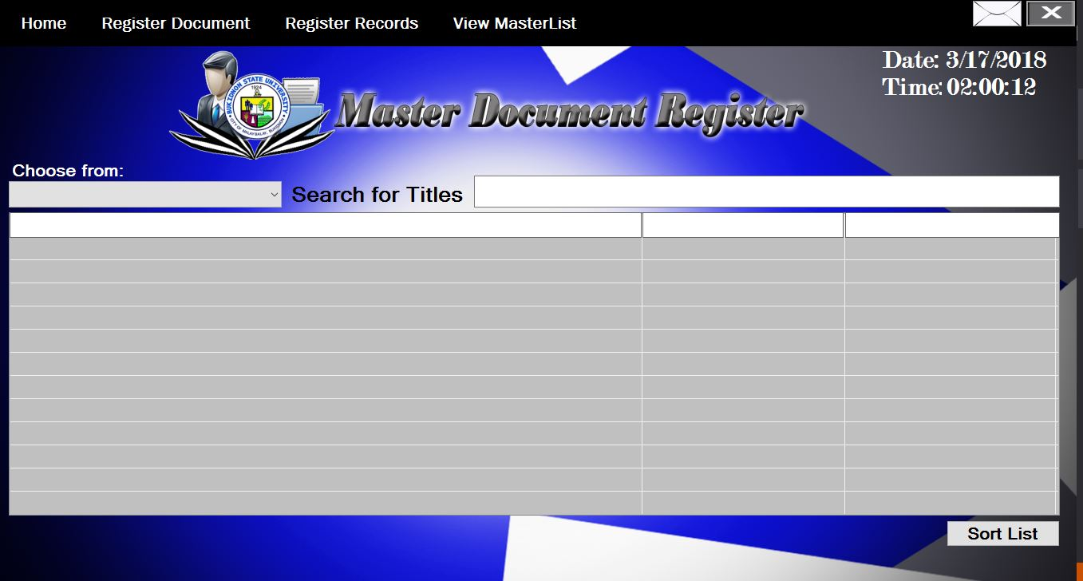Figure 1**: Main Menu**

*Figure 1*: This is the **Main Menu or Home form of the system;** the first form and appearance of the system “**Master Document Registered.”** Home form can display whether you choose “Registered Documents or Registered Record” and once you’ve chosen your choice, then the user can search the Title of document or records that is registered from the system**.**

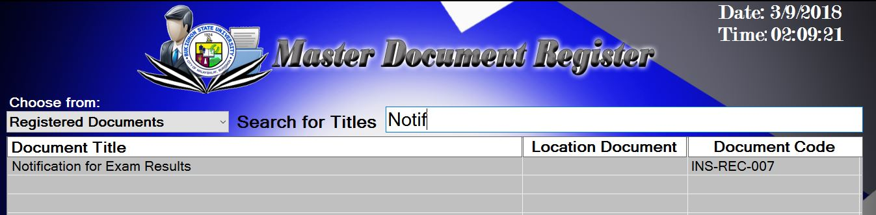

*Figure 1.1:* **The Input box for Search**. This input box will accept input from user allowing user to view and search registered documents and records in the system.

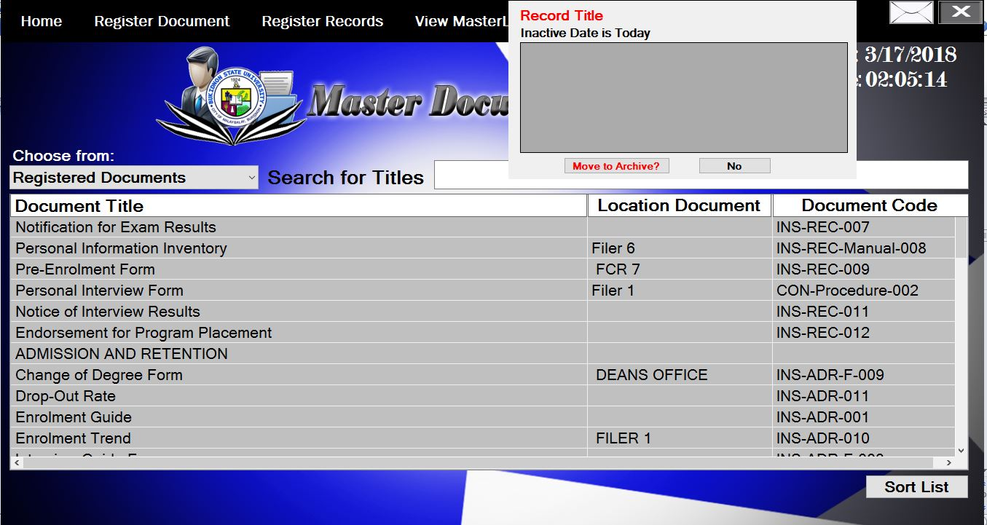

*Figure 1.2:* **The Notification button**; the button at the upper right corner that looks like an envelope that will notify user about the inactive date of the registered records.

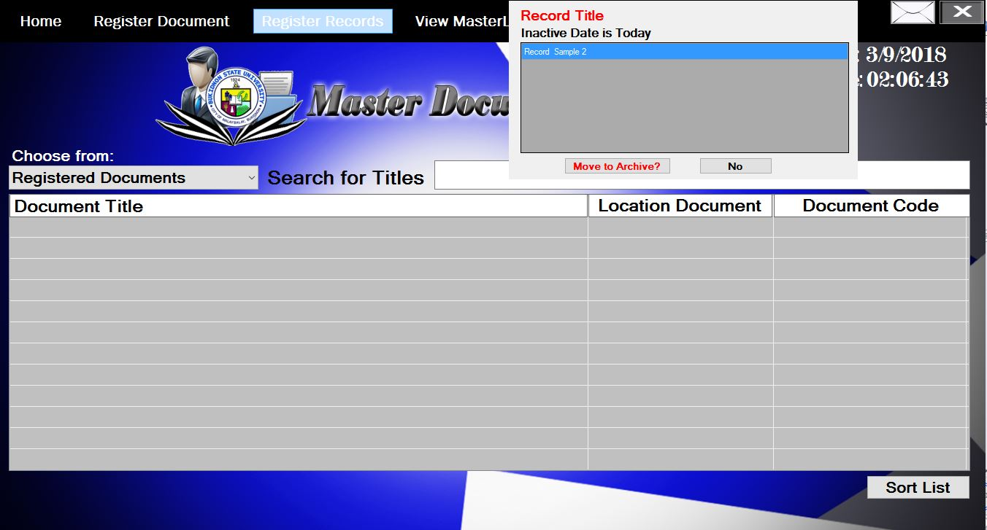

*Figure 1.3:* **The Notification button notification**; the notification button will notify user about the records inactive date and view its record title in the notification, it will allow user to choose whether he or she wanted to move the record into the archive or not.

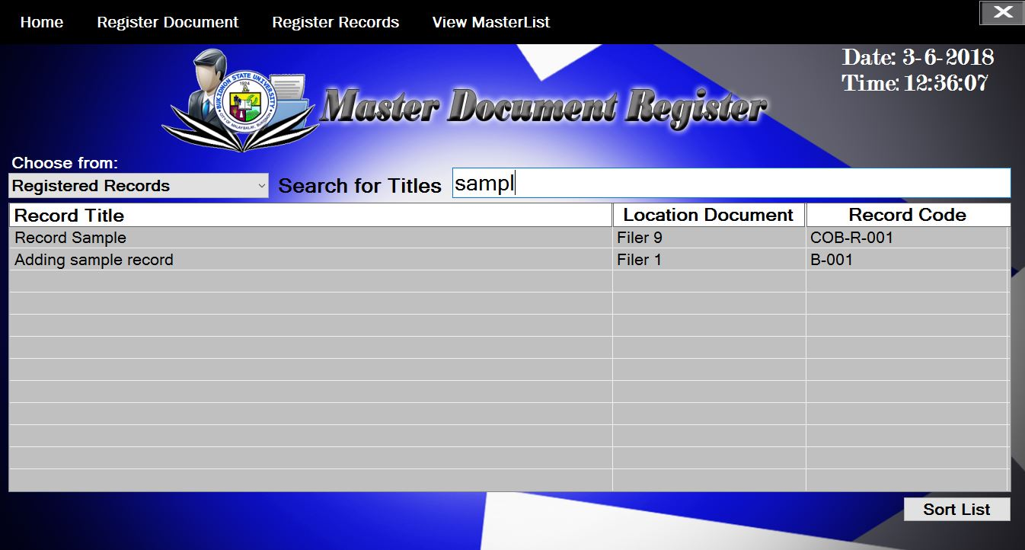

*Figure 1.3:* **Searching for registered Records;** it will allow user to search Registered records from the register and display it’s title, filer, and Code.

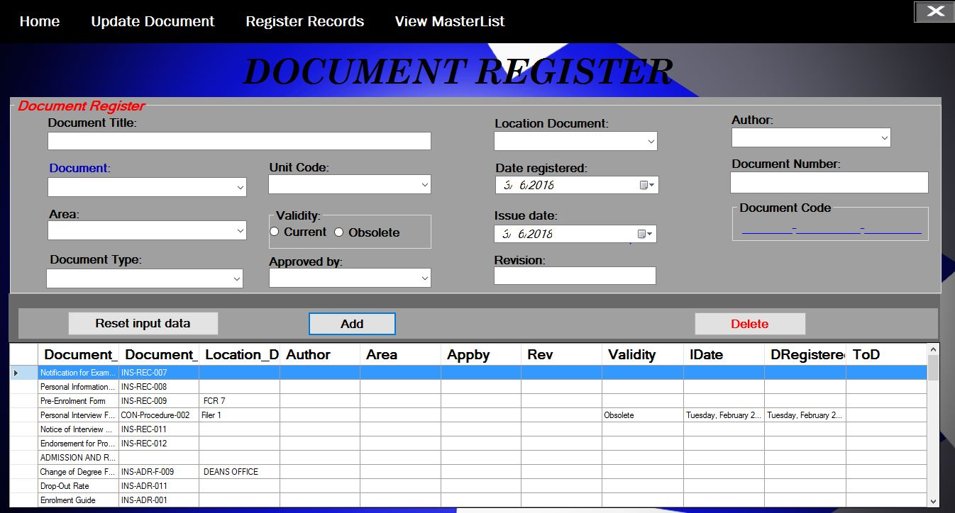Figure 2: **Register Document form**

Figure 2: **Register Document form;** it will accept data information about the documents that user wanted to register in the system. After the data has been inputted in the field then register the Document by clicking the **Add button** to save document data information in the system.

Figure 3: **Viewing and Printing Form.**

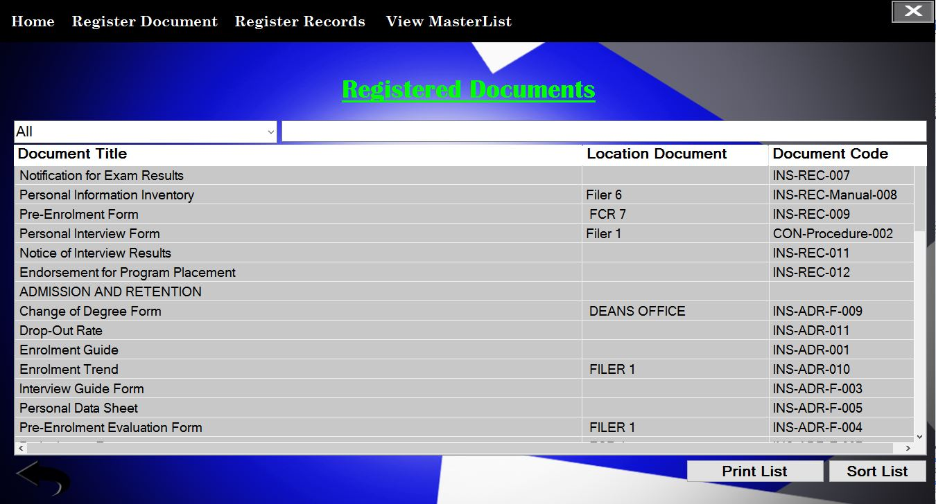

*Figure 3*: Viewing and Printing form; the user may choose into the left active button what he/she wanted to view. For example the user clicked the “Registered documents” in the View Masterlist Menu Strip at the top of the form then choose “All” in the active button, then the user can view all Registered documents and user can also search the Title, filer, and the document code of the registered documents and records.

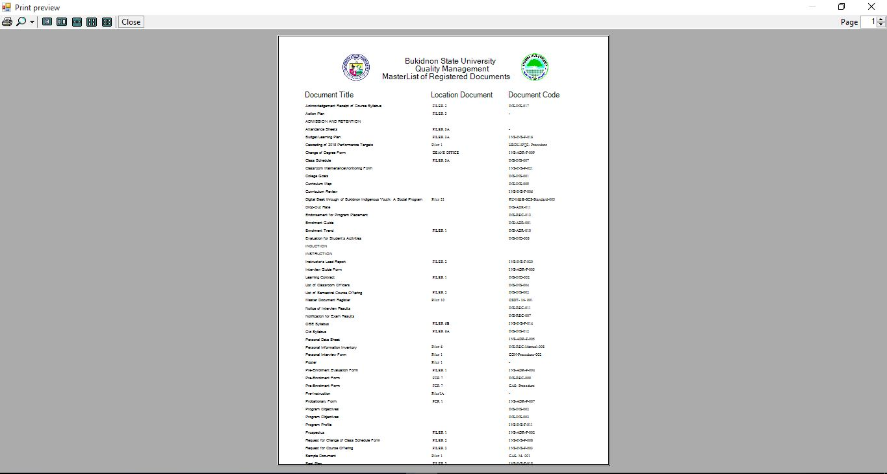Figure 4: **Print Preview of Master List**

*Figure 4*: **Print Preview of MasterList,** this is a sample print preview of all Registered Documents of College of Arts and Sciences. It includes the document information like it’s Title, Filer and its document code.

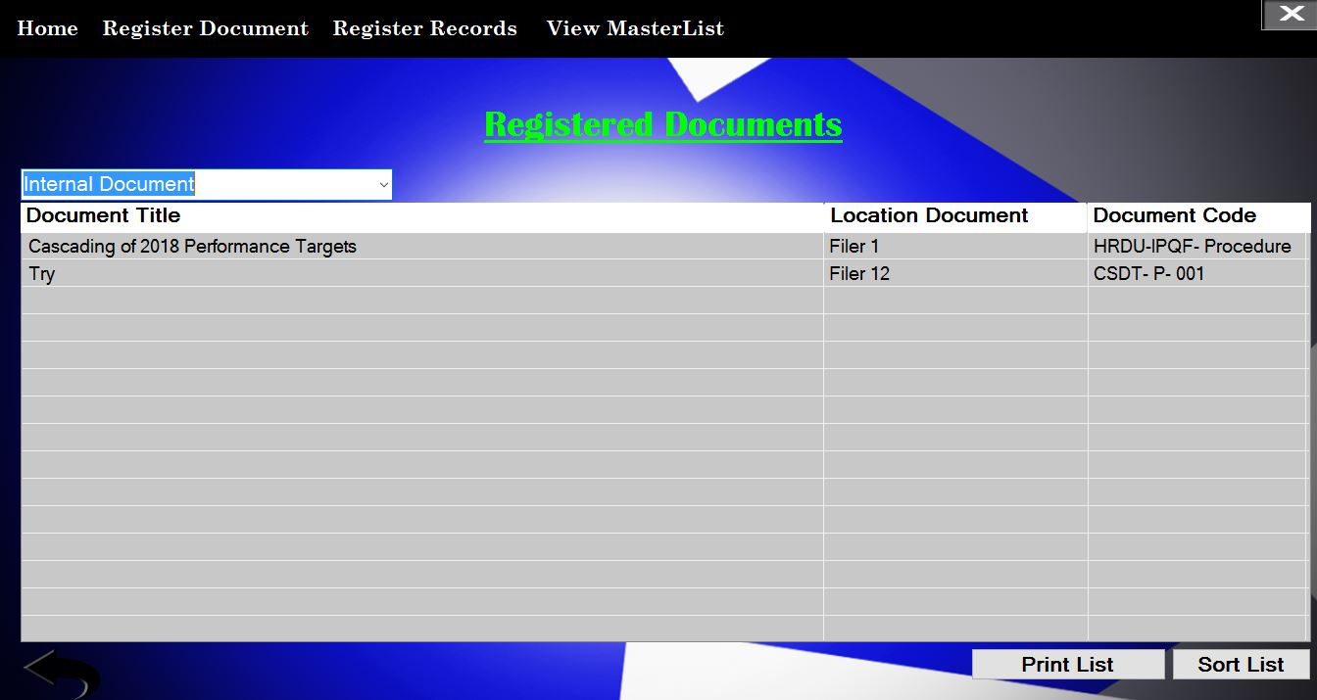Figure 5: **Internal Document**

*Figure 5*: This is in the Preview Masterlist Menu where Internal document has been selected and view.

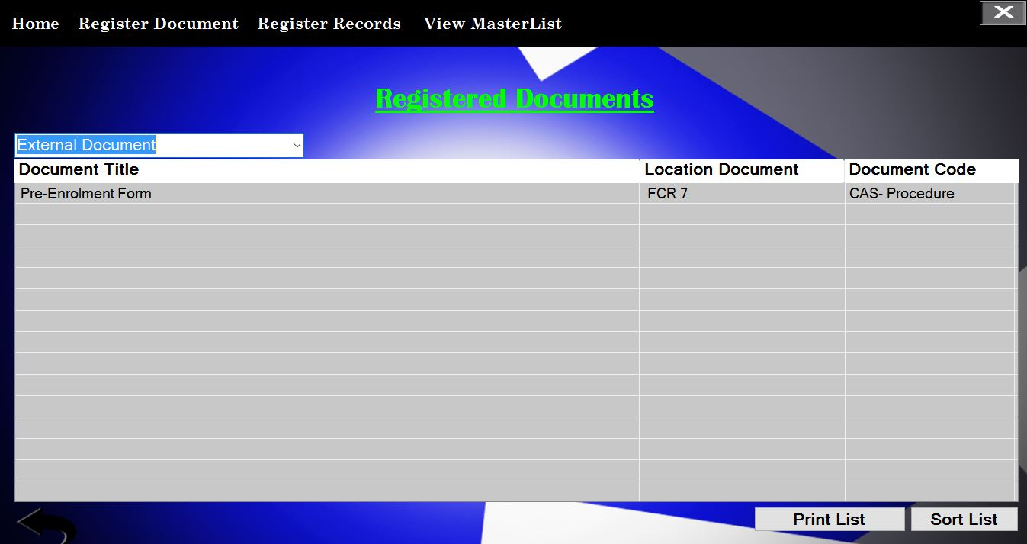Figure 6: **External Documents**

*Figure 6*: In this figure, still in the View MasterList Menu where External Document is selected to be view.

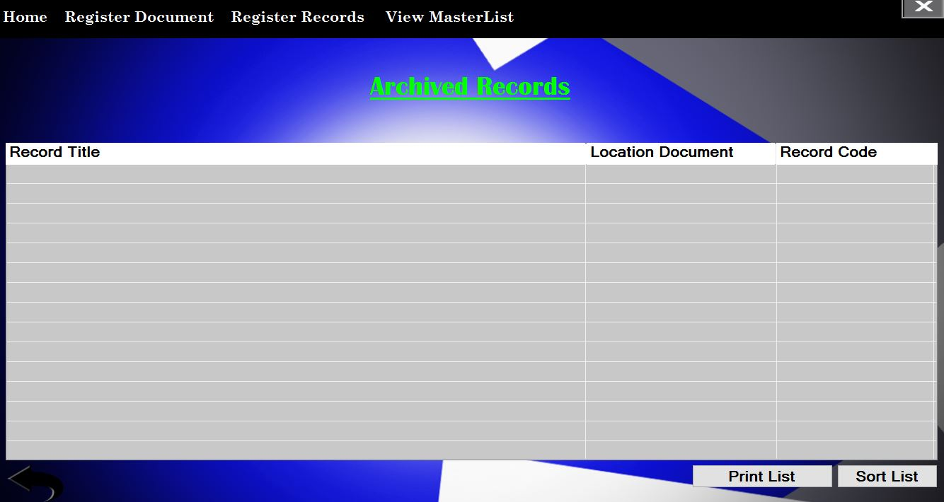Figure 7: **Archived Records**

Figure 7: To view all Inactive Records in the archive.

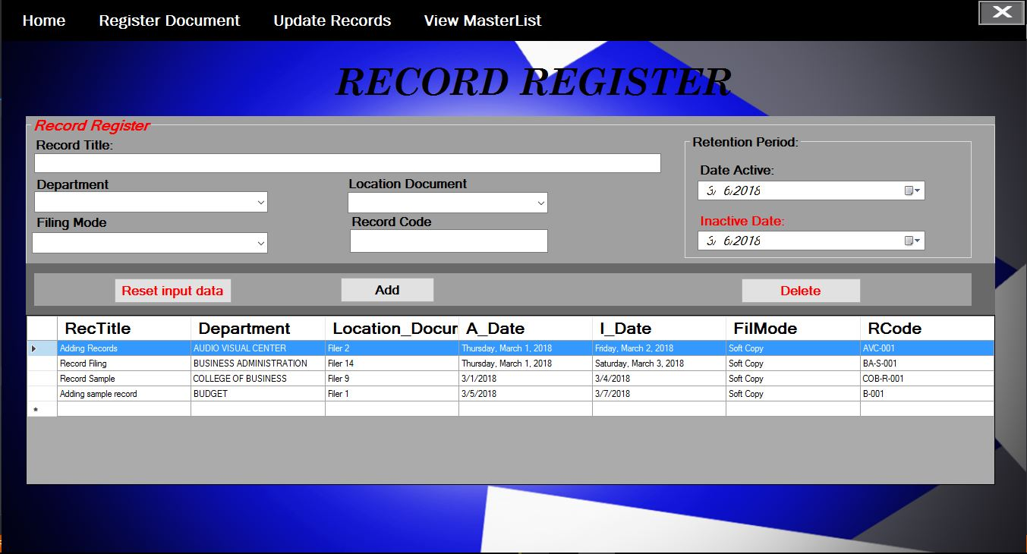Figure 8: **Adding Record**

*Figure 8*: In Adding Record, allow user to fill those empty fields with data needed for registering record and once you are done filling those fields then simply click the Add button to save the record you wanted to register into the system and it will pop-up message and automatically view in the table at the lower portion of the system if the record is successfully registered.

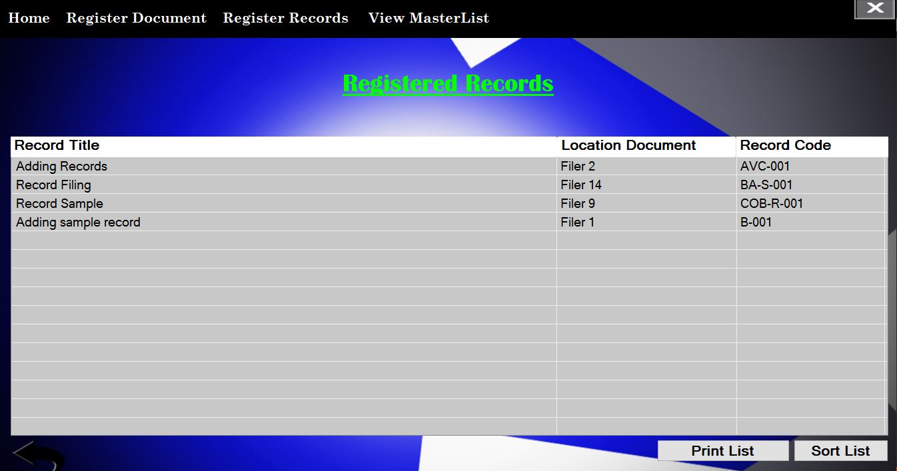Figure 9: **Viewing Registered Records**

*Figure 9:* In this figure the user can print the Registered Records in the table.

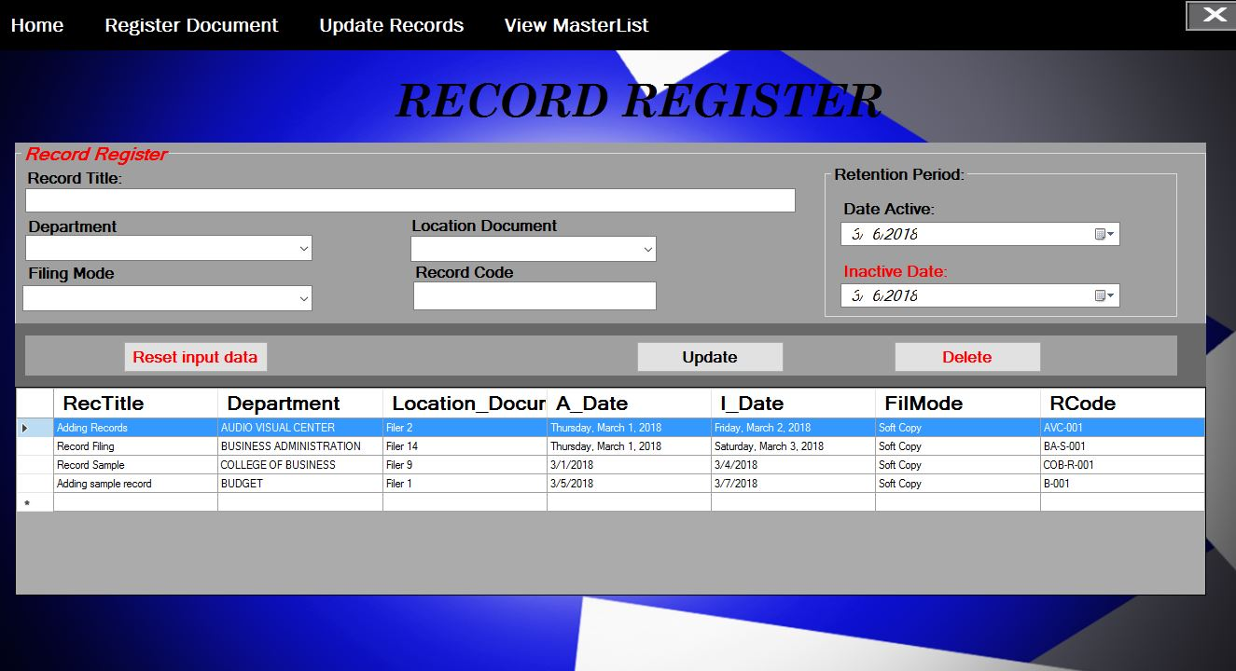Figure 10: **Update and Delete Records**

*Figure 10:* the user can **Update** and **Delete** records, it will allow user to click the data on the Table then once data is filled in those input boxes, and then the user can decide whether he/she can delete or update the registered record.

Figure 11: **Registered** **Document Update and Delete**

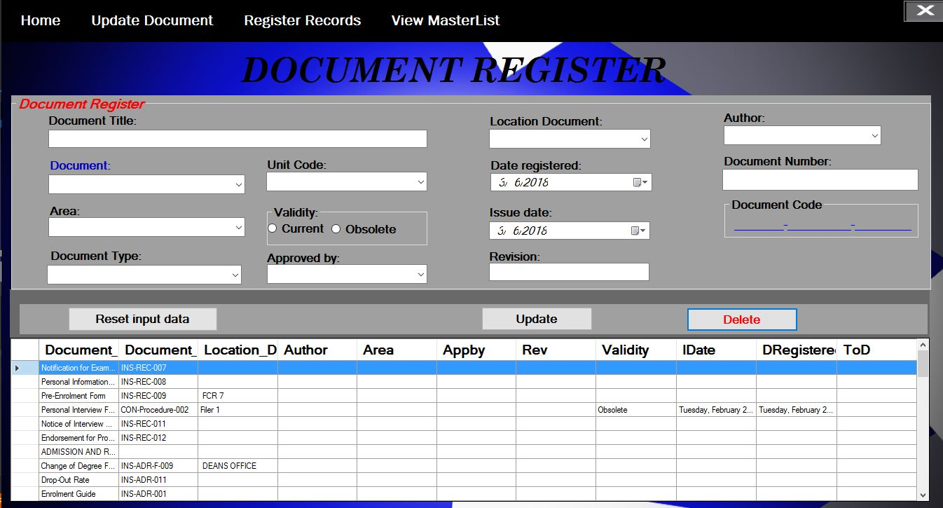

*Figure 11*: Same actions in update and delete in Record register, it will allow user to click the data on the Table then once data is filled in those input boxes, then the user can decide whether he/she can delete or update the registered Document.

***USER FEEDBACK***

These are the Comments and Suggestions of the panels provided by the respondents in accordance to the “Master Document Register” (MDR).

|  |
| --- |
| **“Comments and Suggestions”** |
| “Add Colleges” |
| “Add Assigned Folder/Filer & Docs” |
| “Remove Unnecessary Files” |
| “Search must be to Improve” |
| “List of the Report Active or Inactive Records” |
| “List of External and Internal Documents.” |
| “Home Screen in Register and Search.” |
| “Notification for Active and Inactive Documents and Records” |
| “Separate Adding from Search” |
| “Add Condition of Docs for Editing” |
| “Selected Data List Make it Alphabetical” |
| “Record make it functional” |
| “Template Add Search Only or Edit” |
| “Report Conditional & make it printable” |
| “Menu w/ icons, menu buttons w/option (Add)” |
| “Conditional Statement instead of timer” |

The feedback from the respondents had provided the researchers with fresh ideas for additional improvement of our system in the future. Most of the suggestions strongly pointed out the need for additional function aside from the main function of the system.

There are some positive feedbacks from each Documents and Records Controller in the Bukidnon State University that it will really ease them if they have this “Master Document Register” in their department. They said it is nice and wonderful especially when there is AACCUP that is always looking for their documents and records that has been registered on their department and if the system is deployed on that particular department then it is not hard for them to track down the documents and records registered that those AACCUP accreditors was finding. They were looking forward on the implementation of the system and it’s deployment to their Unit.

If there are Positive feedbacks, then there are negative feedbacks too. Especially to those DCRC’s who have older age that are used in keeping documents and records manually. The system may be helpful for them, but they will be having a hard time to understand the innovative and standard ways of Documents and records keeping.

Some of the comments from the respondents, they are confused about how to use the system especially what if us developers is not there to teach them about the system functions on how to use it, they can’t still tell whether the system is useful and helpful to the organization. And also they will be needed in the ISO. But they won’t have to use in the near future someday.

Figure 1**. User Ecosystem**

Human Resources and Development Unit (HRDU)

University Document and Records Controller

Data Center

(Unit Document and Records Controller)

Library

(Unit Document and Records Controller)

Department Deans Office

(Unit Document and Records Controller)

OSS

(Unit Document and Records Controller)

Registrar

(Unit Document and Records Controller)

Finance Unit

(Unit Document and Records Controller)

**Figure 1.** These are some of the user who will benefit the development of the “Master Document Register. The system can be employed in every Document and Records controller Unit as their Quality Management System so that they can keep their documents and manage their records will and organized.

**CHAPTER 5**

**SUMMARY, CONCLUSION AND RECOMMENDATIONS**

***Summary***

**Data** gathering in **ISO 9001 document control**. ISO 9001:2008 requires an organization establish, document, implement, and maintain a quality management system and continually improve its effectiveness. Master Document Register documentation includes: a documented quality policy and quality objectives; a quality manual, documented procedures documents needed for effective planning, operation and control of processes and certain other records required by the international standard.

The standard also specifically requires a documented procedure be established, documented, implemented and maintained.Defines documented information as meaningful data that is required to be controlled and maintained by the organization and the medium on which it is contained. Notes to this definition indicate that documented information can refer to the Quality Management System (QMS) and its processes, documentation, and records.

***Conclusion***

The study covers the researches on the functionality, efficiency, usability, reliability and portability of the Master Document Register and collaboration of technologies and system’s processes currently available in Bukidnon State University. Based on the developed system “Master Document Register” the study is completely accepted and meet satisfaction of its end user. The efficiency of this system have been examined and it is clear that this system will enhance the understanding and knowledge of every DCRC’s on registering documents and records especially in including standard details for QMS purposes in Bukidnon State University.

The researchers conclude that the Master Document Register system is Highly Accepted and ready to use based on the survey that has been disseminated to the respondents and possible user of the system especially that the system meets their satisfactions on viewing registered documents and records that will ease them on finding it on the actual filer, notify end user on inactive date of records and will enable them to move the records in the archive and allows the users to print document and records registered in the Master Document Register System.

***Recommendations***

Based on the prior findings of the research The Master Document Register are to encourage research activities, use of innovative techniques and the establishment of standards for the University. However research activities have not been satisfactory. Limited research has been conducted other than the ones initiated by private sectors service providers on the adoption of new tools and technique in the construction for the University. The promotion for use of innovative techniques, in particular, the adoption of collaborative technologies, by the DCRCU has not been seen at all. To promote the use of these systems, the government is suggested provide subsidies for companies taking these initiatives and award could be given to those successful projects who can fully adopt these systems.

**Appendices**

**Appendix 1**: **References**

*Internet source:*

ISO 9001: 2008, Clause 4.2.3

ISO 9001 Control of Records Procedure

List of Documents/Records Retention

Bustelo. Serie ISO 30300: Sistema de Gestión para Documentos. SEDIC.Documentos de trabajo.Octubre 2011. www.sedic.es/DT-n2-SEDICISO30300.pdf.

ISO 30301. Information and documentation -- Management systems for records

ISO 9000.Quality management ISO 9001:2008.Quality management systems Nava, V. Jiménez, A.R.

ISO 9000:2000: estrategias para implantar la norma de calidad para la mejora continua. Editorial Limusa, 2005

Bustelo. Serie ISO 30300: Sistema de Gestión para Documentos. SEDIC.Documentos de trabajo.Octubre 2011.[www.sedic.es/DT-n2-SEDICISO30300.pdf](http://www.sedic.es/DT-n2-SEDICISO30300.pdf).

ISO 30301. Information and documentation -- Management systems for records

ISO 9000. Quality management

ISO 9001:2008. Quality management systems Nava, V. Jiménez, A.R.

ISO 9000:2000: estrategias para implantar la norma de calidad para la mejora continua. Editorial Limusa, 2005

ISO 9001:2008 Quality Management Systems - Requirements (Please refer to http://www.iso.org to obtain a copy)

ISO 9000 Introduction and Support Package: Guidance on the Documentation Requirements of ISO 9001:2008 (http://www.iso.org/ iso/02_guidance_on_the_documentation_requirements_of_iso_9001_2008..pdf)

AS/NZS ISO 9001:2008 Quality Management Systems – Requirements

AS ISO 15489.1-2002 Records Management - General

State Records of SA - General Disposal Schedule No.15, 8th Edition.

**Appendix 2: Survey Questioner**

State Records of SA - General Disposal Schedule No.15, 8th Edition. **PART I: Master Document Register**

Name (optional): ________________________________________________________

Office/Department: _______________________________________________________

**Objectives:** This Survey questioner will assess the effectiveness and the need of improvement of the existing system of Master Document Register of Bukidnon State University.

What is your role? (Please check the box provided below.)

󠄀University Document Controller (UDC) 󠄀Unit Document Controller/ Records Controller

󠄀If others, please specify;

___________________________________________________

Directions: Check the box that correspond your answer. Use the legend

**Legend: 5 – Strongly Agree 4 – Agree 3 – Undecided 2 – Disagree 1 – Strongly Disagree**

|  |  |  |  |  |  |
| --- | --- | --- | --- | --- | --- |
| **FUNCTIONALITY** | **5** | **4** | **3** | **2** | **1** |
| The system provides information about documents & records |  |  |  |  |  |
| The system provides alert notification when the records is inactive |  |  |  |  |  |
| Overall, the system is helpful and useful |  |  |  |  |  |
| **USABILITY** |  |  |  |  |  |
| It is easy to perform its functions |  |  |  |  |  |
| It is easy to learn how to use the system |  |  |  |  |  |
| Command buttons are clear |  |  |  |  |  |
| It is easy to operate and control |  |  |  |  |  |
| **EFFICIENCY** |  |  |  |  |  |
| The software’s response time is appropriate |  |  |  |  |  |
| The software’s execution time is appropriate |  |  |  |  |  |
| **RELIABILITY** |  |  |  |  |  |
| The system provides precise and real time notifications |  |  |  |  |  |
| Use of the system is relevant to the purpose and user needs |  |  |  |  |  |
| Information is error free, functional and reliable |  |  |  |  |  |
| **PORTABILITY** |  |  |  |  |  |
| It is easy to adapt in different environment |  |  |  |  |  |
| It is easy to replace another program |  |  |  |  |  |

What changes would most to improve our system?

**Interviewee:**

_________________________________

Signature

**Appendix 3:** **Proponents Biography**



**Remar B. Handugan**

Address: P-5A Kisolon, Sumilao, Bukidnon

Contact: +369358338064

Email: [handuganremar11@gmail.com](mailto:handuganremar11@gmail.com)

**Group Role: Hustler**

**PERSONAL INFORMATION**

Age: 22 years old

Date of Birth: May 4, 1996

Gender: Male

Civil Status: Single

Height: 5’6

Weight: 150 lbs.

Nationality: Filipino

Religion: Roman Catholic

**QUALIFICATION**

* Humorous
* Hardworking and Dedicated to work
* Willing to learn new things
* Pleasing personality
* Respective
* Approachable
* Ability to work with a team
* Cooperative

**TECHNICAL SKILLS**

* Basic knowledge in VB10, C, C++, C# and Java
* Basic database management
* Basic JavaScript, PHP, CSS and HTML
* Basic network management and administration
* Good Presentation Ability
* Microsoft Offices (MS Word, Excel, PowerPoint, Publisher, Access)
* Basic Adobe Photoshop and Adobe Photoshop Lightroom
* Basic Adobe InDesign CC and Power Director

**SEMINAR AND TRAINING**

**2ND Bukidnon Information Technology Summit (BITS)**

February 24, 2014

Bukidnon State University

Malaybalay City

**3rd Bukidnon Information Technology Summit (BITS)**

March 27, 2017

Bukidnon State University

Malaybalay City

**ICT Forum**

March 30, 2017

Bukidnon State University

Malaybalay City

**EDUCATION**

**Kisolon Central Elementary School** 2004 – 2010

Kisolon, Sumilao, Bukidnon

**Impasug-ong National High School** 2010 - 2014

Impasug-ong, Bukidnon

**Bukidnon State University** 2014 – 2018

Malaybalay City, Bukidnon

Bachelor of Science in Information Technology

**AFFILIATION**

**Computer Society Organization Member** 2014 – 2018



**Jay Louwelle E. C abudoy**

P-3A Crossing, Libona, Bukidnon

jaycabudoy14@gmail.com

+639061671045

**Group Role: Hacker**

**PERSONAL INFORMATION**

Age 20

Gender Male

Date of Birth December 13, 1997

Place of Birth Sta. Fe, Libona, Bukidnon

Civil Status Single

Nationality Filipino

Religion Roman Catholic

Languages English, Cebuano and Filipino

**EDUCATIONAL BACKGROUND**

Tertiary Bachelor of Science in Information Technology

Bukidnon State University

Fortich St., Malaybalay City, Bukidnon

June 2014 - Present

Secondary Libona National High School

Crossing , Libona, Bukidnon

June 2010 - March 2014

Elementary Crossing Elementary School

Crossing, Libona, Bukidnon

June 2003 - March 2010

**SEMINARS/TRAININGS ATTENDED**

March 27, 2017 3rd Bukidnon Information Technology Summit (BITS) Technical Seminar

*Bukidnon State University*

*Malaybalay City, Bukidnon*

**ICT Forum**

March 30, 2017

Bukidnon State University

Malaybalay City

**SUMMARY OF SKILLS**

* Computer Literate and Proficient in MS Word, Excel and PowerPoint
* Have knowledge in computer troubleshooting
* Basic knowledge in graphic design
* Basic knowledge in web design
* Basic knowledge in web development
* Photoshop Image Manipulation
* Good oral and communication skills both in Filipino and English
* Vb.net Programmer
* Resourceful and Industrious
* Creativity



**Karl Anthony P. Fabre**

+639264271777  
[kfabre098@gmail.com](mailto:kfabre098@gmail.com)

**Group Role:** Hipster

**Personal Information**

Age : 20 years old

Birthdate : June 13, 1997

Birthplace : P-2 North Poblacion, Maramag, Bukidnon

Current Address : P-2 North Poblacion, Maramag, Bukidnon

Sex : Male

Civil Status : Single

**Education Background**

ELEMENTARY : Maramag Central Elementary School 2004-2010

SECONDARY : Bukidnon National School of Home Industries 2010-2014

COLLEGE : Bukidnon State University 4th year Bachelor Science in Information Technology 2014-2018

**Seminar/Training Attended**

October 28, 2013 Bukidnon Information Technology Seminar (BITS)  
Malaybalay City, Bukidnon

March 30, 2017 **ICT Forum**

Bukidnon State University

Malaybalay City

**Summary of Skills**

* Computer Literate and Proficient in MS Word, Excel and PowerPoint
* Computer Literate
* Back-end Programmer
* Web Developer
* C# and C programmer

**Appendix 4: System Codes**

‘This are added reference to enable vb.net and XAMPP MySql to connect

Imports System.Data

Imports System.Data.SqlClient

Imports MySql.Data.MySqlClient

PublicClassMDR_Option

‘Connection string that will allow vb.net to connect into mySql database

DimstrAsString = "server=localhost; user id=root; password=; database=casdcrc;"

Dim con AsNewMySqlConnection(str)

Dim myconn AsNewMySqlConnection

Dim myC AsNewMySqlCommand

Dim myDR AsMySqlDataReader

Dim file AsString

Dim ROWnotif AsInteger

Dim NOTIFid AsString

Dim increment AsInteger = 0

DimunAsString

Dim pw AsString

DimNOTIFdata(100) AsString

Subload()

Try

myconn.ConnectionString = "server=localhost; user id=root; password=; database=casdcrc;"

myconn.Open()

Catch ex AsException

EndTry

ListView1.Items.Clear()

‘To view database table documents data into ListView.it includes Document_Title, Location_document, and Document_Code which are column names of table documents.

Dim vsql AsString = "select * from documents"

myC = New MySql.Data.MySqlClient.MySqlCommand(vsql, myconn)

myDR = myC.ExecuteReader

While (myDR.Read())

WithMe.ListView1.Items.Add(myDR("Document_Title"))

.subitems.add(myDR("Location_Document"))

.subitems.add(myDR("Document_Code"))

EndWith

EndWhile

myC.Dispose()

myDR.Close()

EndSub

Subld()

Try

myconn.ConnectionString = "server=localhost; user id=root; password=; database=casdcrc;"

myconn.Open()

Catch ex AsException

EndTry

ListView1.Items.Clear()

‘To view database table records data into ListView.it includes RecTitle, Location_document, and RCode which are column names of table records.

Dim vsql AsString = "select * from records"

myC = New MySql.Data.MySqlClient.MySqlCommand(vsql, myconn)

myDR = myC.ExecuteReader

While (myDR.Read())

WithListView1.Items.Add(myDR("RecTitle"))

.subitems.Add(myDR("Location_Document"))

.subitems.Add(myDR("RCode"))

EndWith

EndWhile

myC.Dispose()

myDR.Close()

EndSub

PrivateSub Button2_Click(sender AsObject, e AsEventArgs)

Me.Dispose()

SDocument.Show()

EndSub

PrivateSub Button3_Click(sender AsObject, e AsEventArgs)

Me.Dispose()

SRecords.Show()

EndSub

PrivateSub Button1_Click(sender AsObject, e AsEventArgs) Handles Button1.Click

Me.Close()

MDR_index.Close()

SplashScreen1.Close()

EndSub

PrivateSub Button5_Click(sender AsObject, e AsEventArgs)

Me.Dispose()

Form6.Show()

EndSub

PrivateSub DisplayArchivedDocumentToolStripMenuItem_Click(sender AsObject, e AsEventArgs)

SDocument.Label4.Text = "Archived Documents"

SDocument.Label1.Text = "Document Title"

SDocument.Label2.Text = "Location Document"

SDocument.Label3.Text = "Document Code"

SDocument.ComboBox1.Hide()

Me.Hide()

SDocument.Show()

EndSub

PrivateSub RegisterRecordsToolStripMenuItem_Click(sender AsObject, e AsEventArgs) Handles RegisterRecordsToolStripMenuItem.Click

Me.Hide()

RDocuments.Button4.Hide()

RDocuments.Show()

EndSub

PrivateSub RegisterDocumentToolStripMenuItem_Click(sender AsObject, e AsEventArgs) Handles RegisterDocumentToolStripMenuItem.Click

Me.Hide()

MDR_index.Button3.Hide()

MDR_index.Show()

EndSub

PrivateSub MDR_Option_Load(sender AsObject, e AsEventArgs) HandlesMyBase.Load

Timer1.Enabled = True

EndSub

PrivateSub ComboBox1_TextChanged(sender AsObject, e AsEventArgs) Handles ComboBox1.TextChanged

If ComboBox1.Text = "Registered Documents"Then

Label3.Text = "Document Title"

Label4.Text = "Location Document"

Label5.Text = "Document Code"

load()

ElseIf ComboBox1.Text = "Registered Records"Then

ld()

Label3.Text = "Record Title"

Label4.Text = "Location Records"

Label5.Text = "Record Code"

EndIf

EndSub

PrivateSub TextBox1_TextChanged(sender AsObject, e AsEventArgs) Handles TextBox1.TextChanged

Try

myconn.ConnectionString = "server=localhost; user id=root; password=; database=casdcrc;"

myconn.Open()

Catch ex AsException

EndTry

‘Condition of Search where it will validate and check ComboBox has valid data to be searched in the textbox.

If ComboBox1.Text = ""Then

MsgBox("Must select Item First from *Choose from* box before Searching", MsgBoxStyle.Information, "Error")

ElseIf ComboBox1.Text = "Registered Documents"Then

ListView1.Items.Clear()

Dim vsql AsString = "select * from documents where Document_Title Like '%"& TextBox1.Text &"%' or Location_Document Like '%"& TextBox1.Text &"%' or Document_Code Like '%"& TextBox1.Text &"%'"

myC = New MySql.Data.MySqlClient.MySqlCommand(vsql, myconn)

myDR = myC.ExecuteReader

While (myDR.Read())

WithMe.ListView1.Items.Add(myDR("Document_Title"))

.subitems.add(myDR("Location_Document"))

.subitems.add(myDR("Document_Code"))

EndWith

EndWhile

myC.Dispose()

myDR.Close()

ElseIf ComboBox1.Text = "Registered Records"Then

ListView1.Items.Clear()

‘this series of codes will allow vb.net textbox input to check whether the data that has been input is available. once the data is available, it will view into the listView automatically.

Dim vsql AsString = "select * from records where RecTitle Like '%"& TextBox1.Text &"%' or Location_Document Like '%"& TextBox1.Text &"%' or RCode Like '%"& TextBox1.Text &"%'"

myC = New MySql.Data.MySqlClient.MySqlCommand(vsql, myconn)

myDR = myC.ExecuteReader

While (myDR.Read())

WithMe.ListView1.Items.Add(myDR("RecTitle"))

.subitems.add(myDR("Location_Document"))

.subitems.add(myDR("RCode"))

EndWith

EndWhile

myC.Dispose()

myDR.Close()

myconn.Close()

EndIf

EndSub

PublicFunctionconvertQuotes(ByVal str AsString) AsString

convertQuotes = str.Replace("'", "''")

EndFunction

PrivateSub ComboBox1_SelectedIndexChanged(sender AsObject, e AsEventArgs) Handles ComboBox1.SelectedIndexChanged

EndSub

‘Series of commands that will manipulate Label name values once the MenuStripData is Clicked.

PrivateSub DisplayRegisteredDocumentToolStripMenuItem_Click(sender AsObject, e AsEventArgs) Handles DisplayRegisteredDocumentToolStripMenuItem.Click

SDocument.Label4.Text = "Registered Documents"

SDocument.Label1.Text = "Document Title"

SDocument.Label2.Text = "Location Document"

SDocument.Label3.Text = "Document Code"

Me.Hide()

SDocument.Show()

SDocument.ComboBox1.Text = "All"

EndSub

PrivateSub DisplayRegisteredRecordsToolStripMenuItem_Click(sender AsObject, e AsEventArgs) Handles DisplayRegisteredRecordsToolStripMenuItem.Click

SDocument.ComboBox1.Hide()

SDocument.Label4.Text = "Registered Records"

SDocument.Label1.Text = "Record Title"

SDocument.Label2.Text = "Location Records"

SDocument.Label3.Text = "Record Code"

Me.Hide()

SDocument.Show()

Try

myconn.ConnectionString = "server=localhost; user id=root; password=; database=casdcrc;"

myconn.Open()

Catch ex AsException

EndTry

ListView1.Items.Clear()

Dim vsql AsString = "select * from records"

myC = New MySql.Data.MySqlClient.MySqlCommand(vsql, myconn)

myDR = myC.ExecuteReader

While (myDR.Read())

WithSDocument.ListView1.Items.Add(myDR("RecTitle"))

.subitems.add(myDR("Location_Document"))

.subitems.add(myDR("RCode"))

EndWith

EndWhile

myC.Dispose()

myDR.Close()

myconn.Close()

EndSub

PrivateSub ArchivedRecordsToolStripMenuItem_Click(sender AsObject, e AsEventArgs) Handles ArchivedRecordsToolStripMenuItem.Click

SDocument.ComboBox1.Hide()

SDocument.Label4.Text = "Archived Records"

SDocument.Label1.Text = "Record Title"

SDocument.Label2.Text = "Location Document"

SDocument.Label3.Text = "Record Code"

Me.Hide()

SDocument.Show()

Try

myconn.ConnectionString = "server=localhost; user id=root; password=; database=casdcrc;"

myconn.Open()

Catch ex AsException

EndTry

ListView1.Items.Clear()

Dim vsql AsString = "select * from archiver"

myC = New MySql.Data.MySqlClient.MySqlCommand(vsql, myconn)

myDR = myC.ExecuteReader

While (myDR.Read())

WithSDocument.ListView1.Items.Add(myDR("RecTitle"))

.subitems.add(myDR("Location_Document"))

.subitems.add(myDR("RCode"))

EndWith

EndWhile

myC.Dispose()

myDR.Close()

myconn.Close()

EndSub

‘This Command will view the actual date and hour of your computer into Vb.net labels.

PrivateSub Timer1_Tick(sender AsObject, e AsEventArgs) Handles Timer1.Tick

Label6.Text = Date.Now.ToString("M/d/yyyy")

Label7.Text = Date.Now.ToString("hh:mm:ss")

EndSub

PrivateSub Button2_Click_2(sender AsObject, e AsEventArgs) Handles Button2.Click

If ListView1.Sorting = SortOrder.Descending Then

ListView1.Sorting = SortOrder.Ascending

Else

ListView1.Sorting = SortOrder.Descending

EndIf

EndSub

PrivateSub HomeToolStripMenuItem_Click(sender AsObject, e AsEventArgs) Handles HomeToolStripMenuItem.Click

EndSub

PrivateSub Button3_Click_2(sender AsObject, e AsEventArgs) Handles Button3.Click

‘This command, query and condition will put some action whether you transfer the data into archive database for inactive records. It will check your PC date and database data whether it is the same or not. If the data is the same and the date of your pc, then notification of the data will view in the datagrid. Datagrid data is set to NOTIFid.

If NOTIFid = ""Then

MsgBox("Please select item first!")

ExitSub

EndIf

IfMsgBox("Transfer "& NOTIFid &" to archive?", MessageBoxButtons.YesNo) = vbYes Then

Dim myCommand AsMySqlCommand

If con.State = ConnectionState.Closed Then

con.Open()

EndIf

Try

myCommand = con.CreateCommand()

myCommand.CommandText = "insert into archiver(RecTitle,Department,Location_Document,A_Date,I_Date,FilMode,RCode) values(@RecTitle,@Department,@Location_Document,@A_Date,@I_Date,@FilMode,@RCode)"

With myCommand

.Parameters.AddWithValue("@RecTitle", NOTIFdata(0))

.Parameters.AddWithValue("@Department", NOTIFdata(1))

.Parameters.AddWithValue("@Location_Document", NOTIFdata(2))

.Parameters.AddWithValue("@A_Date", NOTIFdata(3))

.Parameters.AddWithValue("@I_Date", NOTIFdata(4))

.Parameters.AddWithValue("@FilMode", NOTIFdata(5))

.Parameters.AddWithValue("@RCode", NOTIFdata(6))

EndWith

myCommand.ExecuteNonQuery()

'delete records

Try

myCommand = con.CreateCommand()

myCommand.CommandText = "delete from records where RecTitle = '"&NOTIFdata(0) &"';"

myCommand.ExecuteNonQuery()

MsgBox("Successfully transfer to archive.", MsgBoxStyle.OkOnly, "Success")

Panel1.Hide()

Catch ex AsException

MsgBox("Fail Deleting Document", MsgBoxStyle.OkOnly, "Error")

EndTry

Catch ex AsException

MsgBox(ex.Message)

EndTry

EndIf

EndSub

PrivateSub Button4_Click_1(sender AsObject, e AsEventArgs) Handles Button4.Click

If Panel1.Visible = TrueThen

Panel1.Visible = False

Else

Panel1.Visible = True

LoadInactive()

Panel1.Show()

EndIf

EndSub

PrivateSubLoadInactive()

Dim query AsString = "select * from records where I_Date = '"&Label6.Text.Trim() &"'"

Dim adpt AsNewMySqlDataAdapter(query, con)

Dim ds AsNewDataSet()

adpt.Fill(ds)

DataGridNotifData.DataSource = ds.Tables(0)

DataGridNotifData.Columns(1).Visible = False

DataGridNotifData.Columns(2).Visible = False

DataGridNotifData.Columns(3).Visible = False

DataGridNotifData.Columns(4).Visible = False

DataGridNotifData.Columns(5).Visible = False

DataGridNotifData.Columns(6).Visible = False

con.Close()

EndSub

PrivateSub DataGridNotifData_CellClick(sender AsObject, e AsDataGridViewCellEventArgs) Handles DataGridNotifData.CellClick

ROWnotif = DataGridNotifData.CurrentRow.Index

NOTIFid = DataGridNotifData.Item(0, ROWnotif).Value.ToString()

For i = 0 To DataGridNotifData.Columns.Count - 1

NOTIFdata(i) = DataGridNotifData.Item(i, ROWnotif).Value.ToString()

Next

EndSub

PrivateSub Button5_Click_1(sender AsObject, e AsEventArgs) Handles Button5.Click

Panel1.Hide()

EndSub

EndClass

**Adding, Updating, and Deleting on Document Register Query and Commands**

‘Import reference that connects Vb.net to XAMPP mySql

Imports System.ComponentModel

Imports MySql.Data.MySqlClient

PublicClassMDR_index

Dim num AsString

DimvalAsString

DimstrAsString = "server=localhost; user id=root; password=; database=casdcrc;"

Dim con AsNewMySqlConnection(str)

Dim SaveSQL AsString

Dim myDataReader AsMySqlDataReader

Dim myCommand AsNewMySqlCommand

‘This Sub here is to fetch data from mySql to VB.net datagridview for viewing table “documents” in the database name “casdcrc”.

SubLoad()

Dim query AsString = "select * from documents"

Dim adpt AsNewMySqlDataAdapter(query, con)

Dim ds AsNewDataSet()

adpt.Fill(ds, "Emp")

DataGridView1.DataSource = ds.Tables(0)

con.Close()

EndSub

PrivateSub MDR_index_Load(sender AsObject, e AsEventArgs) HandlesMyBase.Load

Panel3.Hide()

Load()

EndSub

PrivateSub Button1_Click(sender AsObject, e AsEventArgs) Handles Button1.Click

‘textboxes and Comboboxes conditions on adding data into database.

‘adding data into table documents where Document_Title, Location_Document, Document_Code, Author, Area, Appby, Rev, Validity, IDate, DRegistered and ToD are the table column names.

If TextBox1.Text = ""And ComboBox6.Text = ""And ComboBox5.Text = ""And ComboBox1.Text = ""And ComboBox2.Text = ""And ComboBox3.Text = ""And ComboBox4.Text = ""Then

MsgBox("Error Adding! Fields are Empty.",MsgBoxStyle.Critical, "Fail")

Else

Dim x AsString

Dim answer AsChar

x = ComboBox4.Text

answer = x.Substring(0, 1)

Dim myCommand AsMySqlCommand

con.Open()

Try

myCommand = con.CreateCommand()

myCommand.CommandText = "insert into documents(Document_Title, Location_Document, Document_Code, Author, Area, Appby, Rev, Validity, IDate, DRegistered, ToD)values(@Document_Title, @Location_Document, @Document_Code, @Author, @Area, @Appby, @Rev, @Validity, @IDate, @DRegistered, @ToD)"

With myCommand

.Parameters.AddWithValue("@Document_Title", Me.TextBox1.Text)

.Parameters.AddWithValue("@Location_Document", Me.ComboBox6.Text)

.Parameters.AddWithValue("@Document_Code", Me.ComboBox5.Text &"- "& answer &"- "& TextBox4.Text)

.Parameters.AddWithValue("@Author", Me.ComboBox1.Text)

.Parameters.AddWithValue("@Area", Me.ComboBox2.Text)

.Parameters.AddWithValue("@Appby", Me.ComboBox3.Text)

.Parameters.AddWithValue("@DType", Me.ComboBox4.Text)

.Parameters.AddWithValue("@Rev", Me.TextBox2.Text)

.Parameters.AddWithValue("@Validity", val)

.Parameters.AddWithValue("@IDate", Me.DateTimePicker2.Text)

.Parameters.AddWithValue("@DRegistered", Me.DateTimePicker1.Text)

.Parameters.AddWithValue("@ToD", Me.ComboBox7.Text)

EndWith

myCommand.ExecuteNonQuery()

MsgBox("Information has been Added.", MsgBoxStyle.Information, "Success")

Load()

Catch ex AsException

EndTry

EndIf

EndSub

PrivateSub Button5_Click(sender AsObject, e AsEventArgs) Handles Button5.Click

‘Reset data button command that will erase the data on the textboxes and comboboxes.

Button1.Show()

Button3.Hide()

TextBox1.Text = ""

TextBox2.Text = ""

TextBox4.Text = ""

ComboBox1.Text = ""

ComboBox2.Text = ""

ComboBox3.Text = ""

ComboBox4.Text = ""

ComboBox5.Text = ""

ComboBox6.Text = ""

ComboBox7.Text = ""

Label16.Text = ""

DateTimePicker1.Text = ""

DateTimePicker2.Text = ""

EndSub

PrivateSub Button4_Click(sender AsObject, e AsEventArgs)

EndSub

PrivateSub Button3_Click(sender AsObject, e AsEventArgs) Handles Button3.Click

‘Condition on updating data from the database

‘Commands and query to update data from the database.

If TextBox1.Text = ""And TextBox2.Text = ""And TextBox4.Text = ""And ComboBox1.Text = ""And ComboBox2.Text = ""And ComboBox3.Text = ""And ComboBox4.Text = ""And ComboBox5.Text = ""And ComboBox6.Text = ""And ComboBox7.Text = ""And Label16.Text = ""And DateTimePicker1.Text = ""And DateTimePicker2.Text = ""Then

MsgBox("No Data to be Updated.", MsgBoxStyle.Information, "Warning")

Else

Dim cmd AsMySqlCommand

con.Open()

Try

cmd = con.CreateCommand()

cmd.CommandText = "Update documents Set Document_Code=@Document_Code, Location_Document=@Location_Document, Author=@Author, Area=@Area, Appby=@Appby, Rev=@Rev, Validity=@Validity, IDate=@IDate, DRegistered=@DRegistered, ToD=@Tod where Document_Title=@Document_Title"

cmd.Parameters.AddWithValue("@Document_Title", TextBox1.Text)

cmd.Parameters.AddWithValue("@Document_Code", ComboBox5.Text &"-"& ComboBox4.Text &"-"& TextBox4.Text)

cmd.Parameters.AddWithValue("@Location_Document", ComboBox6.Text)

cmd.Parameters.AddWithValue("@Author", ComboBox1.Text)

cmd.Parameters.AddWithValue("@Area", ComboBox2.Text)

cmd.Parameters.AddWithValue("@Appby", ComboBox3.Text)

cmd.Parameters.AddWithValue("@Rev", TextBox2.Text)

cmd.Parameters.AddWithValue("@Validity", val)

cmd.Parameters.AddWithValue("@IDate", DateTimePicker2.Text)

cmd.Parameters.AddWithValue("@DRegistered", DateTimePicker1.Text)

cmd.Parameters.AddWithValue("@ToD", ComboBox7.Text)

cmd.ExecuteNonQuery()

Load()

Catch ex AsException

EndTry

MsgBox("Information has been Updated.", MsgBoxStyle.Information, "Success")

EndIf

EndSub

PrivateSub Button7_Click(sender AsObject, e AsEventArgs) Handles Button7.Click

Me.Close()

MDR_Option.Close()

RDocuments.Close()

SDocument.Close()

SRecords.Close()

EndSub

PrivateSub RadioButton1_CheckedChanged(sender AsObject, e AsEventArgs) Handles RadioButton1.CheckedChanged

val = "Current"

EndSub

PrivateSub RadioButton2_CheckedChanged(sender AsObject, e AsEventArgs) Handles RadioButton2.CheckedChanged

val = "Obsolete"

EndSub

PrivateSub ListView1_ColumnClick(sender AsObject, e AsColumnClickEventArgs)

EndSub

PrivateSub ComboBox4_SelectedIndexChanged(sender AsObject, e AsEventArgs) Handles ComboBox4.SelectedIndexChanged

EndSub

PrivateSub Button6_Click(sender AsObject, e AsEventArgs) Handles Button6.Click

Panel3.Show()

EndSub

PrivateSub Button9_Click(sender AsObject, e AsEventArgs) Handles Button9.Click

‘This command and query here will ask to delete data from database base on document their document title.

Dim cmd AsMySqlCommand

con.Open()

Try

cmd = con.CreateCommand()

cmd.CommandText = "delete from documents where Document_Title=@Document_Title;"

cmd.Parameters.AddWithValue("@Document_Title", TextBox1.Text)

cmd.ExecuteNonQuery()

Load()

IfMsgBox("Successfully Deleted.", MsgBoxStyle.OkOnly, "Success") Then

Else

MsgBox("Fail Deleting Document", MsgBoxStyle.OkOnly, "Error")

EndIf

Catch ex AsException

EndTry

Panel3.Hide()

EndSub

PrivateSub Button10_Click(sender AsObject, e AsEventArgs) Handles Button10.Click

Panel3.Hide()

EndSub

PrivateSub Button12_Click(sender AsObject, e AsEventArgs)

Me.Dispose()

MDR_Option.Show()

EndSub

‘This commands from vb.net that once you click MenuStrip data will redirect you to the form specified by the commands bellow.

PrivateSub HomeToolStripMenuItem_Click(sender AsObject, e AsEventArgs) Handles HomeToolStripMenuItem.Click

Me.Dispose()

MDR_Option.Show()

EndSub

PrivateSub RegisterRecordsToolStripMenuItem_Click(sender AsObject, e AsEventArgs) Handles RegisterRecordsToolStripMenuItem.Click

Me.Dispose()

RDocuments.Button4.Hide()

RDocuments.Show()

EndSub

PrivateSub UpdateDeleteMoveToArchiveDocumentToolStripMenuItem_Click(sender AsObject, e AsEventArgs) Handles UpdateDeleteMoveToArchiveDocumentToolStripMenuItem.Click

Button1.Hide()

Button3.Show()

EndSub

PrivateSub DataGridView1_CellContentClick(sender AsObject, e AsDataGridViewCellEventArgs) Handles DataGridView1.CellContentClick

EndSub

PrivateSub RegisterDocumentToolStripMenuItem_Click(sender AsObject, e AsEventArgs) Handles RegisterDocumentToolStripMenuItem.Click

Me.Hide()

SDocument.Show()

SDocument.Label4.Text = "Registered Documents"

SDocument.Label1.Text = "Document Title"

SDocument.Label2.Text = "Location Document"

SDocument.Label3.Text = "Document Code"

Me.Hide()

SDocument.Show()

SDocument.ComboBox1.Text = "All"

EndSub

PrivateSub RegisteredRecordsToolStripMenuItem_Click(sender AsObject, e AsEventArgs) Handles RegisteredRecordsToolStripMenuItem.Click

SDocument.ComboBox1.Hide()

SDocument.Label4.Text = "Registered Records"

SDocument.Label1.Text = "Record Title"

SDocument.Label2.Text = "Location Document"

SDocument.Label3.Text = "Record Code"

Me.Hide()

SDocument.Show()

Try

con.ConnectionString = "server=localhost; user id=root; password=; database=casdcrc;"

con.Open()

Catch ex AsException

EndTry

SDocument.ListView1.Items.Clear()

Dim vsql AsString = "select * from records"

myCommand = New MySql.Data.MySqlClient.MySqlCommand(vsql, con)

myDataReader = myCommand.ExecuteReader

While (myDataReader.Read())

WithSDocument.ListView1.Items.Add(myDataReader("RecTitle"))

.SubItems.Add(myDataReader("Location_Document"))

.SubItems.Add(myDataReader("RCode"))

EndWith

EndWhile

myCommand.Dispose()

myDataReader.Close()

EndSub

PrivateSub ArchivedRecordsToolStripMenuItem_Click(sender AsObject, e AsEventArgs) Handles ArchivedRecordsToolStripMenuItem.Click

SDocument.ComboBox1.Hide()

SDocument.Label4.Text = "Archived Records"

SDocument.Label1.Text = "Record Title"

SDocument.Label2.Text = "Location Document"

SDocument.Label3.Text = "Record Code"

Me.Hide()

SDocument.Show()

Try

‘This is to fill Listview in Record register form with data coming from archiver table.

con.ConnectionString = "server=localhost; user id=root; password=; database=casdcrc;"

con.Open()

Catch ex AsException

EndTry

SDocument.ListView1.Items.Clear()

Dim vsql AsString = "select * from archiver"

myCommand = New MySql.Data.MySqlClient.MySqlCommand(vsql, con)

myDataReader = myCommand.ExecuteReader

While (myDataReader.Read())

WithSDocument.ListView1.Items.Add(myDataReader("RecTitle"))

.SubItems.Add(myDataReader("Location_Document"))

.SubItems.Add(myDataReader("RCode"))

EndWith

EndWhile

myCommand.Dispose()

myDataReader.Close()

EndSub

PrivateSub Button2_Click_1(sender AsObject, e AsEventArgs) Handles Button2.Click

DataGridView1.Sort(DataGridView1.Columns(0), ListSortDirection.Ascending)

EndSub

EndClass

**Adding, Updating, Archiving and Deleting on Records Register Query and Commands**

‘importing references that will allow vb.net and MySql to establish connection

Imports System.ComponentModel

Imports MySql.Data.MySqlClient

PublicClassRDocuments

DimstrAsString = "server=localhost; user id=root; password=; database=casdcrc;"

Dim con AsNewMySqlConnection(str)

Dim SaveSQL AsString

Dim myCommand AsNewMySqlCommand

Dim myDataReader AsMySqlDataReader

Subload()

Dim query AsString = "select * from records"

Dim adpt AsNewMySqlDataAdapter(query, con)

Dim ds AsNewDataSet()

adpt.Fill(ds, "Emp")

DataGridView1.DataSource = ds.Tables(0)

con.Close()

EndSub

PrivateSub Button2_Click(sender AsObject, e AsEventArgs) Handles Button2.Click

Me.Close()

MDR_Option.Close()

MDR_index.Close()

SDocument.Close()

SRecords.Close()

EndSub

PrivateSub Button3_Click(sender AsObject, e AsEventArgs)

Me.Hide()

SDocument.Show()

EndSub

PrivateSub Button8_Click(sender AsObject, e AsEventArgs)

Panel3.Show()

Label15.Text = "Move to Archive?"

EndSub

PrivateSub Button11_Click(sender AsObject, e AsEventArgs)

‘Command and query that will allow user to move database table data into another database table. It is the archiving of records and deletes it on the current list of registered records.

Dim myCommand AsMySqlCommand

Try

myCommand = con.CreateCommand()

myCommand.CommandText = "insert into archiver(RecTitle, Department, Location_Document, A_Date, IDate, FilMode, RCode)values(@RecTitle, @Department, @Location_Document, @A_Date, @IDate, @FilMode, @RCode)"

With myCommand

.Parameters.AddWithValue("@RecTitle", Me.TextBox3.Text)

.Parameters.AddWithValue("@Department", Me.ComboBox1.Text)

.Parameters.AddWithValue("@Location_Document", Me.ComboBox6.Text)

.Parameters.AddWithValue("@A_Date", Me.DateTimePicker1.Text)

.Parameters.AddWithValue("@I_Date", Me.DateTimePicker2.Text)

.Parameters.AddWithValue("@FilMode", Me.ComboBox7.Text)

.Parameters.AddWithValue("@RCode", Me.TextBox4.Text)

EndWith

myCommand.ExecuteNonQuery()

myCommand.Dispose()

Dim sqlDelete AsString = "Delete From records Where RecTitle=@RecTitle"

myCommand = New MySql.Data.MySqlClient.MySqlCommand(sqlDelete, con)

With myCommand

.Parameters.AddWithValue("@RecTitle", Me.TextBox3.Text)

EndWith

myCommand.ExecuteNonQuery()

myCommand.Dispose()

MsgBox("Information has been Archived.", MsgBoxStyle.Information, "Success")

Catch ex AsException

EndTry

Panel3.Hide()

EndSub

PrivateSub Button7_Click(sender AsObject, e AsEventArgs) Handles Button7.Click

‘Commands, query and condition on adding/inserting records into the database.

If TextBox3.Text = ""And ComboBox1.Text = ""And ComboBox6.Text = ""And ComboBox7.Text = ""Then

MsgBox("Error Adding! Fields are empty.",MsgBoxStyle.Critical, "Success")

Else

Dim myCommand AsMySqlCommand

con.Open()

Try

myCommand = con.CreateCommand()

myCommand.CommandText = "insert into records(RecTitle, Department, Location_Document, A_Date, I_Date, FilMode, RCode)values(@RecTitle, @Department, @Location_Document, @A_Date, @I_Date, @FilMode, @RCode)"

With myCommand

.Parameters.AddWithValue("@RecTitle", Me.TextBox3.Text)

.Parameters.AddWithValue("@Department", Me.ComboBox1.Text)

.Parameters.AddWithValue("@Location_Document", Me.ComboBox6.Text)

.Parameters.AddWithValue("@A_Date", Me.DateTimePicker1.Text)

.Parameters.AddWithValue("@I_Date", Me.DateTimePicker2.Text)

.Parameters.AddWithValue("@FilMode", Me.ComboBox7.Text)

.Parameters.AddWithValue("@RCode", Me.TextBox4.Text)

EndWith

myCommand.ExecuteNonQuery()

MsgBox("Information has been Added.", MsgBoxStyle.Information, "Success")

load()

Catch ex AsException

EndTry

EndIf

EndSub

PrivateSub Button6_Click(sender AsObject, e AsEventArgs) Handles Button6.Click

Panel3.Show()

EndSub

PrivateSub Button12_Click(sender AsObject, e AsEventArgs) Handles Button12.Click

‘Commands, query and condition on deleting records into the database.

Dim sqlDelete AsString = "Delete From records Where RecTitle=@RecTitle"

myCommand = New MySql.Data.MySqlClient.MySqlCommand(sqlDelete, con)

With myCommand

.Parameters.AddWithValue("@RecTitle", Me.TextBox3.Text)

EndWith

myCommand.ExecuteNonQuery()

myCommand.Dispose()

MsgBox("Information has been Deleted.", MsgBoxStyle.Information, "Success")

Panel3.Hide()

EndSub

PrivateSub Button1_Click(sender AsObject, e AsEventArgs)

EndSub

PrivateSub RDocuments_Load(sender AsObject, e AsEventArgs) HandlesMyBase.Load

Panel3.Hide()

load()

EndSub

PrivateSub ListView1_SelectedIndexChanged(sender AsObject, e AsEventArgs)

EndSub

PrivateSub Button5_Click(sender AsObject, e AsEventArgs) Handles Button5.Click

Button4.Hide()

Button7.Show()

TextBox3.Text = ""

ComboBox1.Text = ""

ComboBox6.Text = ""

TextBox4.Text = ""

ComboBox7.Text = ""

EndSub

PrivateSub Button4_Click(sender AsObject, e AsEventArgs) Handles Button4.Click

Dim cmd AsMySqlCommand

con.Open()

Try

‘Commands, query and condition on Updating records into the database.

cmd = con.CreateCommand()

cmd.CommandText = "Update records Set Department=@Department, Location_Document=@Location_Document, A_Date=@A_Date, I_Date=@I_Date, FilMode=@FilMode, RCode=@RCode where RecTitle=@RecTitle"

With cmd

.Parameters.AddWithValue("@RecTitle", Me.TextBox3.Text)

.Parameters.AddWithValue("@Department", Me.ComboBox1.Text)

.Parameters.AddWithValue("@Location_Document", Me.ComboBox6.Text)

.Parameters.AddWithValue("@A_Date", Me.DateTimePicker1.Text)

.Parameters.AddWithValue("@I_Date", Me.DateTimePicker2.Text)

.Parameters.AddWithValue("@FilMode", Me.ComboBox7.Text)

.Parameters.AddWithValue("@RCode", Me.TextBox4.Text)

EndWith

cmd.ExecuteNonQuery()

load()

Catch ex AsException

EndTry

MsgBox("Information has been Updated.", MsgBoxStyle.Information, "Success")

EndSub

PrivateSub DataGridView1_CellClick(sender AsObject, e AsDataGridViewCellEventArgs) Handles DataGridView1.CellClick

‘Commands, query and condition on clicking datagrid data and execute data into textboxes and Comboboxes for updating, archiving and deleting purposes.

Button7.Hide()

Button4.Show()

Dim row AsDataGridViewRow = DataGridView1.CurrentRow

Try

TextBox3.Text = row.Cells(0).Value.ToString()

ComboBox1.Text = row.Cells(1).Value.ToString()

ComboBox6.Text = row.Cells(2).Value.ToString()

DateTimePicker1.Text = row.Cells(3).Value.ToString()

DateTimePicker2.Text = row.Cells(4).Value.ToString()

ComboBox7.Text = row.Cells(5).Value.ToString()

TextBox4.Text = row.Cells(6).Value.ToString()

Catch ex AsException

EndTry

EndSub

PrivateSub Button10_Click(sender AsObject, e AsEventArgs) Handles Button10.Click

Panel3.Hide()

EndSub

‘Vb.net commands that will allow user to view and switch forms.

PrivateSub HomeToolStripMenuItem_Click(sender AsObject, e AsEventArgs) Handles HomeToolStripMenuItem.Click

Me.Dispose()

MDR_Option.Show()

EndSub

PrivateSub RegisterDocumentToolStripMenuItem_Click(sender AsObject, e AsEventArgs) Handles RegisterDocumentToolStripMenuItem.Click

Me.Dispose()

MDR_index.Button3.Hide()

MDR_index.Show()

EndSub

PrivateSub UpdateToolStripMenuItem_Click(sender AsObject, e AsEventArgs) Handles UpdateToolStripMenuItem.Click

Button7.Hide()

Button4.Show()

EndSub

PrivateSub RegisteredDocumentsToolStripMenuItem_Click(sender AsObject, e AsEventArgs) Handles RegisteredDocumentsToolStripMenuItem.Click

SDocument.Label4.Text = "Registered Documents"

SDocument.Label1.Text = "Document Title"

SDocument.Label2.Text = "Location Document"

SDocument.Label3.Text = "Document Code"

Me.Hide()

SDocument.Show()

SDocument.ComboBox1.Text = "All"

EndSub

PrivateSub RegisteredRecordsToolStripMenuItem_Click(sender AsObject, e AsEventArgs) Handles RegisteredRecordsToolStripMenuItem.Click

SDocument.ComboBox1.Hide()

SDocument.Label4.Text = "Registered Records"

SDocument.Label1.Text = "Record Title"

SDocument.Label2.Text = "Location Document"

SDocument.Label3.Text = "Record Code"

Me.Hide()

SDocument.Show()

Try

con.ConnectionString = "server=localhost; user id=root; password=; database=casdcrc;"

con.Open()

Catch ex AsException

EndTry

SDocument.ListView1.Items.Clear()

‘This query will fetch data table records and view it on the listview in the record register form.

Dim vsql AsString = "select * from records"

myCommand = New MySql.Data.MySqlClient.MySqlCommand(vsql, con)

myDataReader = myCommand.ExecuteReader

While (myDataReader.Read())

WithSDocument.ListView1.Items.Add(myDataReader("RecTitle"))

.SubItems.Add(myDataReader("Location_Document"))

.SubItems.Add(myDataReader("RCode"))

EndWith

EndWhile

myCommand.Dispose()

myDataReader.Close()

EndSub

PrivateSub ArchivedDocumentsToolStripMenuItem_Click(sender AsObject, e AsEventArgs)

SDocument.Label4.Text = "Archived Documents"

SDocument.Label1.Text = "Document Title"

SDocument.Label2.Text = "Location Document"

SDocument.Label3.Text = "Document Code"

SDocument.ComboBox1.Hide()

Me.Hide()

SDocument.Show()

EndSub

PrivateSub ArchivedRecordsToolStripMenuItem_Click(sender AsObject, e AsEventArgs) Handles ArchivedRecordsToolStripMenuItem.Click

SDocument.ComboBox1.Hide()

SDocument.Label4.Text = "Archived Records"

SDocument.Label1.Text = "Record Title"

SDocument.Label2.Text = "Location Document"

SDocument.Label3.Text = "Record Code"

Me.Hide()

SDocument.Show()

Try

con.ConnectionString = "server=localhost; user id=root; password=; database=casdcrc;"

con.Open()

Catch ex AsException

EndTry

SDocument.ListView1.Items.Clear()

Dim vsql AsString = "select * from archiver"

myCommand = New MySql.Data.MySqlClient.MySqlCommand(vsql, con)

myDataReader = myCommand.ExecuteReader

While (myDataReader.Read())

WithSDocument.ListView1.Items.Add(myDataReader("RecTitle"))

.SubItems.Add(myDataReader("Location_Document"))

.SubItems.Add(myDataReader("RCode"))

EndWith

EndWhile

myCommand.Dispose()

myDataReader.Close()

EndSub

PrivateSub Button1_Click_1(sender AsObject, e AsEventArgs) Handles Button1.Click

Button12.Hide()

Button3.Show()

Panel3.Show()

EndSub

PrivateSub Button3_Click_1(sender AsObject, e AsEventArgs) Handles Button3.Click

Dim myCommand AsMySqlCommand

con.Open()

Try

‘This pile of condition, commands and query will allow user to delete table data and move it into another table for archiving in the records register form.

myCommand = con.CreateCommand()

myCommand.CommandText = "insert into archiver(RecTitle, Department, Location_Document, A_Date, I_Date, FilMode, RCode)values(@RecTitle, @Department, @Location_Document, @A_Date, @I_Date, @FilMode, @RCode)"

With myCommand

.Parameters.AddWithValue("@RecTitle", Me.TextBox3.Text)

.Parameters.AddWithValue("@Department", Me.ComboBox1.Text)

.Parameters.AddWithValue("@Location_Document", Me.ComboBox6.Text)

.Parameters.AddWithValue("@A_Date", Me.DateTimePicker1.Text)

.Parameters.AddWithValue("@I_Date", Me.DateTimePicker2.Text)

.Parameters.AddWithValue("@FilMode", Me.ComboBox7.Text)

.Parameters.AddWithValue("@RCode", Me.TextBox4.Text)

EndWith

myCommand.ExecuteNonQuery()

MsgBox("Information has been Archived.", MsgBoxStyle.Information, "Success")

Dim sqlDelete AsString = "Delete From records Where RecTitle=@RecTitle"

myCommand = New MySql.Data.MySqlClient.MySqlCommand(sqlDelete, con)

With myCommand

.Parameters.AddWithValue("@RecTitle", Me.TextBox3.Text)

EndWith

myCommand.ExecuteNonQuery()

myCommand.Dispose()

Panel3.Hide()

load()

con.Close()

Catch ex AsException

EndTry

EndSub

PrivateSub Button8_Click_1(sender AsObject, e AsEventArgs) Handles Button8.Click

DataGridView1.Sort(DataGridView1.Columns(0), ListSortDirection.Ascending)

EndSub

EndClass

**Viewing and Printing Registered Documents, Registered Records and Archived Records Query and Commands**

‘Import references to enable vb.net and MySql to establish connection

Imports MySql.Data.MySqlClient

PublicClassSDocument

DimstrAsString = "server=localhost; user id=root; password=""; database=casdcrc;"

Dim con AsNewMySqlConnection

Dim SaveSQL AsString

Dim myCommand AsNewMySqlCommand

Dim myDataReader AsMySqlDataReader

Subld()

EndSub

PrivateSub Button1_Click(sender AsObject, e AsEventArgs)

ld()

EndSub

PrivateSub Button3_Click(sender AsObject, e AsEventArgs) Handles Button3.Click

Me.Close()

MDR_Option.Show()

EndSub

PrivateSub Button2_Click(sender AsObject, e AsEventArgs) Handles Button2.Click

Me.Close()

MDR_Option.Close()

MDR_index.Close()

RDocuments.Close()

SRecords.Close()

EndSub

PrivateSub Button4_Click(sender AsObject, e AsEventArgs)

Me.Close()

MDR_index.Show()

EndSub

PrivateSub SDocument_Load(sender AsObject, e AsEventArgs) HandlesMyBase.Load

ComboBox1.SelectedIndex = -1

ComboBox1.Text = String.Empty

EndSub

PrivateSub TextBox1_TextChanged(sender AsObject, e AsEventArgs)

ListView1.ResetText()

EndSub

‘MenuStrip commands that will enable user to switch on viewing forms.

PrivateSub HomeToolStripMenuItem_Click(sender AsObject, e AsEventArgs) Handles HomeToolStripMenuItem.Click

Me.Close()

MDR_Option.Show()

EndSub

PrivateSub RegisterDocumentToolStripMenuItem_Click(sender AsObject, e AsEventArgs) Handles RegisterDocumentToolStripMenuItem.Click

Me.Close()

MDR_index.Button1.Show()

MDR_index.Button3.Hide()

MDR_index.Show()

EndSub

PrivateSub RegisterRecordsToolStripMenuItem_Click(sender AsObject, e AsEventArgs) Handles RegisterRecordsToolStripMenuItem.Click

Me.Close()

RDocuments.Button7.Show()

RDocuments.Button4.Hide()

RDocuments.Show()

EndSub

PrivateSub RegisteredDocumentsToolStripMenuItem_Click(sender AsObject, e AsEventArgs) Handles RegisteredDocumentsToolStripMenuItem.Click

ComboBox1.Show()

TextBox1.Show()

ComboBox1.Text = "All"

Label4.Text = "Registered Documents"

Label1.Text = "Document Title"

Label2.Text = "Location Document"

Label3.Text = "Document Code"

Try

‘Establishing query and connection of database into vb.net

con.ConnectionString = "server=localhost; user id=root; password=; database=casdcrc;"

con.Open()

Catch ex AsException

EndTry

ListView1.Items.Clear()

Dim vsql AsString = "select * from documents"

myCommand = New MySql.Data.MySqlClient.MySqlCommand(vsql, con)

myDataReader = myCommand.ExecuteReader

While (myDataReader.Read())

WithListView1.Items.Add(myDataReader("Document_Title"))

.SubItems.Add(myDataReader("Location_Document"))

.SubItems.Add(myDataReader("Document_Code"))

EndWith

EndWhile

myCommand.Dispose()

myDataReader.Close()

EndSub

PrivateSub RegisteredRecordsToolStripMenuItem_Click(sender AsObject, e AsEventArgs) Handles RegisteredRecordsToolStripMenuItem.Click

TextBox1.Hide()

ComboBox1.Hide()

Label4.Text = "Registered Records"

Label1.Text = "Record Title"

Label2.Text = "Location Document"

Label3.Text = "Record Code"

Try

con.ConnectionString = "server=localhost; user id=root; password=; database=casdcrc;"

con.Open()

Catch ex AsException

EndTry

ListView1.Items.Clear()

Dim vsql AsString = "select * from records"

myCommand = New MySql.Data.MySqlClient.MySqlCommand(vsql, con)

myDataReader = myCommand.ExecuteReader

While (myDataReader.Read())

WithListView1.Items.Add(myDataReader("RecTitle"))

.SubItems.Add(myDataReader("Location_Document"))

.SubItems.Add(myDataReader("RCode"))

EndWith

EndWhile

myCommand.Dispose()

myDataReader.Close()

EndSub

PrivateSub ArchivedRecordsToolStripMenuItem_Click(sender AsObject, e AsEventArgs) Handles ArchivedRecordsToolStripMenuItem.Click

ComboBox1.Hide()

TextBox1.Hide()

Label4.Text = "Archived Records"

Label1.Text = "Record Title"

Label2.Text = "Location Records"

Label3.Text = "Record Code"

Try

con.ConnectionString = "server=localhost; user id=root; password=; database=casdcrc;"

con.Open()

Catch ex AsException

EndTry

ListView1.Items.Clear()

‘To view archived records into the ListView for viewing and printing purposes.

Dim vsql AsString = "select * from archiver"

myCommand = New MySql.Data.MySqlClient.MySqlCommand(vsql, con)

myDataReader = myCommand.ExecuteReader

While (myDataReader.Read())

WithListView1.Items.Add(myDataReader("RecTitle"))

.SubItems.Add(myDataReader("Location_Document"))

.SubItems.Add(myDataReader("RCode"))

EndWith

EndWhile

myCommand.Dispose()

myDataReader.Close()

EndSub

PrivateSub ComboBox1_TextChanged(sender AsObject, e AsEventArgs) Handles ComboBox1.TextChanged

‘Set of Query, commands and condition that will allow user to choose list in comboboxes and view data that are stored in the database into the Listview for viewing and printing purposes.

If ComboBox1.Text = "All"And Label4.Text = "Registered Documents"Then

TextBox1.Show()

Try

con.ConnectionString = "server=localhost; user id=root; password=; database=casdcrc;"

con.Open()

Catch ex AsException

EndTry

ListView1.Items.Clear()

Dim vsql AsString = "select * from documents"

myCommand = New MySql.Data.MySqlClient.MySqlCommand(vsql, con)

myDataReader = myCommand.ExecuteReader

While (myDataReader.Read())

WithListView1.Items.Add(myDataReader("Document_Title"))

.SubItems.Add(myDataReader("Location_Document"))

.SubItems.Add(myDataReader("Document_Code"))

EndWith

EndWhile

myCommand.Dispose()

myDataReader.Close()

ElseIf ComboBox1.Text = "Internal Document"And Label4.Text = "Registered Documents"Then

TextBox1.Hide()

ListView1.Items.Clear()

Dim vsql AsString = "select * from documents where ToD Like '%"& ComboBox1.Text &"%'"

myCommand = New MySql.Data.MySqlClient.MySqlCommand(vsql, con)

myDataReader = myCommand.ExecuteReader

While (myDataReader.Read())

WithListView1.Items.Add(myDataReader("Document_Title"))

.SubItems.Add(myDataReader("Location_Document"))

.SubItems.Add(myDataReader("Document_Code"))

EndWith

EndWhile

myCommand.Dispose()

myDataReader.Close()

ElseIf ComboBox1.Text = "External Document"And Label4.Text = "Registered Documents"Then

TextBox1.Hide()

ListView1.Items.Clear()

Dim vsql AsString = "Select * from documents where ToD Like '%"& ComboBox1.Text &"%'"

myCommand = New MySql.Data.MySqlClient.MySqlCommand(vsql, con)

myDataReader = myCommand.ExecuteReader

While (myDataReader.Read())

WithListView1.Items.Add(myDataReader("Document_Title"))

.SubItems.Add(myDataReader("Location_Document"))

.SubItems.Add(myDataReader("Document_Code"))

EndWith

EndWhile

myCommand.Dispose()

myDataReader.Close()

ElseIf ComboBox1.Text = "Current Document"And Label4.Text = "Registered Documents"Then

TextBox1.Hide()

ListView1.Items.Clear()

Dim vsql AsString = "Select * from documents where Validity = '"&"Current"&"'"

myCommand = New MySql.Data.MySqlClient.MySqlCommand(vsql, con)

myDataReader = myCommand.ExecuteReader

While (myDataReader.Read())

WithListView1.Items.Add(myDataReader("Document_Title"))

.SubItems.Add(myDataReader("Location_Document"))

.SubItems.Add(myDataReader("Document_Code"))

EndWith

EndWhile

myCommand.Dispose()

myDataReader.Close()

ElseIf ComboBox1.Text = "Obsolete Document"And Label4.Text = "Registered Documents"Then

TextBox1.Hide()

ListView1.Items.Clear()

Dim vsql AsString = "Select * from documents where Validity = '"&"Obsolete"&"'"

myCommand = New MySql.Data.MySqlClient.MySqlCommand(vsql, con)

myDataReader = myCommand.ExecuteReader

While (myDataReader.Read())

WithListView1.Items.Add(myDataReader("Document_Title"))

.SubItems.Add(myDataReader("Location_Document"))

.SubItems.Add(myDataReader("Document_Code"))

EndWith

EndWhile

myCommand.Dispose()

myDataReader.Close()

EndIf

EndSub

PrivateSub Button1_Click_2(sender AsObject, e AsEventArgs) Handles Button1.Click

If ListView1.Sorting = SortOrder.Descending Then

ListView1.Sorting = SortOrder.Ascending

Else

ListView1.Sorting = SortOrder.Descending

EndIf

EndSub

PrivateSub Button4_Click_1(sender AsObject, e AsEventArgs) Handles Button4.Click

PrintPreviewDialog1.ShowDialog()

EndSub

PrivateSub PrintDocument1_PrintPage(sender AsObject, e As Printing.PrintPageEventArgs) Handles PrintDocument1.PrintPage

‘This set of commands will be executed intp PrintPreviewDialog whih will be the output of the printing preview.

Dim V AsInteger = 0

V = 50

e.Graphics.DrawString("Bukidnon State University", New Drawing.Font("Calibri FontStyle.Bold", 15), Brushes.Black, 323, V)

V += 20

e.Graphics.DrawString("Quality Management", New Drawing.Font("Calibri FontStyle.Bold", 15), Brushes.Black, 350, V)

V += 20

If Label4.Text = "Registered Documents"Then

e.Graphics.DrawString("MasterList of "& Label4.Text, New Drawing.Font("Calibri FontStyle.Bold", 15), Brushes.Black, 265, V)

V += 50

ElseIf Label4.Text = "Registered Records"Then

e.Graphics.DrawString("MasterList of "& Label4.Text, New Drawing.Font("Calibri FontStyle.Bold", 15), Brushes.Black, 270, V)

V += 50

ElseIf Label4.Text = "Archived Records"Then

e.Graphics.DrawString("MasterList of "& Label4.Text, New Drawing.Font("Calibri FontStyle.Bold", 15), Brushes.Black, 294, V)

V += 50

EndIf

e.Graphics.DrawImage(PictureBox1.Image, 165, 45, 70, 70)

e.Graphics.DrawImage(PictureBox2.Image, 625, 45, 70, 70)

e.Graphics.DrawString(Label1.Text, New Drawing.Font("Times New Roman FontStyle.Bold", 13), Brushes.Black, 65, V)

e.Graphics.DrawString(Label2.Text, New Drawing.Font("Times New Roman FontStyle.Bold", 13), Brushes.Black, 390, V)

e.Graphics.DrawString(Label3.Text, New Drawing.Font("Times New Roman FontStyle.Bold", 13), Brushes.Black, 590, V)

V += 35

ForEach itm AsListViewItemIn ListView1.Items

e.Graphics.DrawString(itm.Text, New Drawing.Font("Times New Roman FontStyle.Bold", 7), Brushes.Black, 68, V)

e.Graphics.DrawString(itm.SubItems(1).Text, New Drawing.Font("Times New Roman", 7), Brushes.Black, 393, V)

e.Graphics.DrawString(itm.SubItems(2).Text, New Drawing.Font("Times New Roman", 7), Brushes.Black, 593, V)

V += 20

Next

EndSub

PrivateSub TextBox1_TextChanged_1(sender AsObject, e AsEventArgs) Handles TextBox1.TextChanged

Try

con.ConnectionString = "server=localhost; user id=root; password=; database=casdcrc;"

con.Open()

Catch ex AsException

EndTry

ListView1.Items.Clear()

‘this set of Command and query will allow user to search on data into the table documents data.

Dim vsql AsString = "select * from documents where Document_Title Like '%"& TextBox1.Text &"%' or Location_Document Like '%"& TextBox1.Text &"%' or Document_Code Like '%"& TextBox1.Text &"%'"

myCommand = New MySql.Data.MySqlClient.MySqlCommand(vsql, con)

myDataReader = myCommand.ExecuteReader

While (myDataReader.Read())

WithMe.ListView1.Items.Add(myDataReader("Document_Title"))

.SubItems.Add(myDataReader("Location_Document"))

.SubItems.Add(myDataReader("Document_Code"))

EndWith

EndWhile

myCommand.Dispose()

myDataReader.Close()

EndSub

EndClass

**Master Document Register for Bukidnon State University**

Researchers:

Jay Louwelle E. Cabudoy

Remar B. Handugan

Karl Anthony Fabre

Adviser:

Melody C. Ravelo

**ABSTRACT**

The conducted study is entitled Master Document Register for Bukidnon State University, it aims to assist every Document Controller and Record Controller (DCRC) to register document and records with detailed technicalities to be followed and its purpose is to pass the standards in the International Organization for Standardization(ISO). As observed, every Documents and Records Controller in the called University is still lack of understandings and knowledge about keeping documents and managing records, documents and records came from their respective department and they only use computer application like Microsoft Excel for recording it and they were having a hard time finding documents and records on which filer they kept it. This is the main factor why the researchers would like to help each DCRC in the University to gain knowledge and better understanding towards electronic document control and records management. By the use of Visual Basic Platform (Computer Software for building system Application) and a database handler MySQL (multithreaded, multi-user, SQL (Structured Query Language) Database Management System (DBMS)) the Master Document Register was developed. The goal of the development of the system will be used for document control and records management in Bukidnon State University for every Documents Controller and Records Controller (DCRC) exists in the called University.

*Keywords: Master Document Register, Document controller and Record Controller, Document Control and Record management, Record Keeping, ISO*

**Introduction**

Every organization had difficulties on managing their documents and records. The way how they compile it into their filers and categorizing each whether it is record or document? Whether it is an Internal or External Document? These are some problems in every organization we would like to take actions because who knows about those things? Especially there are no guidelines for them to follow, there are some system software that is capable on keeping documents and records electronically such as Microsoft Excel where you manually List down all documents and records comes into the organization. This study aims to help Documents and Records Controller (DCRC) to manage their documents and records in every organization that is capable of keeping it. The main purpose of the development of this system is to help documents and records controller on managing it, viewing and monitoring internal and external generated documents and to enable them to keep in track about the records they registered on its inactivity date. There are two types of Documents which are categorized as “Internal and External Documents.” Internal Documents, this are the documents that are released and issued from the organization while External Documents are those documents that are released and issued by another organization into the organization. Sometimes DCRC commit mistakes on registering it for some reasons they think that there is Active and Inactive Documents but in registering documents it is called “Validity of Documents” which is the document is called whether “current or obsolete” then Records there it is the “Retention Period” which means the Active and Inactive Date of Record. Documents are filed and keep into the organization for some reasons more likely for proofs and for audit. Technicalities on registering documents and records will be included on the development of the system so that DCRC will familiarized the process of registering documents and records specially in terms of International Organization for Standardization (ISO).

Document and Records must be kept separately and organized so that DCRC can easily find it in the filer where they compiled their documents and records. With the help of the system that we will be developing, they can keep in track on which or where filer they compiled their documents and records by viewing its Masterlist and search its specific Document Title or Record Title depends on the user what it wanted to view.

According to Urs Raas, an author of the journal “Electronic record keeping- more than electronic document keeping,” he stated in his abstract that “Information and communication technology rapidly developed over the past decade and provided the means to easily capture, store and distribute documents in vast quantities and at an ever‐increasing speed. And it includes electronic record keeping where how developers combines traditional record management practices with electronic document management features to create an electronic recordkeeping system.” The feature of his Electronic record keeping is based on the traditional management practices and he applied it into his system development because he wanted something new and innovative in terms in record keeping which is more likely what we wanted to develop. Urs Raas developed its system on record keeping but we want to combine the keeping of documents and records in 1 system software that makes the system with 2 in 1 feature that can keep both documents and records.

Another study conducted by Lynn Kime entitled “Record keeping as a form of Risk Management” he stated in his introduction “Record keeping may time consuming but it is really important to do especially in his business in agriculture, there are insurance companies, lender and government agencies are requiring better and more accurate records. Lynn Kime is not only concern about his business and how he was doing his record keeping but he wanted to share what is the importance of record keeping especially other organization would like to know the records they have in exchange for their service. For example in our University, we have lots of organization partners commonly DepEd, some Educational Assistance organizations and etc. They need to know the records we have in our University which is related to them so that they can give/render their service in our University and without those records, they can’t give/render their service because there is no records for them to base. That’s how Record keeping as a form of Risk Management.

It is really important to keep documents and records especially those are the things which is usually used as information bases. It is also important to know the technicalities on document and records management especially for ISO purposes. By the development of the system, we will assure that it will help each DCRC to control documents and records with provided detailed technicalities on registering it.

**Conceptual Framework**

The Master Document Register used the conceptual framework illustrated below.

***Process***

* Input document details, and choose whether it is Internal or External Documents.
* Input record details. add some information about its active and inactive date.
* Check whether the fields are empty. If fields are empty then display error message.
* Update input data on document and records register.
* Delete registered document and records data.

check records Inactive date

***Output***

* Register successful message on document and record register.
* Error message.
* Viewing of registered documents and records
* Viewing of Archived records.
* System can print documents and records in the view form.
* System provides Real time notification of record inactivity.
* View Documents and record list via search.

***Input***

With the use of computer and Master Document Register system.

* Internal Documents details
* External Documents details
* Active Records details
* Search Documents and Records in the Home Menu.

Figure 1: Master Document Register Conceptual Framework

Figure 1 shows the Conceptual Framework of Master Document Register System. With the use of a desktop computer and Master Document Registered installed in, upon the start of the application, the user will be able to view system contents and functions in the Home Menu. There is active button in the search function that will let user choose whether registered documents or registered records is to be view in the List View of the System and it will enable user to search documents and records registered in the system. Another thing, some of the functions of the system like registering documents and records are in separate form so that the user will know what to do.

**Methodology**

In order to achieve the objective of this study, the researchers are using literature review; questionnaire and interviews to be conducted in order to review the effectiveness and acceptance of the Master document Register Management System for BukSU-QMS. Prior to the development of the system, the researcher seek the approval from the HRDU-ISO committee for gathering information relevant to the development of the system. Next thing is to ask every Documents and Records Controller (DCRC) about things needed to be included for the development of system prototype. There are a few studies to be conducted around the University reviewing the benefits and adopting the Master document Register management system. These studies proceedings are analyzed in details for their benefits. Data collected from questionnaire and interviews will be compared against these reports to analyze the differences in the perception in adopting these systems for the effectiveness of the system purposes.

**Research Design**

In this study the researcher was able to use of information-gathering tools to collect the data for this study. The group has gathered the survey questioners as baseline from BUKSU employees regarding their level of participation and benefit from the systems’ develop and professional development activities available in Record Controller. There are five offices participated in the survey: Data Center, Library, Department of Dean's Office, OSS, Registrar Office and Finance Unit. This design is used to have a more detailed or thorough information researching for the research paper. Its aim is to obtain information concerning the current status of Document Filing and Management and to describe what changes could be applied with respect to the current situation.

This design is particularly important in the field of instructional technology. When making an automated system, there isn't any way to reverse the changes that happen. Because of this research design, the researcher was able to know what changes occur within time goes by because of the existing system.

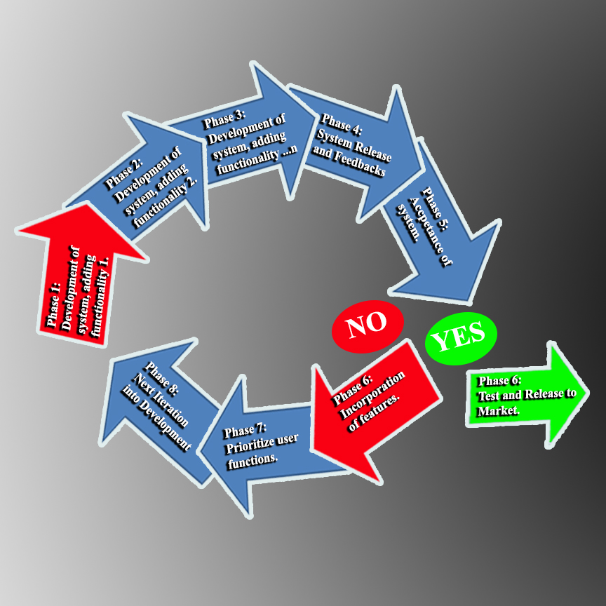**Figure 2 Process Model of Master Document Register System**

Deployment of System

Test Drive Design

Application

Development

Planning and Prototyping

In Figure 2, the process model of Master Document Register System. The Phase on development of the system is shown above and its process until the system meet its final stage whether it is Accepted or otherwise.

**Planning and Prototyping –** the researchers identify and determine the cost and the time that will be consumed in developing the system. The researchers gather information from Bukidnon State University Documents and Records Controller (DCRC) on how its interface will be design, its functionality and its usability especially when the system will be deployed in the respective departments. In this phase of process, the researcher must meet satisfaction of each DCRC’s in the University.

**Application Development-** In this phase of process, the development of the system will takes place where the developers will add functionality of the system and apply system features that the user will be using. The developers will dry-ran the system for trials and correction.

**Test Drive Design (TDD)** – this is the phase where the researchers add a test, after The researchers run the test, The researchers make sure that all of it are being checked and if not the code will be modified again then run the test again.

**Deployment of the system** – for this phase where it is the final stage, the deployment of the system will takes place where the developers will try to install the system in the respective workplace. The developers must meet satisfaction of end user towards there developed system on its complete appearance and functionality of the system.

**Results and Discussions**

As a result, the group was able to develop the Master Document Register; the system can register documents and records with standard technicality to be followed in registering, it can view the registered documents and records and print it, the user can be notified whether there is inactive records in the register and let the user to decide to archive the inactive record and also the developers add some feature of Master Document Register for searching documents and records so that user can easily find the location of the file on its actual filer.

**Prototype Interface**

**Figure 3.1 Home Menu of the system.**



In figure 3.1 the system will view user choice. There is active button on the left upper corner which is “Choose from,” the user can choose what it wanted to view whether Registered Documents or Registered Records and can search at the input field at the top. This is to view registered documents and records in the system in means of finding them in the actual filer.

**Figure 3.2 The Notification Button**



In Figure 3.2 there is an envelope icon button at the top right corner of the system that will give notification to the user of inactive records. It will allow user to decide on moving the records into archive.

**Figure 3.3 The Record Register**



In figure 3.3 this is where the user can register records. Providing record details on registering specially the Inactive date of record must be fill in so that the system can notify user.

**Figure 3.4 The Update Document Register**



In figure 3.4 this is where user can update register document. Then the user will provide details about the document it wanted to edit in the system.

**Figure 3.5 The Updating of Records**



In Figure 3.4 this is where the user will click data inside the grid and enable user to update the record registered.

**Figure 3.5 The Registered Record Update**



In this Figure 3.5 the Update of records will be able user to edit its content.

***Conclusion***

The study covers the researches on the functionality, efficiency, usability, reliability and portability of the Master Document Register and collaboration of technologies and system’s processes currently available in Bukidnon State University. Based on the developed system “Master Document Register” the study is completely accepted and meet satisfaction of its end user. The efficiency of this system have been examined and it is clear that this system will enhance the understanding and knowledge of every DCRC’s on registering documents and records especially in including standard details for QMS purposes in Bukidnon State University.

The researchers conclude that the Master Document Register system is Highly Accepted and ready to use based on the survey that has been disseminated to the respondents and possible user of the system especially that the system meets their satisfactions on viewing registered documents and records that will ease them on finding it on the actual filer, notify end user on inactive date of records and will enable them to move the records in the archive and allows the users to print document and records registered in the Master Document Register System.

**References**

*Internet source:*

ISO 9001: 2008, Clause 4.2.3

ISO 9001 Control of Records Procedure

List of Documents/Records Retention

Bustelo. Serie ISO 30300: Sistema de Gestión para Documentos. SEDIC.Documentos de trabajo.Octubre 2011. www.sedic.es/DT-n2-SEDICISO30300.pdf.

ISO 30301. Information and documentation -- Management systems for records

ISO 9000.Quality management ISO 9001:2008.Quality management systems Nava, V. Jiménez, A.R.

ISO 9000:2000: estrategias para implantar la norma de calidad para la mejora continua. Editorial Limusa, 2005

Bustelo. Serie ISO 30300: Sistema de Gestión para Documentos. SEDIC.Documentos de trabajo.Octubre 2011.[www.sedic.es/DT-n2-SEDICISO30300.pdf](http://www.sedic.es/DT-n2-SEDICISO30300.pdf).

ISO 30301. Information and documentation -- Management systems for records

ISO 9000. Quality management

ISO 9001:2008. Quality management systems Nava, V. Jiménez, A.R.

ISO 9000:2000: estrategias para implantar la norma de calidad para la mejora continua. Editorial Limusa, 2005

ISO 9001:2008 Quality Management Systems - Requirements (Please refer to http://www.iso.org to obtain a copy)

ISO 9000 Introduction and Support Package: Guidance on the Documentation Requirements of ISO 9001:2008 (http://www.iso.org/ iso/02_guidance_on_the_documentation_requirements_of_iso_9001_2008..pdf)

AS/NZS ISO 9001:2008 Quality Management Systems – Requirements

AS ISO 15489.1-2002 Records Management - General

**Plagiarism Test Result**

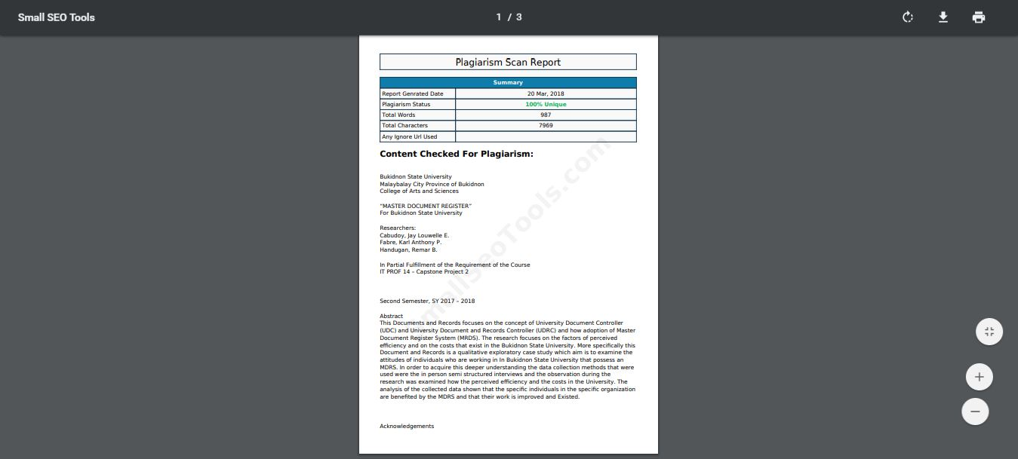

**Plagiarism paragraph test.**

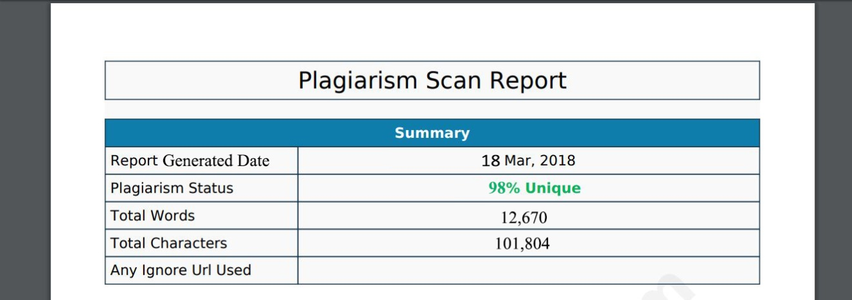

**Over-all Document Plagiarism Result**