Internal IT Ticket LLM Program
Secure, air-gapped enterprise AI assistant for IT service operations
Prepared May 1, 2026 | Planning basis: $70.5B revenue, 470,000+ employees, 180,000+ active engagements/customers
Executive recommendation: Build an internal RAG system first, with model weights and inference hosted entirely inside the company network. Fine-tune after the pilot proves where retrieval, ticket taxonomy, and prompt controls are insufficient.
Decision Summary
The goal is a private IT support assistant trained and grounded on historical IT tickets, knowledge articles, and operational runbooks. Because privacy and security are paramount, the design assumes no external inference calls, no outbound internet from training or serving networks, signed/offline software supply chain, encrypted storage, strict role-based access, and full audit logging.
For a global company at this scale, the first release should be treated as a controlled internal product rather than a lab model. The highest-risk assets are ticket contents, credentials accidentally pasted into tickets, internal hostnames/IPs, customer references, and operational procedures. The safest path is to prove value through retrieval-augmented generation before permanently changing model weights.
Planning view | Pilot | Baseline enterprise build | Scaled HA program
Purpose | One domain, limited users | Multi-domain IT support | Global production service
First-year cost | $2.4M-$3.3M | $7.5M-$10.5M | $15M-$22M
GPU assumption | 1x 8-GPU H100 class node | 4x 8-GPU H100 class nodes | 8-12x nodes plus DR/HA
Timeline | 4-6 months | 12-15 months | 18-24 months
Best use | Prove value safely | Enterprise launch | Global scale + resilience
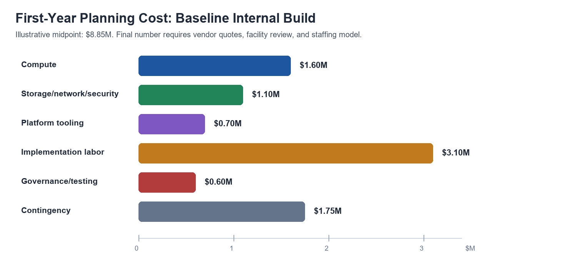

First Five Steps
Step | Five operating details
1. Infrastructure and environment setup | Build the secure foundation before moving data: procure dedicated H100/A100-class systems; implement air-gapped or zero-egress networks; run a private registry/Kubernetes stack; provision encrypted NVMe storage; integrate IAM with AD/SSO, IP controls, and audit trails.
2. Data governance and sanitization | Centralize ITSM exports in the isolated data lake; scrub PII, secrets, hostnames, and customer identifiers; classify tickets by service/domain; deduplicate noisy or duplicate incidents; keep only tickets with credible diagnosis and resolution quality.
3. Model selection and local weight hosting | Select a commercially usable open-weight model; verify SHA-256 hashes before air-gap transfer; choose quantization for latency/cost; mirror dependencies internally; establish baseline tests against unseen ticket scenarios.
4. Fine-tuning strategy | Use LoRA/QLoRA only after RAG validation; standardize Issue -> Diagnosis -> Resolution examples; tune conservatively to avoid forgetting; add instruction behavior for IT assistant use; validate on holdout tickets and human expert reviews.
5. Local inference, RAG, and secure UI | Expose only an internal API; retrieve relevant tickets/docs through a local vector database; give IT staff a secure web UI; log every query, retrieval, and response; capture feedback for governed continuous improvement.
Architecture and Security Controls
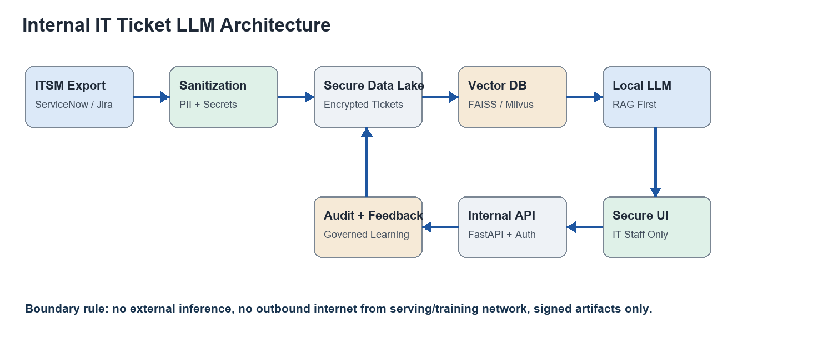
Security design should follow two complementary baselines: NIST AI RMF for governance, risk mapping, measurement, and management, and OWASP LLM guidance for prompt injection, sensitive information disclosure, supply-chain risk, data/model poisoning, and overreliance. This is especially important because ticket systems often contain privileged operational context.
Control layer | Minimum requirement | Why it matters
Network | Zero-egress model-serving/training VLAN, controlled inbound only through VPN or internal app gateway. | Prevents data exfiltration and unapproved model/package calls.
Data | Encrypted lake, row/field classification, PII/secrets redaction, quarantine path for suspicious records. | Tickets can contain credentials, customer data, and internal topology.
Supply chain | Signed containers, private registry, SBOM, hash-verified model weights and Python wheels. | Reduces poisoned dependency and model tampering risk.
Access | AD/SSO groups, least privilege, break-glass process, privileged session recording. | Restricts who can see raw tickets, embeddings, prompts, and outputs.
Model safety | Prompt-injection tests, retrieval allowlists, output policy filters, human approval for actions. | The model should advise; it should not autonomously change systems in the first release.
Audit | Immutable logs for user, prompt, retrieved docs, response, feedback, and admin changes. | Supports compliance, incident response, and quality improvement.

Cost Model
The baseline cost model assumes the company buys and hosts dedicated GPU systems internally. Public cloud GPU rates are used only as a market reference because the project requirement is private internal hosting. NVIDIA publishes DGX H100/H200 technical specifications; public reseller and GPU-cloud pricing indicate why vendor quote ranges should be treated as planning bands until procurement is complete.
Cost area | Planning assumption | Year-1 midpoint | Notes
Compute | Four 8-GPU H100-class nodes | $1.6M | Training, evaluation, staging, and production inference headroom.
Storage/network/security | Encrypted NVMe, backup, 400G/InfiniBand where needed, HSM/KMS, monitoring | $1.1M | Includes resilience and secure transfer path.
Platform tooling | Kubernetes, private registry, vector DB, observability, MLOps, vulnerability scanning | $0.7M | Open-source-heavy stack plus enterprise support where needed.
Implementation labor | 12-month core team: AI/ML, platform, security, data engineering, ITSM SMEs | $3.1M | Largest real cost; assume loaded enterprise labor/contractor rates.
Governance/testing | AI risk, privacy, red-team, validation, change management | $0.6M | Do not defer; this is part of the product.
Contingency | 25% on non-labor plus integration unknowns | $1.75M | Covers vendor variance and facility readiness.
Budget takeaway: Plan a first-year enterprise baseline of $7.5M-$10.5M, then $2.5M-$5M annually for operations, refresh reserve, security testing, model evaluation, and a small continuous-improvement team.

Timeline and Delivery Gates
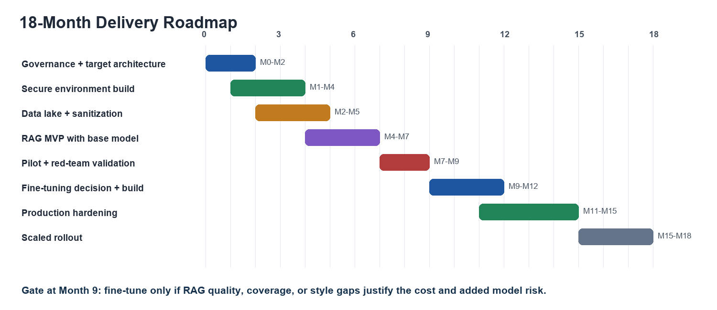
Phase | Exit gate | Primary owner | Decision
0-2 months | Approved risk model, architecture, data handling rules | CISO/CIO/AI governance | Proceed to isolated build
2-5 months | Clean ticket corpus and searchable sanitized lake | Data engineering + ITSM | Permit RAG MVP
4-7 months | RAG answers grounded in citations with low leakage | ML/platform | Start pilot
7-9 months | Human SME scorecard, red-team results, usage feedback | IT operations + security | Fine-tune or improve retrieval
9-15 months | Production SLOs, audit, monitoring, runbooks | Platform + service owner | Launch
15-18 months | Measured deflection/MTTR gains and compliance signoff | Program office | Scale globally

Operating Model and Expected Value
Value should be measured with operational metrics, not model benchmarks alone: mean time to resolution, first-contact resolution, ticket deflection, escalation accuracy, answer citation quality, false-confidence rate, and security/privacy events. A reasonable first production target is 10%-20% faster resolution in selected domains and measurable reduction in repeated knowledge-search time, before expanding to high-risk workflows.
Role group | Core responsibilities | Minimum staffing
AI/product leadership | Scope, roadmap, ROI, executive reporting, release gates | 1 product owner, 1 program manager
Data/ML | Corpus quality, embeddings, evaluations, fine-tuning, drift monitoring | 3-5 engineers/scientists
Platform/SRE | GPU cluster, API, Kubernetes, reliability, backups, observability | 3-4 engineers
Security/privacy | Controls, red-team, IAM, audit, incident response, compliance | 2-3 specialists
ITSM SMEs | Ticket taxonomy, answer review, workflow fit, adoption | 4-6 rotating SMEs
Research Notes
• NVIDIA DGX H100/H200 documentation: 8x H100 or H200 GPUs; DGX H100 includes 640 GB total GPU memory, high-speed NVLink/NVSwitch, and 30 TB NVMe class storage.
• Lambda public AI cloud pricing, reviewed May 1, 2026: H100 SXM on-demand pricing is published per GPU-hour; useful as a benchmark, not as a target architecture because the requirement is internal hosting.
• ServiceNow ITSM pricing pages state enterprise pricing is quote-based and package-dependent; assume custom integration/export effort rather than a public per-seat formula.
• NIST AI RMF 1.0 recommends governing, mapping, measuring, and managing AI risks across the lifecycle; apply it as the program governance backbone.
• OWASP Top 10 for LLM Applications identifies prompt injection, sensitive information disclosure, supply-chain risk, data/model poisoning, overreliance, and model theft as key LLM application risks.
• vLLM supports OpenAI-compatible local serving and offline documentation flags, making it a practical candidate for internal-only inference APIs.
• Mistral documents Apache 2.0 open-weight options and self-hosted deployment paths; license review remains mandatory before selecting any base model.
Recommended Next Action
Approve a 6-week discovery and architecture sprint: inventory ticket sources, sample and classify 25,000-50,000 historical tickets, design the air-gapped build, request vendor quotes for H100/H200-class systems and storage, and define the pilot domain. The sprint should end with a procurement-ready architecture, risk register, data-quality scorecard, and MVP backlog.

