A Geometric Routing Hypothesis for Event-Driven
Sparse Computation in Large Language Models
Research hypothesis paper synthesized from the current AI-router project notes
Abstract. This paper states a mathematically explicit hypothesis for the current project: that useful large-scale computation can be organized by a fixed geometric routing manifold rather than primarily by dense pairwise attention. The working model separates three objects: a routing manifold R, a coupled transport or addressing field F, and a retrieval key derived from both. The preferred candidate geometry is a hyperbolic four-dimensional routing space with Hopf-structured angular coordinates, allowing coarse routing by shell and sector while reserving low-cost fiber phase motion for intra-sector transport. The central claim is not that the architecture is already proved, but that it is coherent enough to be stated rigorously, falsified cleanly, and tested for potential hardware advantages through sparse event-driven computation.

Prepared as a formal hypothesis note, not as a claim of established fact.

1. Statement of the Research Program
The project aims to test whether reasoning and retrieval in large language models can be reorganized as navigation and transport on a structured geometric state space. In the current notes, several recurring ideas converge: negative curvature appears useful for scalable routing, shell structure appears more stable than arbitrary local widening, Hopf-style angular coordinates provide a natural decomposition of the angular component, and phase-like transport may permit cheap internal motion without repeated dense recomputation.
The disciplined version of that intuition is the following research program. One fixes a geometric substrate with built-in global measure law. One learns an embedding of token or state representations into that substrate. One then performs routing, accumulation, and sparse event emission according to geometric compatibility rather than brute-force dense all-to-all mixing. The empirical question is whether the resulting architecture preserves enough semantic structure to be useful while reducing compute, memory traffic, and routing overhead.
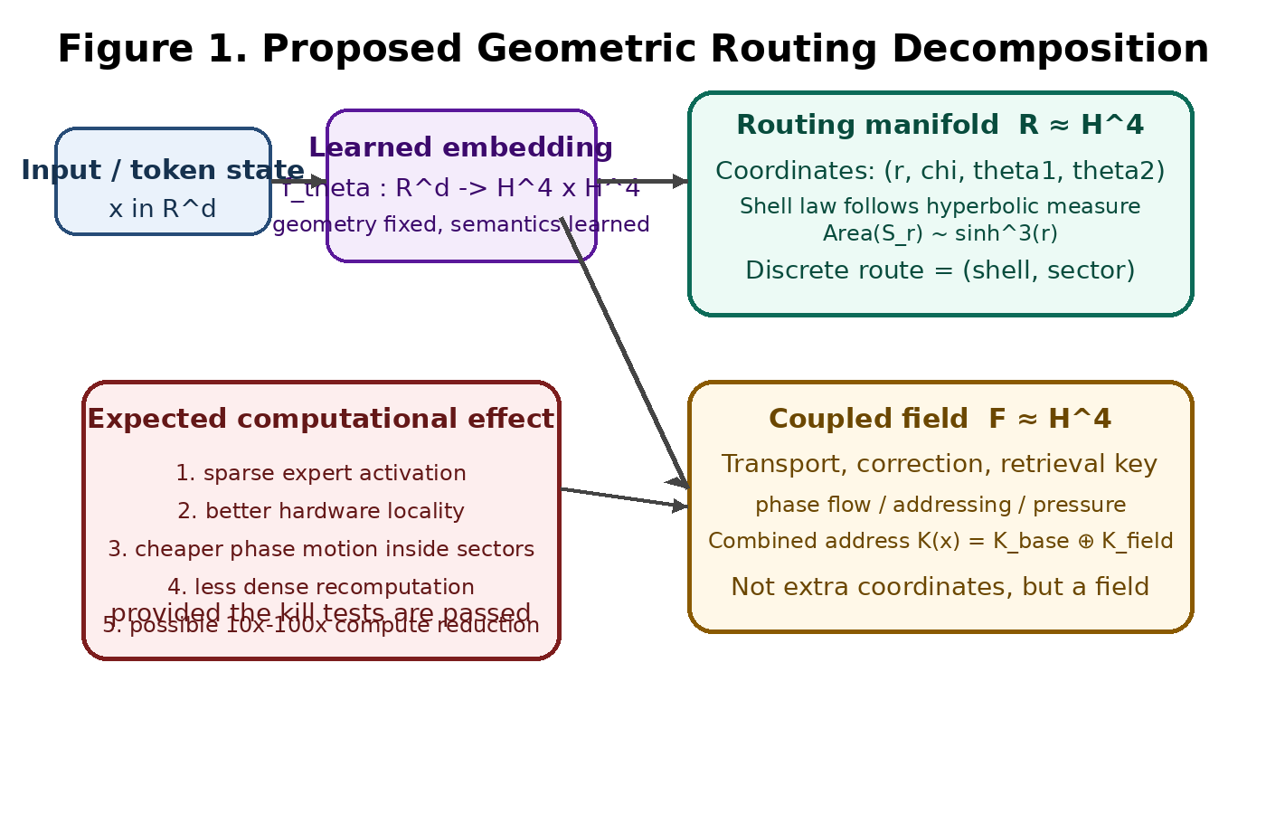
Figure 1. The working decomposition separates the routing manifold from a coupled field instead of forcing all behavior into one coordinate chart.

2. Central Hypothesis
Let x denote a learned representation derived from the current model state. The central hypothesis is that there exists a map
f_theta : R^d -> R x F, with R ≈ H^4 and F ≈ H^4,
such that R governs coarse routing, F governs transport or retrieval correction, and useful computation can then be implemented by sparse interactions between local cells or buckets defined over R and modulated by F.
More concretely, the project hypothesizes that the routing manifold should not be treated as an arbitrary latent chart. It should be chosen so that its measure law already matches the scaling pressure of hierarchical computation. For hyperbolic space H^4, the area of a geodesic sphere grows proportionally to sinh^3(r), which suggests that shell capacity should increase with radius according to geometry rather than according to hand-tuned rescue rules. This is the mathematical reason hyperbolic routing remains the leading structural candidate in the current project notes.
The second hypothesis is that the angular portion of the routing problem is naturally described by an S^3 geometry carrying Hopf-style coordinates. This yields a decomposition in which coarse routing is determined by shell plus angular sector, while a fiber-like phase coordinate supports cheap internal motion inside routed regions. The third hypothesis is that sparse threshold dynamics can convert this geometry into an actual computational graph.

3. Mathematical Working Model

3.1 Routing manifold
The preferred coarse substrate is a hyperbolic manifold with polar decomposition
H^4 ≈ radial coordinate x S^3.
The radial coordinate r encodes hierarchical depth, while the angular component encodes directional identity. The routing address is therefore a quantized pair
Route(x) = (shell(x), sector(x)).
The important point is that shell boundaries should be chosen by a measure-consistent law. If the manifold is genuinely hyperbolic, then global capacity must reflect hyperbolic volume growth. Otherwise the system is forced to patch geometric mismatch using increasingly ad hoc corrective terms.
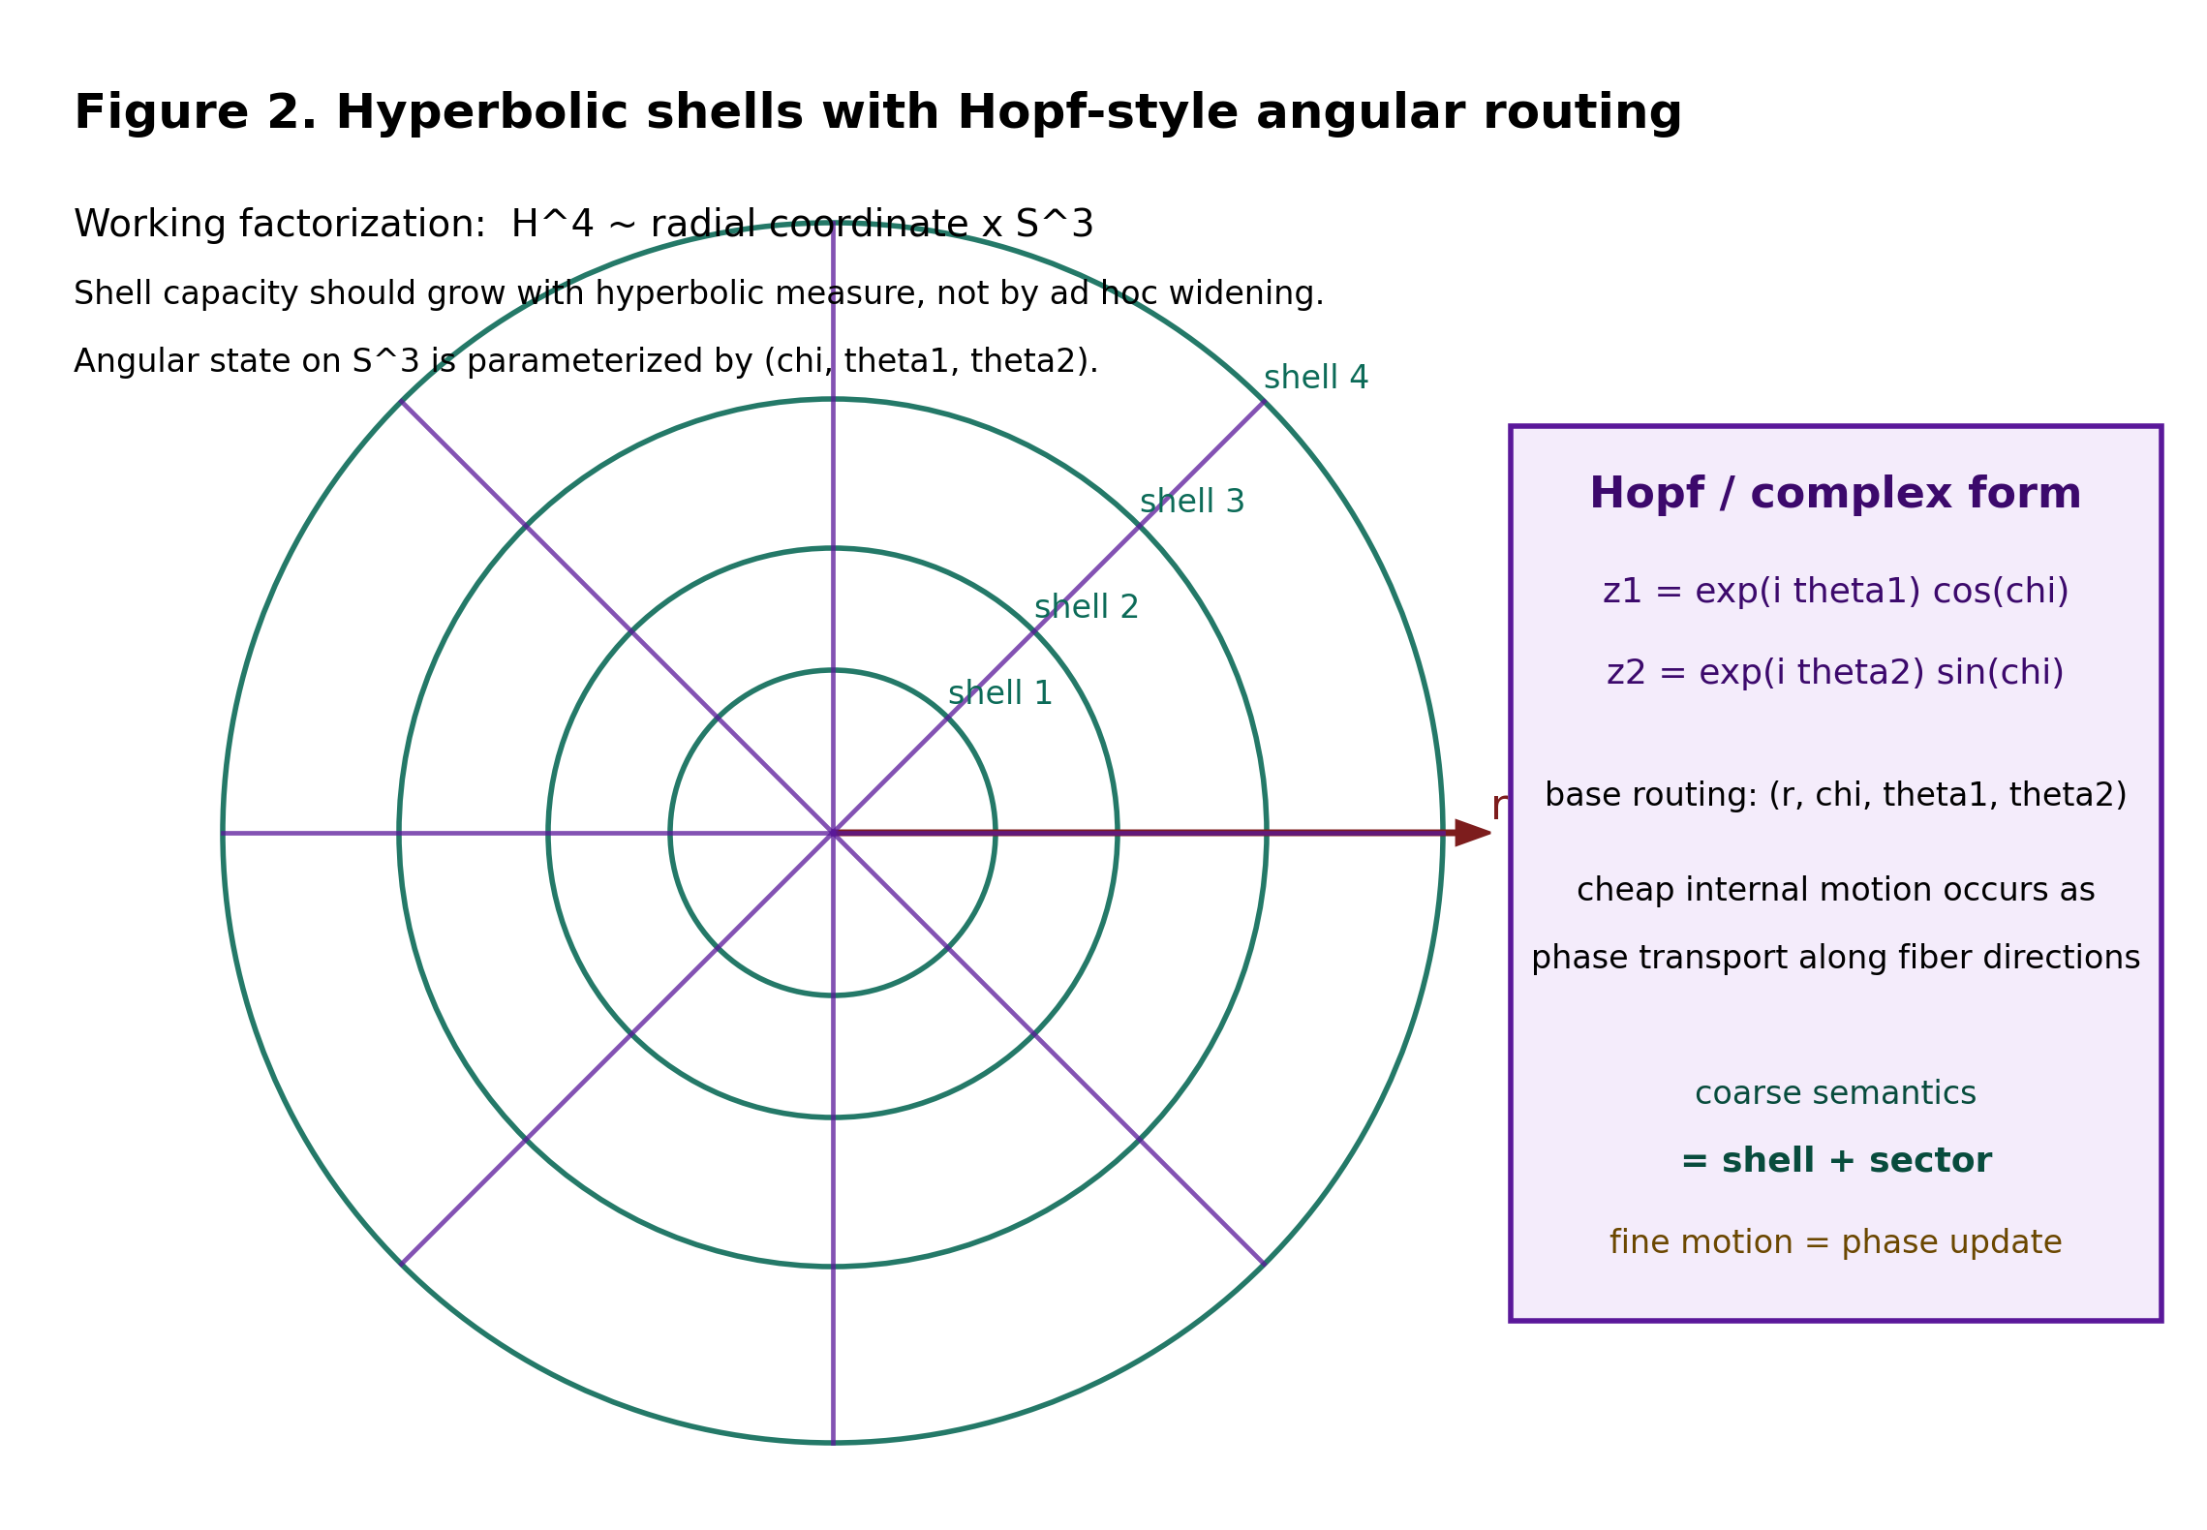
Figure 2. A conceptual picture of hyperbolic shells together with Hopf-structured angular coordinates on S^3.

3.2 Hopf angular structure
A practical coordinate model for the angular component represents points on S^3 as a pair of complex numbers (z1, z2) in C^2 satisfying |z1|^2 + |z2|^2 = 1. A Hopf-style parameterization is
z1 = exp(i theta1) cos(chi), z2 = exp(i theta2) sin(chi).
This expresses the angular state through one amplitude split coordinate chi and two phase coordinates theta1 and theta2. The paper hypothesis is not merely that such coordinates exist, but that they are operationally meaningful: the base angular state identifies sectors, while phase motion along fiber directions may provide a cheap computational primitive.

3.3 Coupled field
The current project notes repeatedly suggest that a second geometric factor is useful, but more coherent as a field than as extra routing coordinates. Accordingly, the present hypothesis introduces a coupled field F, ideally of similar hyperbolic type, to encode one or more of the following: retrieval key refinement, correction flow, pressure redistribution, or phase transport.
K(x) = K_base(x) ⊕ K_field(x).
This separation is mathematically cleaner than forcing routing, retrieval, and transport into one coordinate system. It also clarifies the experimental program because each component can be tested independently.

4. Spectral and Phase-Transport Hypothesis
A recurring conjecture in the project is that geometric routing and spectral transport are related. On a curved manifold M, one may define a Laplace-type operator Delta_M whose eigenfunctions supply natural spectral modes. The corresponding hypothesis is that some computational structure normally engineered through dense matrices may instead emerge from the manifold's own transport operators and low-order modes.
Delta_M phi = lambda phi.
When the angular geometry contains phase degrees of freedom, transport can act by low-cost phase motion rather than by repeated high-dimensional mixing. In its simplest form a phase update is
psi -> exp(i varphi) psi,
which, in real coordinates, is just a two-dimensional rotation. The project's claim is therefore conditional but sharp: if semantic transformations align with such fiber transport even approximately, then some fraction of dense computation might be replaced by cheap phase updates plus sparse expert activation. That is the mathematical core of the expected hardware advantage.
This claim is fragile. If the learned embeddings do not stabilize on the manifold, or if phase has no predictive or routing utility, the supposed advantage collapses. Still, the hypothesis is worth stating clearly because it yields direct ablations and failure criteria.

5. Event-Driven Computation Model
To turn geometry into computation, the project proposes replacing dense global mixing with sparse event cells. Let {B_k} denote a family of cells or buckets distributed over the routing manifold. Each cell carries a center c_k, a membrane state u_k, a threshold theta_k, and a local transport operator T_k.
Given an incoming event packet e_j^t = (x_j^t, a_j^t), define a compatibility kernel
w_jk = K_r(d_H(x_j, c_k)) K_b(d_base(x_j, c_k)) K_phase(Delta alpha_jk).
The membrane update then takes the form
u_k^(t+1) = (1 - lambda_k) u_k^t + sum_j w_jk a_j^t - beta_k rho_k^t,
followed by a threshold rule
s_k^t = 1{u_k^t >= theta_k}.
When a cell fires, it emits a transported state, either by direct coordinate update or by a structured group action such as q' = g_k q on an angular representation. The architectural meaning is simple enough, because apparently humanity cannot leave simple things alone: compatible events accumulate locally, only a small fraction of cells fire, and the active computation graph is sparse.
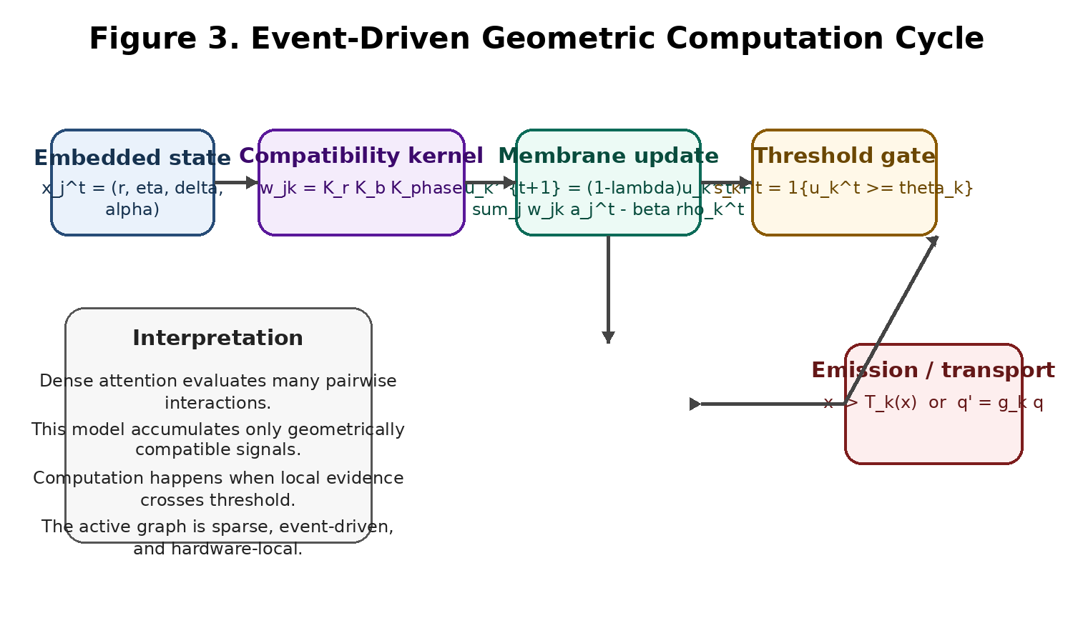
Figure 3. The proposed event-driven cycle converts local compatibility into sparse thresholded emission.

6. Expected Mathematical Signatures
If the hypothesis is correct, the architecture should display several measurable signatures. First, shell occupancy should approximately track the manifold's theoretical measure law rather than collapse toward central shells. Second, angular sectors should remain balanced enough to avoid routing collapse, yet structured enough to preserve neighborhoods and semantic clustering. Third, the phase component should provide measurable signal beyond a no-phase baseline, either by improved routing consistency, better retrieval, or reduced dense compute burden.
At the spectral level, one should expect coherent low-order modes under suitable operators on the routing manifold or its coupled field. At the dynamical level, event activity should be sparse, local, and bursty rather than uniform. At the systems level, memory locality and expert utilization should improve if routing really respects shell-sector organization.
The theory therefore predicts not one miracle number but a family of invariants: shell occupancy scaling, routing entropy, geodesic neighbor preservation, phase-ablation gain, sparse firing rate, and net hardware efficiency.

7. Falsification Criteria
Because speculative geometric architectures can become elaborate nonsense surprisingly fast, this paper states a hard falsification ladder. The architecture should be rejected or fundamentally redesigned if any of the following fail under serious test.
Test | Question | Failure condition
1 | Hyperbolic embedding stability | Embedding distortion grows with scale or fails to preserve hierarchical neighborhoods.
2 | Shell routing preservation | Routing destroys local neighborhoods or collapses toward central shells.
3 | Hopf angular stability | Sector occupancy is random, unstable, or collapses into a few sectors.
4 | Phase utility ablation | No measurable benefit from raw or transported phase over no-phase controls.
5 | Sparse training stability | Threshold routing diverges, saturates, or activates nearly all cells.
6 | Hardware efficiency | Routing overhead cancels any savings from sparsity and locality.

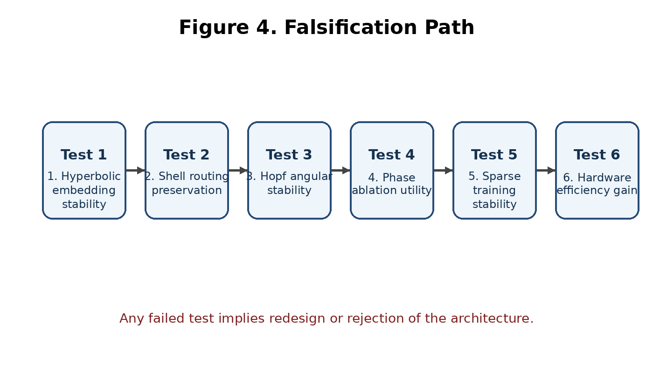
Figure 4. The project is scientific only if it survives the kill sequence in order.

8. Expected Implications if Validated
If the program survives the kill tests, the implications are substantial. For machine learning, it would suggest that part of what is now handled by dense attention and dense feedforward mixing can instead be delegated to geometry, transport, and sparse local threshold dynamics. That would shift architectural design from universal matrix engines toward systems in which geometry determines where computation occurs and transport determines how states move inside routed regions.
For scientific computing more broadly, the project would also support a stronger conceptual claim: that structured computation can emerge from the interplay of curvature, spectral operators, and local dynamical thresholds. In plain language, one may obtain useful computation from the shape of the state space itself rather than from sheer parametric scale.
For physics-inspired modeling, the architecture would not prove that brains, matter, or spacetime literally compute this way. That sort of grand overreach is a beloved human hobby and should be resisted. But it would strengthen a narrower and more respectable analogy: systems with curved geometry, coupled fields, and transport structure can exhibit efficient multi-scale organization without brute-force dense interaction. That is already a meaningful bridge between AI architecture and mathematical physics.

9. Reality Check and Scope
This paper does not claim that the architecture is already demonstrated. It claims that the project now has a coherent enough mathematical form to justify rigorous testing. The likely points of failure are clear: the manifold may not stabilize under learning, the coupled field may be unnecessary, phase may fail to encode useful semantics, sparse threshold dynamics may be too difficult to train, or the theoretical locality advantage may be erased by implementation overhead.
The value of the present formulation is therefore twofold. It sharpens the scientific content of the project, and it prevents the work from dissolving into unbounded metaphor. Every attractive intuition in the notes can now be translated into either a measurable invariant or a kill test.

10. Formal Hypothesis Statement
A concise statement suitable for the repository is as follows.
Hypothesis. There exists a learned embedding f_theta from model state into a product geometry R x F, where R is a hyperbolic routing manifold with Hopf-structured angular coordinates and F is a coupled field governing transport and addressing, such that sparse event-driven computation based on geometric compatibility, threshold accumulation, and phase transport can match useful portions of dense transformer-style computation while improving locality and reducing net hardware cost.
The immediate task is not to celebrate the hypothesis, but to break it. If it survives, then the project has earned the right to become a real architecture rather than a stack of clever sketches.

Appendix A. Source notes synthesized
This document synthesizes and formalizes the project's own working notes rather than outside literature. The main source notes used were: Mathematical Review and Research Guidance; Geometric Routing for LLMs - Architecture Summary; Phase Transport Hypothesis; Event-Driven Geometric Routing Model; Geometric Theory of Mind Routing; Geometric Routing Kill Test Protocol; Geometric Routing and Spectral Transport Hypothesis; Theory Sketch; Evidence Summary; and Next Critical Experiments.

