Standard Operating Procedure (SOP) for Tagging AWS Resources

Purpose

The purpose of this document is to outline the step-by-step procedure for manually tagging AWS resources to ensure consistent organization, cost allocation, and resource management.
Adherence to the tagging standards specified at [Tagging Standards] is mandatory.
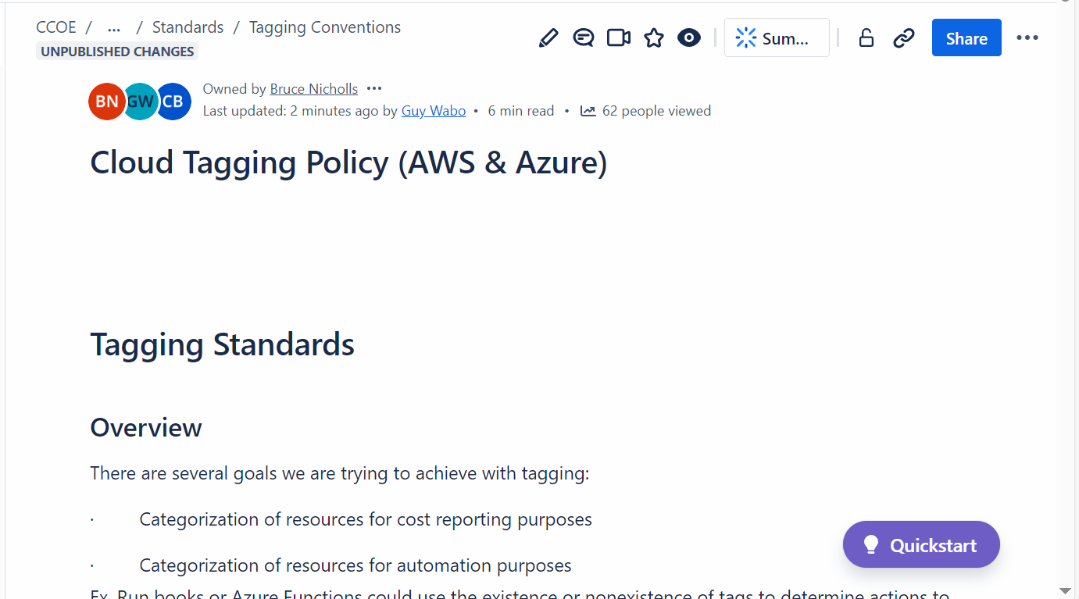

Scope

This procedure applies to all the services supported by AWS for tagging. Some examples are:

Compute
- Amazon EC2 (Elastic Compute Cloud): Instances, volumes, Elastic IPs, security groups, key pairs, etc.
- Amazon ECS (Elastic Container Service): Clusters, tasks, services.
- AWS Lambda: Functions.
- AWS Elastic Beanstalk: Applications and environments.
- AWS Batch: Compute environments and job queues.
Storage
- Amazon S3 (Simple Storage Service): Buckets and objects.
- Amazon EBS (Elastic Block Store): Volumes and snapshots.
- Amazon FSx: File systems.
- Amazon Elastic File System (EFS): File systems.
Database
- Amazon RDS (Relational Database Service): DB instances, clusters, snapshots.
- Amazon DynamoDB: Tables.
- Amazon Aurora: Clusters, DB instances.
- Amazon Redshift: Clusters, snapshots.
Networking & Content Delivery
- Amazon VPC (Virtual Private Cloud): Subnets, route tables, Internet gateways, NAT gateways, and security groups.
- Elastic Load Balancing (ELB): Load balancers and target groups.
- Amazon CloudFront: Distributions.
- Amazon Route 53: Hosted zones and domains.
- Amazon API Gateway: APIs and stages.
Machine Learning
- Amazon SageMaker: Notebooks, models, training jobs, endpoints.
- Amazon Rekognition: Resources associated with image and video analysis.
Analytics
- Amazon EMR (Elastic MapReduce): Clusters.
- Amazon Kinesis: Streams.
- Amazon QuickSight: Dashboards and datasets.
- AWS Glue: Crawlers, jobs.
Security, Identity & Compliance
- AWS Identity and Access Management (IAM): Roles, users, groups, and policies.
- AWS Key Management Service (KMS): Customer-managed keys.
- AWS Certificate Manager (ACM): Certificates.
- AWS WAF (Web Application Firewall): Web ACLs.
Management & Governance
- AWS CloudFormation: Stacks.
- AWS CloudTrail: Trails.
- AWS Config: Configuration recorders, rules.
- Amazon CloudWatch: Alarms, log groups, dashboards.
- AWS Systems Manager: Documents, parameters, patch baselines.
Developer Tools
- AWS CodePipeline: Pipelines.
- AWS CodeBuild: Projects.
- AWS CodeDeploy: Deployment groups.
- AWS CodeCommit: Repositories.
Application Integration
- Amazon SNS (Simple Notification Service): Topics.
- Amazon SQS (Simple Queue Service): Queues.
- AWS Step Functions: State machines.
- Amazon EventBridge: Event buses and rules.
Miscellaneous
- AWS Backup: Backup plans and recovery points.
- AWS Elastic Transcoder: Pipelines and jobs.

Prerequisites
- Ensure you have sufficient IAM permissions to modify tags for AWS resources. For example, you need `CreateTags`, `DeleteTags`, or equivalent permissions.
- Familiarize yourself with the tagging conventions outlined
- Log in to the appropriate AWS account where the resources are located.

Step-by-Step Procedure
Although, tags can be assigned through API, CLI or IaC deployment and you can follow any of this approach. Whereas, you can also manually add the tags following steps below:

Step 1: Log in to AWS Management Console

- Open a web browser, use single sign on and navigate to AWS login tower.
- Select the desired AWS account where the resources are located.

Step 2: Navigate to the AWS Resource
- Identify the type of resource you want to tag (e.g., EC2 instance, S3 bucket, RDS instance, etc.).
- Use the AWS Management Console search bar to locate the specific resource.
- Select the specific resource from the list (e.g., an EC2 instance ID).

Step 3: Add/Modify the tags Manually.

- On the resource’s detail page, locate the **Tags** section. This is usually found in a tab or a section labeled "Tags" or "Tagging".

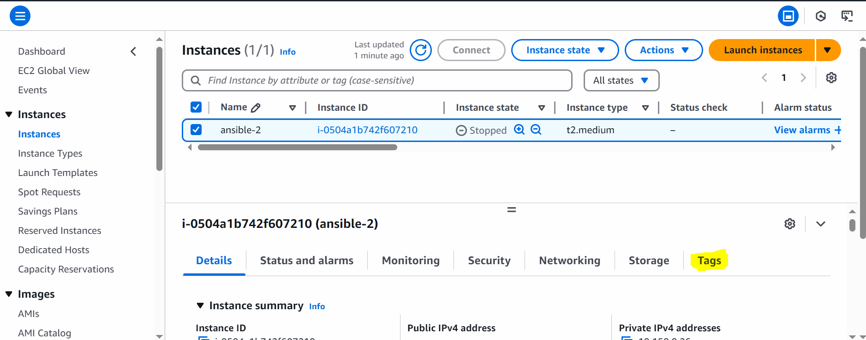

- Click **Manage Tags**, **Edit Tags**, or **Add/Edit Tags** (wording may vary based on the resource type).

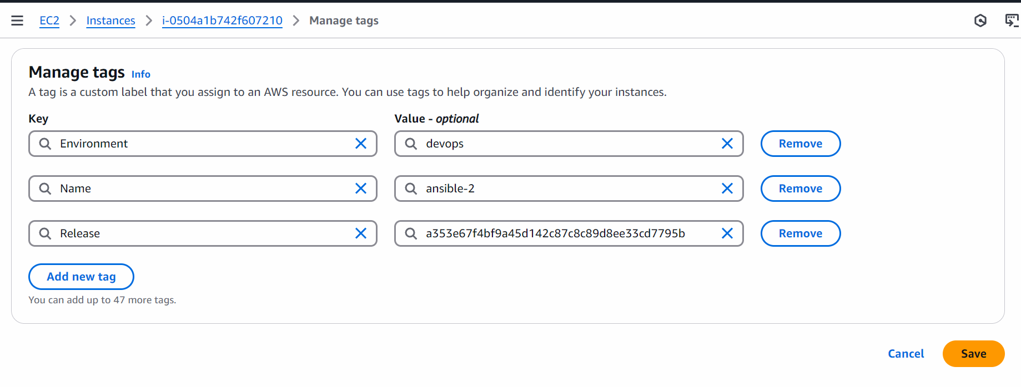

Step 4: Add or Update Tags

- Follow the tagging standards from standards. Conventional tag key examples include:
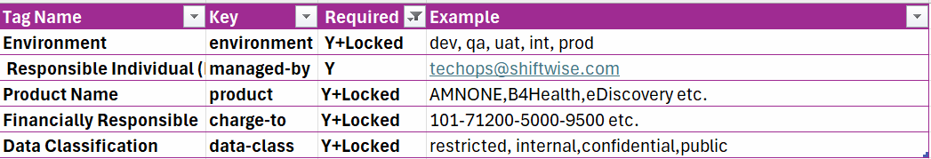

Step 5: Save Changes

- Review the tags to ensure compliance with the Tagging Standards.
- Click Save Changes or Apply to save your modifications.

Step 6: Verify Tags

- Return to the resource’s detail page to ensure the tags are correctly applied.
- Optionally, use the Tag Editor service in the AWS Management Console to search and verify tags across multiple resources.

IaC Updatation
If you update any tag, please make sure to update your infrastructure deployment code (e.g., CloudFormation, Terraform, etc.) accordingly.
This ensures that the changes persist and are not overwritten during the next deployment. Always maintain consistency between the actual tags applied to resources and the tags defined in your Infrastructure as Code (IaC) templates.

