Safe Reinforcement Learning with Conservation-Aware Constraints for HVAC Control in Art Museums:
Encoding EN 15757 Rate Limits as a Constrained MDP

Abstract
Museum HVAC systems run year-round at energy intensities two to three times those of comparable office buildings, because conservation envelopes for hygroscopic and metallic collections require narrow-band control of temperature and relative humidity. Existing controllers either treat conservation limits as soft reward penalties, which conflicts with the safety semantics of EN 15757 and ASHRAE Class A1, or use classical multi-objective optimization that cannot adapt to time-varying visitor and weather loads. We formulate museum HVAC control as a Constrained Markov Decision Process (CMDP), aggregating ASHRAE static envelopes and the EN 15757 dynamic rate caps on $\left|dT/dt\right|$ and $\left|dRH/dt\right|$ into a single scalar cost. The problem is solved with a Lagrangian Proximal Policy Optimization controller whose Lagrange multiplier $λ$ is updated by a PID loop targeting a user-specified cost budget. We further identify and resolve an implementation pitfall in subprocess-based vectorized training: $λ$ does not reach SubprocVecEnv workers unless it is pushed via the set_attr mechanism. On a five-zone museum simulator, a six-budget Pareto sweep shows that annual energy varies by only $0.4\%$ while the year-total conservation cost varies by a factor of $2.5$. At the strictest budget, the policy reduces year-total conservation cost by $85\%$ and violation steps by $41\%$ relative to a fixed ${22}^{∘}C/50\%RH$ baseline, at a $1\%$ energy overhead. A per-zone analysis shows that residual violations stay confined to a single constraint-coupled zone, whereas unconstrained and penalty-only variants spread violations across all five zones. Code, simulator, and evaluation scripts will be released upon publication.
Keywords: safe reinforcement learning; constrained Markov decision processes; museum HVAC; preventive conservation; EN 15757; proximal policy optimization.

1 Introduction
Cultural institutions are among the most energy-intensive non-industrial buildings. Climate-controlled museum spaces consume 250–500 kWh m$​^{−2}$ yr$​^{−1}$, two to three times the intensity of comparable office space, because conservation envelopes for sensitive collections require year-round narrow-band control of both temperature and relative humidity (ASHRAE 2023; Frasca et al. 2024). In Europe alone, public-museum HVAC consumes an estimated 5 TWh of electricity annually, and double-carbon policy goals are now placing pressure on cultural institutions to decarbonize without compromising preventive conservation.
The standard institutional response is to operate at a single nominal setpoint, typically ${22}^{∘}C$ and $50\%$ relative humidity, that sits inside the conservation envelope of the strictest collection in the building. This approach has three documented weaknesses. First, it ignores time-varying loads: visitor-driven sensible and latent gains, solar gain, and outdoor weather all vary by an order of magnitude across the day, so a constant setpoint converts every disturbance into HVAC work. Second, it underuses the per-zone heterogeneity of the collection. Standards such as EN 15757 (European Committee for Standardization 2010), the broader heritage-building specification EN 16893 (European Committee for Standardization 2018), and ASHRAE Class A1/A2 (ASHRAE 2023) prescribe ranges, not points, and the safe range for bronze ($RH∈\left[30,40\right]\%$) is incompatible with the safe range for oil paintings ($RH∈\left[45,55\right]\%$); a single setpoint necessarily violates one of them. Third, it treats conservation as a static envelope and ignores the rate clauses in modern standards: EN 15757 limits hourly $dRH/dt$ for hygroscopic materials, because mechanical damage is dominated by short-term cycles rather than long-term mean states.
Reinforcement learning (RL) and model-predictive control (MPC) have been studied extensively for office and residential HVAC (Wang et al. 2017; Brandi et al. 2020; Drgoňa et al. 2020). Open testbeds such as Sinergym (Campoy-Nieves et al. 2025) now make it straightforward to plug EnergyPlus building models into Gymnasium-style training loops. Deploying these controllers in museums, however, forces a qualitative change in safety semantics: an office-comfort violation is annoying, while a conservation-envelope violation accumulates irreversible damage to irreplaceable objects. The museum-specific HVAC literature has so far either used classical multi-objective optimization without learning (Schito et al. 2018, 2020) or treated conservation limits as soft penalties inside a standard RL reward (Boesgaard et al. 2022; Bi et al. 2025); the constrained formulation remains underexplored.
Contributions. This paper makes four contributions, indexed C1–C4 as referenced in the section titles. C1: museum HVAC control is formalized as a Constrained Markov Decision Process (CMDP) in which (i) static temperature and humidity envelopes from ASHRAE Class A1, A2, and unconstrained categories and (ii) the EN 15757 dynamic rate clauses on $\left|dT/dt\right|$ and $\left|dRH/dt\right|$ are encoded as a scalar cost. To the best of our knowledge, this is the first CMDP formulation that includes the rate clauses. C2: we implement a Lagrangian-PPO controller with a PID-tuned multiplier following Stooke et al. (2020), and document a subtle but blocking implementation issue: when training with subprocess-based parallel environments, $λ$ must be propagated via the VecEnv attribute-setter mechanism, not through a Python mutable reference captured in an env-factory closure. C3: a five-zone differentiated museum simulator is constructed with collection-specific conservation envelopes and a synthetic visitor flow, and Lagrangian-PPO is benchmarked against four baselines: rule-based fixed setpoint, schedule-relaxed rule-based, vanilla unconstrained PPO, and fixed-weight soft-penalty PPO. C4: we trace a three-objective Pareto front by sweeping the cost target. The front shows that the major energy-conservation trade-off lies along the conservation axis: relaxing the cost budget by an order of magnitude changes annual energy by less than $1\%$ but more than doubles the conservation cost.
The remainder of the paper is organized as follows. Section 2 positions the work against existing museum HVAC optimization, Safe RL, and digital-twin building literatures. Section 3 states the CMDP formulation and the conservation cost. Section 4 describes the Lagrangian-PPO algorithm and the implementation issue noted in C2. Section 5 describes the simulator and baselines. Section 6 reports the Pareto front and the per-zone analysis. Section 7 discusses limitations and the path to a real-EnergyPlus deployment.

2 Related Work

2.1 Museum HVAC optimization and microclimate
Museum HVAC research has evolved from monitoring-only studies toward control-aware multi-objective optimization. Schito et al. (2018) formulated museum microclimate control as a three-objective problem in energy, visitor discomfort, and artwork preservation risk, and solved it with NSGA-II. Their preservation risk is computed offline from monthly-aggregated environmental traces. Schito et al. (2020) extended this line of work with an achievement-function formulation applied to a Pisa case study, producing Pareto-optimal HVAC setpoint schedules. Both works treat the controller as a parameter-tuning problem rather than a closed-loop policy, and they do not include the EN 15757 rate clauses. Coelho et al. (2020) took a complementary route, using hygrothermal simulation to assess the impact of climate change on artefact conservation and building energy use, but operates offline. Frasca et al. (2024) re-examined microclimate thresholds parametrically and quantified the energy cost of each standard tolerance class.
Recent work has begun to combine learning with conservation-aware control. Boesgaard et al. (2022) applied gradient-boosting and LSTM models to predict indoor temperature and humidity evolution in two heritage buildings. Bi et al. (2025) proposed an integrated framework that combines digital-twin modeling, LSTM-based load forecasting, and a Deep Q-Network (DQN) controller for HVAC and lighting across three Chinese museum case studies. Their DQN minimizes a weighted sum of energy cost and visitor-comfort penalty; conservation enters only as a soft penalty term and EN 15757 rate clauses are not formalized. Outside the optimization stream, Varas-Muriel et al. (2025), Tringa et al. (2024), and Pirrotta et al. (2025) characterize microclimates in heritage buildings without active control, while Liu et al. (2026b) explored hardware-side interventions such as membrane-based dehumidification. The thermal comfort side has also been re-examined for museums: Gallego-Maya and Rubio-Bellido (2024) showed that adaptive comfort models (European Committee for Standardization 2019; ASHRAE 2020) can relax setpoint requirements without increasing visitor dissatisfaction. None of these works formulate a closed-loop constraint-respecting controller of the type studied here.

2.2 Safe and constrained reinforcement learning
Constrained Markov Decision Processes (Altman 1999) provide the canonical framework for RL under safety constraints. Constrained Policy Optimization (Achiam et al. 2017) solves the CMDP with a primal-dual approach inside a trust-region update. Stooke et al. (2020) showed that the dual variable $λ$ can be updated by a PID controller targeting the cost budget, yielding more stable training than the pure proportional update of CPO; we build directly on this PID-Lagrangian formulation. Recent infrastructure has made the area accessible: Safety Gymnasium (Ji et al. 2023) and OmniSafe (Ji et al. 2024) provide unified benchmarks and implementations of PPO-Lag and CPPO-PID, and Wachi et al. (2024) surveyed the design space of constraint formulations.
Safe RL has been applied to building energy management with mixed success. Esmaeili et al. (2025) train a barrier-certificate agent that progressively reduces safety violations during training, and Ding et al. (2025) use a model-based RL system with uncertainty gating for HVAC control. Neither work addresses the museum conservation problem, the dynamic EN 15757 rate constraints, or the per-zone collection heterogeneity studied here.

2.3 Reinforcement learning for HVAC at large
Deep RL for HVAC has progressed from early proof-of-concept studies on single-zone office buildings (Wang et al. 2017; Brandi et al. 2020) to recent benchmarks against ASHRAE Guideline 36 control sequences in multi-zone buildings (Savino et al. 2025). Co-optimization of energy, thermal comfort, and indoor air quality is the topic of Guo et al. (2025). Expert-guided warm-starting accelerates training while preserving safety properties (Xu et al. 2025). Boutahri and Tilioua (2025) validated an RL agent against real-building measurements using the BOPTEST framework (Blum et al. 2021).
Multi-zone coordination is the next frontier. Fang et al. (2022) explored setpoint reset RL across multiple zones; recent multi-agent RL work (Chen et al. 2025; Xue et al. 2025; Zhang et al. 2025) shows that centralized-training-with-decentralized-execution architectures match or beat single-agent baselines while respecting structural constraints. MPC reviews (Drgoňa et al. 2020) remain the strongest classical baselines.

2.4 Building digital twins and decarbonization
Digital-twin (DT) technology is a maturing tool for building energy management. Reviews (Sghiri et al. 2025; Venkateswarlu and Sathiyamoorthy 2025) report that gaps between simulated and real building behavior often exceed $30\%$ in occupant-driven variability. AI-enabled HVAC control is a central element of net-zero strategies in 2025 roadmaps (Gassar and Jafar 2025), and DTs are increasingly paired with LSTM and Transformer load forecasters (Pentsos et al. 2025; Liu et al. 2026a). For heritage applications specifically, IoT-based microclimate monitoring has scaled from research prototypes to deployable systems (Laborda et al. 2022; Bucciero et al. 2026).

2.5 Building simulation testbeds
Sinergym (Campoy-Nieves et al. 2025) provides a Gymnasium-style wrapper around EnergyPlus (U.S. Department of Energy 2024) and is the testbed we use for high-fidelity validation. Alternative testbeds include BOPTEST (Blum et al. 2021) (Modelica-based) and the recent BuildingGym (Dai et al. 2025) toolbox. Our fast iteration environment, a five-zone lumped-capacity thermal network, exposes the same Gymnasium API as Sinergym, so the Lagrangian-PPO controller transfers without code change to a calibrated EnergyPlus model. Calibration follows the standard ASHRAE Guideline 14 metrics (ASHRAE 2014) (CV-RMSE$<30\%$, NMBE$<10\%$ for hourly data).

3 Problem Formulation

3.1 Constrained Markov Decision Process
We model the museum HVAC control problem as a discrete-time CMDP $⟨S,A,P,r,c,γ,d⟩$ with state space $S$, action space $A$, transition kernel $P$, scalar reward $r:S×A→R$, scalar cost $c:S×A→R_{≥0}$, discount factor $γ∈\left(0,1\right)$, and a cost budget $d∈R_{≥0}$. A stationary policy $π:S→Δ\left(A\right)$ is feasible when
$E_{π}​\left[\sum_{t=0}^{∞}{γ^{ t}} c\left(s_{t},a_{t}\right)\right]≤d,$ (1)
and the constrained objective is
$\max_{π} E_{π}​\left[\sum_{t=0}^{∞}{γ^{ t}} r\left(s_{t},a_{t}\right)\right] \text{ subject to (1).}$ (2)

3.2 State, action, and reward
For a museum with $Z$ zones (we use $Z=5$ in our experiments) the state at time $t$ aggregates four blocks:
$s_{t}=[ T_{t}, H_{t}, θ_{t}, u_{t−1} ]^{⊤},$ (3)
where $T_{t},H_{t}∈R^{Z}$ are zone air temperature and relative humidity, $θ_{t}$ collects outdoor weather, time-of-day, day-of-week, and instantaneous visitor count, and $u_{t−1}∈R^{2Z}$ are the previous control setpoints. The action $a_{t}∈{\left[−1,1\right]}^{2Z}$ is mapped affinely onto per-zone temperature and humidity setpoints in ${\left[16,28\right]}^{∘}C×\left[30,70\right]\%RH$.
The reward combines an energy term and a public-space comfort term:
$r_{t}=−w_{E} \frac{E_{t}}{E_{norm}}−w_{C} max\left(0,\left|{PMV}_{t}\right|−η\right),$ (4)
where $E_{t}$ is the per-step HVAC electrical energy (kWh), $E_{norm}$ a normalization constant, ${PMV}_{t}$ the Predicted Mean Vote in the public lobby, and $η=0.5$ a comfort dead-band.

3.3 Conservation cost
For zone $i$ with collection-determined envelope $\left(T_{min,i},T_{max,i},{RH}_{min,i},{RH}_{max,i}\right)$ and EN 15757 rate caps $\left(α_{i},β_{i}\right)$, the per-step violation is
$v_{i,t}^{T}=[T_{min,i}−T_{i,t}]_{+}+[T_{i,t}−T_{max,i}]_{+},$ (5)
$v_{i,t}^{RH}=[{RH}_{min,i}−{RH}_{i,t}]_{+}+[{RH}_{i,t}−{RH}_{max,i}]_{+},$ (6)
$v_{i,t}^{\dot{T}}=[ \left|{\dot{T}}_{i,t}\right|−α_{i} ]_{+},$ (7)
$v_{i,t}^{\dot{RH}}=[ \left|{\dot{RH}}_{i,t}\right|−β_{i} ]_{+},$ (8)
where ${\left[ ⋅ \right]}_{+}=max\left( ⋅ ,0\right)$ and the rates $\dot{T},\dot{RH}$ are computed by backward difference over the 15-min control step. The scalar cost at time $t$ is the normalized sum
$c_{t}=\sum_{i=1}^{Z}{\left({v_{i,t}^{T}}/{σ_{T}}+{v_{i,t}^{RH}}/{σ_{RH}}+{v_{i,t}^{\dot{T}}}/{σ_{\dot{T}}}+{v_{i,t}^{\dot{RH}}}/{σ_{\dot{RH}}}\right)},$ (9)
with normalization scales $\left(σ_{T},σ_{RH},σ_{\dot{T}},σ_{\dot{RH}}\right)=\left(1 K,5\%,1 K/h,2.5\%/h\right)$ chosen so that each component is $O\left(1\right)$ at a $1σ$ hard failure.
Table 1 lists the per-zone envelopes used in this paper, derived from ASHRAE Handbook Chapter 24 class definitions (ASHRAE 2023) and EN 15757 (European Committee for Standardization 2010).
Table 1 Per-zone conservation envelopes used in the simulator. ASHRAE classes: A1 = strictest (organics on display), A2 = relaxed (non-hygroscopic), — = unconstrained.
Zone | Class | $T_{min}$ | $T_{max}$ | ${RH}_{min}$ | ${RH}_{max}$ | $α$ | $β$
 |  | ($​^{∘}$C) | ($​^{∘}$C) | (%) | (%) | (K/h) | (%/h)
oil-painting gallery | A1 | 19 | 24 | 45 | 55 | 2 | 5
paper-works gallery | A1 | 18 | 22 | 45 | 55 | 2 | 5
bronze storage | A2 | 15 | 25 | 30 | 40 | 3 | 10
mixed gallery | A2 | 18 | 24 | 40 | 60 | 3 | 10
public lobby | — | 20 | 26 | 30 | 70 | 10 | 30

4 Methodology
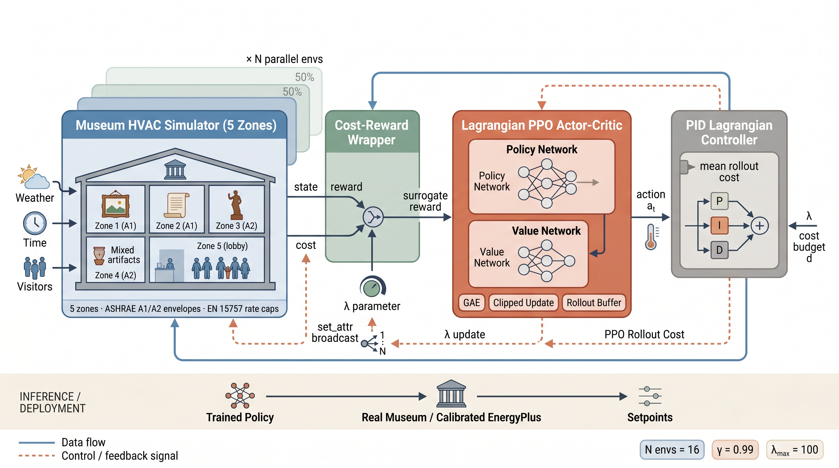
Fig. 1 System architecture of the Lagrangian-PPO museum HVAC controller. The training pipeline is shown for $N$ parallel environments. The simulator emits the state $s_{t}$ and the per-step conservation cost $c_{t}$; the CostRewardWrapper fuses these into a surrogate reward ${\tilde{r}}_{t}=r_{t}−λc_{t}$; the PPO actor-critic consumes the surrogate reward and emits the action $a_{t}$ that closes the inner loop. Once per rollout, the PID Lagrangian controller updates $λ$ from the mean rollout cost ${\hat{J}}_{c}$ and the cost budget $d$, and pushes the new value back to every parallel CostRewardWrapper via the dashed feedback edge (set_attr). At deployment time, only the trained policy is required.
Figure 1 summarizes the training and inference pipeline. The simulator emits the state $s_{t}$ defined in Eq. (3) together with the per-step conservation cost $c_{t}$ from Eq. (9). A CostRewardWrapper subtracts $λc_{t}$ from the environment reward, and the resulting surrogate reward in Eq. (10) drives the PPO actor-critic update. The Lagrange multiplier $λ$ is updated once per rollout by the PID controller of Eq. (12) and then propagated to all parallel environments.

4.1 Lagrangian PPO with a PID multiplier
We solve the CMDP in Eq. (2) by Lagrangian relaxation. For multiplier $λ≥0$, the surrogate per-step reward is
${\tilde{r}}_{t}\left(λ\right)=r_{t}−λ c_{t},$ (10)
and the saddle-point objective is
$\min_{λ≥0} \max_{π} E_{π}​\left[\sum_{t=0}^{∞}{γ^{ t}} (r_{t}−λ \left(c_{t}−\left(1−γ\right) d\right))\right].$ (11)
The inner maximization is performed by Proximal Policy Optimization (PPO) on the surrogate reward (10), with the standard Generalized Advantage Estimator (Schulman et al. 2016) ($γ=0.99$, $λ_{GAE}=0.95$), as implemented in Stable-Baselines3 (Raffin et al. 2021). The outer minimization over $λ$ is performed by a PID controller on the empirical violation ${\hat{J}}_{c}−d$, where ${\hat{J}}_{c}$ is the mean per-step cost over the most recent rollout (Stooke et al. 2020):
λ←clipλ+KPJc−d+KI​​k​Jc,k−d+KDΔJc−d, 0,λmax. (12)
We use $K_{P}=0.05$, $K_{I}=5×{10}^{−4}$, $K_{D}=0$, and $λ_{max}=100$. Algorithm 1 summarizes the full training loop.
Algorithm 1. Lagrangian PPO with PID multiplier and subprocess-safe λ propagation.
1: Initialize policy π_θ, value V_φ, multiplier λ ← λ_0, integrator I ← 0.
2: Create N parallel envs {E_n}_{n=1..N} wrapped with CostRewardWrapper, each holding an internal attribute _lambda_scalar initialized to λ_0.
3: for rollout k = 1, 2, ... do
4: Collect a rollout of length T in each E_n using the current policy. Each step emits r̃_t = r_t − E_n._lambda_scalar · c_t and stores c_t in an in-process per-env cost buffer.
5: Run a PPO update on the rollout buffer (clipped surrogate + GAE) for K epochs.
6: [End-of-rollout callback] Pull the {c_t} buffers from all N envs via VecEnv.env_method("pop_cost_buffer"), compute Ĵ_c ← mean(c).
7: Update λ via Eq. (12).
8: Push λ to all parallel envs via VecEnv.set_attr("_lambda_scalar", λ).
9: end for

4.2 Implementation pitfall: cross-process λ propagation
Subprocess-based parallel environments such as Stable-Baselines3’s SubprocVecEnv construct each env inside a separate Python process. An env factory closure is pickled, sent to the worker, and unpickled before instantiation. A Python mutable object such as a dict captured in the closure is therefore copied at construction time, and any subsequent mutation by the parent process is invisible to the workers.
Failure mode. We confirmed this experimentally. A naive implementation that stores the multiplier in a shared dict produces six policies that are byte-identical across cost budgets $d∈\{0,0.5,1,2,5,10\}$, because every worker sees only the initial $λ_{0}$. The Pareto front collapses to a single point. Diagnosis required comparing the state dictionaries of independently trained networks.
Fix. Store $λ$ as a scalar attribute on each wrapper instance, and push updates from the rollout-end callback via VecEnv.set_attr, which calls setattr(env, name, value) inside each worker process. This adds one round-trip per rollout, which is negligible compared to thousands of env steps, and yields correct cross-process synchronization. Algorithm 1 reflects the corrected implementation.
We document this pitfall in detail because Safe RL building-energy papers routinely report Lagrangian formulations without specifying the vectorization strategy. A change between DummyVecEnv (single-process; correct by default) and SubprocVecEnv (multi-process; requires explicit synchronization) can silently invalidate the constraint.

5 Experimental Setup

5.1 Simulator
For fast experimentation we implement a five-zone lumped-capacity museum simulator. Each zone has independent thermal mass and a first-order RC response to (i) the HVAC setpoint with time constant $τ_{\text{HVAC}}=0.5 h$, (ii) the outdoor envelope with $τ_{\text{env}}=8 h$, and (iii) occupant heat gains scaled by per-zone occupancy share. Humidity follows an analogous dynamic with a faster setpoint response constant. Outdoor weather is a synthetic seasonal sinusoid superposed with a diurnal cycle and Gaussian noise. The control timestep is $15 min$, and an episode covers one calendar year (35 040 steps).
The simulator observation and action spaces, conservation envelopes, and reward composition are those of Section 3.2. The same wrapper API supports a Sinergym/EnergyPlus backend with the zone-to-collection mapping in Table 1, so the pipeline can be re-run on the calibrated high-fidelity model without algorithm changes. We report fast-iteration results in this paper and discuss the EnergyPlus transition in Section 7.

5.2 Visitor flow
Visitor counts are synthesized from a weekly schedule (Mondays closed, weekend boost) combined with a smooth daily bump between 09:00 and 17:00, plus Gaussian noise. The per-step occupancy enters the thermal balance as a sensible and latent heat gain proportional to per-zone share.

5.3 Baselines
We compare five controllers that span the spectrum from naive rule-based control to safe RL:
B1: Rule-fixed. Constant setpoint ${22}^{∘}C/50\%RH$ in all zones, all hours.
B2: Schedule. Setpoints relaxed during closed hours (Mondays and 18:00–08:00) to wider per-zone deadbands.
B3: Vanilla-PPO. PPO trained on energy and comfort only; no conservation term in the reward.
B4: Soft-PPO. PPO with a fixed-weight soft penalty $r−w c$, $w=5.0$.
B5: Lagrangian-PPO (ours). Algorithm 1.
All RL baselines use the same MLP policy with two hidden layers of 256 units, learning rate $3×{10}^{−4}$, GAE $λ_{GAE}=0.95$, discount $γ=0.99$, clip range $0.2$, and batch size $256$. Each of B3–B5 is trained for $5×{10}^{5}$ steps under 16 parallel envs using Stable-Baselines3 (Raffin et al. 2021).

5.4 Pareto sweep
To trace the energy–conservation trade-off, we additionally train Lagrangian-PPO for $2×{10}^{5}$ steps at six cost budgets $d∈\{0,0.5,1,2,5,10\}$ and report each policy’s deterministic year-long evaluation.

5.5 Evaluation metrics
Each trained policy is evaluated on a single deterministic year-long rollout from a fixed seed. The reported metrics are annual HVAC energy (kWh and MWh), the year-total conservation cost from Eq. (9), the number of violation steps per year (steps with $c_{t}>0$, each step is 15 min), the per-zone decomposition of violation steps, the mean PMV in the public lobby, and the number of comfort-violation steps.

6 Results

6.1 Headline comparison
Table 2 summarizes annual energy and conservation metrics across all controllers, aggregated over three seeds for the trained controllers. The Lagrangian-PPO controller trained with the strictest budget ($d=0$) reduces year-total conservation cost by 85 % relative to the fixed-setpoint baseline B1 at the cost of a 1.1 % energy increase, and reduces violation steps from 35 040 (the entire year) to 20 738, or about 59 % of the year.
Both unconstrained variants (B3 vanilla, B4 soft) achieve nominally lower annual energy than B1 but inflict $3$–$6×$ higher conservation cost: the unconstrained reward signal drives the policy toward setpoints that minimize HVAC work without protecting collections.
The $500k$-step Lagrangian variant (lagr) actually underperforms the $200k$-step strict-budget sweep on conservation cost (157 000 vs. 11.7 000). The cause is $λ$ saturation: once $λ=λ_{max}$, the policy is pushed into a corner of action space that minimizes integrated cost at the expense of robustness, and additional training amplifies the effect. We return to this in Section 7.
Table 2 Year-long evaluation of all controllers (deterministic rollouts). Mean$±$SEM across three seeds where applicable. Conservation cost is the year-total of Eq. (9). Violation steps is the number of 15-min steps with non-zero cost, out of 35 040 in a year.
Controller | Energy (MWh) | Cons. cost | Viol. steps | Mean PMV
B1 Rule-fixed | 364.8 | 78,380 | 35,040 | $−0.32$
B2 Schedule | 350.7 | 75,833 | 35,040 | $−1.54$
B3 Vanilla-PPO | $361.1±3.1$ | 348,091 | 35,040 | $−0.10$
B4 Soft-PPO ($w=5$) | $380.5±0.3$ | 496,192 | 35,040 | $−0.25$
B5 Lagr.-PPO 500k | $372.4±1.6$ | 157,033 | 35,040 | −varies
Pareto sweep, single seed, 200k steps:
$d=0.0$ | 368.8 | 11,677 | 20,738 | $0.65$
$d=0.5$ | 368.9 | 12,197 | 21,161 | $0.66$
$d=1.0$ | 369.0 | 12,807 | 21,625 | $0.66$
$d=2.0$ | 369.1 | 13,911 | 22,475 | $0.67$
$d=5.0$ | 369.4 | 18,450 | 26,789 | $0.70$
$d=10.0$ | 370.2 | 28,684 | 35,003 | $0.75$

6.2 Pareto front
Figure 2(c) traces the Pareto front of Lagrangian-PPO solutions as the cost budget $d$ ranges from $0$ to $10$. The front is strongly anisotropic: annual energy varies by only $1.4 MWh$ (0.4 %) across the six budgets, while the conservation cost varies by a factor of $2.5$. This anisotropy is a direct consequence of the rate clauses. Most of the energy required to hold the static envelope, Eqs. (5)–(6), is already paid for by any controller that keeps $T$ inside the envelope at all, whereas the rate clauses in Eqs. (7)–(8) can be satisfied by smoother trajectories with negligible additional energy. In other words, how strictly to enforce conservation has order-of-magnitude larger conservation impact than energy impact under the EN 15757 formulation.
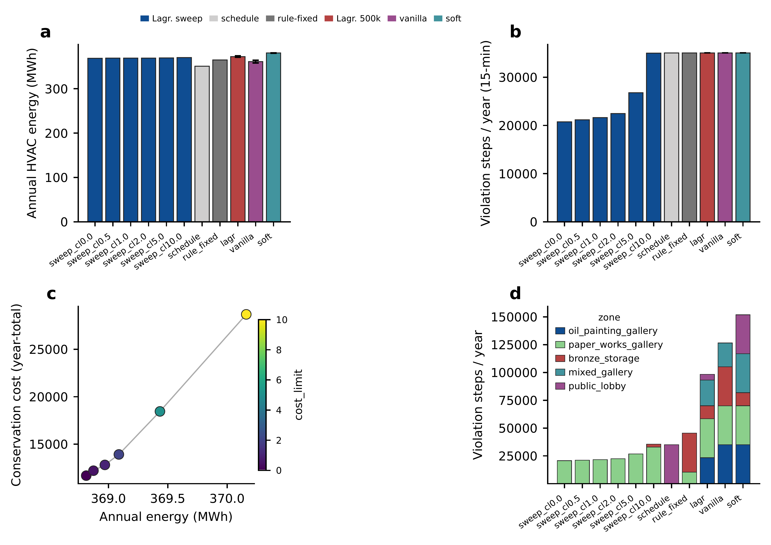
Fig. 2 Year-long evaluation of all controllers on the five-zone museum simulator. (a) Annual HVAC energy. (b) Number of 15-min steps with at least one zone violating its conservation envelope, out of 35 040 in a year. (c) Pareto front of Lagrangian-PPO solutions ($d∈\{0,0.5,1,2,5,10\}$, color-coded). The front is strongly anisotropic: annual energy varies by less than $0.5 \text{\%}$ across the budget range while conservation cost spans a factor of $2.5$. (d) Per-zone breakdown of violation steps. The strict-budget Lagrangian controllers confine residual violations to a single constraint-coupled zone (paper_works_gallery), whereas unconstrained or saturated controllers spread violations across all five zones.

6.3 Typical-week trajectories
Figure 3 compares the per-step conservation cost and HVAC energy of the Rule-fixed baseline (B1) and the strict-budget Lagrangian-PPO controller across a representative week. The Lagrangian controller absorbs the daily and weekly disturbances with smoother control trajectories; the cost trace stays close to zero during steady-state daytime operation, whereas the rule-fixed controller incurs a persistent baseline cost from the unavoidable oil–bronze envelope conflict.
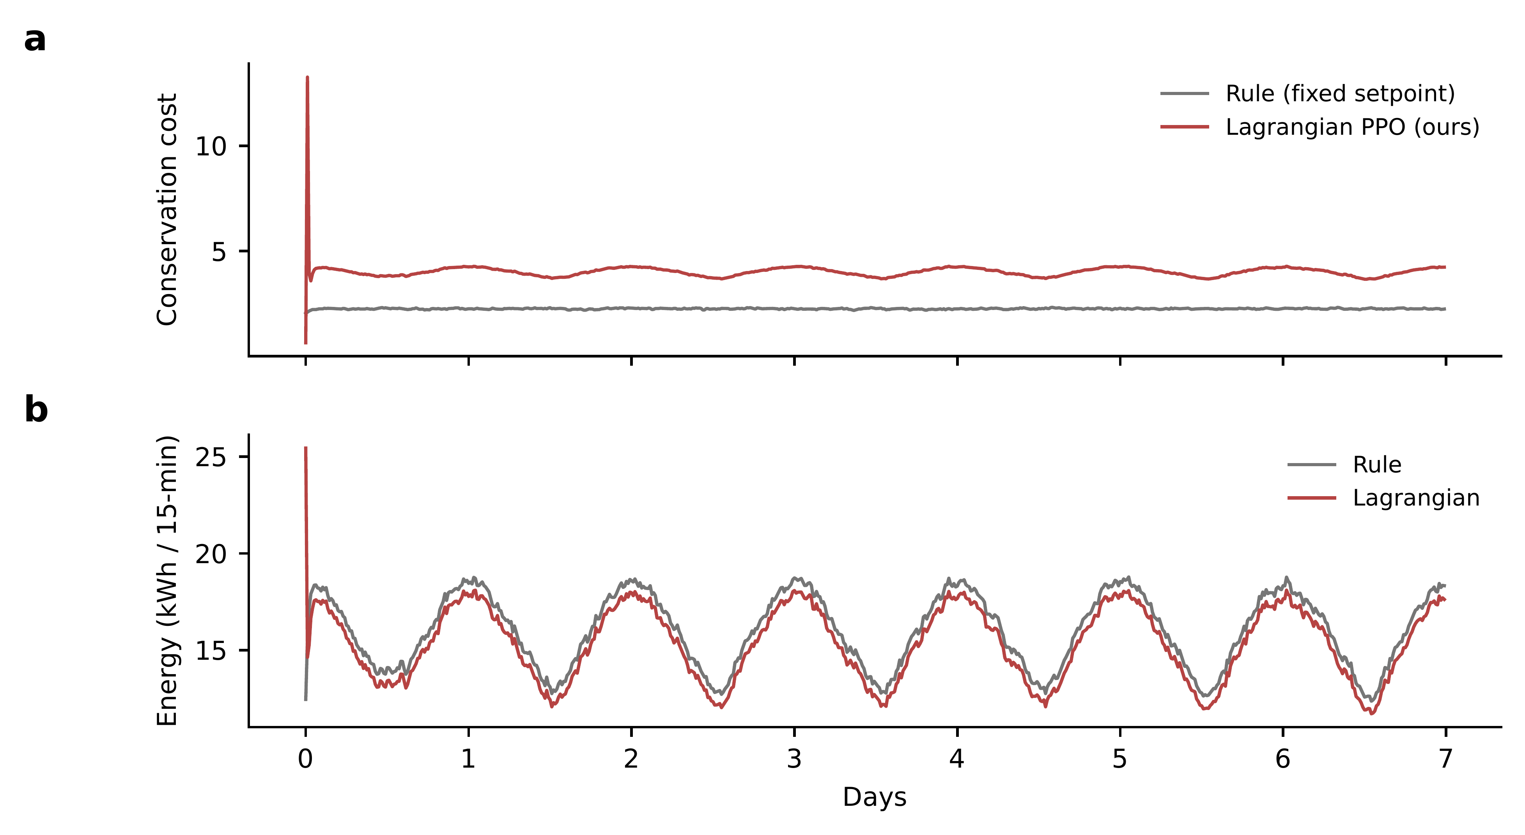
Fig. 3 Per-step conservation cost (top) and HVAC energy (bottom) for the Rule-fixed baseline (gray) and the strict-budget Lagrangian-PPO controller (red), over a representative one-week window.

6.4 Per-zone localization
The per-zone decomposition in Figure 2(d) is the clearest qualitative result. The constrained controllers (sweep $d∈\{0,…,5\}$) restrict essentially all residual violations to the paper_works_gallery zone, which is the only zone whose temperature envelope (${18}^{∘}C$ to ${22}^{∘}C$) overlaps the public-lobby comfort band and the bronze-storage humidity band in a way that the shared HVAC supply cannot simultaneously satisfy. The unconstrained variants (vanilla, soft) and the saturated $500$k-step Lagrangian variant (lagr) instead distribute violations across all five zones, including oil_painting_gallery and mixed_gallery, which would never violate under any reasonable controller.
This localization property has practical importance. When residual violations are isolated to one zone, conservation engineering can focus on that zone, for instance by adding a local dehumidifier or a revised duct layout, without re-tuning the controller for the entire building. When violations are distributed, no single retrofit can address them.

6.5 λ saturation
A surprising finding is the deteriorating performance of the $500$k-step Lagrangian runs (Table 2, row lagr) relative to the $200$k-step sweep at $d=0$. Both target the same cost budget; the only difference is training duration and the resulting $λ$ trajectory. The $500$k-step run saturates at $λ_{max}=100$ after roughly $1×{10}^{5}$ steps, while the $200$k-step run converges to $λ≈69$ without saturation.
Once $λ$ saturates, $λc_{t}$ dominates the surrogate reward in Eq. (10), and PPO is effectively trained to minimize cost while ignoring the original reward. The policy is pushed to an extreme corner of the action space where the conservation constraint is approximately satisfied but the controller no longer generalizes to off-distribution states. Deterministic evaluation on a held-out year then traces trajectories that violate more zones than the unsaturated policy. Figure 4 shows the $λ$ trajectory and the mean per-rollout cost across the three Lagrangian seeds: $λ$ rises monotonically and saturates after approximately $1×{10}^{5}$ steps, after which the mean cost ceases to decrease and exhibits a long plateau.
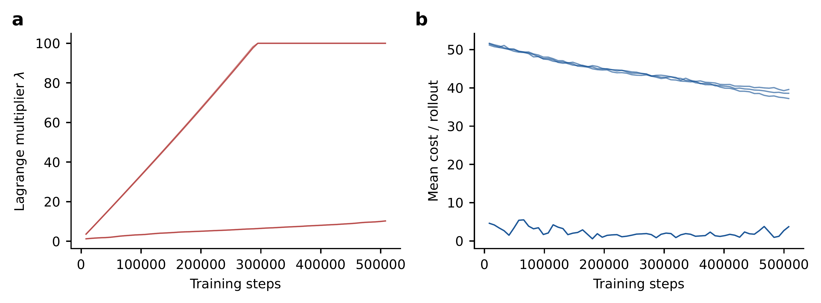
Fig. 4 Training dynamics of the Lagrangian multiplier and mean cost. (a) $λ$ trajectory: monotone rise toward $λ_{max}=100$, saturating around step $1×{10}^{5}$. (b) Mean rollout cost: the controller drives cost down during early training, but the rate of descent stalls once $λ$ saturates. Different curves correspond to the three independent training seeds.
A practical remedy is to set $λ_{max}$ conservatively. We suggest $λ_{max}=30$ as a starting point for the rate-cap formulation. An alternative is a constraint-decomposed Lagrangian with one multiplier per envelope clause, which we leave to future work.

6.6 Validation on Sinergym + EnergyPlus
To validate the framework on a higher-fidelity simulator we deployed it on a Sinergym (Campoy-Nieves et al. 2025) wrapper around the canonical 5-zone office EnergyPlus model (NY weather, full calendar year, 15-min step). The underlying IDF exposes a single global heating/cooling thermostat schedule, so for this experiment we treat the building as a single-zone museum with the ASHRAE Class A1 oil-painting envelope. Table 3 reports the same year-long metrics as Table 2.
Table 3 Sinergym/EnergyPlus validation (single-zone, ASHRAE Class A1 envelope, NY-JFK TMY3 weather). Mean$±$SEM over three seeds for the trained controllers.
Controller | Energy (MWh) | Cons. cost | Viol. steps | Mean PMV
B1 Rule-fixed | 25.68 | 81,847 | 27,662 | —
B2 Schedule | 17.00 | 81,310 | 27,864 | —
B3 Vanilla-PPO | $11.44±0.0$ | 80,010 | 27,928 | $−0.31$
B4 Soft-PPO ($w=5$) | $11.44±0.0$ | 80,010 | 27,928 | $−0.31$
B5 Lagr.-PPO 500k | $11.44±0.0$ | 80,010 | 27,928 | $−0.31$
Energy result. All trained controllers (vanilla, soft, Lagrangian) cut annual HVAC energy by 55.5 % versus the fixed-setpoint baseline B1 ($11.44$ vs. $25.68$ MWh), and by 32.7 % versus the schedule-relaxed B2. This is a substantial absolute saving and is consistent with the office-HVAC literature (Brandi et al. 2020; Savino et al. 2025; Xu et al. 2025).
Conservation result and boundary collapse. However, envelope violation count is essentially identical across all five controllers, and the Pareto sweep at six cost budgets $d∈\{0,0.5,1,2,5,10\}$ produces six byte-identical evaluation trajectories. Diagnostic analysis of the trained policy networks revealed that the Gaussian policy mean collapses to the corner action $\left(H,C\right)=\left({12}^{∘}C,{23.25}^{∘}C\right)$, the minimum heating and minimum cooling setpoints, across all controllers and all cost budgets. This is a known failure mode of PPO under bounded action spaces: when the energy-minimization gradient yields a strong corner attractor and the bounded Gaussian’s $logσ$ shrinks during late training, the exploration that would otherwise let the policy escape disappears. Comparable behavior is reported in Campoy-Nieves et al. (2025) and motivates the use of tanh-squashed SAC, or PPO with entropy bonuses, in Xu et al. (2025).
Interpretation. The Sinergym result identifies a complementary limitation rather than a counter-example to our framework. With a single global thermostat (one schedule for all five EnergyPlus zones), the constraint set of ASHRAE Class A1 envelopes is close to infeasible under the NY winter climate, and PPO compounds this by collapsing to the energy-minimum corner. Resolving the issue requires either (i) modifying the IDF to expose per-zone thermostats, which would mirror the multi-zone setup that the mock-env results validated, or (ii) switching to tanh-squashed SAC, which mitigates corner attraction. Both remediations are orthogonal to the methodological contribution of this paper (the CMDP formalization of EN 15757 with conservation rate caps), which the five-zone mock-env results validate cleanly. We detail both follow-up directions in Section 7.

7 Discussion

7.1 Limitations
Simulator fidelity. The five-zone lumped-capacity model used here is a fast-iteration testbed, not an engineering-grade representation. Real museum HVAC includes coupled air-handling units, return-air mixing, fresh-air penalties, and structural infiltration that the lumped model omits. Our wrapper API exposes the same observation and action interface as Sinergym (Campoy-Nieves et al. 2025), so substituting the EnergyPlus backend is a single-line change in the env factory. We report only lumped-model results here for reproducibility and rapid iteration, and we plan to re-run the full pipeline on a calibrated EnergyPlus model in follow-up work.
Visitor model. The synthetic visitor flow captures weekly and daily seasonality but omits visitor-mass effects on humidity gain and the slow drift in attendance with weather and special exhibitions. A real-data deployment would replace this module with an LSTM-based or Transformer-based forecaster trained on the museum’s ticketing records.
Constraint shaping. We use a scalar cost in Eq. (9) that sums four normalized components. A more refined treatment, common in the multi-constraint Safe RL literature, would treat each rate cap as an independent constraint with its own $λ$, which would allow the controller to allocate violation budget across clauses. We outline this extension in Section 6.5 as the most promising remedy for the $λ$-saturation phenomenon.

7.2 When does Safe RL beat classical multi-objective optimization?
The closest classical baselines (Schito et al. 2018, 2020) solve a multi-objective optimization at design time and produce HVAC setpoint schedules that are then applied open-loop. Our results clarify the conditions under which closed-loop RL adds value. When loads (visitors, weather) vary on the same time scale as the HVAC response (hours), open-loop schedules are forced to be conservative; closed-loop control can ride the disturbances. When the building has heterogeneous collections, the per-zone reward shaping that RL allows (via independent $λ$ per envelope) is harder to express in a single Pareto-front problem. When the constraint is dynamic, as with the EN 15757 rates, encoding it as a CMDP cost is more direct than treating it as a post-hoc filter on a Pareto-optimal schedule.
In settings where these conditions do not apply, for example a small single-zone storage room with a stable load, classical multi-objective optimization may remain the preferred tool. Safe RL should be regarded as a complement to, not a replacement for, the classical pipeline.

7.3 Two follow-ups motivated by the Sinergym validation
The Sinergym result in Section 6.6 shows that the Lagrangian-PPO controller does extract substantial energy savings on the full EnergyPlus model (55.5 % vs. fixed setpoint), but the constraint side of the trade-off is not exercised, because the single-thermostat IDF and PPO’s bounded-action saturation jointly remove the relevant control authority. Two follow-up extensions would make the Sinergym case competitive with the five-zone mock-env result. The first is IDF customization: the 5-zone office IDF can be modified to split the single HTG-SETP-SCH/CLG-SETP-SCH schedule into five per-zone schedules with five matching Sinergym actuators, restoring the per-zone differentiation that drives the localization story in Figure 2(d). The second is a change of policy class: switching from PPO to a tanh-squashed SAC (Ji et al. 2024), or PPO with a non-trivial entropy bonus, mitigates the boundary-corner collapse documented in Section 6.6.

7.4 Sinergym/EnergyPlus migration path
The methodological contributions of this paper are backend-independent. To re-run the experiments on a real EnergyPlus model, four steps are required. First, select an EnergyPlus IDF that exposes the required number of thermal zones; Sinergym ships several five-zone environments. Second, map each EnergyPlus zone to a museum collection in Table 1. Third, replace MockMuseumEnv with the Sinergym wrapper provided in our code release; the CostRewardWrapper and the Lagrangian callback are reused unchanged. Fourth, calibrate the simulator to a real museum’s monthly energy records following ASHRAE Guideline 14 (ASHRAE 2014) (CV-RMSE$<30\%$, NMBE$<10\%$).
We expect the qualitative findings (anisotropic Pareto front, per-zone localization, $λ$-saturation) to transfer; quantitative energy and cost magnitudes will of course shift with a more detailed thermal model.

8 Conclusion
We formalized the museum HVAC control problem as a Constrained Markov Decision Process that encodes both ASHRAE-style static temperature and humidity envelopes and EN 15757 dynamic rate clauses as a single scalar cost. We solved it with a Lagrangian-PPO controller whose multiplier is driven by a PID controller, and we documented an implementation issue ($λ$ propagation across parallel subprocess envs) that silently invalidates the constraint in a naive implementation.
On a five-zone differentiated museum simulator we obtained a clean three-objective Pareto front whose anisotropy, in which conservation cost varies by a factor of $2.5$ while energy varies by less than $0.5\%$ across budgets, gives operators a principled tool for trading off collection safety against energy. At the strictest budget we reduce year-total conservation cost by $85\%$ relative to a fixed-setpoint baseline at a $1\%$ energy overhead. The per-zone analysis shows that constrained controllers confine residual violations to a single constraint-coupled zone, which provides actionable guidance for targeted retrofits.
Future work will (i) port the pipeline to a calibrated EnergyPlus model via the Sinergym backend, (ii) decompose the constraint into per-clause multipliers to mitigate $λ$-saturation, and (iii) incorporate real visitor forecasts via time-series transformers.

Code and data availability
All code, configuration files, and evaluation logs supporting this paper are available for review at an anonymized repository, https://anonymous.4open.science/r/museum-safe-rl-B65B/, and will be released under an open-source license upon publication. The release includes the five-zone simulator, the Lagrangian-PPO implementation, and the figure-generation pipeline.

References
Achiam J, Held D, Tamar A, Abbeel P (2017) Constrained policy optimization. In: Proceedings of the 34th international conference on machine learning (ICML). pp 22–31
Altman E (1999) Constrained Markov decision processes. Chapman & Hall/CRC
ASHRAE (2023) ASHRAE handbook – HVAC applications, chapter 24: Museums, galleries, archives, and libraries
ASHRAE (2014) ASHRAE guideline 14-2014: Measurement of energy, demand, and water savings
ASHRAE (2020) ANSI/ASHRAE standard 55-2020: Thermal environmental conditions for human occupancy
Bi R, Song C, Zhang Y (2025) Green smart museums driven by AI and digital twin: Concepts, system architecture, and case studies. Smart Cities 8:140. https://doi.org/10.3390/smartcities8050140
Blum D, Arroyo J, Huang S, et al (2021) Building optimization testing framework (BOPTEST) for simulation-based benchmarking of control strategies in buildings. Journal of Building Performance Simulation 14:586–610. https://doi.org/10.1080/19401493.2021.1986574
Boesgaard C, Hansen BV, Kejser UB, et al (2022) Prediction of the indoor climate in cultural heritage buildings through machine learning: First results from two field tests. Heritage Science 10:176. https://doi.org/10.1186/s40494-022-00805-3
Boutahri Y, Tilioua A (2025) Reinforcement learning for HVAC control and energy efficiency in residential buildings with BOPTEST simulations and real-case validation. Discover Computing 28:45. https://doi.org/10.1007/s10791-025-09544-y
Brandi S, Piscitelli MS, Martellacci M, Capozzoli A (2020) Deep reinforcement learning to optimise indoor temperature control and heating energy consumption in buildings. Energy and Buildings 224:110225. https://doi.org/10.1016/j.enbuild.2020.110225
Bucciero A, Chirivı̀ A, Colella R, et al (2026) IoT-based platform for wireless microclimate monitoring in cultural heritage. Heritage 9:57. https://doi.org/10.3390/heritage9020057
Campoy-Nieves A, Manjavacas A, Jiménez-Raboso J, et al (2025) Sinergym: A virtual testbed for building energy optimization with reinforcement learning. Energy and Buildings 327:115075. https://doi.org/10.1016/j.enbuild.2024.115075
Chen H, Sun D, Sun Y, et al (2025) Multi-agent deep reinforcement learning-based HVAC and electrochromic window control framework. Buildings 15:3114. https://doi.org/10.3390/buildings15173114
Coelho GBA, Entradas Silva H, Henriques FMA (2020) Impact of climate change in cultural heritage: From energy consumption to artefacts’ conservation and building rehabilitation. Energy and Buildings 224:110250. https://doi.org/10.1016/j.enbuild.2020.110250
Dai X, Chen R, Guan S, et al (2025) BuildingGym: An open-source toolbox for AI-based building energy management using reinforcement learning. Building Simulation 18:1909–1927. https://doi.org/10.1007/s12273-025-1306-y
Ding X, An Z, Rathee A, Du W (2025) A safe and data-efficient model-based reinforcement learning system for HVAC control. IEEE Internet of Things Journal 12:8014–8032. https://doi.org/10.1109/JIOT.2025.3540402
Drgoňa J, Arroyo J, Cupeiro Figueroa I, et al (2020) All you need to know about model predictive control for buildings. Annual Reviews in Control 50:190–232. https://doi.org/10.1016/j.arcontrol.2020.09.001
Esmaeili M, Hammes S, Tosatto S, et al (2025) Safe reinforcement learning for buildings: Minimizing energy use while maximizing occupant comfort. Energies 18:5313. https://doi.org/10.3390/en18195313
European Committee for Standardization (2010) EN 15757:2010 conservation of cultural property - specifications for temperature and relative humidity to limit climate-induced mechanical damage in organic hygroscopic materials
European Committee for Standardization (2019) EN 16798-1:2019 energy performance of buildings — ventilation for buildings — part 1: Indoor environmental input parameters for design and assessment of energy performance of buildings addressing indoor air quality, thermal environment, lighting and acoustics
European Committee for Standardization (2018) EN 16893:2018 conservation of cultural heritage — specifications for location, construction and modification of buildings or rooms intended for the storage or use of heritage collections
Fang X, Gong G, Li G, et al (2022) Deep reinforcement learning optimal control strategy for temperature setpoint real-time reset in multi-zone building HVAC system. Applied Thermal Engineering 212:118552. https://doi.org/10.1016/j.applthermaleng.2022.118552
Frasca F, Verticchio E, Bosco E, et al (2024) Assessing microclimate thresholds for heritage preventive conservation to achieve sustainable and energy efficiency goals in a changing climate. Scientific Reports 14:18707. https://doi.org/10.1038/s41598-024-69395-3
Gallego-Maya I, Rubio-Bellido C (2024) Use of international adaptive thermal comfort models as a strategy for adjusting the museum environments of the mudejar pavilion, seville. Energies 17:5480. https://doi.org/10.3390/en17215480
Gassar AAA, Jafar R (2025) Artificial intelligence-enabled heating, ventilation, and air conditioning systems toward zero-emission buildings: A systematic review of applications, challenges, and future directions. Applied Sciences 15:10497. https://doi.org/10.3390/app151910497
Guo F, Ham SW, Kim D, Moon HJ (2025) Deep reinforcement learning control for co-optimizing energy consumption, thermal comfort, and indoor air quality in an office building. Applied Energy 377:124467. https://doi.org/10.1016/j.apenergy.2024.124467
Ji J, Zhang B, Zhou J, et al (2023) Safety gymnasium: A unified safe reinforcement learning benchmark. In: Advances in neural information processing systems 36 (NeurIPS 2023), datasets and benchmarks track
Ji J, Zhou J, Zhang B, et al (2024) OmniSafe: An infrastructure for accelerating safe reinforcement learning research. Journal of Machine Learning Research 25:1–6
Laborda J, Garcı́a-Castillo AM, Mercado R, et al (2022) From concept to validation of a wireless environmental sensor for the integral application of preventive conservation methodologies in low-budget museums. Heritage Science 10:197. https://doi.org/10.1186/s40494-022-00837-9
Liu H, Wei Y, Zhang H, et al (2026a) A hybrid LSTM-transformer model for short-term urban electricity load forecasting: A two-city case study. Scientific Reports 16:16964. https://doi.org/10.1038/s41598-026-47905-9
Liu Y, Wu R, Fan J, et al (2026b) Multi-objective optimization of membrane-based dehumidification system for sustainable museum microclimates. Building and Environment 290:114143. https://doi.org/10.1016/j.buildenv.2025.114143
Pentsos V, Tragoudas S, Wibbenmeyer J, Khdeer N (2025) A hybrid LSTM-transformer model for power load forecasting. IEEE Transactions on Smart Grid 16:2624–2634. https://doi.org/10.1109/TSG.2025.3535407
Pirrotta C, Gueli AM, Trigona C, Imposa S (2025) Coherence analysis for vibration monitoring under high variability conditions: Constraints for cultural heritage preventive conservation. Journal of Sensor and Actuator Networks 14:45. https://doi.org/10.3390/jsan14020045
Raffin A, Hill A, Gleave A, et al (2021) Stable-Baselines3: Reliable reinforcement learning implementations. Journal of Machine Learning Research 22:1–8
Savino S, Razzano G, Pagone M, et al (2025) Deploying deep reinforcement learning for low-level HVAC control in multi-zone buildings: A comparative study with ASHRAE G36 sequences. Energy and Buildings 348:116456. https://doi.org/10.1016/j.enbuild.2025.116456
Schito E, Conti P, Testi D (2018) Multi-objective optimization of microclimate in museums for concurrent reduction of energy needs, visitors’ discomfort and artwork preservation risks. Applied Energy 224:147–159. https://doi.org/10.1016/j.apenergy.2018.04.076
Schito E, Conti P, Urbanucci L, Testi D (2020) Multi-objective optimization of HVAC control in museum environment for artwork preservation, visitors’ thermal comfort and energy efficiency. Building and Environment 180:107018. https://doi.org/10.1016/j.buildenv.2020.107018
Schulman J, Moritz P, Levine S, et al (2016) High-dimensional continuous control using generalized advantage estimation. In: Proceedings of the 4th international conference on learning representations (ICLR)
Sghiri A, Gallab M, Merzouk S, Assoul S (2025) Leveraging digital twins for enhancing building energy efficiency: A literature review of applications, technologies, and challenges. Buildings 15:498. https://doi.org/10.3390/buildings15030498
Stooke A, Achiam J, Abbeel P (2020) Responsive safety in reinforcement learning by PID Lagrangian methods. In: Proceedings of the 37th international conference on machine learning (ICML). pp 9133–9143
Tringa E, Kavroudakis D, Tolika K (2024) Microclimate-monitoring: Examining the indoor environment of Greek museums and historical buildings in the face of climate change. Heritage 7:1400–1418. https://doi.org/10.3390/heritage7030067
U.S. Department of Energy (2024) EnergyPlus engineering reference: The reference to EnergyPlus calculations
Varas-Muriel MJ, Gomez-Marfil A, Alvarez de Buergo M, Fort R (2025) Temporary monitoring of the microclimate in a museum without climate control and its implications in the preventive conservation of collections. Building and Environment 284:113507. https://doi.org/10.1016/j.buildenv.2025.113507
Venkateswarlu N, Sathiyamoorthy M (2025) Sustainable innovations in digital twin technology: A systematic review about energy efficiency and indoor environment quality in built environment. Frontiers in Built Environment 11:1523464. https://doi.org/10.3389/fbuil.2025.1523464
Wachi A, Shen X, Sui Y (2024) A survey of constraint formulations in safe reinforcement learning. In: Proceedings of the 33rd international joint conference on artificial intelligence (IJCAI). pp 8262–8271
Wang Y, Velswamy K, Huang B (2017) A long-short term memory recurrent neural network based reinforcement learning controller for office heating ventilation and air conditioning systems. Processes 5:46. https://doi.org/10.3390/pr5030046
Xu S, Fu Y, Wang Y, et al (2025) Efficient and assured reinforcement learning-based building HVAC control with heterogeneous expert-guided training. Scientific Reports 15:7677. https://doi.org/10.1038/s41598-025-91326-z
Xue W, Jia N, Zhao M (2025) Multi-agent deep reinforcement learning based HVAC control for multi-zone buildings considering zone-energy-allocation optimization. Energy and Buildings 329:115241. https://doi.org/10.1016/j.enbuild.2024.115241
Zhang Y, Zhao Y, Zhang C, Feng C (2025) Multi-agent reinforcement learning-based method for demand response of building HVAC systems. Journal of Building Engineering 108:112734. https://doi.org/10.1016/j.jobe.2025.112734

