Fixed problem: when server shuts down and restarts, the website did NOT restart with it until manually had to go into Putty and type forever start app.js

Log into Putty using: **ec2-18-214-144-55.compute-1.amazonaws.com**

Login as: bitnami

Now using pm2 (<https://www.npmjs.com/package/pm2>) to restart website when server restarts.

I opened Putty and typed the following commands:

sudo pm2 startup -u nodeuser

pm2 start app.js

pm2 save

Now when you log into Putty you can see:

If so pm2 list to see list of all processes running, can see

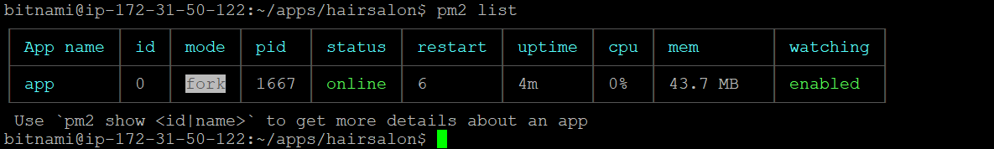

Notes: don’t worry if you the putty terminal crashes when the server and website crash. Not sure why this happens, but it does restart the website when the server comes back up.

Notes: I was having problems with restarting until this source(<https://futurestud.io/tutorials/pm2-restart-processes-after-system-reboot>) told me I had to do sudo pm2 startup -u nodeuser

Note: if trying to log into Putty while instance Is stopped, will not be able to, instead will get network failed to connect or something like that. Need to log into putty when instance is running.

Note: when instance is running and then stops, the putty becomes like this below because of previous note. While worrisome, it shouldn’t be because can access website and this putty terminal when instance resumes.

