Homework #6

Firewall-VPN Lab

* Task 1  
  Here is a screenshot of me beginning the simpletun server on VM A:  
  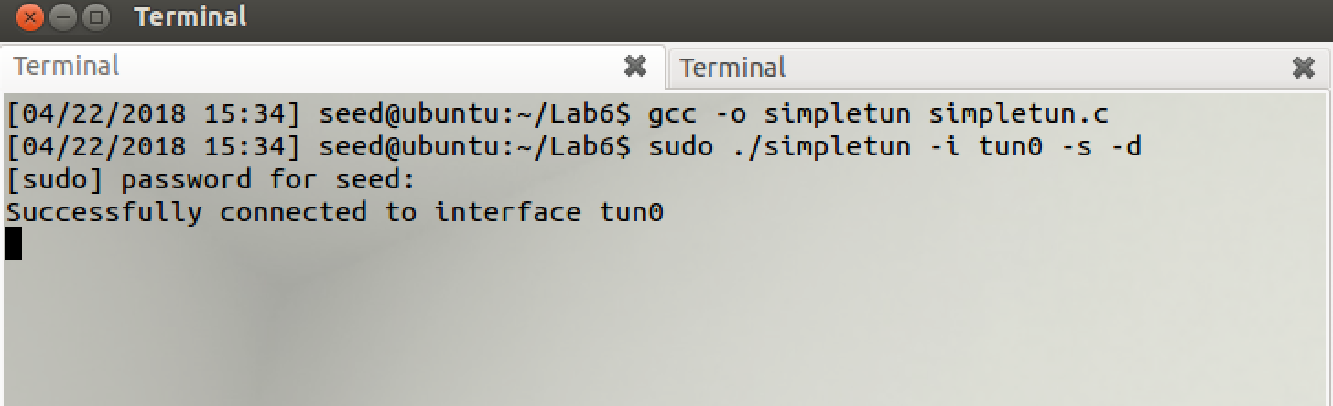  
    
  Here is a screenshot of me configuring the network interface *tun0* on VM A:  
  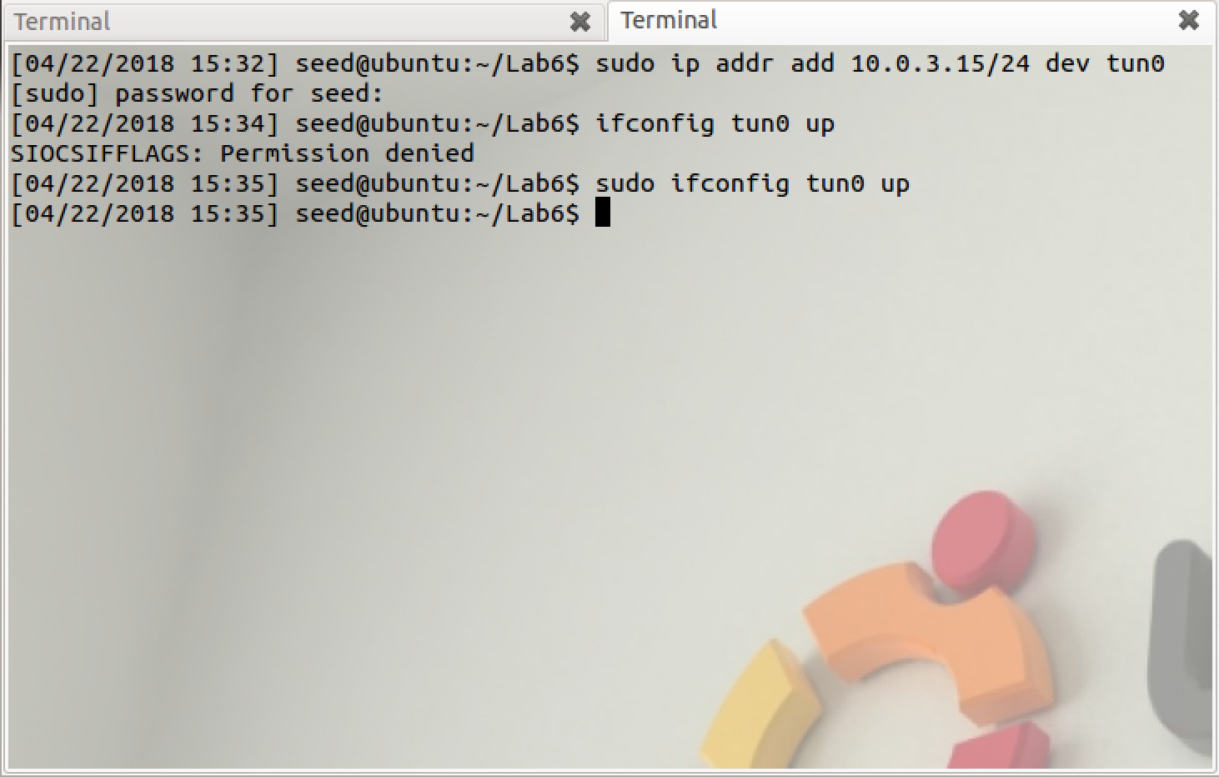

Here is a screenshot of me beginning the simpletun client on VM B:  
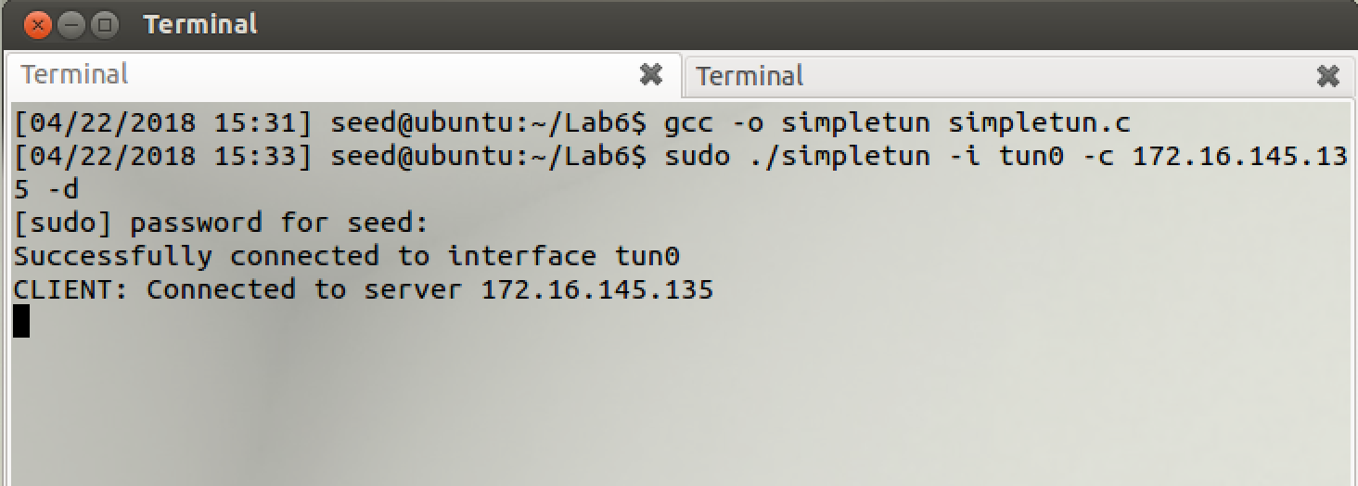  
  
Here is a screenshot of me configuring the network interface *tun0* on VM B:  
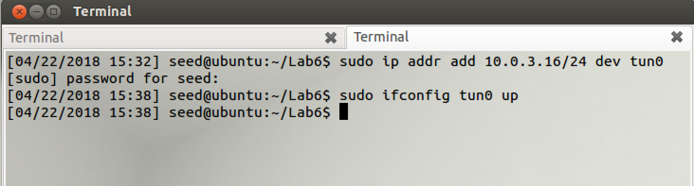  
  
Here is a screenshot of me adding the routing paths to VM A and B, and then testing the tunnel from both sides, using *ping* and *ssh* (VM B is on the left and VM A is on the right):  
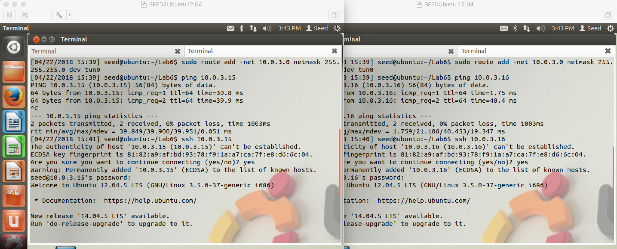

* Task 2  
  Here is a screenshot of me adding the IP Forwarding and applying the NAT fix to VM B:  
  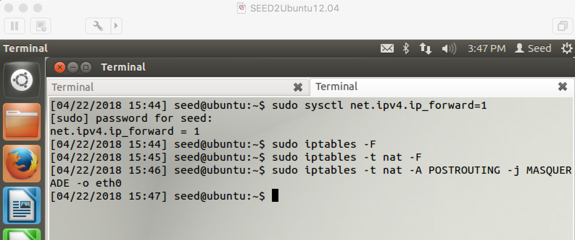
* Task 3  
  Here is a screenshot of me adding a firewall to VM A, disallowing it from communicating to a machine on my network at 172.16.145.136:  
  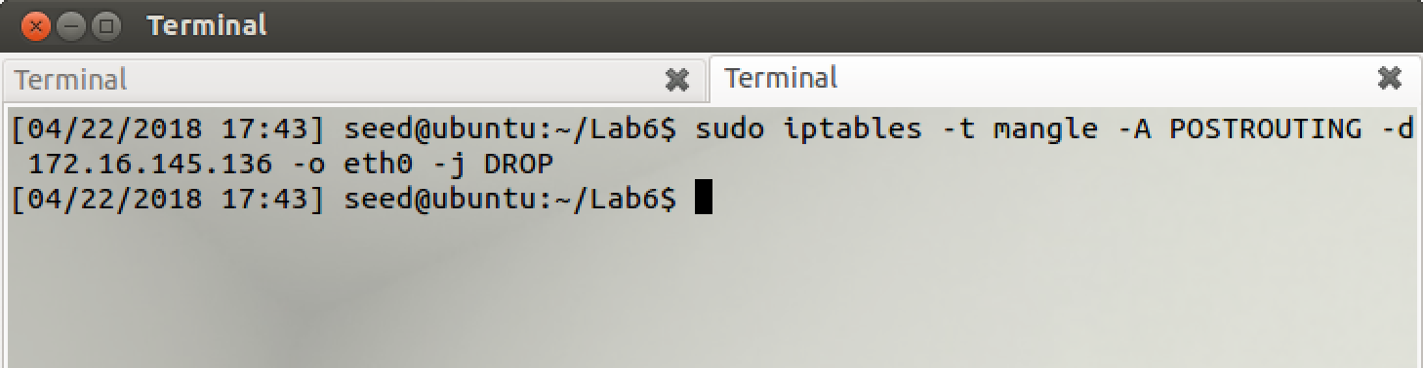
* Task 4  
  Here is a screenshot of me attempting to ping 172.16.145.136 from VM A with the firewall up:  
  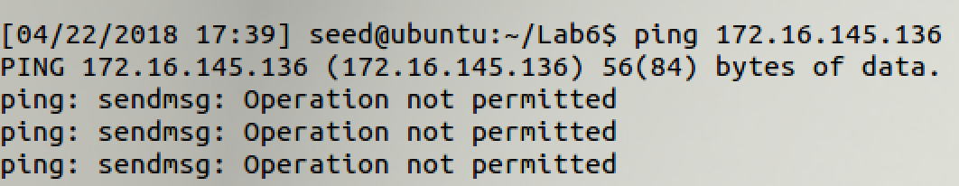  
  Note that the firewall blocks the ping request from even being sent through VM A’s *eth0* interface.  
  Running the VPN and choosing to use *tun0* as the network interface will solve the problem.  
    
  Running ping -I tun0 172.16.145.136 results in the following output:  
  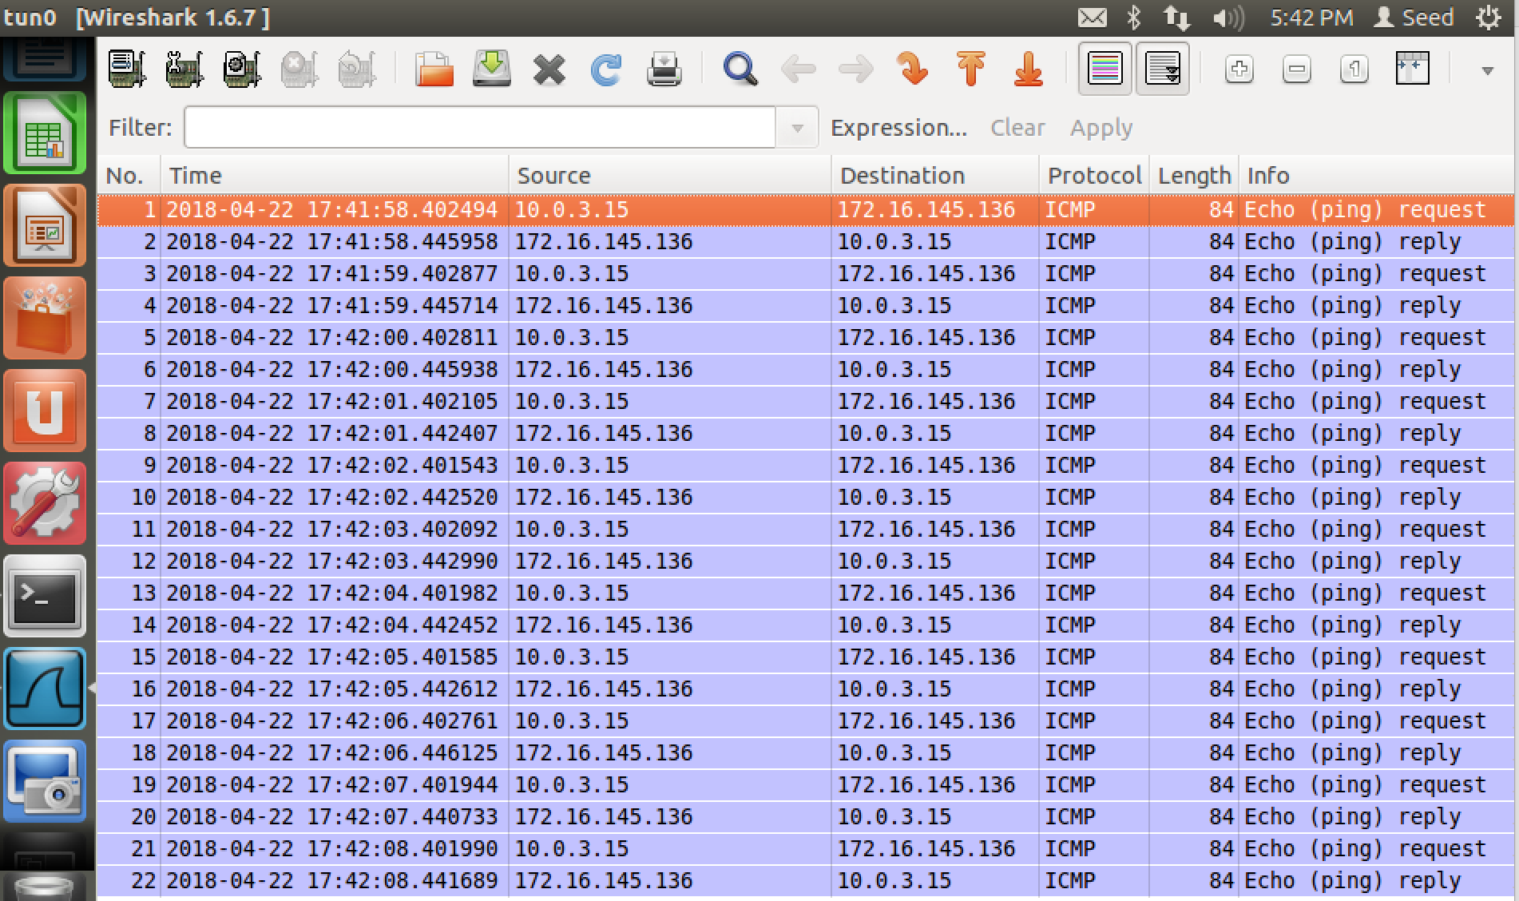  
  Now the VPN is being used to successfully contact the machine that was being blocked by the firewall. Note that it uses 10.0.3.15 as the source of its packets, which is the IP address of VM A’s virtual interface *tun0*.