# 1

# Mips assembly hello world program PCSpim

# https://www.youtube.com/watch?v=8dyibkAtaTM

main:

.text

la $a0,str

li $v0,4

syscall

li $v0,10

syscall

.data

str: .asciiz "Hello World\n"

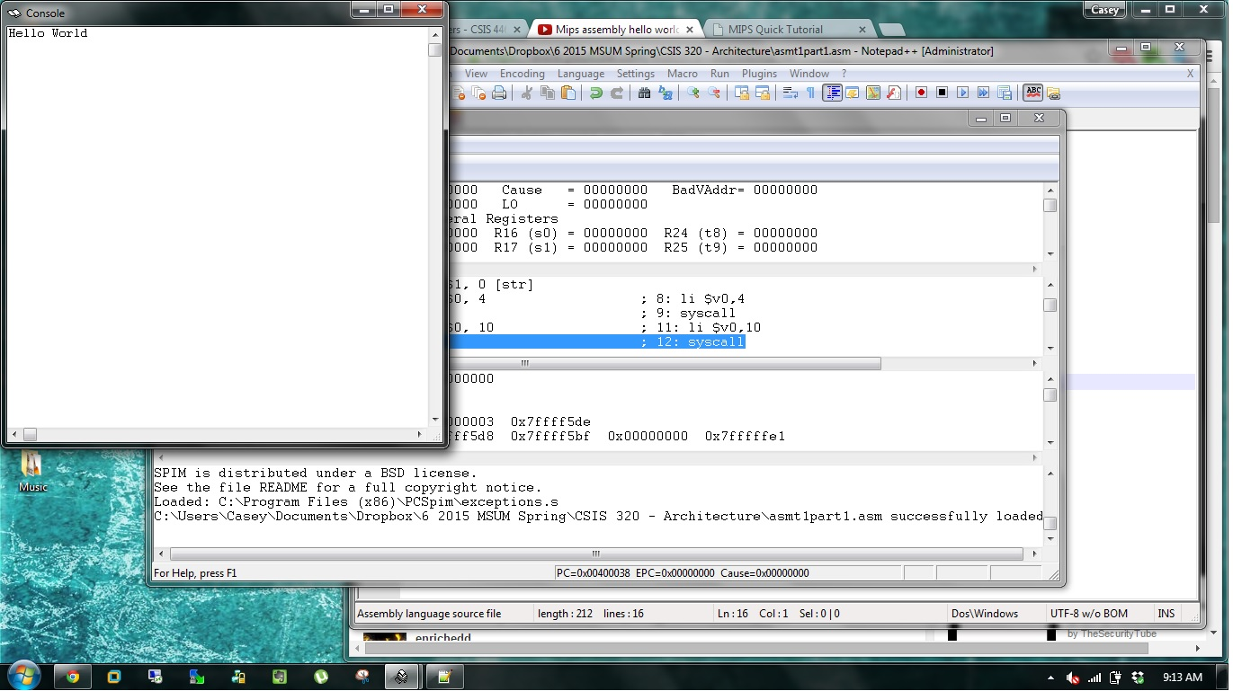

#2

# Mips assembly hello world program PCSpim

# https://www.youtube.com/watch?v=8dyibkAtaTM

main:

.text

la $a0,str

li $v0,4

syscall

li $v0,10

syscall

.data

str: .asciiz "Hello World\nMy name is Casey.\nFollow me for a trip... ;)"

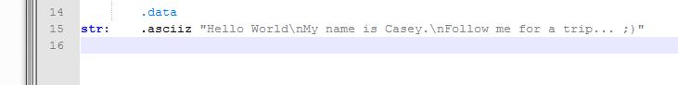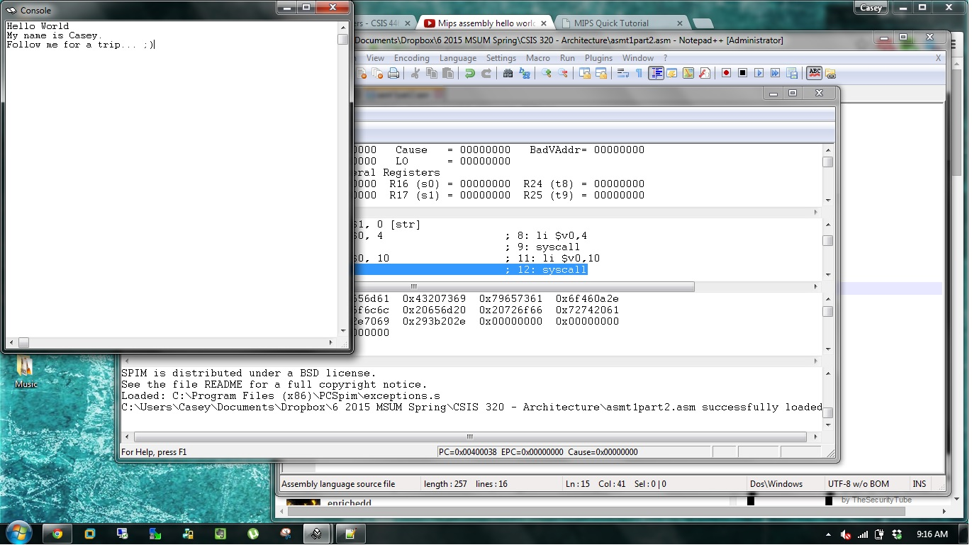

#3

# Mips assembly hello world program PCSpim

# https://www.youtube.com/watch?v=8dyibkAtaTM

main:

.text

la $a0,str

li $v0,4

syscall

li $v0,10

syscall

.data

str: .asciiz "Name: Casey Bladow\nMajor: Information Technology\nFavorite Animal: Black Lab"

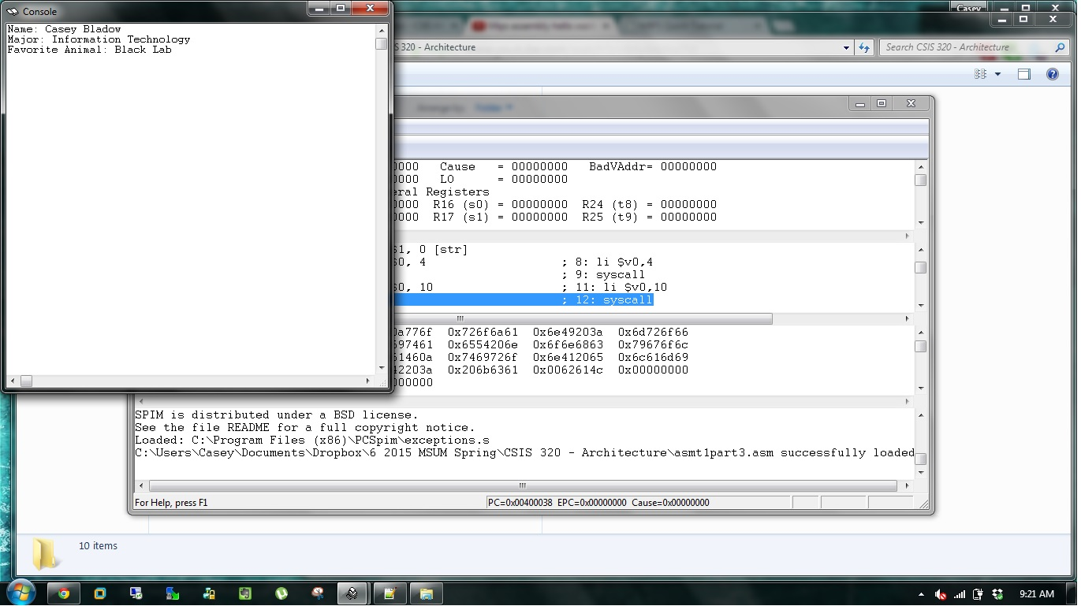

#4

3 Instruction types: R-type, I-type, and J-type.

R-type:

R-type instructions refer to register type instruction. The most complex.

add $rd, $rs, $rt

where $rd refers to some register d. $rs, $rt are also registers.

R[d] = R[s] + R[t]

Addition.

I-type:

I-type is short for "immediate type".

lw/sw $1,1000($2)

$1 <-- Mem[$2+1000]

$1 --> Mem[$2+1000]

J-type:

J-type is short for "jump type".

j target

Jump to instruction (not byte) target