Assignment 1: Java Program Using the Scanner Class 25 pts

Step 1: Review the API documentation for Java's Scanner class

<http://docs.oracle.com/javase/7/docs/api/>

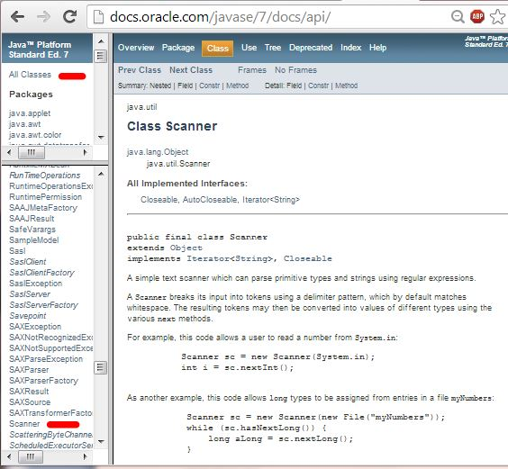

 Step 2:

* Create an application that reads from a text file using the Scanner class.
* Be sure to include documentation as shown in the scoring guide below.
* Use COMMAND LINE ARGUMENTS to allow provide the following information at runtime:
  + overtime rate (assume it will be a decimal value between 0 and 1.
  + the name of the text file
* Notes about the text file:
  + The **name of the text file must be specified via a command-line argument**.  Assume that I will give a valid filename, and that the file will have comma-delimited fields as shown: firstName, lastName, hourlyRate, hoursWorked, yearHired
  + Assume the text file can contain an unspecified number of lines
  + Assume that the bonus rate will be in the appropriate range (between 0 and 1), and that the hourlyRate and hoursWorked will always be numeric and positive.
  + The delimiter for the fields in each line of the text file MUST be a comma. Note that there will NOT be a comma at the end of each line.
* For each employee, calculate and print the
  + grossPay ( Use the overtime rate that was specified on the command line to calculate overtime pay if the hoursWorked is greater than 40.)
  + FICA amount (Use 7.5% as the FICA rate)
  + net pay
* Summary Report: Calculate and print
  + the minimum, maximum, and average of the gross pay for the group.
  + the first and last name of the employee who has worked the longest for the company.
  + the first and last name of the employee who is the most recently hired.
* REMEMBER to carefully label your output, and format all currency appropriately with a $ and two digits past the decimal.

**Example Text file: empInfo.txt**

John,Smith,10.50, 40,1997

Mary,Jones, 7.25,32,2012

Steven, Jackson, 15.00,42,1990

**SCORING GUIDE:  Total 25 pts**

2 pts:  Includes documentation at the top of the source file as shown:

     /*   FirstName LastName  
          Program 1 -- Due Sept 11, 2013  
          brief description of the functionality of the program goes here  
    */

2 pts:  Allows filename for the text file to be obtained via command-line arguments

4 pts:  Correctly reads the data from the comma-delimited text file (you can illustrate this by echoing each line read with println statements as you debug) -- leaving these statements in can prove that your program correctly processed the text file, even if other things go wrong.

2 pts:  output is labeled and correctly formatted

4 pts: correctly calculates each employee’s gross pay, including overtime pay when appropriate

4 pts: correctly calculates the FICA amount and net pay

3 pts: correctly reports the average, highest , and lowest gross pay

2 pts: prints the first and last name of the employee who has worked the longest for the company

2 pts: prints the first and last name of the employee who was most recently hired