Worksheet Set 5
Network Utility
Go to the Utilities folder and find the “Network Utility” application. Open it. What do you see?
Info, Netstat, Ping, Lookip, Traceroute, Whois, Finger, Port Scan
Click on the “Ping” area. Within there, where it says to enter the network address to ping, type in “puff.mnstate.edu” address. Then click the Ping button. What happens?
Pings puff.mnstate.edu 10 times… sends packets to the server and then receives them. Telling you how long it takes in ms
Go to the “Port Scan” area and paste in “puff.mnstate.edu” and specify a range of port numbers to scan and then click Scan. What happens?
Searches for available ports in puff.mnstate.edu
Ports can be thought of as things on a computer that you connect to. As you see, puff.mnstate.edu is running a web server (port 80, http). Use a web-browser such as Safari to connect to puff.mnstate.edu. What do you see?
Beings I’m doing this at home I need to use an ssh client to access puff. But what you would see is server listing. I use puff on a daily basis for Databases

Run your own web server

Using your current web design skills and these sites: http://www.htmlgoodies.com/primers/html/article.php/3478151 and
http://webdesign.about.com/od/textedit/a/aa122006.htm

Make an HTML document by writing HTML in TextEdit
Here are step-by-step instructions to get you started:

- Open TextEdit
- Change the format to plain text so you can write your HTML – Click Format – Make Plain Text OR Shift-command-T
- Write your HTML – be careful with your “/” and “<” If you mess one thing up it will screw up your page. You should start with <html> and end with </html>
- Title your page “My first HTML document”. In the body it should say “Hello World!” with the word World in bold. Then the next sentence should say “This is (your name) HTML page. Your name should be italics.
- Click File Save As and rename it to end in .html

Open the .html file that you created by control-clicking on it and then choose “Open With” and then from the submenu choosing “Safari”. Print a copy of your “site” and hand it in with this worksheet or do a screen shot and email the screen shot to me.
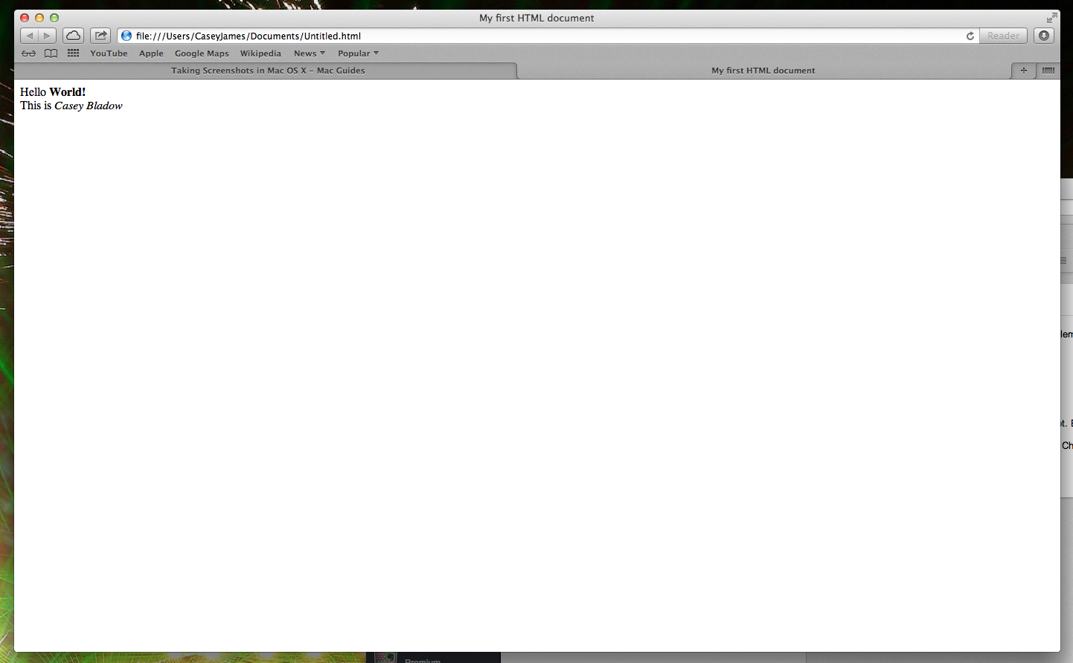
Go to your SITES folder. Go – Home – Sites Folder

Rename the existing “index.html” file that is in your “Sites” folder to “original index.html”.
Take the .html file that you created today and copy it into the “Sites” folder and then rename it as “index.html”.

Go to System Preferences and turn on “Web Sharing”.
Click on the clickable link which gives you the “index.html” file that was in the “Sites” folder.

Now, it should give you the “index.html” file that you had just put in the “Sites” folder. If it does not, try reloading the file within the browser.

Write down the URL here… it should begin with http: (If you end up with a file: - that’s ok.)

file://localhost/Users/CaseyJames/Documents/original%20index.html

iTunes (You can do this portion of the worksheet with your own iTunes account if you have one. You don’t need to be in the lab for this section.)
Open iTunes. Import any music you have.
Either “Sign In…” or “Create Account…” to access the iTunes Store (you might be able to access the store without creating an account, you can agree to the license agreement and not give any account info. If you don’t want an iTunes account).
Browse the iTunes Store. Play a movie trailer. Play some song samples.
Click on the “Radio” portion along the left of the iTunes window.
Find an Internet radio station that you like. What is it?
Classic rock the vault
Using iChat, set your status to “Current iTunes Track”. What songs are some of your classmates or friends listening to? If you are not together in the lab check any online status update in Google or Pandora or Facebook etc. What are your friends listening to right now? Nothing…
Find one other feature of iTunes. What is it?
Movies

Describe how to use it and why one would want to:
click on what you would like to watch and make a purchase. Stream movies from home… super slick if you own an AppleTV

GarageBand
Open the application called GarageBand.
Which folder is GarageBand found in? (Circle one): Applications Utilities Dock
What can GarageBand be used for? Creating music

Create a new project in GarageBand.
Figure out where your new project is stored and write that location here:
Music/GarageBand Folder

Open the finder window that has the icon for the project that you created. Take a picture of just that window. Command – Shift – 4 Email me that photo! 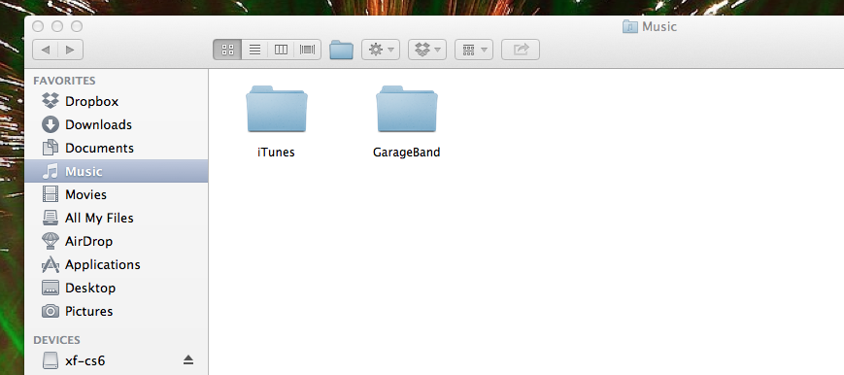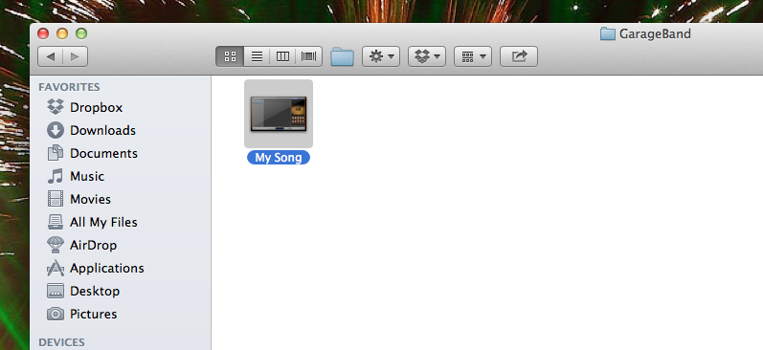
Create a simple song in GarageBand. Save it. Export it to iTunes. Describe the steps you took to do it:
Click share and Send to iTunes…

Convert the song you created into an MP3. This is easy to do! Right click on the song and click Create Mp3 Version. It sends it back to iTunes once it is converted. Double check the new extension on the song you created.

Send your mp3 song file to a friend and to yourself.
Who did you send to? Zach Bladow

iMovie

Open the application iMovie. Click on the help (use the Help menu if there is no question mark for you to click on). From within the Help Viewer, learn about iMovie and try to gain an overview of what it is. What did you think of iMovie so far? Nifty… haven’t used a video editor since middle school…

Using help, read a bit more about iMovie. Try to figure out how to create your own movie. Do you think you could figure out how to create a movie on your own? Yes
What is something else you want to learn about iMovie? Adding background music, titles, onscreen graphics, etc.
Film Students! What do you use to edit your films? Don’t use iMovie! ☺
Not a film student ☺

I love this guide to iMovie 9. Check it out! http://dwcblog.files.wordpress.com/2010/11/imovie-handout.pdf
Make a short movie using iMovie. Use the music that you composed in Garage Band or your favorite song for the audio bed.
What do you think of iMovie? Nice. Super easy to use and understand
Do you think you would ever use it again? (Circle one) YES NO

Why or why not? Unless I need to use it for school I have no use for it…

That is it for Worksheet 4.

