Worksheet Set 7/Take Home Worksheet
Turn this in by the end of class on May 1, 2013

The Dock
Read or review pages 69-78 of the “Mac OS X Snow Leopard Pocket Guide”. Customize your Dock.
Describe your customizations: ___________________________________________________________________________________
________________________________________________________________________________________________________________________________________________________________________

Show In Finder
Start iTunes.
The iTunes application should still be running (open) (with the little blue bubble under its Dock icon).
Control-click on the dock icon on iTunes app (or, press-and-hold the icon).
Click on Options and Show In Finder. Select that menu item. What happens?
______________________________________________________________________
Here is what to know: The items in the Dock are simply a reference to other locations. As a result, the Dock itself is never a location, so don’t write “the Dock” as an answer to a worksheet question that asks for a location.

The Trash
Read page 75 of the “Mac OS X Snow Leopard Pocket Guide”. Use TextEdit to create a file.
Make two copies of this file. Move one to the trash. Empty the trash. Move another copy to the trash. Securely empty the trash. Describe your experiences: ____________________________________________________________________________________________________________________________________________________________________________________________________________________________________________________________

QuickLook

Read page 65 of the “Mac OS X Snow Leopard Pocket Guide”.

Do you feel you understand what QuickLook is? Circle one: Yes No

Use QuickLook now. How well does it work for you? __________________________________________

Do you think you would use QuickLook again? Circle one: Yes No

Why or why not? ______________________________________________________________________ ____________________________________________________________________________________________________________________________________________________________________________________________________________________________________________________________

Important Keyboard Shortcuts
Read pages 196 and 197 of the “Mac OS X Snow Leopard Pocket Guide”. Try out each of the key commands. After trying them out – reinforce what you have learned by writing it down. What do these do:

Option-Command-Escape __________________________________________________________

Command-Tab __________________________________________________________

Shift-Command-Tab __________________________________________________________

Command-Space __________________________________________________________

Command-` __________________________________________________________
(also known as command back-tick. The key is just below the escape key and just above the tab key on most keyboards. You will need to have multiple windows open within the same application to observe the effect of this one.)

Editing Text
When you’re editing a document in TextEdit, there are a few basics that most of you may know already. Create a new document within TextEdit and write a few sentences. Describe how you would do these items in your document (you can use key commands or highlight text etc.)

Select some text _________________
_________________ __________________________________
Delete some text
__________________________________
_________________ __________________________________
Replace some text (type over some selected text) _________________
_________________ __________________________________
Hold down the shift key while pressing arrow keys (up, down, left, and right) _________________
_________________ __________________________________
Change the font of some text
_________________
_________________ __________________________________
Change the alignment of some text _________________
_________________ __________________________________
Cut some text _________________
_________________ __________________________________
Copy some text _________________
_________________ __________________________________
Paste some copied text _________________
_________________ __________________________________

Paste some cut text _________________
_________________ __________________________________

Create a new document, copy (or cut) from one document and paste into the other document
_________________
_________________ __________________________________

Editing International Text
If you want to use TextEdit to do something other than try to write HTML (which is what we do during one or two class periods), you will be able to take advantage of rich text formatting which will allow for multiple different fonts as well as languages. Here is information on how to do that.

Accent Keys and International Characters
Open TextEdit. Make sure you have the window for a new blank TextEdit document in front of you.
Under the Format menu, if a “Make Rich Text” menu item is available, select it.
(Do NOT select a “Make Plain Text” menu item. If the “Make Rich Text” menu item is not available, do nothing with the Format menu at this time.)
Hold down the Option key. Press the e key. Now release the Option key. What do you see appear in that TextEdit window?
______________________________________________________________________
Before you type anything else, press the e key again. Now what do you see in that TextEdit window?
______________________________________________________________________
Quit TextEdit.
Go to the System Preferences. Click on Language & Text. Click on Input Menu.
Make sure that “Show input menu in menu bar” is checked. (At the bottom of the window.)
Also make sure that “Keyboard Viewer” is checked “On”. (In the scrolling lists in Palette input types.)
Now click on Show All.
Quit System Preferences.
Open TextEdit again, ensuring you have an empty Rich Text document in front of you.
From the menubar, there should now be a little something on the right-hand side (it may display as either a little American Flag or as a little keyboard depending on which operating system version you are using and some other settings). It is a menu. Click on it. Choose Show Keyboard Viewer.
Now type something in TextEdit. Watch the Keyboard Viewer Palette as you do so. What happens to the Keyboard Viewer Palette (how does the Palette change) when you hold down the Option key? ________________________________________________
What other accents (modifiers to other letters, similar to what happened with Option-e) can you type on letters using Option-Key combinations? __________________________________________________________
Are you glad you learned this feature? Yes No

Spotlight and Activity Monitor
In the Utilities folder there is an application called Activity Monitor. Open it. What does it do? __________________________________________________________________
Read or review pages 88-90 of the “Mac OS X Snow Leopard Pocket Guide”. What does Spotlight do?
______________________________________________________________________

Use Spotlight. Does it work for you? What are your thoughts about using Spotlight?

Spotlight works by “indexing” everything on the computer. There is one important thing about it that you should know: it can consume the computational resources of your computer. Usually this is something that you want, because you’d rather it find things for you faster rathar than find things slower (which is what would happen if there was no “indexing” or only very poor “indexing”). However, there are times when you want the maximum amount of performance that you can get out of your computer. When that time comes, you can use the Activity Monitor to determine what is using up the most of the CPU and then quit that application.

To prevent Spotlight “indexing” from occurring all together, go to the System Preferences, and click on Spotlight (in the Personal group of preferences). From there, click on the Privacy “tab”.

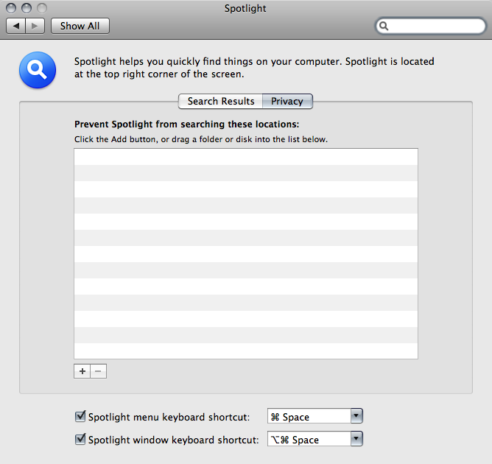
Drag all hard drives on your system, so that Spotlight will be prevented from searching anything on the system. This is how you can disable Spotlight “indexing” from causing your computer to do other work when you would rather it do just what you told it to do and nothing else. (You can undo this to re-enable Spotlight indexing.)

Try this and see how well it works for you.
What do you think?

___________________________________________________________________________________

Use Activity Monitor.
Set Activity Monitor to show “All Processes”.
Observe Activity Monitor as you do something else on the computer (such as start or quit an application). What happens? ________________________________________________________________________________________________________________________________________________________________________
Note that you can sort the processes in the Activity Monitor by name. Do so.
Look for a process named mdworker. Can you find it? (Circle one.) YES NO
If you presently have Spotlight indexing disabled, re-enable it. If you presently have Spotlight indexing enabled, disable it. Now, once again, look for a process named mdworker. Can you find it? (Circle one.)

YES NO
Try using Spotlight, when it is enabled. What does this do to the mdworker process?
______________________________________________________________________
Try using Spotlight, when it is disabled. What does this do to the mdworker process?
______________________________________________________________________
Why do you suppose enabling/disabling Spotlight and/or using Spotlight affects the mdworker process the way that it does? ______________________________________________________________________
________________________________________________________________________________________________________________________________________________________________________

Exposé
Read pages 71 and 94 of Mac OS X Snow Leopard Pocket Guide about Exposé.
Describe what Exposé does: ______________________________________________________________________________

Try to use Exposé. Were you successful at using Exposé? (Circle one)
YES NO

Why or why not? ______________________________________________________________________________

If you were not successful at using Exposé, Keep on trying until you are successful.

What do you think of Exposé? ____________________________________________________________________________________________________________________________________________________________

Do you think you would use Exposé again?
(Circle one)
YES NO

Why or why not? __________________________
______________________________________________________________________________

Spaces
Read pages 95 and 96 of Mac OS X Snow Leopard Pocket Guide about Spaces.
Describe what Spaces does: ______________________________________________________________________________
Try to use Spaces. Were you successful at using Spaces? (Circle one)
YES NO
Why or why not? ______________________________________________________________________________
If you were not successful at using Spaces, Keep on trying until you are successful.
What do you think of Spaces? ___________________________________________________________________________________________________________________________________________________________________________________________________
Do you think you would use Spaces again?
(Circle one)
YES NO
Why or why not? __________________________ ______________________________________________________________________________

Installing Software
Visit http://www.apple.com/downloads/macosx/internet_utilities/mozillafirefox.html
Download Mozilla Firefox, Google Chrome, or if you are working on your own computer, download any file or app you are interested in.
How well did the download process go for you? ______________________________________________
After downloading Firefox, install it.
How well did the installation process go for you? _____________________________________________
After installing it, use it.
How well did the use of it go for you? ______________________________________________________
Which do you like better? Circle one: Firefox Safari Google Chrome Other_______________
Why? _______________________________________________________________________________

AppleScript
Go to the Applications folder in the Finder. Look for the AppleScript Editor (which may be in the Utilities folder) (on older systems, it was called “Script Editor” and was in a folder called “AppleScript”). Open that application.
What is the title of the window that the application displays? ______________________
Do you see a record button? (Circle one) YES NO
Do you see a stop button? (Circle one) YES NO
Do you see a play/run button? (Circle one) YES NO
Do you see an area to edit text? (Circle one) YES NO
Click the “record” button. Do something in the Finder like open up some Finder windows. Then click the “stop” button.
Does what is there make sense to you? (Circle one) YES NO
Is what you see in the “Script Editor” window in English? (Circle one) YES NO
Is what you see in the “Script Editor” window something that you understand just by looking at?

YES NO
Is what you see in the “Script Editor” window a set of instructions that you think you could follow?

YES NO
Click the “play/run” button. What happens? ______________________________________

Now read page 176 of the “Mac OS X Snow Leopard Pocket Guide”. What do you think of the Script Editor so far?
______________________________________________________________________
______________________________________________________________________
Go to the Help Menu within the Script Editor application and click on the “Script Editor Help” menu item. Use the resulting help to find out what Script Editor is, what it does, what a script is, how to record a script, how to write a script, and more. Summarize what you’ve learned below:
______________________________________________________________________
______________________________________________________________________
______________________________________________________________________
______________________________________________________________________
______________________________________________________________________

Using the help, browse around (you can use the left and right pointing triangles to go forward and back through the pages that you’ve been on so far within help) and try to find out more about some aspect of AppleScript. What more did you try to find out about?
______________________________________________________________________
How successful were you at finding what you were trying to find out about?
______________________________________________________________________

Do you think you would ever use the Script Editor again? If so, how? If not, why not?
______________________________________________________________________
______________________________________________________________________

Thank you all for a great class!
Thanks for being flexible and working on your own, too!
I hope you have gained a little or a lot of knowledge about this operating system.
Good luck with the rest of your college career!

~Trina

