Casey Bladow

Assignment 05

2/24/15

1. ***After installation, take a screen shot of the Synaptic window that shows a green fill next to vim and include it in your assignment 5 document.***

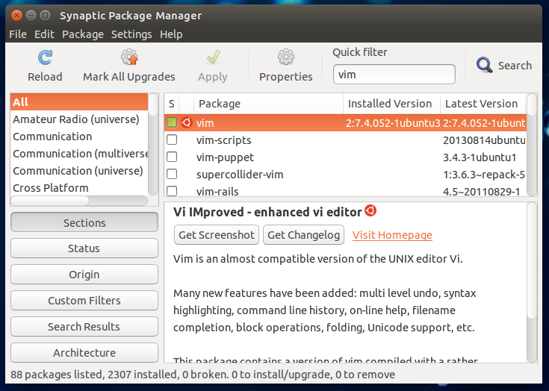

5. ***In your assignment 5 document, give a brief summary of what you found to be important or interesting.***

It seems to be a great programming tool. With the dot command, smart ranges, delimited blocks, block indenting, and its visual nature, it seems great. Visual nature has always been a big one for me. It seems to just make seeing everything that much easier.

**6. *Once you have completed the tutorial, upload your tutorial file to the assignment 5 dropbox on D2L. You will need to rename it to tutorial.txt as D2L does not like files without an extension. Be careful to get everything correct in the tutorial!***

**7. *Include in your assignment 5 document the URLs of some that you found useful.***

<http://www.fprintf.net/vimCheatSheet.html>

<http://www.radford.edu/~mhtay/CPSC120/VIM_Editor_Commands.htm>

<http://www.catswhocode.com/blog/130-essential-vim-commands>

<http://stackoverflow.com/questions/1276403/simple-vim-commands-you-wish-youd-known-earlier>

<http://xmodulo.com/useful-vim-commands.html>

1. ***What did you think of this assignment? How long did it take you? Do you have any suggestions for the next time I teach this class?***

This assignment was bad. Pretty easy really. Definitely shorter and a little simpler to understand with practice. It’s definitely different trying to reposition your fingertips on the keyboard. I spent about 2.5 hours on it. Not much to suggest, the tutorial was very informative and well put together.

1. ***What did you learn from this assignment?***

I would say I got a very basic understanding of vim. It would take a little while to grasp completely but by the end of the tutorial I was definitely moving faster than I was at the beginning. Actually had to stop and restart because I entered something in and couldn’t figure out how to get out…