**Casey Bladow**

**CSIS 360 - Spring 2015**   
**Assignment 9 - 25 points**   
**Due Tuesday, April 14**

Follow the [**Creating Assignments**](http://dragon.mnstate.edu/~brekke/spring15/360/handouts/assignments.htm) handout while performing the below steps. The purpose of this assignment is to ...

If any of you find that I am misusing or have incorrect terminology in any of my descriptions, please drop me a note with an explanation. I'm learning too!

1. *rsync* is an important backup utility for Linux systems. Unfortunately, it is not covered in the textbook. Learn about the *rsync* utility through the following articles while at the keyboard experimenting with the commands. The articles refer to using the option *-e ssh* so that *ssh* is used as the protocol, but *ssh* is used by default ([**http://www.rsync.net/resources/faq.html**](http://www.rsync.net/resources/faq.html) <-- you don't need to read this, it's just where I found the information).
   * [**http://www.thegeekstuff.com/2010/09/rsync-command-examples/**](http://www.thegeekstuff.com/2010/09/rsync-command-examples/)
   * [**http://www.tecmint.com/rsync-local-remote-file-synchronization-commands/**](http://www.tecmint.com/rsync-local-remote-file-synchronization-commands/)
   * [**https://www.digitalocean.com/community/tutorials/how-to-use-rsync-to-sync-local-and-remote-directories-on-a-vps**](https://www.digitalocean.com/community/tutorials/how-to-use-rsync-to-sync-local-and-remote-directories-on-a-vps)
   * Once you have learned about *rsync* from the above articles, perform the following.
     + For convenience open two terminal windows, one for your Ubuntu box and log into *smaug* using *ssh* in the other.
     + Create a directory on your Ubuntu box called *assign9*. Within the *assign9* directory, create a directory called *ubuntuDir* that contains the files *file1*, *file2*, through *file50* (the 3rd article shows you a convenient shortcut).
     + Using rsync, copy the *assign9* directory (which should include *ubuntuDir* and the 50 files in it) from your Ubuntu box up to your smaug account. Immediately repeat the successful command (up arrow) to note that nothing is transferred the second time as nothing has changed.
     + On your *smaug* account, verify that the files were successfully transferred. Then on *smaug*, delete *file30* and *touch file40*. Repeat the *rsync* command on your Ubuntu box, which should upload only *file30* and *file40*.
     + On your Ubuntu box, delete files *file11* through *file15*, touch files *file21* through *file25* then give the *rsync* command from your Ubuntu box to update the files on *smaug*, including deleting the files deleted from your Ubuntu box (did you read the above articles?). ***Do a window grab of the terminal window showing the command you issued on your Ubuntu box and include it in your assignment 9 document.***

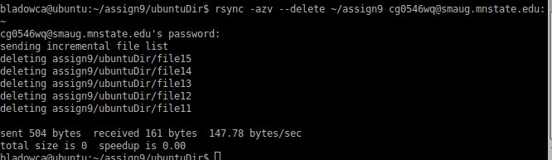

* + - Create a directory on your smaug account called *smaugDir* in the *assign9* directory that contains the files *fileA*, *fileB*, through *fileZ*.
    - Using rsync from your Ubuntu box, copy the *assign9* directory from *smaug* that contains the *ubuntuDir* and the *smaugDir* directory on smaug down to your Ubuntu box. Immediately repeat the successful command (up arrow) to note that nothing is transferred the second time as nothing has changed. Do an *ls* command on your Ubuntu box from the appropriate directory to verify the successful transfer of the directory, then ***do a window grab of the terminal window showing the files now on your Ubuntu box and include it in your assignment 9 document.***

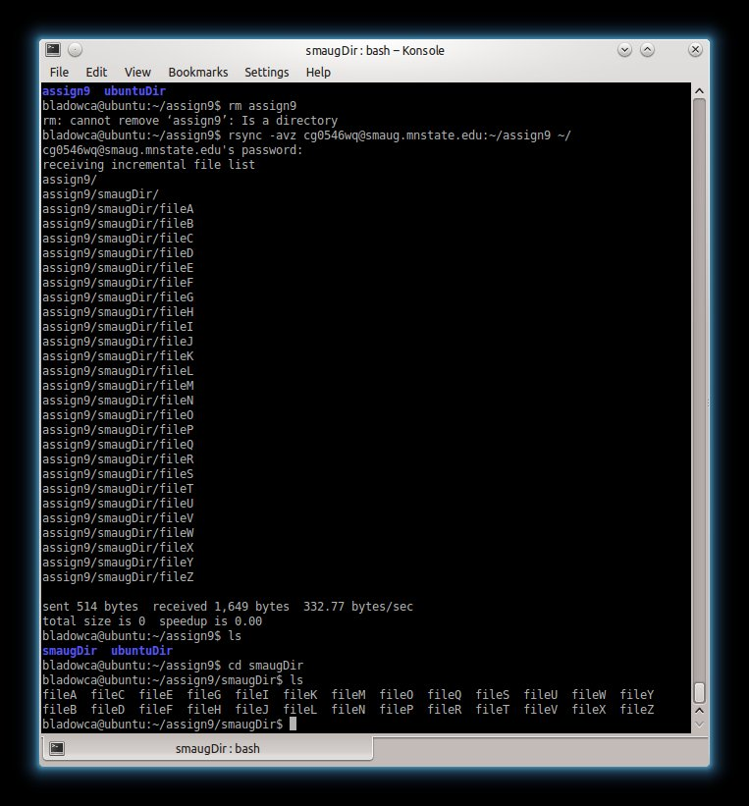

* + - NOTE: KEEP THE assign9 DIRECTORY AS IT WILL BE USED IN A FUTURE ASSIGNMENT!
  + ***Include answers for the following in your assignment 9 document.***
    - ***What do the following rsync options mean***
      * ***-v*** verbose
      * ***-r*** indicates recursive
      * ***-a*** archive mode
      * ***-z*** enable compression
      * ***-h*** human-readable, output numbers in a human-readable format
      * ***-n*** dry run (simulation)
      * ***--delete*** deletes files that are not there in source directory
      * ***--include***  allows you to include files or directories while doing synchronization
      * ***--exclude*** allows you to exclude files or directories while doing synchronization
    - ***what's the difference between using a slash following a directory, for example dir vs. dir/?*** Different results…

without the trailing slash…

rsync -avz 192.168.200.10:/tmp/dir .

would produce

dir/file01

dir/file02

whereas including the trailing slash…

rsync -avz 192.168.200.10:/tmp/dir/ .

would produce

file01

file02

1. Read chapter 7 (The Shell) while at the keyboard experimenting with the commands as you read the chapter. ***Answer the following questions in your assignment 9 document (yes, there's quite a long list, keep these in mind for the final test)***
   * ***When issuing commands to execute utilities, what are "options?" Give a couple examples and what the options would do.***

An option is an argument that modifies the effects of a command.

--help generates a usage message

-r causes the ls utility to display the list of files in reverse alphabetical order.

* + ***What is the -h option?***

Display readable file sizes

* + ***What do the following control characters do on a command line?  
    cntl-u*** to kill a line ***cntl-w*** to erase a word ***cntl-h*** to erase a character
  + ***What option can you give with a command to get help on the command?*** --help
  + ***What command will temporarily add the working directory to PATH? (remember when you had to type ./a.out instead of just a.out?)*** PATH=$PATH:.
  + ***How can you redirect input to a program so that the input comes from a file?*** Command [arguments] < filename
  + ***How can you redirect output from a program so that the output goes to a file?***  >
  + ***How can you redirect output from a program so that the output is appended to a file?*** >>
  + ***Give a good description of a filter and how it's used.*** A filter is a command that process an input stream of data to produce an output stream of data. A command line that includes a filter uses a pipe to connect standard output of one command to the filter’s standard input.
  + ***What is /dev/null?*** /dev/null is a data sink or bit bucket
  + ***What suspends a running job?*** CONTROL-Z
  + ***What command would send the directory listing to the line printer?*** lpr
  + ***What is the noclobber feature of the shell?*** Prevents overwriting a file using redirication.
  + ***What is an ambiguous file reference?*** Filenames that contain special characters because they do not refer to any one specific file.
  + ***What is globbing?*** The process that the shell performs on these filenames.
  + ***What is a PID?*** Process identification number – a large number assigned by the operating system.
  + ***What does it mean when a utility is a builtin?*** A builtin is a command that is built into a shell.
  + ***What do the following utilities do?***
    - ***fg*** Moves a process to the foreground
    - ***bg*** Moves a process to the background
    - ***kill*** Aborts a background job
    - ***tr*** Maps one string of characters to another
    - ***tee*** Sends standard input of both a file and standard output
    - ***jobs*** Displays a list of suspended jobs and jobs running in the background
  + ***What do the following special characters do or what are they for?***
    - ***&*** run a command in the background
    - ***?*** generate filenames
    - ***\**** performs a function similar to the question mark but matches any number of characters in a filename
    - ***|*** The symbol for a pipe
    - ***[ ]*** causes the shell to match filenames containing the individual characters.

1. ***What did you think of this assignment? How long did it take you? Do you have any suggestions for the next time I teach this class?*** Wasn’t bad. Easy to follow through. Only took a few hours
2. ***What did you learn from this assignment?*** rsync is a nice utility to keep things synced up from a home system to one that is not (i.e. my laptop and smaug).