Casey Bladow
Assignment 01
1/17/15

1. Give a description of your previous experience with Linux. Where would you put yourself on the 0-10 Linux scale described in the syllabus?
I can't say I have a whole lot of experience using Linux, however, I have played with a tad here and there when necessary in a situation that calls for it. It has been a long time since I learned all the ins and outs of the OS. 4-5.
3. Answer each of the exercise questions at the end of chapter 1.
1. Free software is exactly what it's called. Free to use, distribute, and change. Three characteristics are: The source code must be distributed with the program, you cannot restrict people it anyway, user must be allowed to redistribute their modified versions under the same terms.
2. It's portable, based on standards, written in C, can support many users, and runs multiple tasks flawlessly.
The source code for all Linux OS's is freely available so students can understand how Linux works. They can modify the code further to change and understand the way it works.
3. Multiuser OS's allows multiple users to access the resources of a single system. Allows many users to take advantage of the available resources simultaneously.
4. The Free Software Foundation is the principal organization sponsor of the GNU project. GNU developed a lot of the tools, including the C compiler, that are part of the Linux OS.
Linus is the name of the OS kernel, that was developed by Linus Torvalds. It has since been expanded and improved by countless amounts of people on the Internet.
Torvald's kernel and GNU's tools work together as the Linux operating system.
5. Linux is written in C. C is portable because it is written in a higher-level, machine-independent language. Because Linus portable, it can be adapted to different machines and can meet different requirements.
6. A utility program performs a task that is frequently related to the OS. It's simpler than an application program. Usually referred to as a command.
7. The shell is a command interpreter. It acts as an interface between you and the operating system. When you enter a command on the screen, the shell interprets the command and calls the program you want.
8. Write a shell script, make the file executable, and give the name of the file as a command. Shell will then executes the commands in the file. Just like it would if you had typed in each one individually.
9. Linux does not has drives with assigned letters. Instead a hard drive can be mounted to any directory within an entire file system. On the top of the file system hierarchy structure is a root directory represented by “/” which expands to sub-directories forming hierarchical tree.
10. Multiprocessor – is a system with more then 1 CPUs.
Multiprocessing – is a system that can can process more than one task at a time.
11. Almost always. Whenever you are running two or more tasks at the same time.
12. Thousands of people have been involved in creating the Linux OS. It's unique because there's no other project out there that has been attempted.
13. Run, Study, Redistribute, Improve
5. What is a virtual machine? List some advantages of virtual machines.
A virtual machine is like a pretend computer running inside your computer. Pretty awesome really. Enabling you have multiple Operating Systems installed and never having to mess with you actual hard drive. (No partitioning!) I have found they are great to install just for a class or two. You can use them, abuse them, fill them full of stuff you'll never use again after 16 weeks, back up the necessary files you would like to keep, and scrap the rest. The list of advantages goes on and on. Like I just mentioned. You could also use them when you need them, hackers are known for this when it comes to doing some penetration testing. In reality, you could have a whole secret life hidden inside another virtual machine. And until someone figures out how to boot it, log into it, and gain access... they'll never know.
7. What virtual machine did you choose and why?
I went with Vmware because I've used VirtualBox prior and use Fusion at home.
10. List some of the best Linux distros described in the articles.
Ubuntu, OpenSUSE, Fedora, Mint, Debian, Korora and Mageia, Elementary OS, Sparky Linux, Gentoo
11. Why are there so many Linux distros?
Linux is free and open source. This enables everyone and their grandmother to download a copy, tweak it to their liking, and send it out for the world to share.
13. Include a screenshot of your virtual machine software that shows your Ubuntu virtual machine.
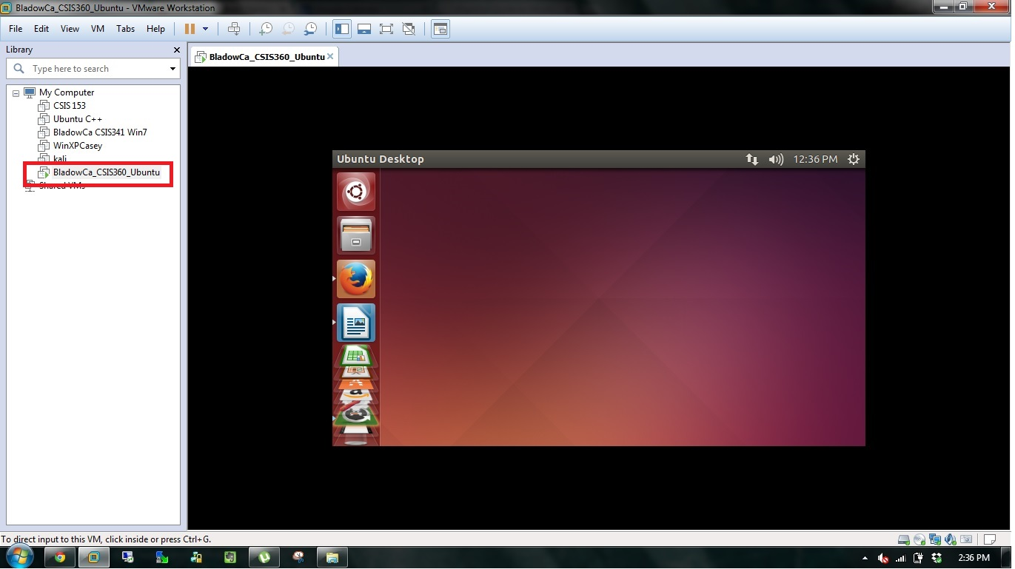
14. Include a screenshot of your Ubuntu desktop.
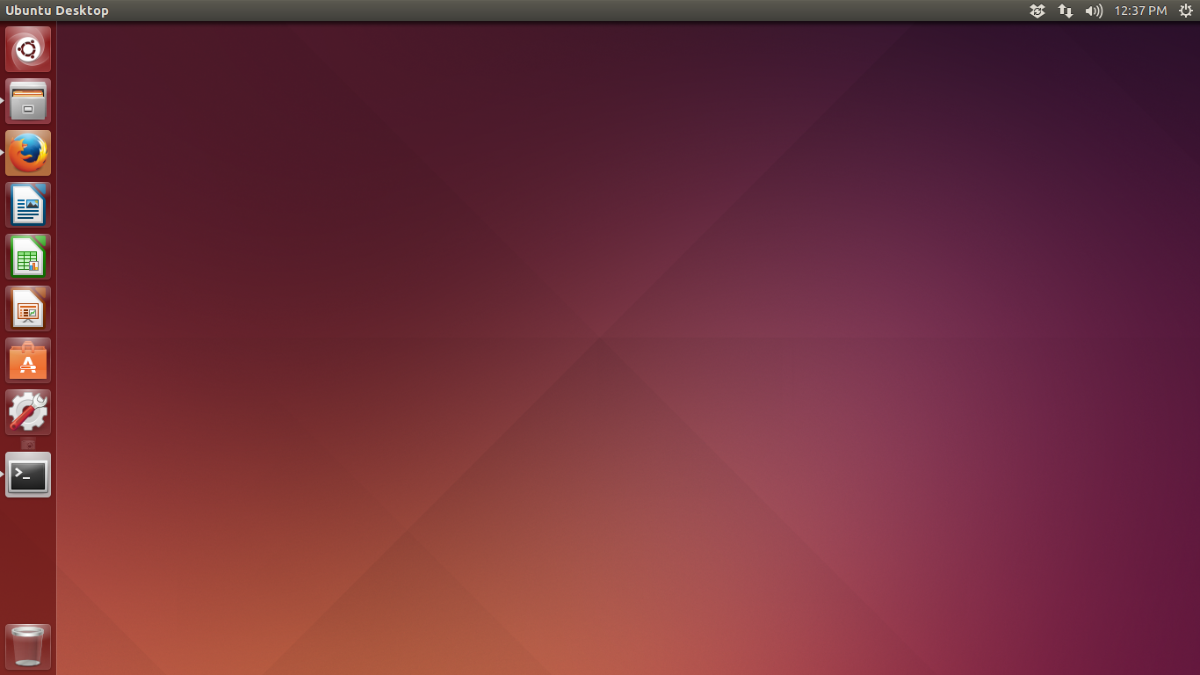
15. What did you learn from this assignment?
That I am going to need to plan more time for homework...
Actually, although long and time consuming, the questions in the end of the chapter filled a few blanks I wasn't aware of.

