Casey Bladow
Assignment 02
1/25/15

1.
Give a good description of this feature.
Gets rid of the window that your virtual machine is trapped and sort of merges the guest OS with the host OS. Running the virtual machine in the background, still keeping host files sand-boxed, and allowing much more work space.
Were you successful? If not, why?
I have gotten this to work before, however I'm not sure why this one is fighting me. I have reinstalled the VMware tools and that should have fixed the issue...
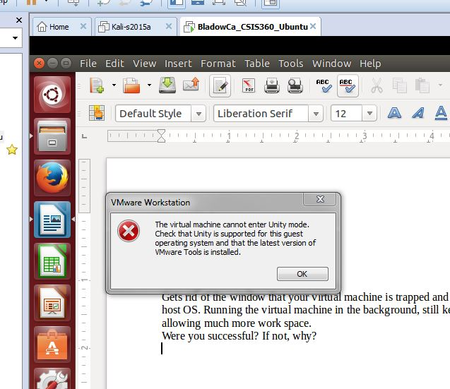
4.
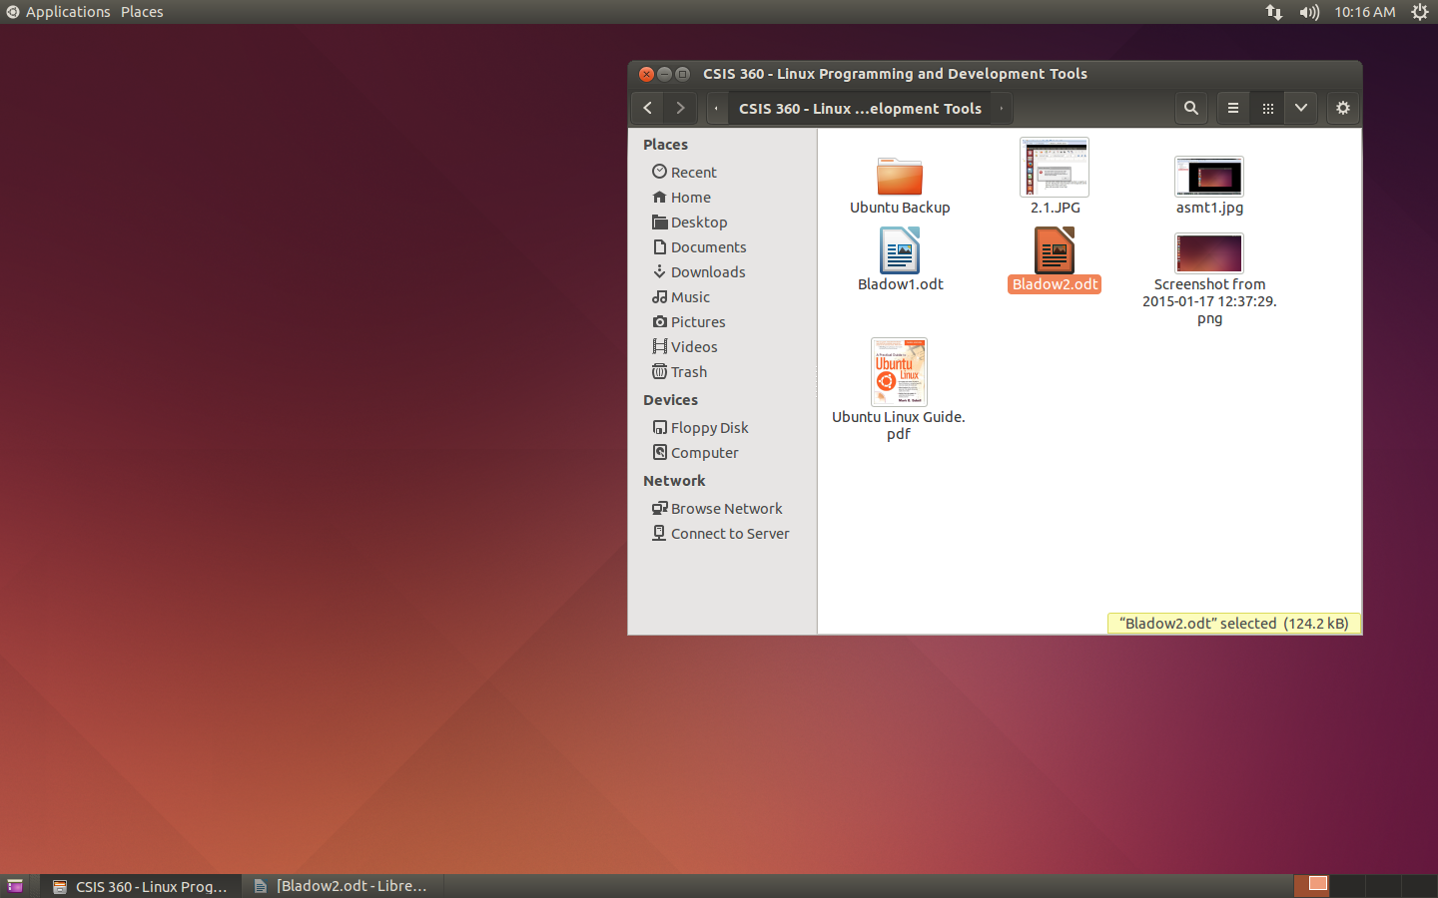
6.
1.
a. It's a strategy to discourage people from guessing names and/or passwords to access to a system.
b. Prevents brute force attacks from cracking the systems security features.
2. 123456 – Most common poor password. GURANTEED to be in a hackers dictionary.
password – Most common base word password. Also, will be found in a dictionary.
ssdd – Too short and doesn't contain any numbers.
3. No, a password should be at least 8 characters long, and contain at least 1 number. Not providing this will create a potentially very easy password to guess.
4. A context menu is a menu with choices that apply to the windows or icon you click on. It will be specific to what you previously right clicked on, like an extension of options.
5. Displays the desktop menu, enabling you to create a folders, documents, or launchers.
6. Edit the Mouse settings (System>Preferences>Mouse) and change functions of the right and left buttons. Specifies how fast you must drag something before the OS considers it being part of a drag-and-drop operation. Changing it can also be done in the Mouse Preferences.
7. To show options at login.
8. The input focus specifies where keyboard input will go. When no window is being focused on, the input gets lost. I prefer Click-to-focus, I like to be in full control of where my input specifically goes. Just seems sloppy any other way.
9. The Window Operations menu contains operations that you most commonly need to perform on any window. Right-click either the title-bar or the Window List applet to display this menu. You can use the menu to move a window to another workspace, keep the window on top of or below other windows, and cause the window o always be visible on the displayed workspace.
10. A panel is the bar that appears on the desktop and holds objects. By default there is a a panel on Top and the Button holding several objects. Each rectangle in the Workplace Switcher applet represents a single workspace. You can switch between workspaces by clicking each rectangle. One Window List applet is also on the bottom panel for each window that is open. Clicking each will either bring it to the front or minimize it. Right clicking will bring up different options. Think any Windows OS in the last 15 years.
11. A tooltip is a small box that appears near an object in a GUI when a pointer controlled by a mouse passes over or rests on the object and contains a brief text message identifying or explaining the object.
7. People make mistakes, and this can be done far to easy if you are always logged into root. Using sudo instead limits your ability to do this.
8. Panels are like bar strips. They contain menus and icons for different things (time, workspaces, Internet connection, sound volume, etc)
9. Workspaces are like having multiple screens. Incredibly handy if you're multitasking!
10. Repositories are archives filled with different software. There are literally thousands of these out there. Having a few of these would be good to make sure you can keep all your software up to date, however, I don't believe having as many of these as you can installed would be a good thing. Just unnecessary.
11.
Alt-Tab – lets you fast swap through each of the windows currently running
Alt-F2 – opens the Run applet. Just like in Windows
Cntl-Z - Undo
Cntl-C - Copy
man – opens the manual pages for Linux. First it will ask you for a specific page and you can go from there.
apropos – Displays a list of all the topics in the man pages.
info – tells you everything you need to know about major topics whichever node you are in. You can navigate through this quiet easily.
--help – lists commands and how to use them
12. a conceptual combination of the keyboard and display for a computer user interface. The first six virtual consoles provide a text terminal with a login prompt. The graphical X Windows System starts in the seventh virtual console.
14.
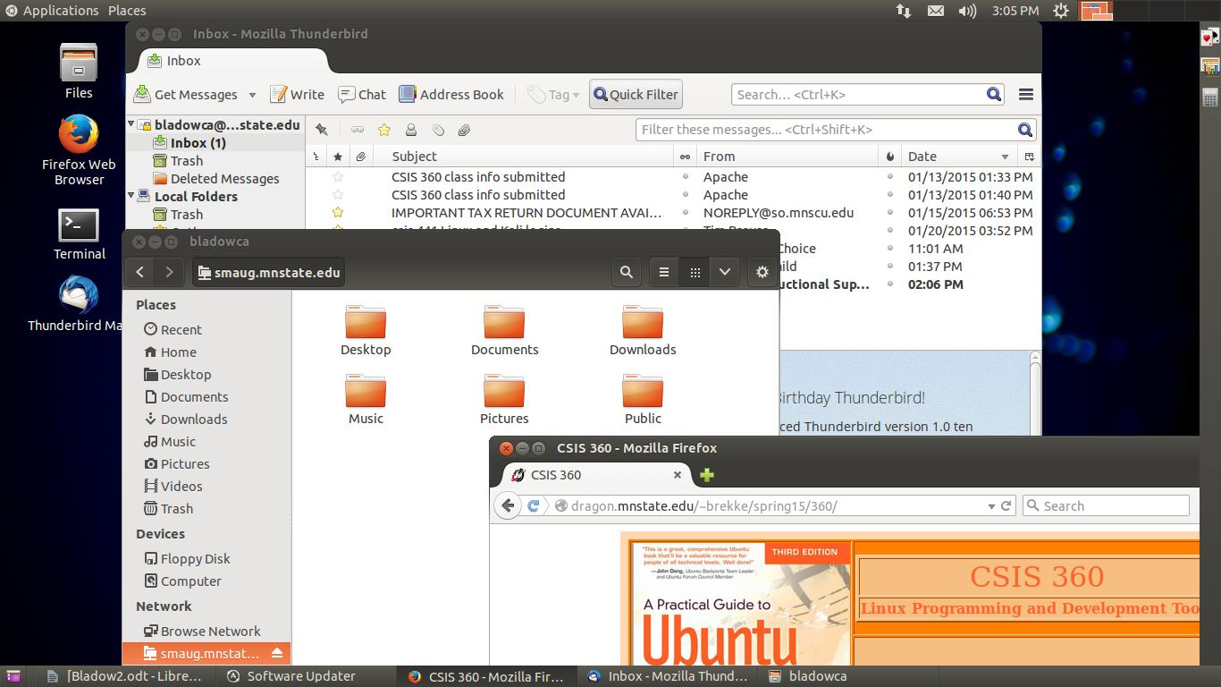
16. A little heavy on the time consumption. Probably spent around 4-5 hours on it. Suggestions, maybe teach it like Server-Side PHP with some examples and what not. Or include tutorial links...
17. A lot. I fought with setting up Thunderbird (but I believe this was StarID and MSUM ID confusion issues), spent far too much time trying to figure out how to create a new panel or move the spaces (had myself convinced this wasn't even possible.). I knew a couple of the shortcuts but you can always learn more. Overall, good learning assignment, just took a lot longer than I would have liked...

