Casey Bladow
Assignment 03
2/1/15

2. Distinguish between a heavyweight desktop environment and a lightweight desktop environment.
A heavyweight desktop environments require more resources to run. They don't run well on older hardware and would not be a good choice if you have insufficient RAM, CPU or old graphics card. They'll include a panel at the bottom, icons on the desktop and a traditional menu system.
A lightweight desktop environment will require less resources and will work on most hardware. They also use panels, icons, and menus however they much simpler and not as fancy. They're very very simple. Cut down to use the least amount of resources possible.
4. Take a screen shot and include it in your assignment 3 document. Describe your experience with Unity. What is the default file manager?
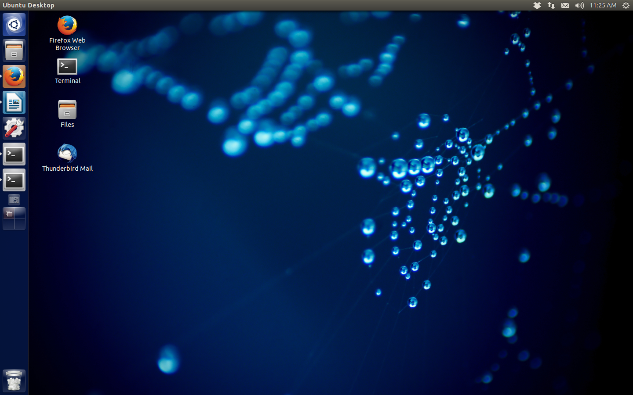
I prefer unity, this is probably only because it is the one I'm most familiar with but I also like the layout and customization of the side panel and menus. Metacity's just kind of a pain unless you know specifically where something is. The Workspace Switcher is stuck in the left panel after you enable it, I wasn't able to find a way to move this, however I think I prefer Metacity's switcher a little more. This one is a tad slower and takes a little more effort to use. And you can definitely see it have an impact on resources loading all four screens and fading in and out. I also had issues building another panel, certainly isn't as simple as Metacity's. I assume there is a way, but I will have to come back to this and look for it. The default file manager for Unity is also Nautilus.
5. Take a screen shot and include it in your assignment 3 document. Describe your experience with Xfce4. What is the default file manager?
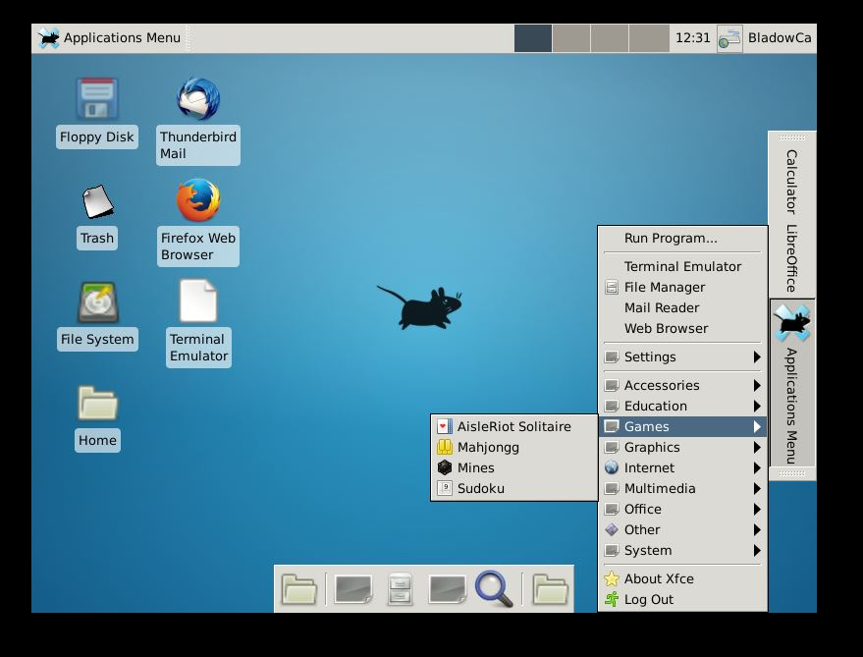
Xfce4 is definitely lightweight. Very minimal GUI and maximum simplicity. The panel is super easy to make, the Workspace Shifter was already on top but much easier to move than the other systems we've used thus far. I wasn't able to make a direct shortcut to the Games folder, however, the second did allow a menu and only involved an extra click to get there. Creating the launchers were easier to just use labels instead of the icons. The default file manager is called Thunar 1.6.3.
6. Take a screen shot and include it in your assignment 3 document. Describe your experience with KDE (Kubuntu). What is the default file manager?
I like KDE, It's simple and elegant. Super easy to use and has the classic windows feel to it. Took a little over an hour to figure out the panels and workspace manager. The default file manager is Dolphin. I would definitely say this is my favorite file manager. The look, feel and features are very slick and easy to use. Navigating around is a breeze.
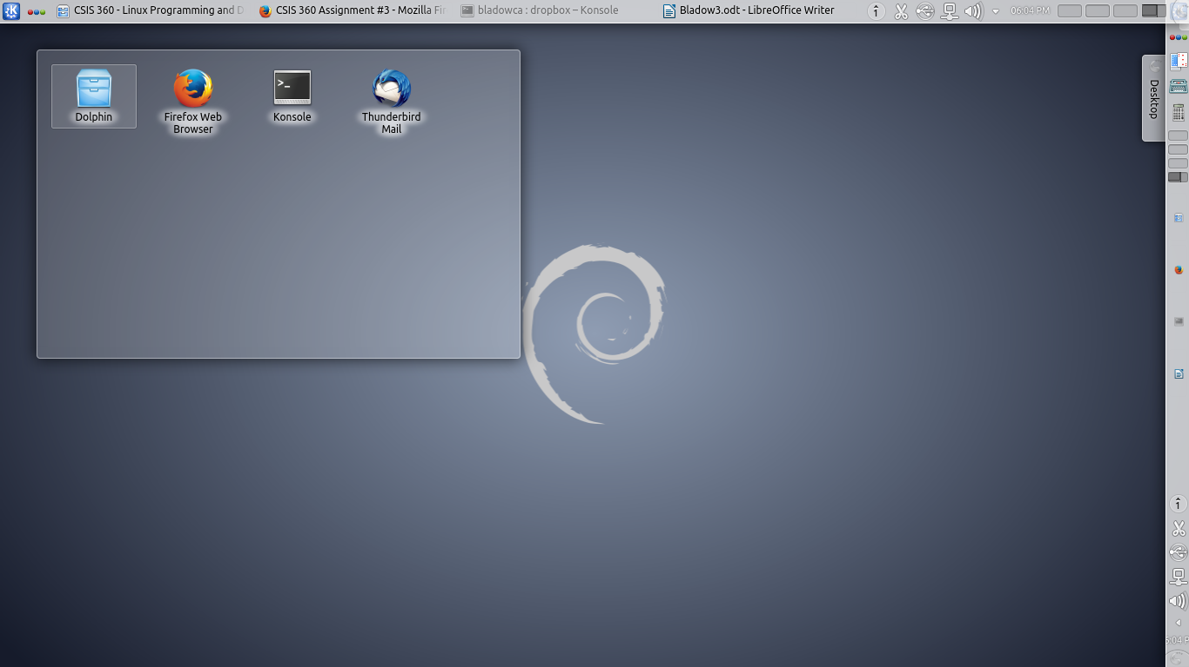
10. Which desktop environment did you choose and why? Take a screen shot and include it in your assignment 3 document.
I'm going to stick with KDE for awhile. I like the look and feel of it. Tweaked it down to its simplest form and kept a few things we have been working with.
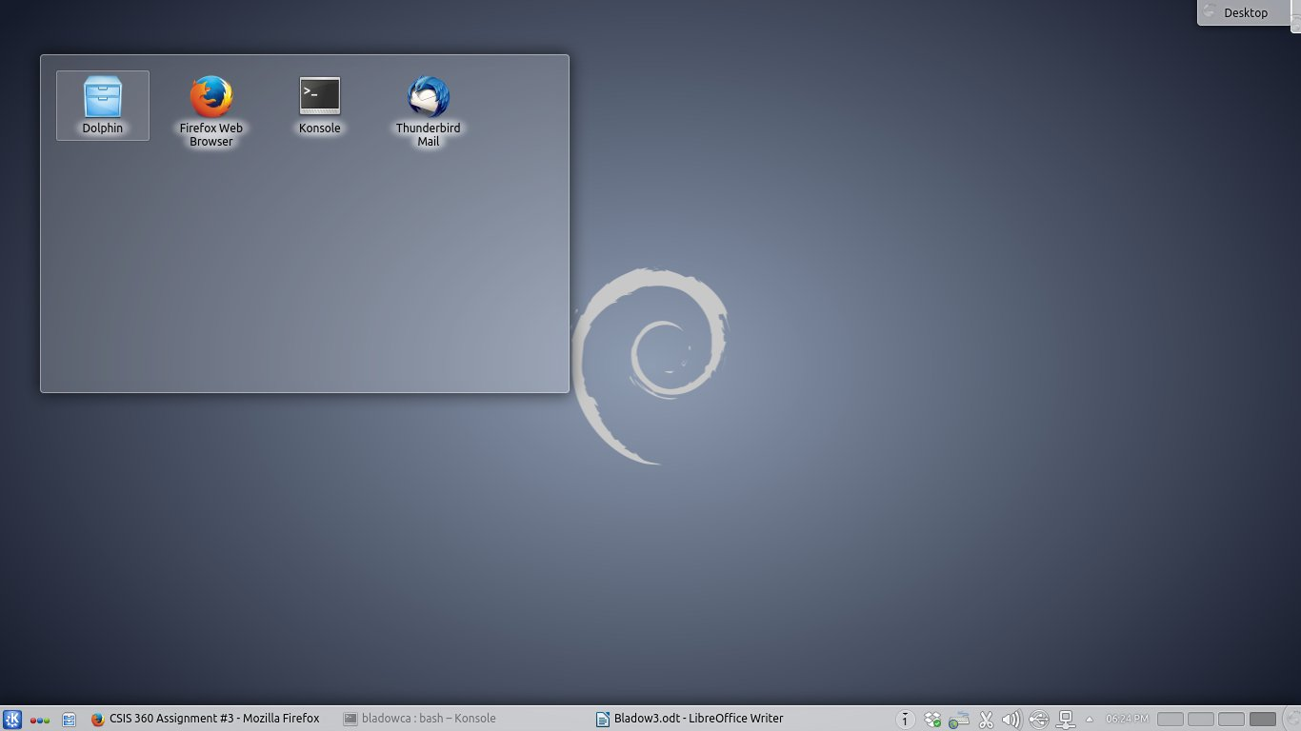
11. What did you think of this assignment? How long did it take you? Do you have any suggestions for the next time I teach this class?
It was a nice way to get a feel for multiple Linux desktop environments. It is really frustrating that they all do things in slightly different manners tho. I worked on this a little here and a little there, all together somewhere around 5 hours I would imagine. One of the environments took a little while to download. Show us how to do some these some of these things, or provide links that document this well. Having to Google each and every thing is very time consuming.
12. What did you learn from this assignment?
Linux definitely has different environments for anyones needs. Whether it is limited to what your PC can handle, or you are just looking for something simple, or even something similar to what most people are use to and like it that way.

