Casey Bladow
Assignment 04
2/10/15

4. What is LAMP?
LAMP is a group of open source software that is installed together to enable a server to host dynamic websites and apps.
Linux operating system
Apache web server
MySQL database
PHP
6. take a screen shot when the answer is displaying and include it in your assignment 4 document.
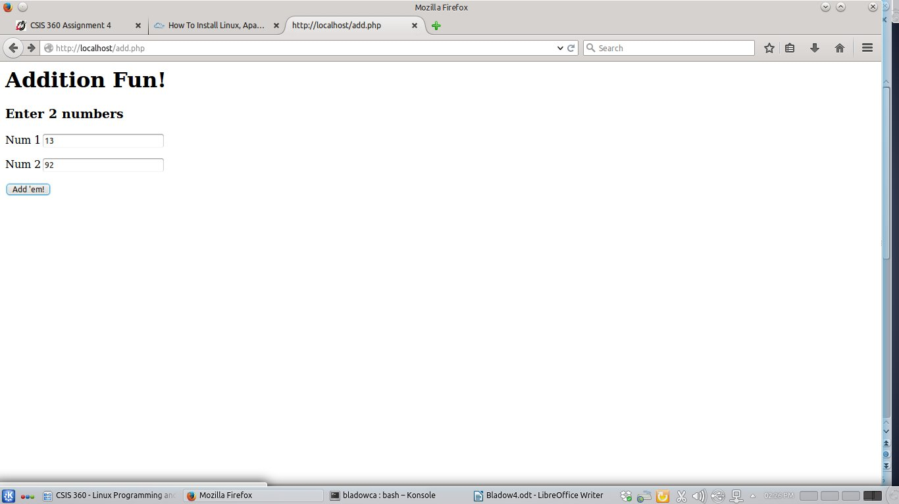
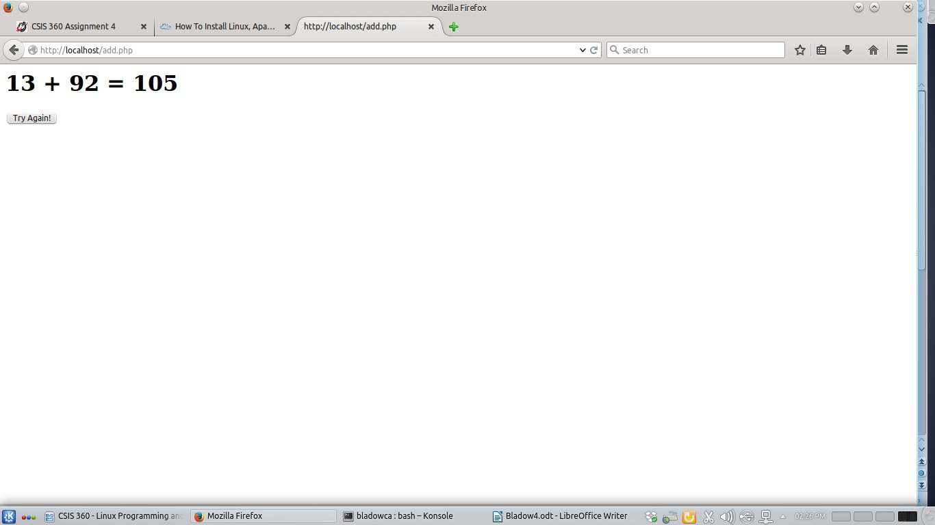
10. Take a screen shot of your web browser and include it in your assignment 4 document.
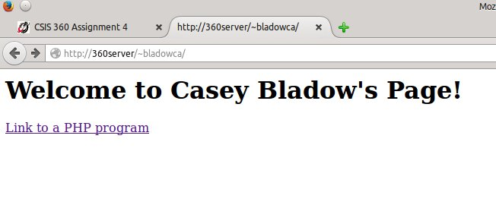
11. Take a screen shot and include it in your assignment 4 document. Take a screen shot of the web browser and include it in your assignment 4 document.
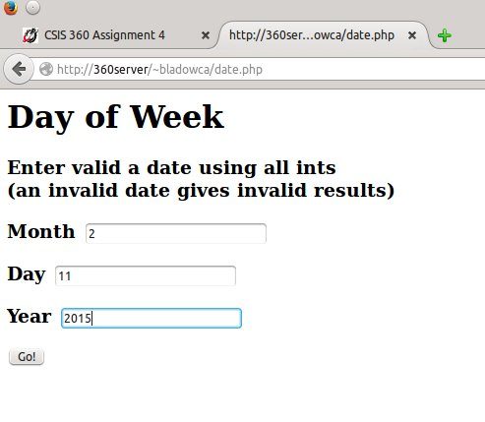

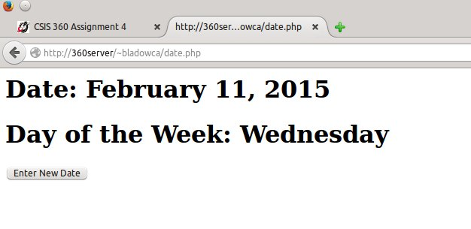

14. Take a screen shot of the terminal window and include it in your assignment 4 document.
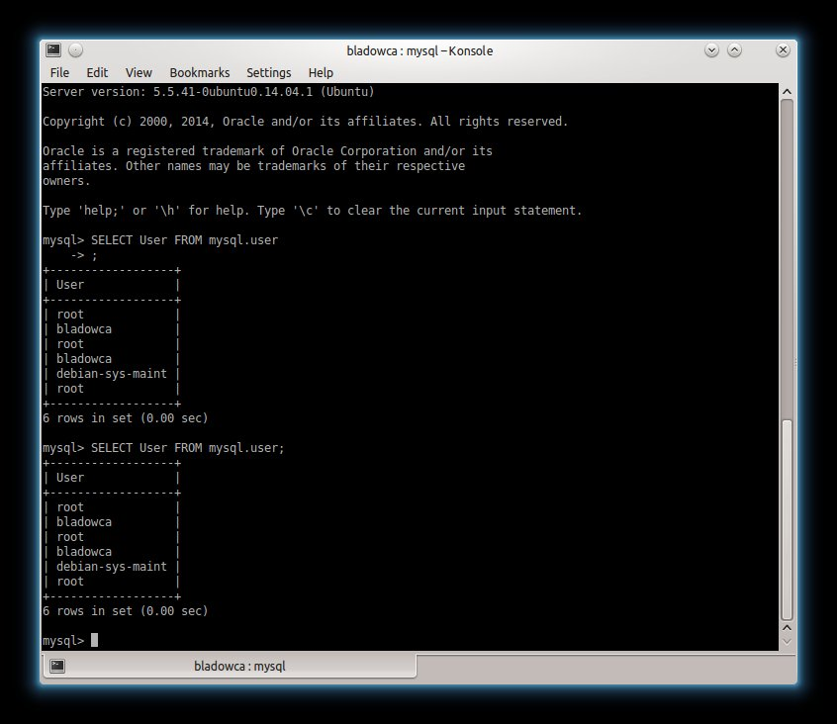
16. With PHPMyAdmin in a browser, click on Users then take a screen shot of the browser window and include it in your assignment 4 document.
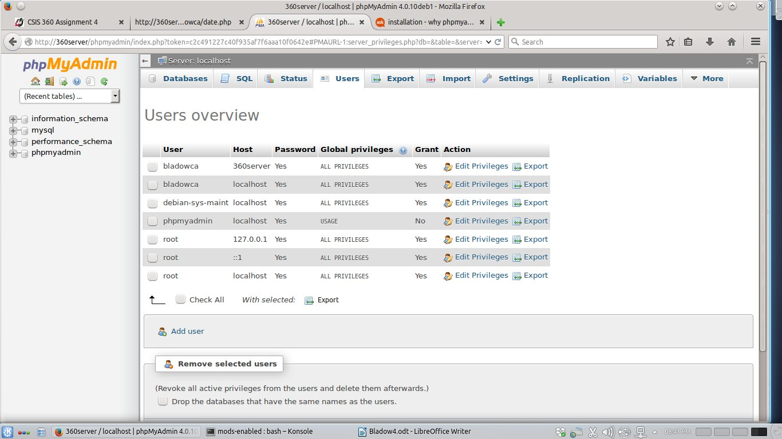
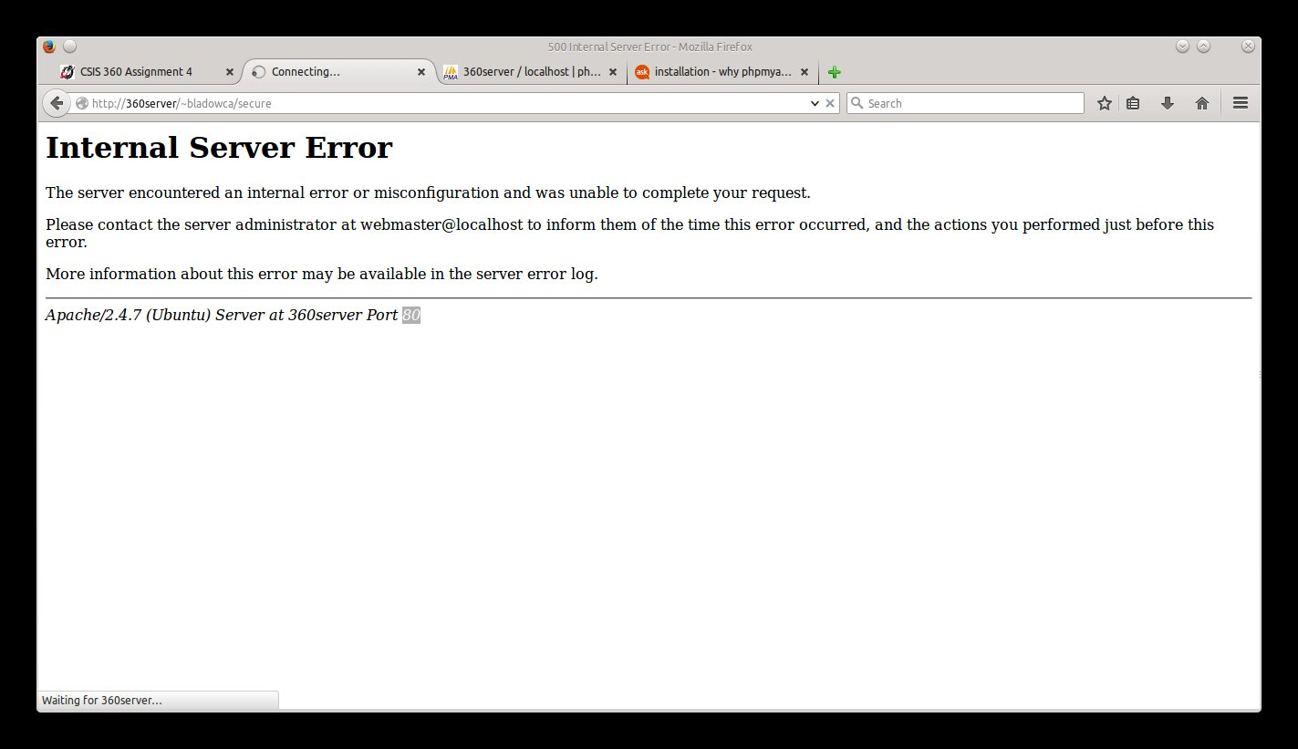
17. Take a screen shot and include it in your assignment 4 document.
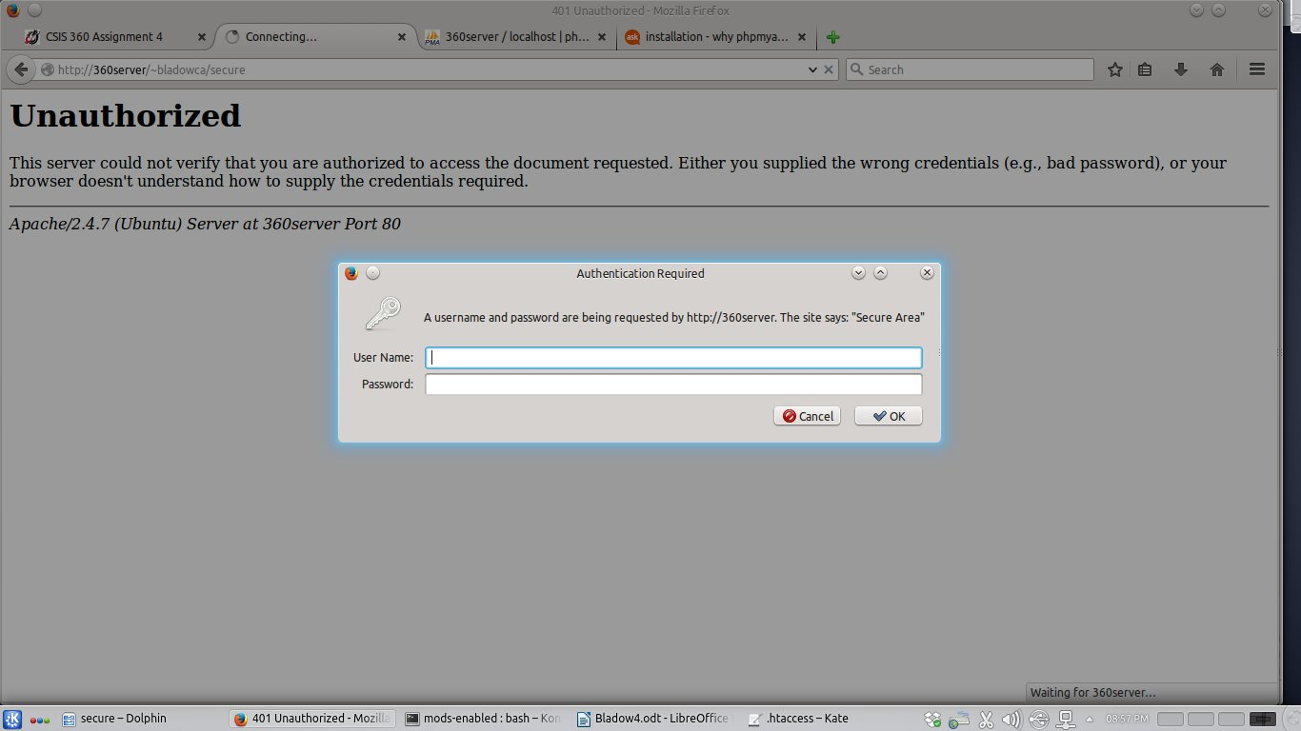
19. What did you think of this assignment? How long did it take you? Do you have any suggestions for the next time I teach this class?
Better than the last, personnaly I enjoy setting up things and making them work. That last one just got annoying bouncing around trying to figure 19 different ways to do the same thing. I don't when we discussed securing the webpage, but that took all of 5 minutes to find on the Google machine. Took about 4 hours I would guess. A little here and a little there.
20. What did you learn from this assignment?
I believe in Databases we set up a Server and what not before. However, we didn't do much with web-pages or securing pages, so that was new. LAMP was new. Apache seemed new, although I've probably used it before and haven't realized it.

