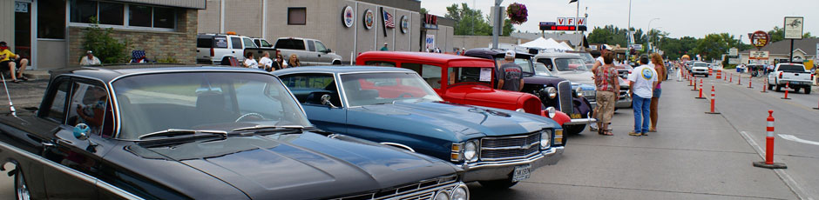

Toppers Car Club  
P.O. Box 3171  
Fargo, ND 58108

[http://www.topperscarclub.com](http://www.topperscarclub.com/" \t "_blank)

*Saturday, March 29th*

*Sunday, March 30th, 2014*

*West Fargo Veteran Memorial Arena*

West Fargo Veteran Memorial Aren

*56th Annual Rod and Custom Car Show*