Homework2

Changed the source but this is what we need for homework2. I’m still having issues with PhoneGap however. <http://www.adobe.com/devnet/html5/articles/hangman-part-1.html> and <http://www.adobe.com/devnet/html5/articles/hangman-part-2.html>

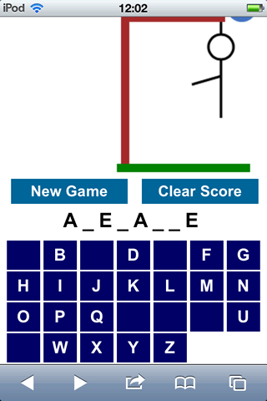

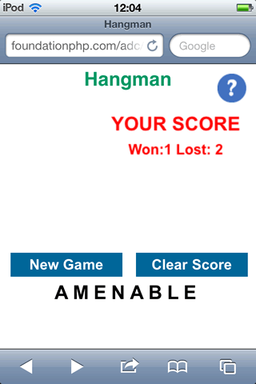

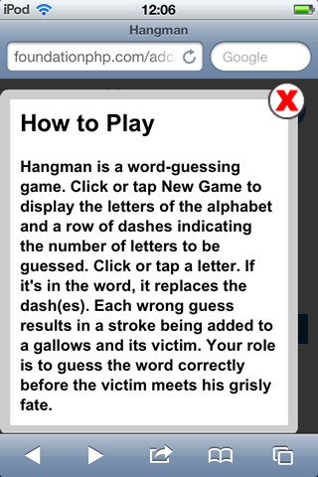

<h1>Hangman</h1>

<p id="warning">JavaScript must be enabled to play this game.</p>

<div id="help"></div>

<div id="helptext">

<h2>How to Play</h2>

<div id="close"></div>

<p>Hangman is a word-guessing game. . .</p>

</div>

<p id="loading">Game loading. . .</p>

<canvas id="stage" width="200" height="200">Sorry, your browser needs to support canvas for this game.</canvas>

<div id="play">New Game</div> <div id="clear">Clear Score</div>

<p id="word"></p>

<div id="letters"></div>

// Global variables

var canvas = document.getElementById('stage'),

word = document.getElementById('word'),

letters = document.getElementById('letters'),

wordToGuess,

wordLength,

badGuesses,

correctGuesses;

function newGame() {

alert('Game started');

}

function resetScore() {

alert('Score has been reset');

}

// Check whether selected letter is in the word to be guessed

function checkLetter(letter) {

var placeholders = word.innerHTML,

wrongGuess = true;

// split the placeholders into an array

placeholders = placeholders.split('');

// loop through the array

for (var i = 0; i < wordLength; i++) {

// if the selected letter matches one in the word to guess,

// replace the underscore and increase the number of correct guesses

if (wordToGuess.charAt(i) == letter.toLowerCase()) {

placeholders[i] = letter;

wrongGuess = false;

correctGuesses++;

// redraw the canvas only if all letters have been guessed

if (correctGuesses == wordLength) {

drawCanvas();

}

}

}

// if the guess was incorrect, increment the number of bad

// guesses and redraw the canvas

if (wrongGuess) {

badGuesses++;

drawCanvas();

}

// convert the array to a string and display it again

word.innerHTML = placeholders.join('');

}