3.     This section is worth 100 points toward the final. Please put all  
the required documentation in a pdf file called /section03.pdf/.  
  
3.1.   Identify the host name, all nic mac addresses, host operating  
system version, show the host is current with updates, and show the host  
has a current, running anti-malware protection you are using for this  
section.

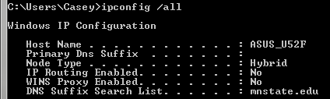

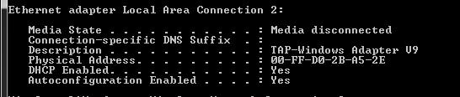

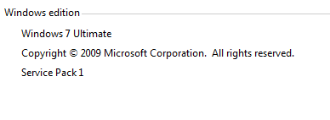

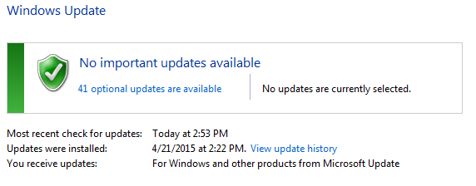

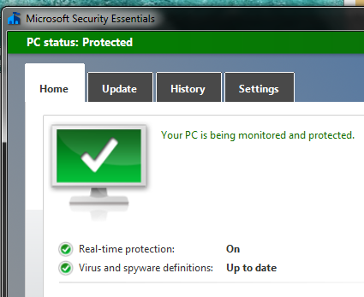  
  
3.2.   Create three logons/logins for the host you selected.  
  
3.2.1.Each logon/login must be a form of your name.  
  
3.2.2.Show each logon/login must have a password of at least 10  
characters, at least one number, mix case, and at least one  
non-alphanumeric.

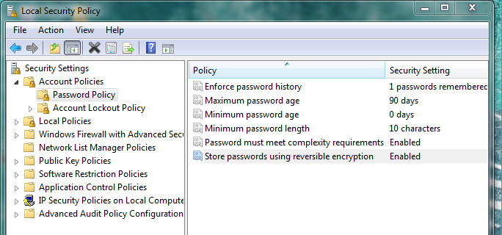

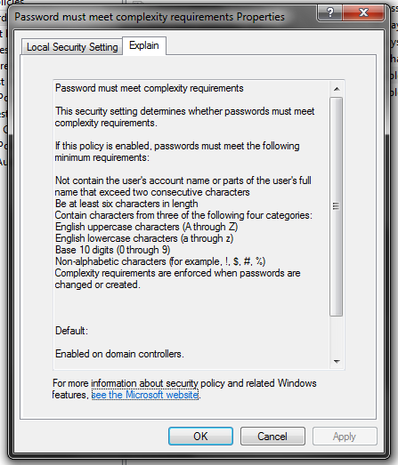  
  
3.2.3.Show each logon/login has successfully changed passwords at least  
once.  
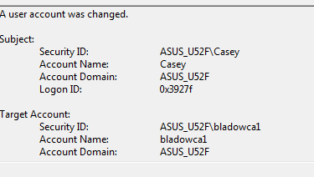

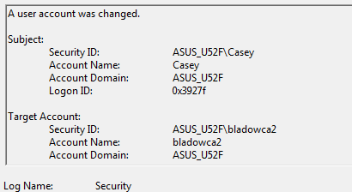

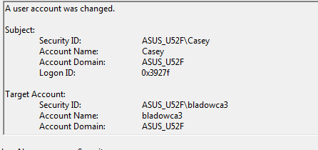  
3.2.4.Show each logon/login will expire on 5/18/2015.  
  
3.3.   Provide evidence (log file listing) each logon/login has failed  
to logon/login at least once to the host.  
  
3.4.   Provide evidence (log file listing) each logon/login has failed  
to access a file or directory at least once on the host.  
  
3.5.   Provide evidence (log file listing) each logon/login has failed  
to perform a host administration function at least once on the host.  
  
3.6.   Provide evidence (log file listing) of three different suspicious  
or unauthorized network traffic to the host