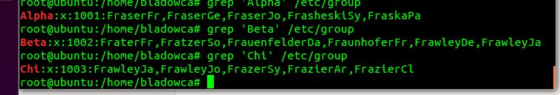 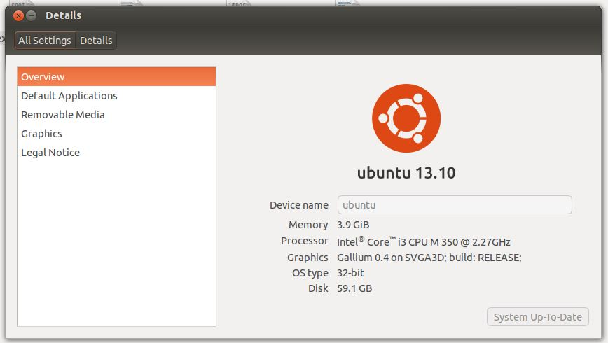

root

Last password change : Aug 26, 2013

Password expires : never

Password inactive : never

Account expires : never

Minimum number of days between password change : 0

Maximum number of days between password change : 99999

Number of days of warning before password expires : 7

daemon

Last password change : Apr 24, 2013

Password expires : never

Password inactive : never

Account expires : never

Minimum number of days between password change : 0

Maximum number of days between password change : 99999

Number of days of warning before password expires : 7

bin

Last password change : Apr 24, 2013

Password expires : never

Password inactive : never

Account expires : never

Minimum number of days between password change : 0

Maximum number of days between password change : 99999

Number of days of warning before password expires : 7

sys

Last password change : Apr 24, 2013

Password expires : never

Password inactive : never

Account expires : never

Minimum number of days between password change : 0

Maximum number of days between password change : 99999

Number of days of warning before password expires : 7

sync

Last password change : Apr 24, 2013

Password expires : never

Password inactive : never

Account expires : never

Minimum number of days between password change : 0

Maximum number of days between password change : 99999

Number of days of warning before password expires : 7

games

Last password change : Apr 24, 2013

Password expires : never

Password inactive : never

Account expires : never

Minimum number of days between password change : 0

Maximum number of days between password change : 99999

Number of days of warning before password expires : 7

man

Last password change : Apr 24, 2013

Password expires : never

Password inactive : never

Account expires : never

Minimum number of days between password change : 0

Maximum number of days between password change : 99999

Number of days of warning before password expires : 7

lp

Last password change : Apr 24, 2013

Password expires : never

Password inactive : never

Account expires : never

Minimum number of days between password change : 0

Maximum number of days between password change : 99999

Number of days of warning before password expires : 7

mail

Last password change : Apr 24, 2013

Password expires : never

Password inactive : never

Account expires : never

Minimum number of days between password change : 0

Maximum number of days between password change : 99999

Number of days of warning before password expires : 7

news

Last password change : Apr 24, 2013

Password expires : never

Password inactive : never

Account expires : never

Minimum number of days between password change : 0

Maximum number of days between password change : 99999

Number of days of warning before password expires : 7

uucp

Last password change : Apr 24, 2013

Password expires : never

Password inactive : never

Account expires : never

Minimum number of days between password change : 0

Maximum number of days between password change : 99999

Number of days of warning before password expires : 7

proxy

Last password change : Apr 24, 2013

Password expires : never

Password inactive : never

Account expires : never

Minimum number of days between password change : 0

Maximum number of days between password change : 99999

Number of days of warning before password expires : 7

www-data

Last password change : Apr 24, 2013

Password expires : never

Password inactive : never

Account expires : never

Minimum number of days between password change : 0

Maximum number of days between password change : 99999

Number of days of warning before password expires : 7

backup

Last password change : Apr 24, 2013

Password expires : never

Password inactive : never

Account expires : never

Minimum number of days between password change : 0

Maximum number of days between password change : 99999

Number of days of warning before password expires : 7

list

Last password change : Apr 24, 2013

Password expires : never

Password inactive : never

Account expires : never

Minimum number of days between password change : 0

Maximum number of days between password change : 99999

Number of days of warning before password expires : 7

irc

Last password change : Apr 24, 2013

Password expires : never

Password inactive : never

Account expires : never

Minimum number of days between password change : 0

Maximum number of days between password change : 99999

Number of days of warning before password expires : 7

gnats

Last password change : Apr 24, 2013

Password expires : never

Password inactive : never

Account expires : never

Minimum number of days between password change : 0

Maximum number of days between password change : 99999

Number of days of warning before password expires : 7

nobody

Last password change : Apr 24, 2013

Password expires : never

Password inactive : never

Account expires : never

Minimum number of days between password change : 0

Maximum number of days between password change : 99999

Number of days of warning before password expires : 7

libuuid

Last password change : Apr 24, 2013

Password expires : never

Password inactive : never

Account expires : never

Minimum number of days between password change : 0

Maximum number of days between password change : 99999

Number of days of warning before password expires : 7

syslog

Last password change : Apr 24, 2013

Password expires : never

Password inactive : never

Account expires : never

Minimum number of days between password change : 0

Maximum number of days between password change : 99999

Number of days of warning before password expires : 7

messagebus

Last password change : Apr 24, 2013

Password expires : never

Password inactive : never

Account expires : never

Minimum number of days between password change : 0

Maximum number of days between password change : 99999

Number of days of warning before password expires : 7

avahi-autoipd

Last password change : Apr 24, 2013

Password expires : never

Password inactive : never

Account expires : never

Minimum number of days between password change : 0

Maximum number of days between password change : 99999

Number of days of warning before password expires : 7

usbmux

Last password change : Apr 24, 2013

Password expires : never

Password inactive : never

Account expires : never

Minimum number of days between password change : 0

Maximum number of days between password change : 99999

Number of days of warning before password expires : 7

dnsmasq

Last password change : Apr 24, 2013

Password expires : never

Password inactive : never

Account expires : never

Minimum number of days between password change : 0

Maximum number of days between password change : 99999

Number of days of warning before password expires : 7

whoopsie

Last password change : Apr 24, 2013

Password expires : never

Password inactive : never

Account expires : never

Minimum number of days between password change : 0

Maximum number of days between password change : 99999

Number of days of warning before password expires : 7

kernoops

Last password change : Apr 24, 2013

Password expires : never

Password inactive : never

Account expires : never

Minimum number of days between password change : 0

Maximum number of days between password change : 99999

Number of days of warning before password expires : 7

rtkit

Last password change : Apr 24, 2013

Password expires : never

Password inactive : never

Account expires : never

Minimum number of days between password change : 0

Maximum number of days between password change : 99999

Number of days of warning before password expires : 7

speech-dispatcher

Last password change : Apr 24, 2013

Password expires : never

Password inactive : never

Account expires : never

Minimum number of days between password change : 0

Maximum number of days between password change : 99999

Number of days of warning before password expires : 7

lightdm

Last password change : Apr 24, 2013

Password expires : never

Password inactive : never

Account expires : never

Minimum number of days between password change : 0

Maximum number of days between password change : 99999

Number of days of warning before password expires : 7

avahi

Last password change : Apr 24, 2013

Password expires : never

Password inactive : never

Account expires : never

Minimum number of days between password change : 0

Maximum number of days between password change : 99999

Number of days of warning before password expires : 7

colord

Last password change : Apr 24, 2013

Password expires : never

Password inactive : never

Account expires : never

Minimum number of days between password change : 0

Maximum number of days between password change : 99999

Number of days of warning before password expires : 7

pulse

Last password change : Apr 24, 2013

Password expires : never

Password inactive : never

Account expires : never

Minimum number of days between password change : 0

Maximum number of days between password change : 99999

Number of days of warning before password expires : 7

hplip

Last password change : Apr 24, 2013

Password expires : never

Password inactive : never

Account expires : never

Minimum number of days between password change : 0

Maximum number of days between password change : 99999

Number of days of warning before password expires : 7

saned

Last password change : Apr 24, 2013

Password expires : never

Password inactive : never

Account expires : never

Minimum number of days between password change : 0

Maximum number of days between password change : 99999

Number of days of warning before password expires : 7

bladowca

Last password change : Aug 26, 2013

Password expires : never

Password inactive : never

Account expires : never

Minimum number of days between password change : 0

Maximum number of days between password change : 99999

Number of days of warning before password expires : 7

debian-tor

Last password change : Oct 03, 2013

Password expires : never

Password inactive : never

Account expires : never

Minimum number of days between password change : 0

Maximum number of days between password change : 99999

Number of days of warning before password expires : 7

FraserFr

Last password change : May 06, 2015

Password expires : never

Password inactive : never

Account expires : May 15, 2015

Minimum number of days between password change : 0

Maximum number of days between password change : 99999

Number of days of warning before password expires : 7

FrazierCl

Last password change : May 06, 2015

Password expires : never

Password inactive : never

Account expires : May 15, 2015

Minimum number of days between password change : 0

Maximum number of days between password change : 99999

Number of days of warning before password expires : 7

FraserGe

Last password change : May 06, 2015

Password expires : never

Password inactive : never

Account expires : May 15, 2015

Minimum number of days between password change : 0

Maximum number of days between password change : 99999

Number of days of warning before password expires : 7

FraserJo

Last password change : May 06, 2015

Password expires : never

Password inactive : never

Account expires : May 15, 2015

Minimum number of days between password change : 0

Maximum number of days between password change : 99999

Number of days of warning before password expires : 7

FrasheskiSy

Last password change : May 06, 2015

Password expires : never

Password inactive : never

Account expires : May 15, 2015

Minimum number of days between password change : 0

Maximum number of days between password change : 99999

Number of days of warning before password expires : 7

FraskaPa

Last password change : May 06, 2015

Password expires : never

Password inactive : never

Account expires : May 15, 2015

Minimum number of days between password change : 0

Maximum number of days between password change : 99999

Number of days of warning before password expires : 7

FraterFr

Last password change : May 06, 2015

Password expires : never

Password inactive : never

Account expires : May 15, 2015

Minimum number of days between password change : 0

Maximum number of days between password change : 99999

Number of days of warning before password expires : 7

FratzerSo

Last password change : May 06, 2015

Password expires : never

Password inactive : never

Account expires : May 15, 2015

Minimum number of days between password change : 0

Maximum number of days between password change : 99999

Number of days of warning before password expires : 7

FrauenfelderDa

Last password change : May 06, 2015

Password expires : never

Password inactive : never

Account expires : May 15, 2015

Minimum number of days between password change : 0

Maximum number of days between password change : 99999

Number of days of warning before password expires : 7

FraunhoferFr

Last password change : May 06, 2015

Password expires : never

Password inactive : never

Account expires : May 15, 2015

Minimum number of days between password change : 0

Maximum number of days between password change : 99999

Number of days of warning before password expires : 7

FrawleyDe

Last password change : May 06, 2015

Password expires : never

Password inactive : never

Account expires : May 15, 2015

Minimum number of days between password change : 0

Maximum number of days between password change : 99999

Number of days of warning before password expires : 7

FrawleyJa

Last password change : May 06, 2015

Password expires : never

Password inactive : never

Account expires : May 15, 2015

Minimum number of days between password change : 0

Maximum number of days between password change : 99999

Number of days of warning before password expires : 7

FrawleyJo

Last password change : May 06, 2015

Password expires : never

Password inactive : never

Account expires : May 15, 2015

Minimum number of days between password change : 0

Maximum number of days between password change : 99999

Number of days of warning before password expires : 7

FrazerSy

Last password change : May 06, 2015

Password expires : never

Password inactive : never

Account expires : May 15, 2015

Minimum number of days between password change : 0

Maximum number of days between password change : 99999

Number of days of warning before password expires : 7

FrazierAr

Last password change : May 06, 2015

Password expires : never

Password inactive : never

Account expires : May 15, 2015

Minimum number of days between password change : 0

Maximum number of days between password change : 99999

Number of days of warning before password expires : 7